Project Report Prepared By The Computer and Biomedical Engineering Departments

2024

HAZIRLAYANLAR

1. Alperen Yüksel-22197484 BİL

2. Mehmet Kaan Yılmam 22197367 BİL

3. Mina Ece Yıldız 22298304 BİL

4. Eren Yurtal 22298411 BİL

5. Azra Yılmaz 22298321 BİL

6. Yiğit Kemal Yeşiltaş 22298241 BME

7. İrem Yıldırım 22197320 BME

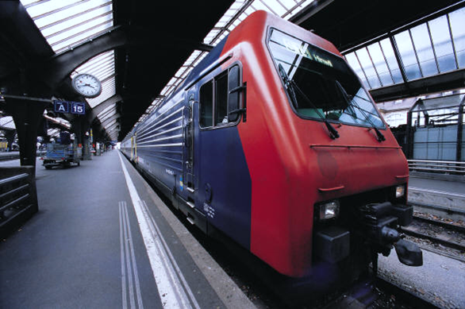

**CONTENTS PAGE NO**

**1- MEETING NO:1 / TASKS ………………………………………………….………..2-3**

**2-MEETING NO:2 / PROJECT CONTENT……………………………………….….4-5**

**3-MEETING NO:3 / PROJECT CONTENT……………………………………….…..6**

**4-MEETING NO:4 / PLANNİNG AND IMPLEMENTATİON ………….…………...7**

**5- ABOUT PROJECT AND PROJECT INFORMATION……………………………8-10**

**6- FIRST LITERATURE RESEARCH …………………………………………………11**

**7-MATLAB CODES………………………………………………………………………12**

**8-MATLAB OUTPUTS…………………………………………………………………...13-14**

**9-EXCEL TABLES ……………………………………………………………………….15-16**

**10-PROJECT TASK DISTRIBUTION……………………………………………….….17**

**12- SECOND LITERATURE RESEARCH ……………………………………………...18**

**13-PROJECT OUTPUTS ………………………………………………………….………19**

**14- C++ CODES………………………….…………………………………………………20-21**

**15- FREFERENCES……………………. …………………………………………………22**

**MEETING NO:1**

**OCTOBER 17, 2023 13.00**

giyim, kişi, şahıs, insan yüzü, kadın içeren bir resim

Açıklama otomatik olarak oluşturuldu

**Topics Discussed at the Meeting :**

1. How to classify and analyze ECG data.

2. File types and names to be used.

3. Project chair and vice-chair selected.

4. Distribution of work and responsibilities.

**Project Task Distribution :**

1. Alperen YÜKSEL - 22197484 – **BİL** - Libraries used for writing code and main function.

2. Mehmet Kaan YILMAM - 22197367 – **BİL** - The readData function used in the public part of the class structure.

3. Mina Ece YILDIZ - 22298304 – **BİL** - The private part of the class structure.

4. Eren YURTAL - 22298411 – **BİL** - The analyzeData() function used in the public part of the class structure.

5. Azra YILMAZ - 22298321 – **BİL** - The writeResults function used in the public part of the class structure.

6. Yiğit Kemal YEŞİLTAŞ - 22298241 – **BME** - Taking data from ECG simulator, combining and graphing with mathlab code, determining the approximate values of P-R-T points and tabulating them.

7. İrem YILDIRIM - 22197320 – **BME** - Taking data from ECG simulator, combining and graphing with mathlab code, determining the approximate values of P-R-T points and tabulating them.

metin, makbuz, yazı tipi, el yazısı içeren bir resim

Açıklama otomatik olarak oluşturuldu

**MEETING NO:2**

**NOVEMBER 3, 2023 12.00**

giyim, kişi, şahıs, insan yüzü, adam, insan içeren bir resim

Açıklama otomatik olarak oluşturuldu

After the 1st data taken by the BME students were converted into code, the BIL students went to the lab to take data again. After BME students received the given outputs, BIL students started to design their own project codes using these outputs.

giyim, kişi, şahıs, ayakkabı, iç mekan içeren bir resim

Açıklama otomatik olarak oluşturuldu **Collaboration Target :** To carry out joint project work with mixed project groups formed by students who will enroll in "BME207 Computer Applications in Biomedical Engineering" and "BİL265 Data Structures" courses.

metin, makbuz, ekran görüntüsü, yazı tipi içeren bir resim

Açıklama otomatik olarak oluşturuldu

**MEETING NO:3**

**NOVEMBER 29, 2023 12.35**

metin, el yazısı, mürekkep, hat sanatı, kaligrafi içeren bir resim

Açıklama otomatik olarak oluşturuldu

**MEETING NO:4**

**12 DECEMBER, 2023 13.30**

giyim, kişi, şahıs, insan yüzü, kadın içeren bir resim

Açıklama otomatik olarak oluşturuldu

metin, el yazısı, mürekkep, yazı tipi içeren bir resim

Açıklama otomatik olarak oluşturuldu

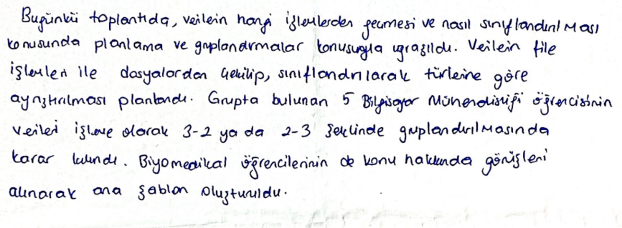

**Expected Output:**

* Students should able to work on the real life problems;
* Application of simple solution steps for the entry-level "Signal Processing", one of the complex engineering problems
* They have developed an application/software.
* Before graduating, they must have worked on a joint project with a team from the same or different branches and thus gained teamwork experience;
* Students use the information they have learned within the scope of the course and what they have learned by studying the literature in the project.
* Explain their study results in front of the community by making oral and written presentations;
* Documented the study results as a project report;

is among the expected outputs.

**Common Project Topic:**

The first steps that can be used in solving complex problems have been taken by automatically processing, storing, and analyzing the ECG data produced by biomedical engineering students within the scope of the course titled "BME207 Computer Applications in Biomedical Engineering" given in the Biomedical Engineering department, by the students taking the CENG265 Data Structures course, and sharing the results with the biomedical department.

**Task to be Performed:**

In this context, with the information on data collection to be learned in the BME207 course, students of the biomedical engineering department create ECG data, which is important during the diagnosis, treatment, and monitoring of heart diseases, through a simulator and record them in digital format. Computer Engineering students process the digital forms of this ECG data in a way suitable for real-life use, using the information they learned in the data structures course, and producing useful information that can help the doctor.

This project includes steps such as data collection, processing and organizing at a level of complexity that sophomore students in both departments can perform. For the project, mixed groups organized between departments present a single report as a team and take common project notes by making a short presentation online or face to face.

# **“BME-207 Biomedical Eng. Steps to be taken within the scope of the "Computer Applications" project…**

* ECG data will be created with the help of the simulator.
* For recording, a sampling frequency that can be used for the ECG signal (short research is required for this), a recording time of 5 seconds, and a depth of 16 bits will be used.
* Each group records data at different values for normal sinus rhythm, tachycardia, and bradycardia. Two normal sinus rhythm data, two tachycardia, and two bradycardia data should be taken. These data are combined (normal_X, tachycardia_X, and bradycardia_X ) and a 15-second data file (PersonX.dat) is created.
* The recorded ECG data will be exported as both a "text file" and a "data file". (In this section, you are expected to do a short research and learn the codes that will perform the relevant tasks.)
* The text file to be saved will be in "txt" format and the data will be saved in vertical format. The data will be recorded in two columns; the first column will contain time data, and the second column will contain voltage values.
* The ECG data to be recorded will be in "dat" or "mat" format and will be recorded by the sampling frequency.
* It is expected that a separate “info.txt” file will be created for each ECG data and the information will be recorded in this file. The file should include the name of the data, total duration, number of beats, and sampling frequency information.
* In the last step, you are expected to record approximately the time corresponding values (in milliseconds or seconds) on the x-axis of the P start, R peak, and T end points of the beats (PQRST wave sequence) in the relevant ECG signal (in milliseconds or seconds) in an Excel or Word document (3 columns: P start, R top, and T end).

# **Scope of “BİL265 Data Structures” and Following Steps**

Within the scope of this project, students with BİL code are expected to write a pure C++ code that can perform the operations below, using the .txt extensions of the ECG files coming from the BME group. According to this;

* For the solution, create a class for the necessary informations.
* Methods of this class are arbitrary.
* You have to use vectors, lists, stacks and queues for whenever is appropiate. **Your program should read data from the file.** The file should be opened otomatically and you have to analyse this information located in the file. Analysis process includes to detection interval of “Tachycardia and Bradycardia” signals from a persons’ ECG.

**Project Information**

**-BME-**

The heartbeat is governed by the electrical impulses of heart cells, originating from the sinus node, which sequentially stimulate the atria and ventricles. This cardiac activity is observed through an electrocardiogram (ECG) test. The sinus node generates electrical signals that lead to atrial contraction, manifested as the P wave on the ECG graph. Subsequently, these signals are conducted to the ventricles via the AV node and His bundle, producing a broad waveform known as the QRS complex, indicative of ventricular contraction. Following this, there is a brief pause during which the heart muscles rest, resulting in the ST segment on the ECG. Finally, the T wave signifies the completion of ventricular relaxation and preparation for the next cycle. The ECG interprets cardiac function by analyzing these distinct waveforms.

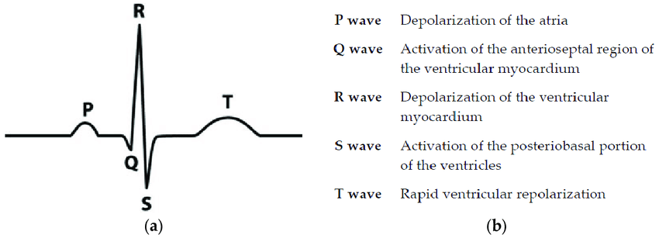

Heartbeat rates falling within the range of 60 to 100 beats per minute are considered normal, while rates below 60 are classified as bradycardia, and those exceeding 100 are termed tachycardia.

Data collected independently from the ECG device underwent consolidation using MATLAB code. A unified ECG signal image was generated, illustrating bradycardia, normal heartbeats, and tachycardia. Subsequent analysis involved scrutinizing the values associated with P, R, and T waves across these signals, with the findings documented in an Excel file.

Each signal depicted a duration of 5 seconds for its respective ailment. The beats per minute for each condition were determined based on their specific value ranges, and a corresponding txt file was compiled and provided to the BIL students.

**Distribution of Tasks:**

1. Yiğit Kemal Yeşiltaş – 22298241 – BME (Code-Report-Presantation)
2. İrem Yıldırım - 22197320 – BME (Code-Presantation)

**Literature Research:**

The collaborative project, undertaken jointly by Computer and Biomedical Engineering students, focused on the Biomedical Engineering aspect, aligning with the curriculum of the "BME207 Computer Applications in Biomedical Engineering" course. This initiative encompassed the acquisition and processing of ECG data, culminating in a detailed analysis of the obtained outputs. Here is an overview of the key steps involved:

1. ECG data was procured with the assistance of a simulator.
2. Utilizing a 5-second duration and a specified sampling frequency, ECG signals were captured.
3. Values were recorded for normal, bradycardia, and tachycardia data. This process was repeated twice, and the acquired data sets were amalgamated to form 15 seconds of comprehensive data.
4. The obtained data was exported in both .txt and data file formats.
5. The recorded information was organized into two columns, representing time and voltage values.
6. For each set of data, corresponding info.txt files were generated.
7. The commencement of the P wave, the conclusion of the R and T waves on the x-axis were manually calculated and documented in an Excel file for further reference.

**MATLAB CODES:**

**PERSON 1:**

clc

clear all

close all

load('data.mat'); %bradycardia

bradycardia = data;

load('data2.mat'); %normal

normal = data2;

load('data3.mat'); %tachycarida

tachycardia = data3;

t = 1/8000:1/8000:15;

datas = vertcat(bradycardia, normal, tachycardia);

plot(t,datas);

veriTable = table(t',datas,'VariableNames',{'Time','Voltage'});

disp(veriTable);

writetable(veriTable, 'datas.txt','Delimiter','\t');

**PERSON 2:**

clc

clear all

close all

load('data1.mat');

bradycardia=data1;

load('data2 (1).mat');

normal=data2;

load('data3 (1).mat');

tachycardia=data3;

t=1/8000:1/8000:15;

datas= vertcat(bradycardia,normal,tachycardia);

plot(t,datas);

veriTable=table(t',datas,'VariableNames',{'Time','Voltage'});

disp(veriTable);

writetable(veriTable,'datas.txt','Delimiter','\t');

**MATLAB OUTPUTS:**

**PERSON 1:**

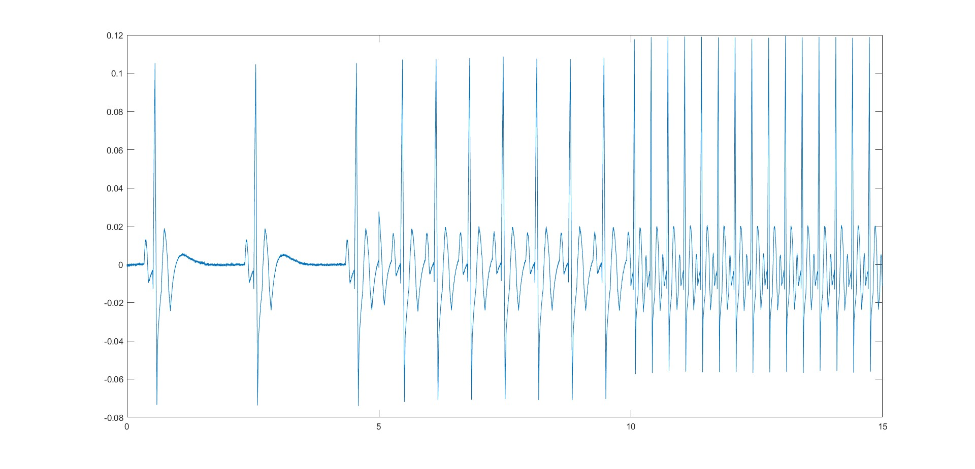

BRADYCARDIA

total duration: 5 second

sampling frequency: 8000 Hertz

number of beats: 36 beats

NORMAL

total duration: 5 second

sampling frequency: 8000 Hertz

number of beats: 84 beats

TACHYCARDIA

total duration: 5 second

sampling frequency: 8000 Hertz

number of beats: 180 beats

**PERSON 2:**

çizgi, öykü gelişim çizgisi; kumpas; grafiğini çıkarma, diyagram, metin içeren bir resim

Açıklama otomatik olarak oluşturuldu

BRADYCARDIA

total duration: 5 second

sampling frequency: 8000 Hertz

number of beats: 36 beats

TACHYCARDIA

total duration: 5 second

sampling frequency: 8000 Hertz

number of beats: 180 beats

NORMAL

total duration: 5 second

sampling frequency: 8000 Hertz

number of beats: 72 beats

**PERSON 1 EXCEL TABLE:**

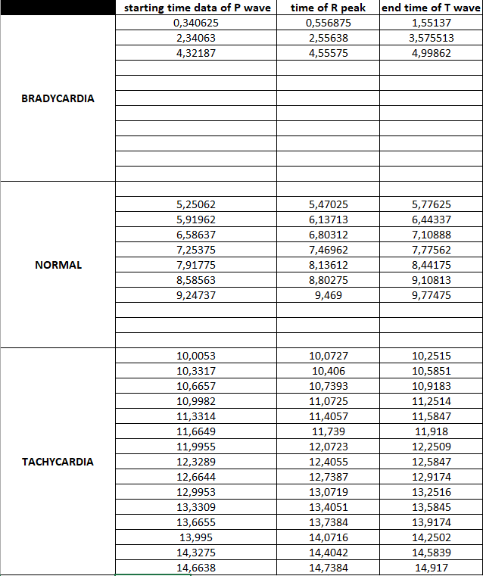

Person 1 veriler

**PERSON 2 EXCEL TABLE:**

**metin, sayı, numara, paralel, yazı tipi içeren bir resim

Açıklama otomatik olarak oluşturuldu**

Person 2 veriler

**-BİL-**

Proje Görev Dağılımı:

1. Alperen YÜKSEL-22197484 BİL (Başkan) Kod yazımı için kullanılan kütüphaneler ve main fonksiyonu.

2. Mehmet Kaan YILMAM 22197367 BİL Class yapısının public kısmında kullanılan readData fonksiyonu.

3. Mina Ece YILDIZ 22298304 BİL( Başkan Yardımcısı) Class yapısının private kısmı.

4. Eren YURTAL 22298411 BİL Class yapısının public kısmında kullanılan analyzeData() fonksiyonu.

5. Azra YILMAZ 22298321 BİL Class yapısının public kısmında kullanılan writeResults fonksiyonu.

6. Yiğit Kemal YEŞİLTAŞ 22298241 EKG simülatöründen verilerin alınması , mathlab kodu ile birleştirilmesi ve grafiğe dökülmesi , P-R-T noktalarının yaklaşık değerlerinin belirlenmesi ve tablo haline getirilmesi.

7. İrem YILDIRIM 22197320 EKG simülatöründen verilerin alınması , mathlab kodu ile birleştirilmesi ve grafiğe dökülmesi , P-R-T noktalarının yaklaşık değerlerinin belirlenmesi ve tablo haline getirilmesi.

Literatür Araştırması:

Derslerden yaptığımız analizler sonucunda , verilerin alım kısmında file fonksiyonların kullanımı ve verilerin class yapısı içinde işlenip, sınıflandırılarak if yapılarında bradycardia ya da normal ya da tachycardia olacağına karar verip kişi dosyaları içine yazdırılmasında fikir birliği yapıldı.

Proje Hakkında Bilgi:

Bu proje, elektrokardiyogram (EKG) verilerini analiz eden ve belirli kriterlere dayanarak sınıflandıran bir C++ programını içerir. EKG, kalbin elektrik aktivitesini ölçen bir tıbbi testtir. Bu veriler belirli zaman aralıklarında kaydedilir ve "Normal", "Taşikardi" veya "Bradikardi" olarak incelikle sınıflandırılır. [1]

"Bradycardiainfo1.txt" ve "Bradycardiainfo2.txt": Bu dosyalar, Bradikardi durumunu kapsar.

"Normalinfo1.txt" ve "Normalinfo2.txt": Normal durumu temsil eder.

"Tachycardiainfo1.txt" ve "Tachycardiainfo2.txt": Taşikardi durumunu içerir.

Ek olarak, «person1.txt", «person2.txt": Bu dosyalar, her durum için ayrıntılı bilgileri barındırır.

Veriler, zaman aralıklarına göre dikkatlice analiz edilir: [2]

0-5 saniye: Bradikardi.

5-10 saniye: Normal.

10-15 saniye: Taşikardi.

Her kişiye ait veriler, «Kişi-1 Result» ve «Kişi-2 Result» dosyalarında yazdırılır, bu da her kişinin adını ve kişilerin hangi kalp atış grubunda olduğunu yansıtır.

Proje Ekran Çıktıları:

BİL:

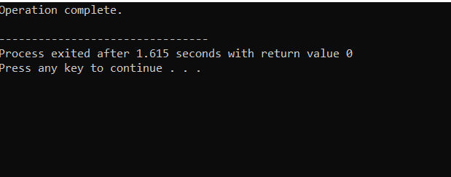

Şekil 1 Çıktı

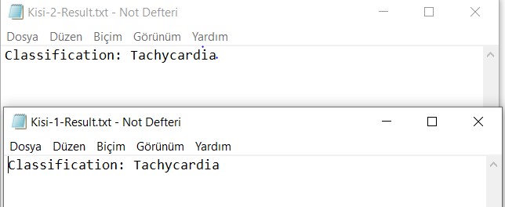

File Outputs

C++ Kodları:

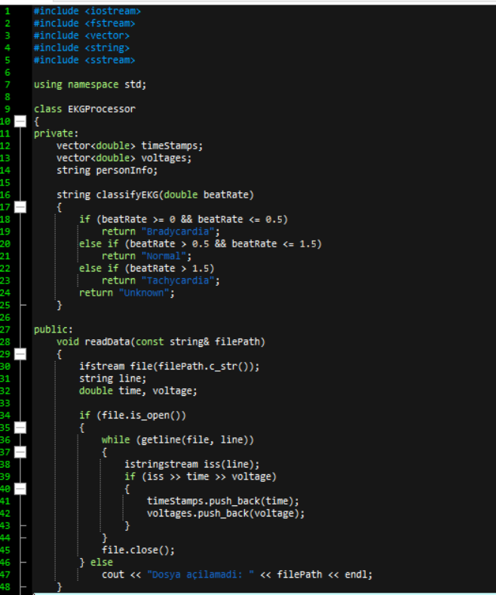

Şekil 3 Kod Part-1

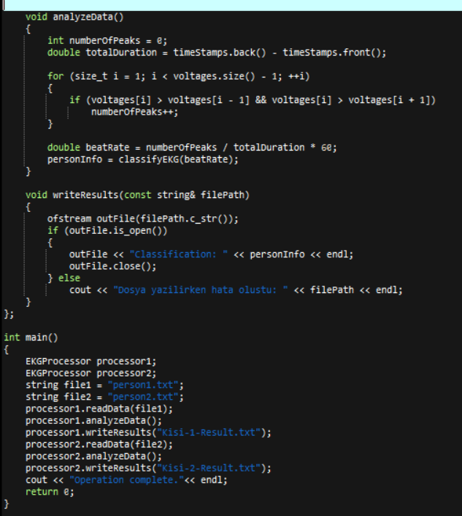

Şekil 4 Kod Part 2

Referans Listesi/References:

CE:

[1] Kaplan, B. M., Langendorf, R., Lev, M., & Pick, A. (1973). Tachycardia-bradycardia syndrome (so-called “sick sinus syndrome”): pathology, mechanisms and treatment. *The American journal of cardiology*, *31*(4), 497-508.

[2] Padeletti, L., Santini, M., Boriani, G., Botto, G., Capucci, A., Gulizia, M., ... & Grammatico, A. (2005). Temporal variability of atrial tachyarrhythmia burden in bradycardia–tachycardia syndrome patients. *European heart journal*, *26*(2), 165-172.

BME:

[1] The MathWorks Inc. (2022). MATLAB version: 9.13.0 (R2022b), Natick, Massachusetts: The MathWorks Inc. https://www.mathworks.com