

YILDIZ TECHNICAL UNIVERSITY
FACULTY OF ELECTRICAL AND ELECTRONICS ENGINEERING
COMPUTER ENGINEERING DEPARTMENT

SENIOR PROJECT

USING DEEP LEARNING TECHNIQUES
IN VICTIM DETECTION

Project Group:
10011065 Cengiz KAYGUSUZ
10011003 Alper MITINCIK

Istanbul, 2014

© All rights reserved to Yildiz Technical University, Computer Engineering Department.

CONTENTs
1.INTRODUCTION 9
1.1.An Explanatory Foreword on Machine Learning 9
1.2.General Concepts 10
1.3.General Algorithm for Building a Model 10
1.4.Mainstream Methods of Building a Model 11
1.4.1.Naïve Bayes 11
1.4.2.Decision Trees 11
1.4.3.Regression Analysis 12
1.4.4.Neural Networks 12
2.FEASIBILITY STUDIES 13
2.1.Schedule Feasibility 13
2.2.Development Tools 13
2.3.Hardware 13
3.DESCENDING INTO FEEDFORWARD NEURAL NETWORKS 14
3.1.The Hidden Function 14
3.2.The Perceptron 14
3.3.Breaking the Linearity 16
3.3.1.Multi-layer Perceptrons 16
3.3.2.Activation Function 17
3.4.Training a Multi-Layered Neural Network: 18
3.4.1.Evolution-Inspired Training of Neural Networks 18
3.4.2.Batch-Evolution Algorithm 18
3.4.3.Activity-Oriented Approach 19
3.4.4.Backpropagation 20
3.4.4.1.Deriving Backpropagation 20
3.4.4.2.Modes of Backpropagation 22
3.5.Training Arbitrarily Deep Architectures 23
3.5.1. Beyond Backpropagation: the Vanishing Gradient Problem 23
4.IMAGE PROCESSING WITH NEURAL NETWORKS 25
4.1.Object Recognition 25
5.IMPLEMENTATION AND TESTS 26
5.1.Caffe 26
6.RESULTS AND DISCUSSION 27
7.REFERENCES 28
8.CURRICULUM VITAE 29
ABBREVIATION LISTFIGURE LISTTABLE LIST
PREFACE
ABSTRACT
ÖZET

INTRODUCTION

An Explanatory Foreword on Machine Learning
Machine learning is the field of study that deals with construction and study of algorithms that can learn from data. By using the knowledge gathered in the past, a machine learning model can be used to make predictions, estimations and take decisions without explicitly being programmed. The discipline marries two grandeur fields of Computer Science and Statistics, and exploits many techniques from both fields.
There are two main facets of machine learning, namely:
- Supervised Learning
In this sub-field a model is being constructed from data that its class (or label) is known a priori. The labeling is known with certainty that it is accurate and generally is done my humans.
- Unsupervised Learning
In contrast with supervised learning, the goal here is to find a hidden structure that needs to be discovered in the unlabeled data.
In this study, we will mainly focus on supervised learning.

General Concepts

In this section, will define and explain generic terms in Machine Learning that is necessary to understand the material.

# UFAK VERI SETI UYDURUP ONUN UZERINDEN ANLATALIM

Construction of a model goes through two phases:

Training

Generally speaking, constructing a model is an iterative process. In the training period, the parameters of a model is changed incrementally turn by turn so that it may perform better.

Testing

In order to assess how well a model would perform, we test the model.

Loss is a value computed according to a given function with respect to internal parameters of a model. During the training phase, the parameters of a model is modified so it may reduce loss. Loss functions are selected by the person who is constructing a model. A well chosen loss function should represent the overall accuracy of a model.

Accuracy is simply the measure of how well the generated model is able to predict the data.

General Algorithm for Building a Model
In its most general sense, the algorithm is as follows:
Given a dataset and a loss function,
Initialize a preliminary model
For every input in the training dataset, begin:
Try to classify the given input
With the produced values, calculate the loss function
Modify the internal parameters with respect to loss
end

Mainstream Methods of Building a Model

Naïve Bayes
In machine learning, Naive Bayes is statistics based Supervised Learning classifier. It is required the values of unrelated features. Nb classifier present very efficiecnt results when the given variables and features are independent.
Theorem:
P(A|B) = P(B|A)*P(A)/P(B)
P(A|B): degree of belief in A, having taken B into account (conditional probability)
P(A): initial degree of belief in A (prior probability)

Decision Trees
Decision tree is a technique for modelling of training data. In tree, internal nodes represent inputs and attributes (branches correspond to attribute values), leaves represent outputs.
An example:
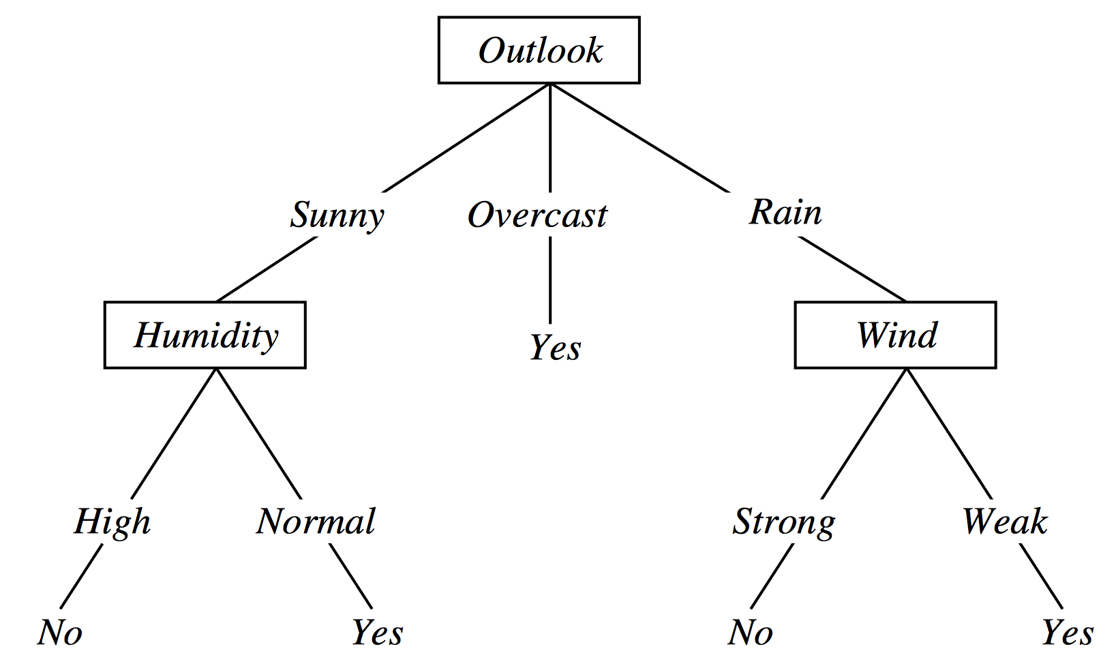

Desicion tree is used for supervied learning and it is talented to do classification if the features are discrete, else regression. It has White Box Approach, this means every steps can be monitored.

Regression Analysis
Regression analysis consists of techniques to understand between a variable variable and independent variables of a problem and predicts the conditional expectations.
In machine learning, regression is function approximation and to do this, it has linear and non-linear models:

Neural Networks

FEASIBILITY STUDIES

Schedule Feasibility
Gannt Diagram will be added.

Development Tools
PyCharm IDE
Caffe Library
Docker

Hardware
Macbook Pro (Mid’14)
PC

DESCENDING INTO FEEDFORWARD NEURAL NETWORKS

The Hidden Function
The learning methods described in the previous chapters are quite powerful algorithms on their own account, but their operation strictly depends on the data supplied to the model, which means they cannot learn the hidden structure that is inherent in the raw data. Finding these hidden structures solely depends on the ability and foresight of the person building the model.
The prime advantage of the neural networks is that, in addition to discovering the statistical separability of the input, they can learn the transformations from raw data and build semantic abstractions for classification. For example, a neural model intended for classifying cars can learn that cars has wheels and door handles.
ORNEK VERILECEK BITMEDI

The Perceptron
Perceptron is the most fundamental building block of neural networks. In the FIGURES, the intuition and its mathematical representations are given as follows.
- Gather the signals emitted from the previous layer.  - Take a weighed sum of the these signals.  - Compare the sum against 0 value  - If it is higher, emit 1.  - Else, emit 0. | where  the weight of the previous neuron,  the value emitted from previous neuron  is the bias of the calculating neuron
Table 1: Mathematical and intuitive description of the perceptron algorithm. Parameters are simplified in order to propagate the idea concisely.
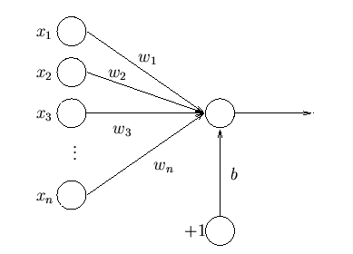Illustration 1: Visualization of a simple perceptron
The perceptron, in its ample idea is a powerful algorithm yet it comes with its own limitations. It is said to be linear, that is, it can only separate entities that can only be separated by a linear function.

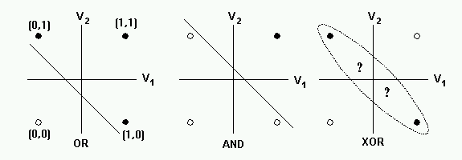Illustration 2: The linearity problem with the perceptron
From Illustration 2, we see that the AND and OR functions are linearly separable. In contrast, when the function is not able to be separated by a single line, the perceptron cannot possibly model the function.

Breaking the Linearity
Perceptrons are very good at learning how to separate linear data, but the fact that most things we observe in the universe aren't linear. This fact greatly hinders the
usability of the neural networks. Somehow the linearity must be broken

Multi-layer Perceptrons
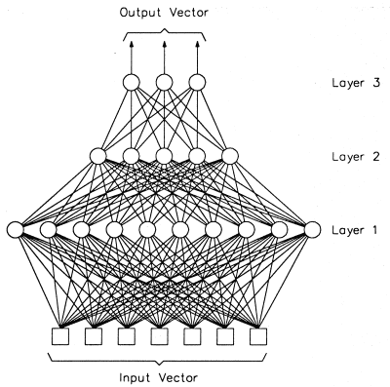Illustration 3: An example Multi-layer perceptron with 4 layers. Note that the input vector layer is also considered as a "layer".
Multi-layer perceptron is our first answer for combating linearity. Such layer model consists of at least 3 layers; 2 for input and output and 1 the interim layer. Traditionally, a neuron is connected with every neuron on its previous and next layer, but not with the neurons that is on the same layer.
Constructing a multi-layered neural network with the classic perceptron algorithm doesn't break the linearity. Through linear algebra, it can be easily shown that the linear combination of linear functions is a linear function. This means the neural network shown in illustration 3 can be reduced to one that is shown in illustration 1.

–----> Onemli: but in simple algorithm above is not enough, more neurons and layers give more iscomplexity therefore perceptrons do not use every neuron each process, select some neurons by using activation function.

Activation Function
The activation function of a neural network is the function decides what value should a unit's output should take with respect to its input. On TABLO_REFERANS, we have shown how a neural unit calculates its output using a simple thresholding and emitting values that are either 1 or 0. We will now extend this idea; collecting the input from the previous layer, applying a function to the weighed sum and emitting the output according to the function. RESIM KOY ANLAT.
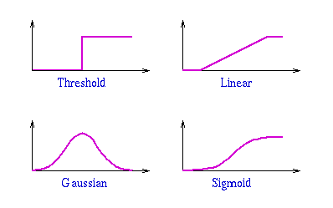Illustration 4: Samples of activation functions.
Coupling multi-layer perceptrons with non-linear activation functions finally breaks the linearity and allows us to model real-world data much more efficiently.

Training a Multi-Layered Neural Network:
Training a simple perceptron does not deviate from the general algorithm we outlined in the introduction. For multi-layered networks, training arbitrarily big networks were not possible prior to the invention of backpropagation algorithm.
To really understand why backpropagation is essential, we will progressively explore ideas, eventually reaching the backpropagation algorithm.

Evolution-Inspired Training of Neural Networks
We have discussed the inspiration point of the neural networks is the insights we have on cognitive systems of the organic creatures. Since the idea of neural nets are inspired from nature, this training idea is somewhat relevant, as it has been independently invented by many scientists. The algorithm is given below.
There are several issues with this algorithm:
- Initiallize the network
- For a defined iteration number or until a certain condition satisfied:
  - Randomly select a synapse weight
  - Apply a small variation to weight
  - Calculate the error
  - Accept the change if the error is less than the previous round, else discard
- Because the randomness is inherent in this algorithm, it might take arbitrarily long time to arrive to a feasible model.
- Inefficiency. We need to run the model with the determined (possibly whole training set) data to calculate error and deviate only one single weight.
- Large variations on the synapses are almost always results in a worse model. It is important to realize that neural networks works best when their weights are working in harmony.

Batch-Evolution Algorithm
To solve some of the problems with the given algorithm before, instead of choosing and updating individual synapses, we could select a batch of synapses, apply variation to them and then test the network. The algortihm is given as follows

Although now the algorithm may achieve the harmony we argued that was lacking in the previous algorithm, it is not guaranteed. The randomness is still inherent, we don't know which way and which synapse to apply variation. We still don't have a guarantee that the model will converge to a feasible model in a feasible amount of time.
- Initiallize the network
- For a defined iteration number or until a certain condition satisfied:
  - Randomly choosing synapses, construct a synapse set
  - For all apply a random variation.
  - Calculate the error
  - Accept the change if the error is less than the previous round, else discard

Activity-Oriented Approach
Instead of modifying weights, we may try to modify the activation values of the hidden layer neurons and using the deviation, we can reflect this change to the synapses.
Aside from the still-inherent randomness, with this algorithm there may not be a way to modify the synapses so that it will only change the selected neuron.
- Initiallize the network
- For a defined iteration number or until a certain condition satisfied:
  - Randomly select a neuron
  - Run the model with training set and calculate the activation of
  - Apply a random variation to the activation value
  - Run the model again, calculating the error.
  - If the error drops, modify the synapses so that it will only change the selected neuron's activation value to the desired point, else discard.

Backpropagation
We now arrive at the algorithm. Here, we calculate a gradient to abolish randomness, and calculate the error derivatives of all the synapses simultaneously. The algortihm can be briefly as follows:
The gist of the algorithm is in the 4th step, the chain rule allows us to reuse the computations we've done in the previous layers, giving us a very efficient algorithm. This aspect is akin to dynamic programming.
- Initialize the network
- Try to classify the input to get all the neuron activations. This is called Forward Propagation.
- Calculate the deviation of the model from the perfect output. This is called Backward Propagation.
For each synapse;
- Calculate the gradient using chain rule.
- Apply the gradient to synapse weighed by a learning rate.
Text 1: Basic description of backpropagation

Deriving Backpropagation
Although simple in principle, this algorithm should be explained in mathematical terms in order to fully understand what it brings. We will demonstrate how backpropagation works on the following illustration.
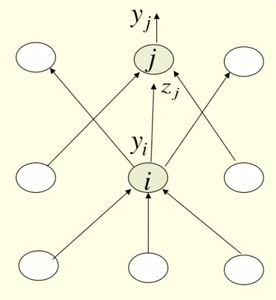Illustration 5: The neural network we will compute backpropagation over.

Let's consider the neural network given in illustration 5, where
- Is the particular output neuron shown,
- is the weighed sum of activations that is arriving to unit
- is the activation value of the particular neuron shown.

As with the typical learning algorithm, an error function is essential in training a neural network. For simplicity it brings, we will assume . Our goal is to compute for all we denote as weights. Let us demonstrate how we use backpropagation on the particular synapse that connects unit and which we denote as . The value we want to calculate is
(1.1)
using chain rule on value (1.1), we obtain the following equation,
(1.2)
we know from perceptrons that is simply the sum of activations of previous layer,
(1.3)
using (1.3) the leftside partial derivative can be easily computed as
(1.4)
so that we can rewrite (1.2) as
(1.5)
now we need to find a way to calculate .
Using chain rule again, we arrive at the following equation
(1.6)
This equation can be easily computed, since
is just the derivative of the activation function of a neuron.
Is simply the derivative of the error function with respect to . For our example it is computed as .

The above computation is sufficient for computing backpropagation just for 2 layers. To move forward, it will be necessary to also compute .
Using chain rule, we have
(1.7)
As we said, computing this equation is only necessary if there are no layers left behind. Usually this is necessary, though, and it is better to calculate (1.7) before (1.6), for that the partial derivatives we will obtain from (1.7) can be re-used for all the outgoing synapses belonging to that particular neuron.
Having obtained the efficiently, we can update simply by .

Modes of Backpropagation
Three modes of backpropagation exist
- Online
This mode is straightforward, we perform a weight update after every single training example.
- Batch
We perform more than one passes of different training data before performing
- Stochastic
Akin to online mode, but we go through the training data in random order to reduce our chances of getting stuck in local minima.

Training Arbitrarily Deep Architectures

Problems Associated with Backpropagation

Vanishing Gradient Problem
In 1991, it was discovered by Sepp Hochreiter that, as errors propagated from layer to layer, they started to shrink exponentially. This means as a network gets deeper and deeper, less and less error information will propagate, and the chain of abstractions neural networks are capable of doing well collapses from beginning layers.

Overfitting and Lack of Generalization
Aside the problem we just have discussed, backpropagation tends to achieve poor generalization when applied to a model with excess hidden units. This means either our model operates successfully on training data but not on test data (overfitting), or achieving a classification rate close to %50 (lack of generalization).

With a series of unexpected results, these problems with backpropagation solved with applying an unsupervised pre-training phase to the model, and using backpropagation as a fine tuning to the resulting parameters. We will now discuss these two flagship techniques of unsupervised pre-training.

Restricted Boltzmann Machines

IMAGE PROCESSING WITH NEURAL NETWORKS

Object Recognition

IMPLEMENTATION AND TESTS

Caffe
Caffe is a fast, extendable, modular and opensource framework for deep learning on artificial neural networks. created by Yangqing Jia and is in active development. Caffe includes models and optimizations, it presents these as plaintext, not code. caffe has c++/cuda architecture and commandline, pyton, matlab interfaces.

a network defining:
name: "net-name"
layers { name: "data"}
layers { name: "conv"}
...
layers { name: "loss"}
a layer defining:
name: "conv"
type: CONVOLUTION
bottom: "data"
top: "conv"
conv_param {
//specific params
...
}
solver configuring:
train_net: "conv.prototxt"
base_lr: 0.01
momentum: 0.9
weight_decay: 0.0005
max_iter: 10000
snapshot_prefix: "conv_snapshot"
solver_mode: GPU
running:
caffe train -solver conv_solver.prototxt -gpu 0 [3]

RESULTS AND DISCUSSION
-

REFERENCES
[1]http://www.jilp.org/cbp/Daniel-slides.PDF
[2] http://en.wikipedia.org/wiki/Backpropagation
[3]https://docs.google.com/presentation/d/1UeKXVgRvvxg9OUdh_UiC5G71UMscNPlvArsWER41PsU/edit#slide=id.g355666fe0_069

CURRICULUM VITAE

