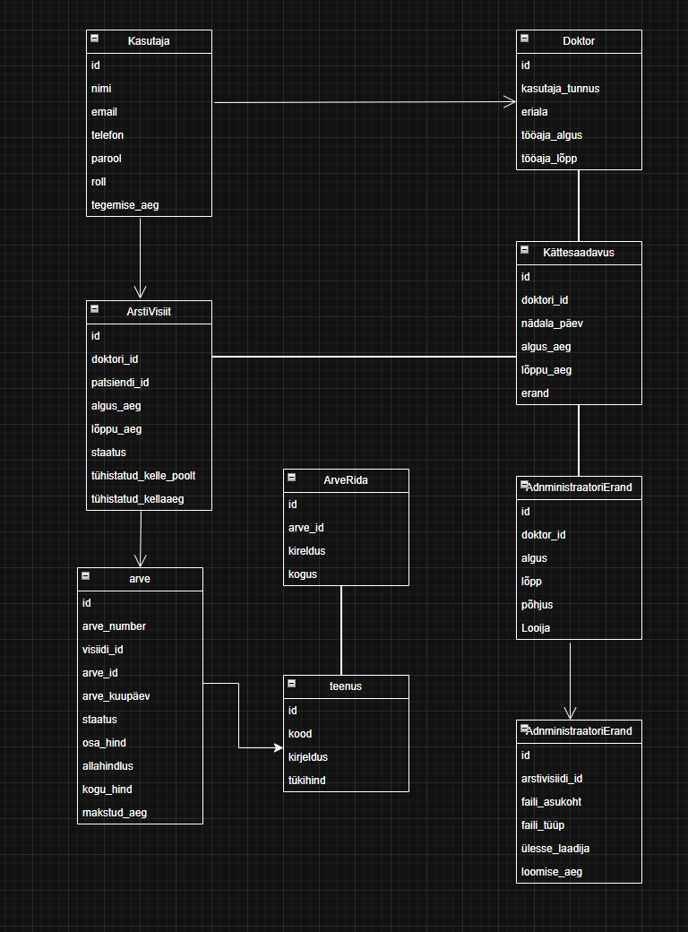

|  |  |  |  |  |  |
| --- | --- | --- | --- | --- | --- |
| Nimetus | Omadus | Tüüp | Pikkus Costumer | Kohustuslik | Unikaalne |
| Kasutaja |  |  |  |  |  |
|  | Id | Int |  | + | + |
|  | Nimi | String | 100 | + |  |
|  | Email | String | 255 | + |  |
|  | Telefon | String | 15 |  |  |
|  | Parool | String | Min.8 | + |  |
|  | Roll | Sting | 100 | + |  |
|  | Tegemis_aeg | dateTime |  |  |  |
|  |  |  |  |  |  |
| Doktor |  |  |  |  |  |
|  | Id | Int |  | + | + |
|  | Kasutaja_tunnus | String | 255 | + |  |
|  | Eriala | String | 100 | + |  |
|  | Tööaja_algus | DateTime |  | + |  |
|  | Tööaja_lõpp | DateTime |  | + |  |
|  |  |  |  |  |  |
| Kättesaadavus |  |  |  |  |  |
|  | Id | Int |  | + | + |
|  | Doktor_id | Int | 255 | + | + |
|  | Nädala_päev | Date |  | + |  |
|  | Algus_aeg | Time |  | + |  |
|  | Lõppu_aeg | Time |  | + |  |
|  | Erand | String | 255 | + |  |
|  |  |  |  |  |  |
| ArstiVisiit |  |  |  |  |  |
|  | Id | Int |  | + | + |
|  | Doktor_id | Int |  | + | + |
|  | Patsiendi_id | Int |  | + | + |
|  | Tööaja_algus | DateTime |  | + |  |
|  | Tööaja_lõpp | DateTime |  | + |  |
|  | Staatus | String | 64 | + |  |
|  | Tühistatud_kelle_poolt | String | 255 |  |  |
|  | Tühistatud_kellaaeg | DateTime |  |  |  |
|  |  |  |  |  |  |
| Arve |  |  |  |  |  |
|  | Id | Int |  | + | + |
|  | Arve_number | String | 15 | + | + |
|  | Visiidi_id | Int |  | + | + |
|  | Arve_id | Int |  | + | + |
|  | Arve_kuupäev | Time |  | + |  |
|  | Staatus | String | 64 |  |  |
|  | Osa_hind | Decimal |  | + |  |
|  | Allahindlus | Decimal |  | + |  |
|  | Kogu_hind | Decimal |  | + |  |
|  | Makstud_aeg | DateTime |  | + |  |
|  |  |  |  |  |  |
| ArveRida |  |  |  |  |  |
|  | Id | Int |  | + | + |
|  | Arve_id | Int |  | + | + |
|  | Kirjeldus | String |  | + |  |
|  | Kogus | Decimal |  | + |  |
|  |  |  |  |  |  |
| Teenus |  |  |  |  |  |
|  | Id | Int |  | + | + |
|  | Kood | Int |  | + |  |
|  | Kirjeldus | String |  | + |  |
|  | Tükihind | Decimal |  | + |  |
|  |  |  |  |  |  |
| AdministraatoriErand |  |  |  |  |  |
|  | Id | Int |  | + | + |
|  | Doktor_id | Int |  | + | + |
|  | Algus | Datetime |  | + |  |
|  | Lõpp | DateTime |  | + |  |
|  | Põhjus | String |  | + |  |
|  | Looija | String |  | + |  |
|  |  |  |  |  |  |
| AdministraatorErandi fail | Id | Int |  | + | + |
|  | Arstivisiidi_id | Int |  | + | + |
|  | Faili_asukoht | String |  | + |  |
|  | Faili_tüüp | String |  | + |  |
|  | Ülesse_laadija | String |  | + |  |
|  | Loomise_aeg | DateTime |  | + |  |
|  |  |  |  |  |  |