ggplot2 demo
alper
2023-06-01
Table of contents

1. Air Quality
Figure 1 further explores the impact of temperature on ozone level.
library(tidyverse)
library(ggplot2)
ggplot(airquality, aes(Temp, Ozone)) +
geom_point() +
geom_smooth(method = "loess"
)
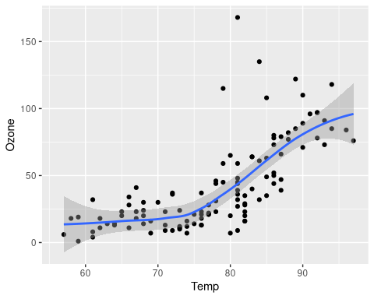
Figure 1: Temperature and ozone level.

2. mpg data

2.1 mpg scatter plot
Figure 2 shows correlation between highway and city mileages.
ggplot(mpg, aes(hwy, cty, color=cyl)) +
geom_point(alpha=0.5, size=2) +
scale_color_viridis_c() +
theme_minimal()
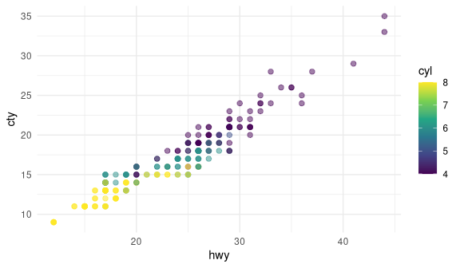
Figure 2: City and highway mileage for 38 popular models of cars.

2.2 the mpg data as table
There are 32 observations in our data.
# A tibble: 32 × 4
# Groups: manufacturer [15]
manufacturer cyl avg_cty avg_hwy
<chr> <int> <dbl> <dbl>
1 audi 4 19.1 28.1
2 audi 6 16.4 25.3
3 audi 8 16 23
4 chevrolet 4 20.5 28.5
5 chevrolet 6 17.7 27
6 chevrolet 8 13.6 19.9
7 dodge 4 18 24
8 dodge 6 15 20.7
9 dodge 8 11.6 15.7
10 ford 6 15.3 20.7
# ℹ 22 more rows
Hypothetical table_viewer will show your tables in a much better way.
table_viewer(mpg)

3. Formulas
you can have formulas in your document
$$price={\hat{β}}_{0}+{\hat{β}}_{1}×area+ϵ$$

4. Citations
We’re going to do this analysis using literate programming [@Knuth1984].

5. Layout

5.1 Callouts
 Note
Here’s some information

