Project code:11
DOCUMENT ARCHIVAL
by ALPESH KAUSHAL(17CS30003)
CHAITANYA BHUTADA(17CS10011)

(1)

INTRODUCTION:

This project is need to archive important document for available to view in
future.

Need can be addressed by developing some way to archive documents so
that user can store its document or view document anytime and saving its
system space.

Prospective users can be different organization or can be done by
individuals.

This web application will be developed using java web framework.

Our Web Application will be used to upload any type of files like pdf , word, etc.) into a database table and can download any type of files from the database.

User Interface:

The web application contains four web pages like Home page, Upload page, download Page and About Us page.

On every page there are four buttons named Home, Upload,
download and AboutUs, and the user can click on any of the button to go to that particular page. The Home page and AboutUs page contains details about the project.

In the Upload page, the user can upload any type of files into a database table by selecting any file from the computer
using ‘choose a file’ button and once the user click on the upload button the file will be uploaded to a database table.

The Download page contains all the files that are in the database table. When the user clicks on a particular file that is displayed on a Download page the file will be downloaded into the computer. In this way the user can upload and download files using Web Application.

Their will be some additional facility such as login/signup or save new version,etc.

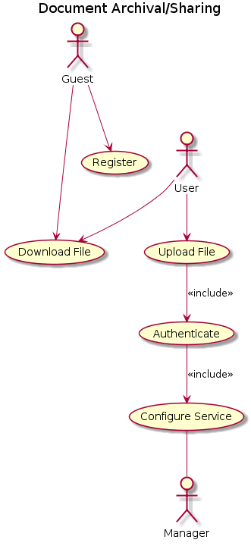

Purpose:

Organizations archive documents for a variety reasons, in most cases relating to the overall purpose or role of the organization. Often, organizations archive documentation because it is of cultural or historical importance. Alternatively, a business may have a legal or financial reason for keeping a reliable record of past documentation, for which archiving is the most effective management method.

Challenges:

Challenge is to store huge amount of archived documents and they should be secured. They should be available when the consent authority want to view archived document.

(2) PLAN:

Date: | Plan:
8 February | We will prepare SRS document and do tentative planning for this Project.
15 February | We will work on design of the system.  (Use case diagram) , modifying SRS document
1 March | We will work on user interface(GUI) .
8 March | We will do system analysis process and again will work on its design.
15 March | Will work with JDBC + Networking for requirement of our project , how to store archived document
29 March | Will work on its implementation (all programming work will be done ) and Demo-1
5 April | Will test and Demo-2
12 April | Final Demo-3

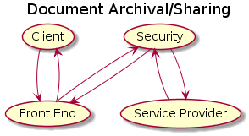

(3)

Functional requirement:
- Login/sign up facility
- Search facility
- Save as favourite or move to top option or mark useful button
- Download option
- Upload option / Save new version(Replace or add to existing)
- Logout

Non-Functional requirement:

- Availability: It should be available when consent authority wants to view archived document.
- Reliability:It should be safe from hackers or data manipulator.
- Recoverability : Document should be stored safely and should be recoverable when required.
- Maintainability:Database should be well maintained and particular document should be able to search when required.
- Capacity: should be able to store ,should have enough memory.

(4)

Software requirement:

- A computer running one of the following operating systems:
  - Microsoft Windows 7, 10 Windows Server 2012
- Mozilla Firefox or Google Chrome
- Java Runtime Environment (JRE) version 8 or later, Java JDBC.

Hardware requirement:
(Minimum requirements)

- 1.5 GHz Intel Pentium Processor (or equivalent).
- Minimum of 2 GB of system memory (4 GB recommended).
- Monitor : 15 VGA color.
- Ethernet connection (LAN) OR a wireless adapter (Wi-Fi).
- Keyboard: 108 keys
- Mouse: 2 button mouse
- RAM: 512 MB

(5)

Attractive features:
* We will try to keep it user-friendly and try to keep it simple
and easy to use.
* We will add guide for new users to use it.
* We will add FAQ’s page.
* Will try to make easy search results available.
* Sorting or filtering of document based on likes or useful
ways .

