About Dubai Production Facility
Wilo has been present in the MENA region for over 35 years through its local distributors. Wilo Dubai began local production in 2019 with a focus on four main product ranges (Atmos GIGA-N, SCP, Booster Set & Control Panel) primarily to cater the MENA region. As a result of growing demand and favorable customer feedback, Wilo opened the extended state-of-the-art facility in 2024, a comprehensive production facility that satisfies global production demands.
Strategic Location
Dubai is one of the world’s leading digital hubs. As such, it offers the Wilo Group an excellent opportunity to designate it as its headquarters to strengthen its position as a digital pioneer in the pump industry and to promote the use of digital products and solutions across the MENA and LATAM region.
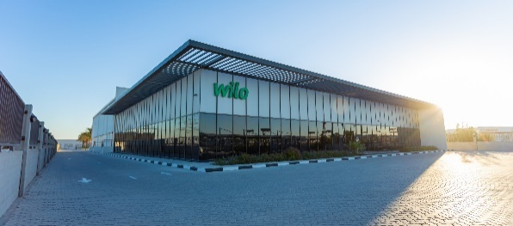

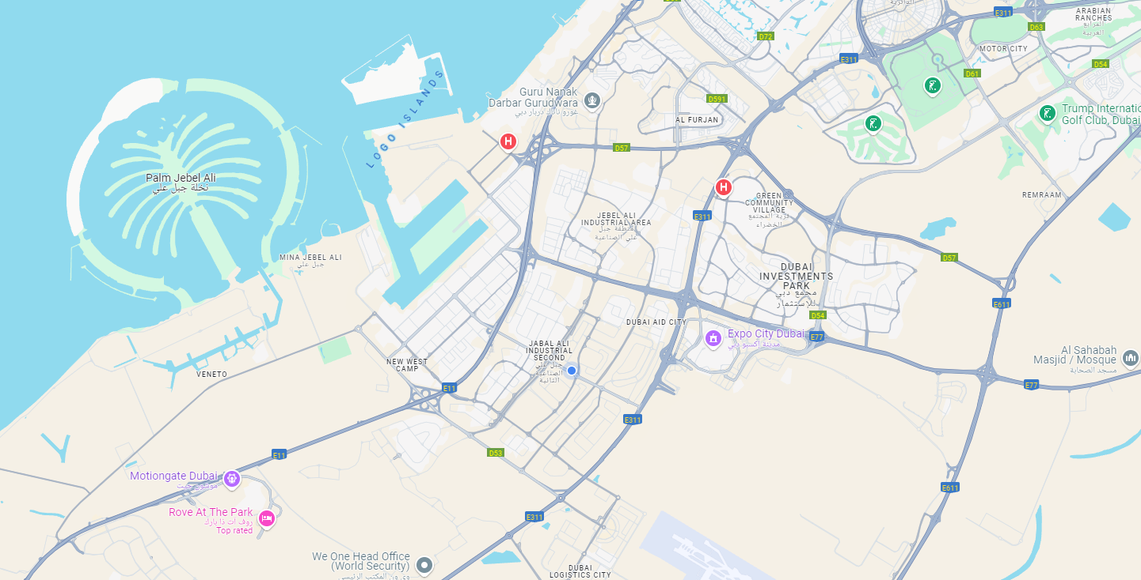
Accredited Pump Testing Facility
Our accredited pump testing facility stands as the Middle East’s exclusive pump test bed with ISO/IEC 17025 accreditation, ensuring the highest standards of accuracy and reliability. This state-of-the-art facility not only validates the performance of our pumps but also provides a crucial platform for innovation and excellence. By enabling rigorous testing and certification, we open endless opportunities for sales growth within the region, reinforcing our commitment to quality and customer satisfaction.
IMAGE OF NEW PUMP TEST BED

Expanded Product Range
Now featuring nine product ranges, our facility supports diverse sectors, including building services, residential and commercial applications, water management, and general industry segments. This broad range allows us to provide tailored solutions that meet the specific demands of our clients.
Norm Pump
Split-Case Pump
Control Panel
Booster System

Fire Fighting Systems
Borehole Pump
Pump-Motor Alignment
Helix Pump

Commitment to Quality
Quality is at the core of everything we do. Our facility adheres to stringent quality control measures and industry standards, ensuring that every product we produce meets our customers' expectations. Our dedicated team of experts works tirelessly to maintain these standards throughout the production process.




MATERIAL CONTROL
PRODUCT QUALITY CONTROL
CUSTOMER QUALITY

NON-CONFORMANCE MANAGEMENT

ISO 9001
ISO 45001
Sustainability Focus
We are committed to sustainable practices that minimize our environmental impact. Our facility incorporates energy-efficient systems and eco-friendly materials, aligning with our goal to contribute positively to the community and the planet.
ISO 14001
Cloud based Energy metering systems
Solar PV panels
H2 PowerPlant
LEED Gold certified building building
Paper-less production

Skilled Workforce
Our team is our greatest asset. Comprised of skilled professionals with extensive experience in production, engineering, quality and R&D, we foster a culture of innovation and continuous improvement. This expertise enables us to tackle challenges and drive excellence in every aspect of our operations.
AHMED NABIL ASSEMBLY MANAGER ahmed.nabil@wilo.com

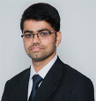
SIVA SUBRAMANIAN DESIGN ENGINEER siva.subramanian@wilo.com

….. (add rest of the team here)
Innovation and Growth
At our Dubai facility, we believe in the power of innovation. We are constantly exploring new methods and solutions to enhance our production processes and expand our product offerings. This commitment to growth positions us as a leader in our industry.
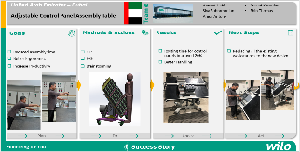

Join us on our journey as we continue to redefine manufacturing excellence from our Dubai production facility.
SUCCESS STORIES #3

SUCCESS STORIES #1

SUCCESS STORIES #2



=============Ends 1============
2) About the Test Facility
- Size of the facility Capacity (flow, power)
- What kind of tests we can do
- Different product types that can be tested
- Different tools used in testing
- Accreditation
- Remote testing option
- 3rd party testing support
Front facia:
How the image for each icon-
- About dubai production:
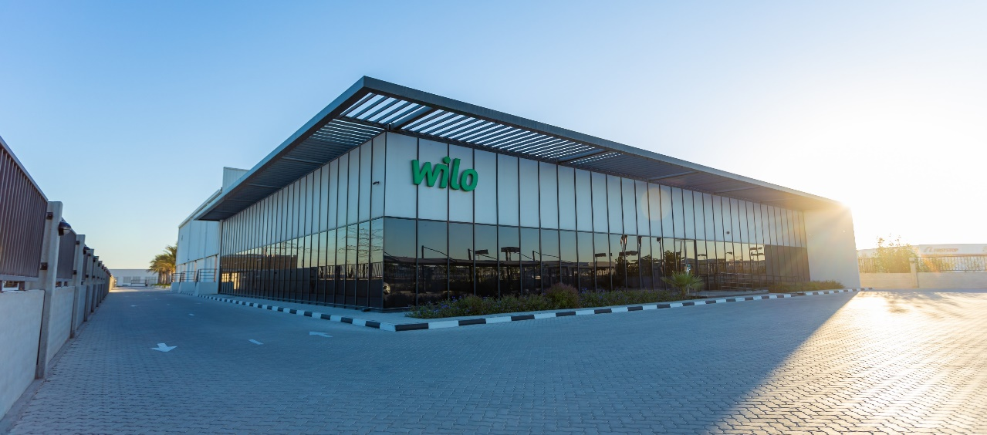

- Pricing tool:
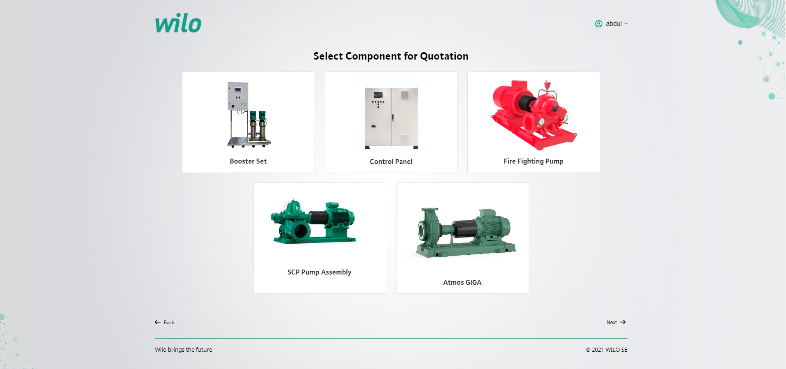

- Orders tracking:
Similar to pricing tool image
- Document portal + Pre-qualification + Certificates: 

- Virtual tour

- Media database (product photos, BIM files, product videos, spare parts, name plate details)


- Reference list: (list of projects with value >250k Euro since 2019)

- About Test Facility:
Image of new test facility
- Witness Test (Registration):


Drop down option

Select product type:


Choose a Preferred date: (set available dates for each month)
User can only select as admin set from backend

Additional notes: (text input box)
Submit btn
Admin will get in backend & via email notify

- Training request (Registration):

Mention the kind of training required:
User name auth
Email
phone

Select Training type: Pricing tool, orders tracking, product training, Test facility radio
Text input box -> Other then specify
Submit btn
Admin will get in backend & via email notify

- Feedback form /suggestions:
Suggestions: Text input box

Image by our self
Admin will get in backend & via email notify
Admin email ->
abdul.waris@wilo.com
renjith.pillai@wilo.com

Admin backend last

User name
First name
Last name
Phone
Email
Country name
Role

