Estimation Tool – Finding (point) for each component.

Download document selection not found anywhere, BOM, DRAWING, OPERATION MANUAL. PUMP INSTALLATION MANUAL

Admin Panel (functionality)

Module (dropdown will show all 4 components)
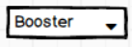

- Quotation Generated Article will be shown in dropdown
- There will be a searchable dropdown to search Article Number

Article Number
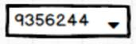

Module Name | Article Number | File Upload
Booster | 9356244

- Once any number is selected, the file upload option will show against that Article Number.

Admin can further Edit this, by changing the file or adding/remove Article Number.

Note. Admin can upload multiple files against the Article Number. The file format will be (Excel, PDF, word & image).

Admin have the option to upload manual against each component.

User Flow

- There will be two more options here.
- Documents
- Manual

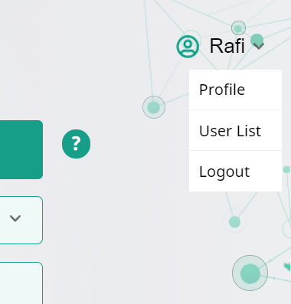

- When a user clicks on documents, it will show all the documents against Article Number. In case of no upload document, it will show the validation message.

- When the user clicks on manual, it will show the upload manual against each component, in case of no upload manual nothing will show here.

