MICROSOFT POWER PLATFORM PROJECT
Employee Wellness
Management System
Project Documentation
Item | Details
Solution name | Employee Wellness Solution
Applications | Employee Fitness (Canvas app) | Employee Wellness Management Admin (Model-driven app)
Technologies | Power Apps | Microsoft Dataverse | Power Automate | Power BI
Prepared by | Parth Jasathy
Document date | October 2026
Table of Contents
1. Problem Statement 3
2. Use Case 3
2.1 Actors 3
2.2 Primary Use Cases 3
2.3 End-to-End User Journey 4
3. Project Overview 4
3.1 Purpose 4
3.2 Objectives 4
3.3 Scope 4
4. Solution Architecture and Components 5
4.1 Components 5
4.2 Design Principles 5
5. Data Model 5
5.1 Employee Wellness Profile 6
5.2 WellnessActivity 7
5.3 Choice Columns 7
5.4 Relationship 7
5.5 Autonumber Columns 7
6. Canvas App: Screens and Functionality 8
6.1 Screens 8
6.2 Activity Submission 11
6.3 Activity Lifecycle 12
6.4 Cancel and Complete Actions 12
6.5 Progress Calculation 12
7. Model-driven App: Views and Forms 12
7.1 Navigation 12
7.2 Views 12
7.3 Forms 13
8. Power Automate Flows 14
8.1 New Activity Notify Flow 14
8.2 Activity Completion Flow 14
8.3 Pending Activity Reminder Flow 14
8.4 New Employee Added Flow 15
9. Business Rules 15
9.1 BR - Activity Date Validation 15
9.2 Other Data Validation 15
10. Changes in Model-driven App New Form 16
11. Future Enhancements 16
12. Outcome 16

1. Problem Statement
Organisations that want to encourage healthier employees often track wellness activity in spreadsheets, chat messages or on paper. This makes the information scattered, inconsistent and difficult to act on.
The key problems this project addresses are:
- No central record. Employee wellness details and activities live in disconnected files, so HR has no single source of truth.
- No simple way for employees to log activities. Employees need a quick, mobile-friendly way to record what they plan to do and what they have completed.
- No controlled activity status. Without a defined lifecycle (Pending, Completed, Cancelled) it is impossible to measure real participation.
- Poor data quality. Free-form entry leads to invalid dates, missing values and duplicate or inconsistent data.
- No reminders or confirmations. Employees forget planned activities because nothing prompts them, and nothing confirms that an entry was saved.
- Limited visibility for management. HR cannot easily see participation, calories burned or wellness points across employees.

Problem in one line
The organisation needs one governed platform where employees log and complete wellness activities, HR administers the data, and routine communication is automated.

2. Use Case

2.1 Actors
Actor | Role in the solution | Application used
Employee | Views their profile, logs wellness activities, completes or cancels pending activities and tracks personal progress. | Employee Fitness (Canvas app)
HR / Wellness Coordinator | Maintains employee wellness profiles, reviews activity records and monitors participation. | Employee Wellness Management Admin (Model-driven app)
Administrator | Configures Dataverse tables, apps, flows, business rules and security. | Power Apps maker portal, Power Automate

2.2 Primary Use Cases
# | Use case | Description
UC-1 | View my profile | Employee opens My Profile to see department, designation, BMI, activity level, wellness score, goal and enrollment date.
UC-2 | Add a wellness activity | Employee submits a new activity with type, date, duration, calories, points and remarks. The status is set to Pending.
UC-3 | View my activities | Employee sees a list of their activities with date, duration and status.
UC-4 | Complete an activity | Employee taps Mark Complete on a pending activity; the status becomes Completed.
UC-5 | Cancel an activity | Employee taps Cancel on a pending activity; the status becomes Cancelled.
UC-6 | Track my progress | Employee views totals for completed activities, points, minutes, calories and a progress percentage.
UC-7 | Receive notifications | Employee gets an email when an activity is added or completed, and reminders for pending activities.
UC-8 | Administer wellness data | HR creates and edits profiles and activities through views and forms in the Model-driven app.

2.3 End-to-End User Journey
- An employee profile is created and the Enrollment Date is populated automatically.
- The employee opens the Employee Fitness app and lands on the Home screen.
- The employee opens Add Activity, enters the details and selects Submit.
- Dataverse creates the Wellness Activity with Participation Status = Pending.
- A confirmation email is sent by Power Automate.
- A reminder is sent while the activity is still pending.
- The employee performs the activity and selects Mark Complete.
- The My Progress screen updates, and the data is available for reporting in Power BI.

3. Project Overview
The Employee Wellness Management System is a Microsoft Power Platform solution that helps an organisation record, manage, automate and analyse employee wellness activities. Microsoft Dataverse is the central data platform; a Canvas app serves employees, a Model-driven app serves administrators, Power Automate handles notifications and background processing, and Power BI provides the analytics layer.

3.1 Purpose
The purpose of the project is to replace manual, disconnected tracking with a single, secure and automated wellness platform that is simple for employees to use and easy for HR to manage and extend.

3.2 Objectives
- Create a central Dataverse data model for employee wellness information.
- Build an employee-friendly, mobile-style Canvas app for entering and tracking activities.
- Build a Model-driven app for structured administration and data management.
- Automate confirmations, reminders and other activity-related notifications with Power Automate.
- Apply business rules and validation to improve data quality.
- Provide a foundation for Power BI dashboards on participation and wellness trends.
- Deliver a solution that can be extended with additional wellness features.

3.3 Scope

In scope
- Dataverse tables: Employee Wellness Profile and WellnessActivity, with choice, lookup and autonumber columns.
- Canvas app "Employee Fitness" with Home, My Profile, Activities, Add Activity and My Progress screens.
- Model-driven app "Employee Wellness Management Admin" with views and forms for both tables.
- Four Power Automate cloud flows for notifications, reminders and profile automation.
- Business rule for Activity Date validation.
- Reporting design for Power BI on top of the wellness data.

Out of scope (future enhancements)
- Integration with wearable devices or external fitness trackers.
- Team challenges, leaderboards and rewards.
- Mobile push notifications and Microsoft Teams adaptive cards.

4. Solution Architecture and Components
The solution follows a layered architecture in which Dataverse is the single source of truth. Both apps read and write the same tables, Power Automate reacts to data changes, and Power BI consumes the data for reporting.
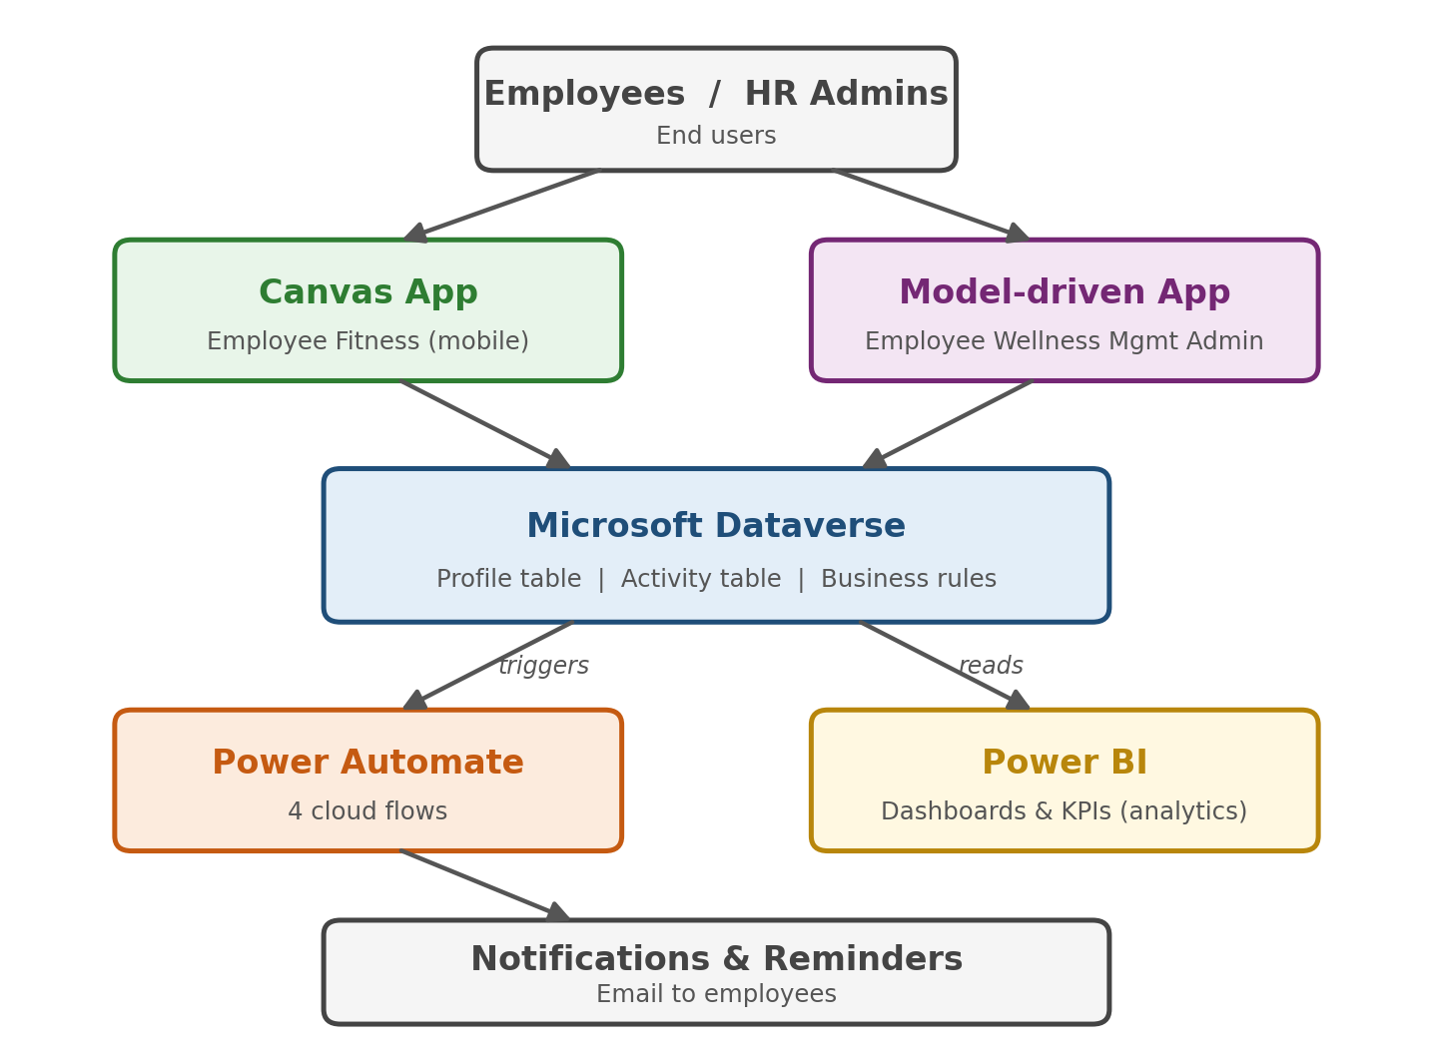
Figure 1: Solution architecture

4.1 Components
Component | Name | Responsibility
Solution | Employee Wellness Solution | Packages all tables, apps, flows and rules for transport between environments.
Data platform | Microsoft Dataverse | Stores profiles and activities; provides choice columns, lookups, autonumber, business rules and security.
Canvas app | Employee Fitness | Employee-facing phone-style app for profile, activities, activity entry and progress.
Model-driven app | Employee Wellness Management Admin | Administrator interface with views and forms for both tables.
Automation | 4 cloud flows | Confirmations, reminders, completion handling and new-profile automation.
Business logic | BR - Activity Date Validation | Dataverse business rule that keeps Activity Date valid.
Analytics | Power BI | Dashboards for participation, calories, points and trends.

4.2 Design Principles
Dataverse is the single source of truth and is never duplicated inside the apps. Employees and administrators each get the app that suits them, routine communication is automated with Power Automate, and data quality is enforced at the source through choice columns, lookups and business rules.

5. Data Model
Dataverse was chosen as the central data store because it supports structured business data, relationships, Choice and Lookup columns, security, business rules and native integration with Power Apps and Power Automate. The data model contains two custom tables in the Employee Wellness Solution, using the publisher prefix pj_.
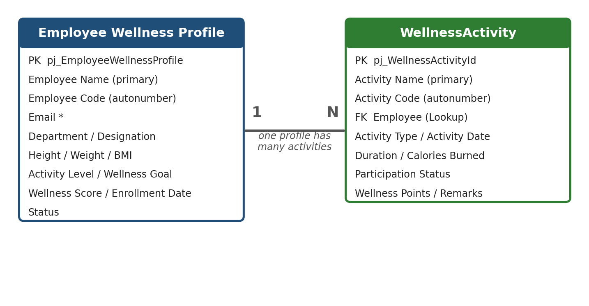
Figure 2: Table relationship (Employee Wellness Profile 1 : N WellnessActivity)

5.1 Employee Wellness Profile
Stores the employee information used by the wellness solution. The primary name column is Employee Name.
Display name | Schema name | Data type | Required | Purpose
Employee Name | pj_EmployeeName | Single line of text (primary) | Yes | Full name of the employee
Employee Code | pj_EmployeeCode | Autonumber | No | Auto-generated business identifier (e.g. Emp-10001)
Email | pj_Email | Email | Yes | Employee email address
Department | pj_Department | Choice | No | Employee department (e.g. HR, Finance, IT, Marketing)
Designation | pj_Designation | Single line of text | No | Job title
Enrollment Date | pj_EnrollmentDate | Date only | No | Date the profile was enrolled; populated automatically
Status | pj_Status | Choice | No | Profile status (e.g. Active)
Height (in meter) | pj_Heightinmeter | Decimal | No | Height used for BMI
Weight (kg) | pj_Weightkg | Decimal | No | Weight used for BMI
BMI | pj_BodyMassIndex | Decimal (calculated) | No | Body Mass Index calculated from height and weight
Activity Level | pj_ActivityLevel | Choice | No | General activity level (e.g. Moderate)
Wellness Goal | pj_WellnessGoal | Choice | No | Goal such as Weight Loss, Stress Reduction, Fitness Improvement
Wellness Score | pj_WellnessScore | Decimal | No | Overall wellness score
Employee Wellness Profile | pj_EmployeeWellnessProfileId | Unique identifier | Yes | System primary key

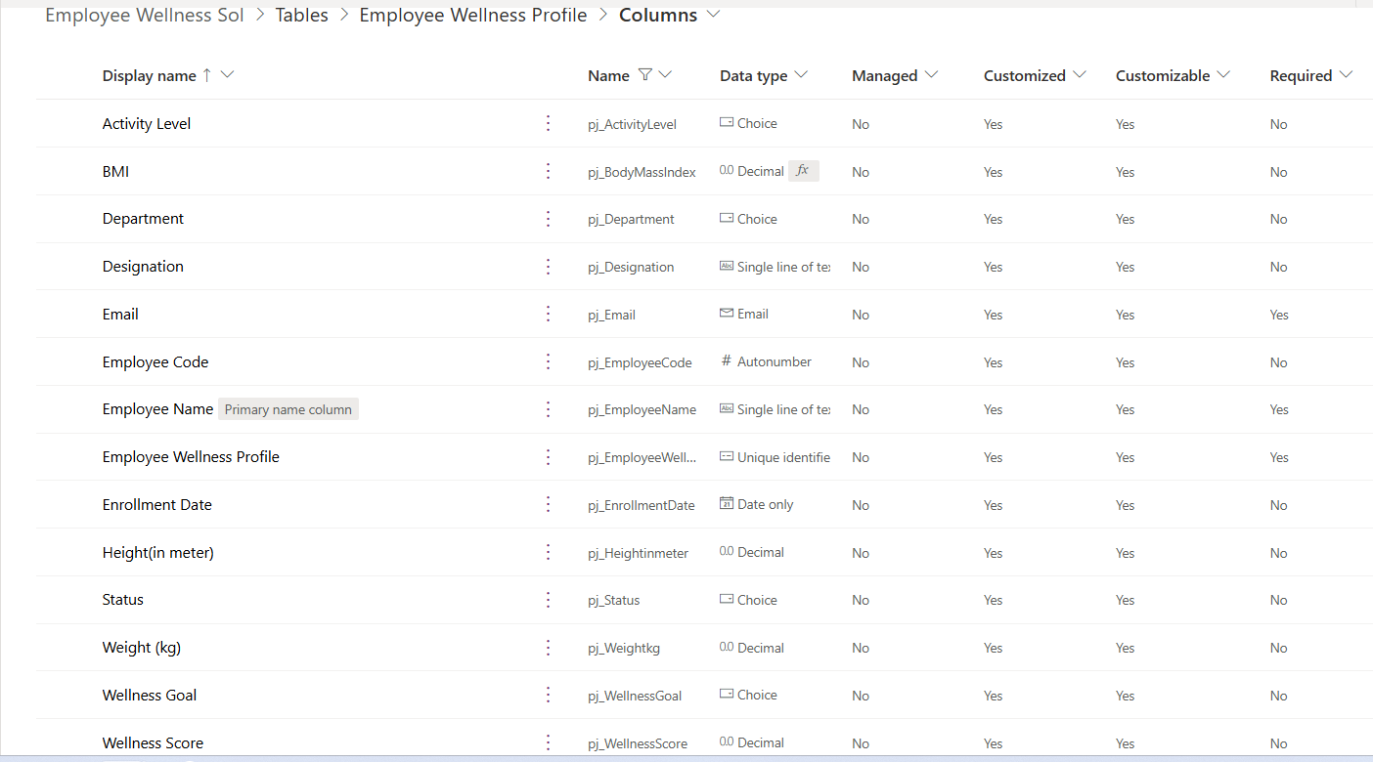
Figure 3: Employee Wellness Profile columns in the maker portal

5.2 WellnessActivity
Stores each wellness activity created by or for an employee. The primary name column is Activity Name.
Display name | Schema name | Data type | Purpose
Activity Name | pj_ActivityName | Single line of text (primary) | Name of the activity
Activity Code | pj_ActivityCode | Autonumber | Unique reference in A-0001 style
Activity Type | pj_ActivityType | Choice | Category: Exercise, Meditation, Nutrition, Sports, Health
Activity Date | pj_ActivityDate | Date only | Date the activity is planned or performed
Duration (Minutes) | pj_DurationMinutes | Whole number | Length of the activity
Calories Burned | pj_CaloriesBurned | Whole number | Calories associated with the activity
Employee | pj_Employee | Lookup | Links the activity to an Employee Wellness Profile
Participation Status | pj_ParticipationStatus | Choice | Lifecycle status: Pending, Completed, Cancelled
Wellness Points | pj_WellnessPoints | Whole number | Points earned for the activity
Remarks | pj_Remarks | Multiple lines of text | Additional notes
WellnessActivity | pj_WellnessActivityId | Unique identifier | System primary key

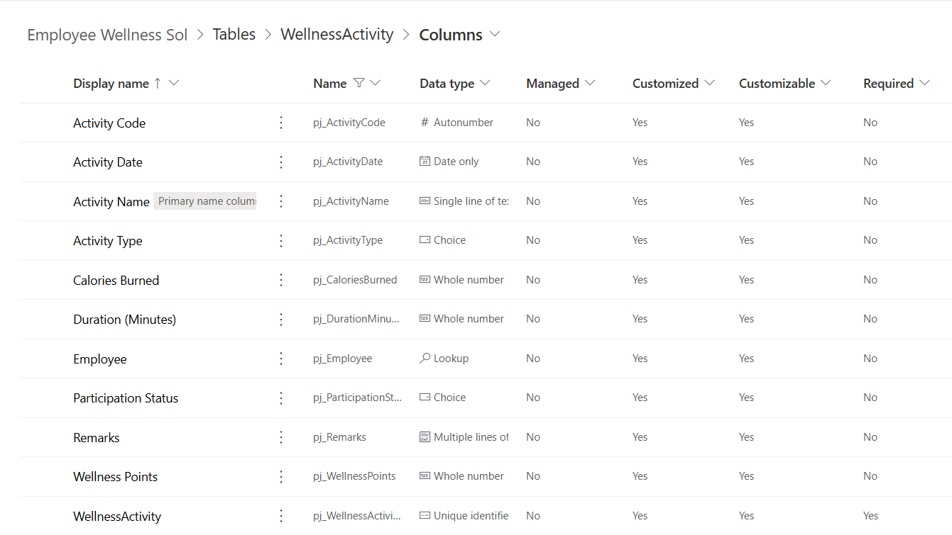
Figure 4: WellnessActivity columns in the maker portal

5.3 Choice Columns
Column | Values
Participation Status | Completed, Pending, Cancelled
Activity Type | Exercise, Meditation, Nutrition, Sports, Health
Department | HR, Finance, IT, Marketing and other departments
Wellness Goal | Weight Loss, Stress Reduction, Fitness Improvement
Activity Level | Moderate and other activity levels
Choice values are stored as numbers in Dataverse; both apps display the human-readable labels.

5.4 Relationship
WellnessActivity has a many-to-one relationship to Employee Wellness Profile through the Employee lookup column (pj_Employee). One employee profile can therefore have many wellness activities. The Canvas app shows the employee name to the user while Dataverse stores the relationship using the record's unique identifier.

5.5 Autonumber Columns
- Employee Code identifies the employee for business use instead of a raw Employee ID.
- Activity Code gives each activity a business-friendly reference in the format A-0001, A-0002, A-0003, ...

6. Canvas App: Screens and Functionality
Employee Fitness is the employee-facing Canvas app. It is designed for a phone-style layout with a green header bar, a blue-grey title strip for each screen, and large green action buttons. Every screen other than Home has a back arrow in the header.

6.1 Screens
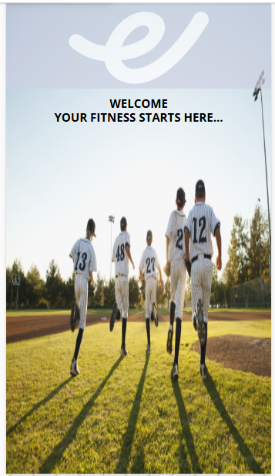 | Welcome Screen  Branded splash screen with the logo and the message "Welcome - Your fitness starts here...".

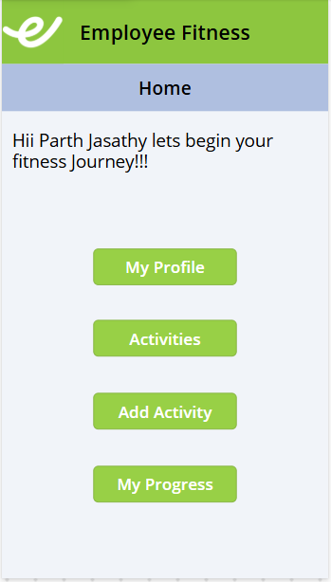 | Home Screen  Greets the signed-in employee by name and provides navigation to the four main areas of the app.  - My Profile - opens the employee's wellness profile.  - Activities - lists all of the employee's activities.  - Add Activity - opens the new activity form.  - My Progress - shows wellness progress.

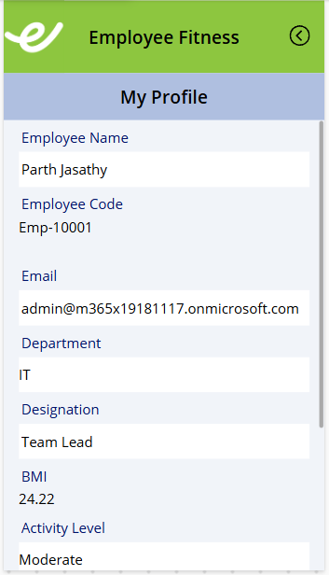 | My Profile (top)  Displays the employee's profile record from Dataverse. The first part of the screen shows:  - Employee Name and Employee Code (for example Emp-10001)  - Email, Department and Designation  - BMI (24.22) and Activity Level (Moderate)

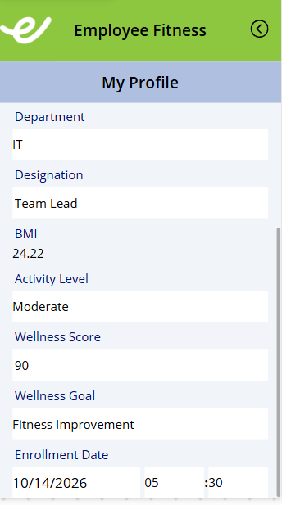 | My Profile (bottom)  Scrolling down shows the remaining wellness details:  - Wellness Score (90) and Wellness Goal (Fitness Improvement)  - Enrollment Date, which is set automatically when the profile is created

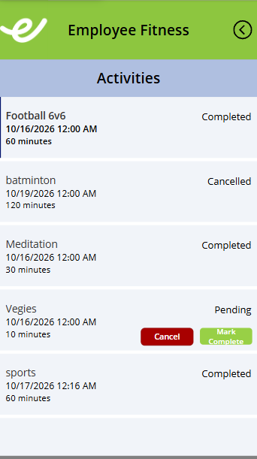 | Activities Screen  A vertical gallery lists the employee's own activities. Each item shows the activity name, date, duration in minutes and its Participation Status.  - Completed / Cancelled activities are shown for reference only.  - Pending activities show a red Cancel button and a green Mark Complete button.  - Cancel asks for confirmation before changing the status to Cancelled.

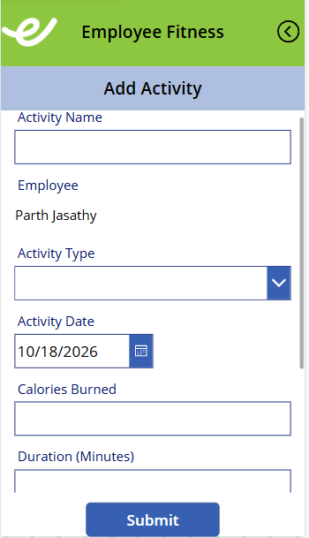 | Add Activity (top)  A Power Apps form that creates a new WellnessActivity record in Dataverse. The top of the form contains:  - Activity Name - free text.  - Employee - shows the signed-in employee's name (lookup).  - Activity Type - drop-down from the Dataverse choice column.  - Activity Date - date picker, defaulting to today.

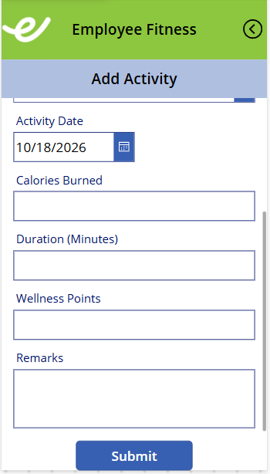 | Add Activity (bottom)  Scrolling down shows the remaining fields and the Submit button.  - Calories Burned, Duration (Minutes), Wellness Points - whole numbers.  - Remarks - multi-line notes.  - Submit - runs SubmitForm() to save the record. New activities automatically receive the status Pending.

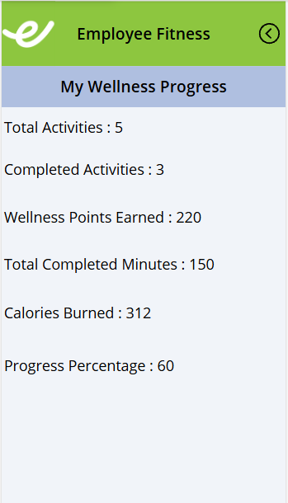 | My Progress Screen  Summarises progress for the signed-in employee. Only Completed activities contribute to the totals.  - Total Activities 5  - Completed Activities 3  - Wellness Points Earned 220  - Total Completed Minutes 150  - Calories Burned 312  - Progress Percentage 60 (3 completed out of 5 activities)

6.2 Activity Submission
The employee fills in the form and selects Submit. SubmitForm() writes the record to the WellnessActivity table in Dataverse.
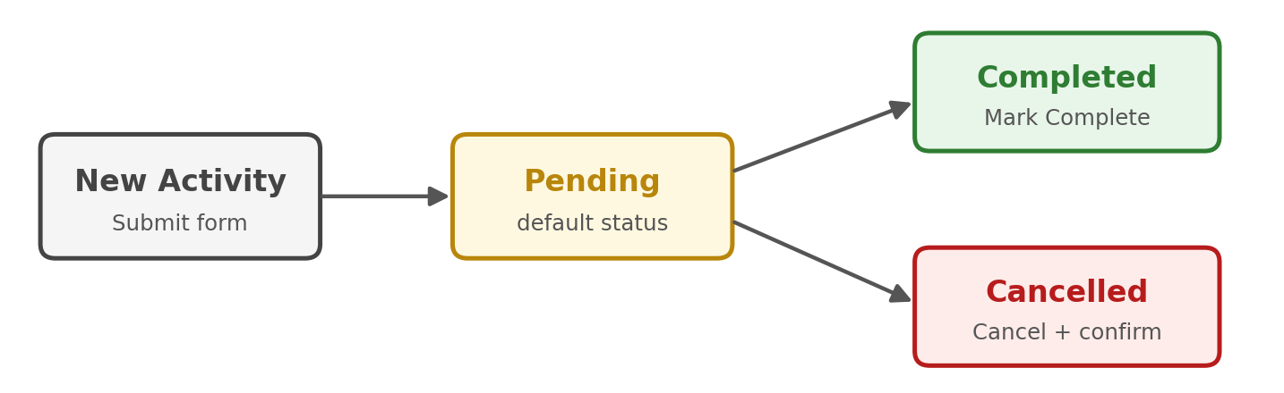
Figure 5: Activity lifecycle

6.3 Activity Lifecycle
- Pending: created but not yet performed. This is the default status.
- Completed: the employee performed the activity. Completed activities feed the progress calculations.
- Cancelled: the employee cancelled the planned activity. Cancelled activities are not counted as completed.

6.4 Cancel and Complete Actions
Cancel: Pending activity, then Cancel, then a confirmation popup, then the user confirms and Participation Status = Cancelled. The popup reduces accidental cancellations.
Complete: Pending activity, then Mark Complete, then Participation Status = Completed, and the activity is included in My Progress.

6.5 Progress Calculation
Metric | How it is calculated
Total Activities | Count of all activities for the employee
Completed Activities | Count of activities with Participation Status = Completed
Wellness Points Earned | Sum of Wellness Points for completed activities
Total Completed Minutes | Sum of Duration (Minutes) for completed activities
Calories Burned | Sum of Calories Burned for completed activities
Progress Percentage | Completed Activities / Total Activities x 100

7. Model-driven App: Views and Forms
Employee Wellness Management Admin is the administrative app used by HR, Wellness Coordinators and Administrators. It provides structured, standard Dataverse forms and views for maintaining wellness data.

7.1 Navigation
The site map contains one group, New Group, with two areas:
- Employee Wellness Profiles - manage employee profiles.
- WellnessActivities - manage wellness activity records.
The command bar offers New, Delete, Refresh, Email a Link, Flow, Run Report, Visualize this view and Share.

7.2 Views
Views let administrators open the records they need without building filters each time.

Active Employee Wellness Profiles
Lists active profiles, sorted by Employee Name. Columns: Employee Name, Email, Department, Designation, Wellness Goal, BMI, Wellness Score and Enrollment Date. The view currently shows six profiles.
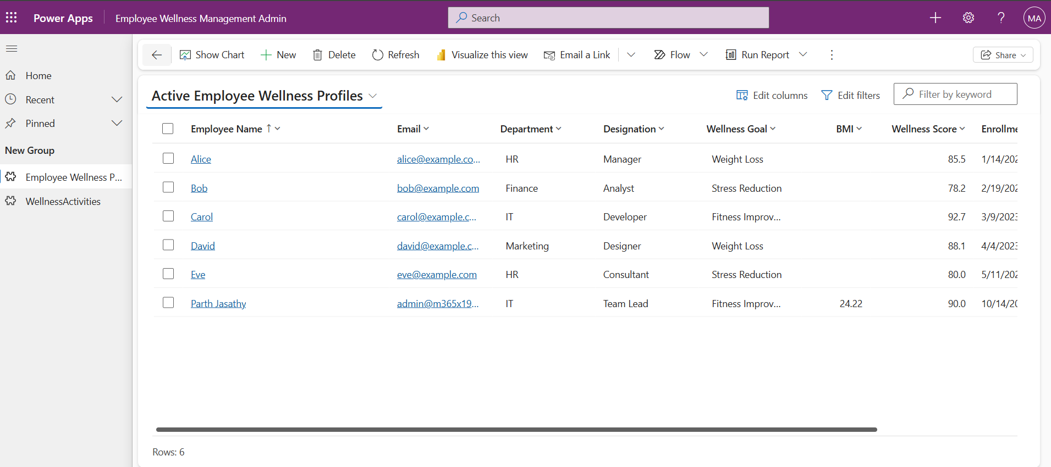
Figure 6: Active Employee Wellness Profiles view

Active WellnessActivities
Lists active activities, sorted by Activity Name. Columns: Activity Name, Activity Type, Activity Date, Duration (Minutes), Calories Burned, Participation Status and Wellness Points.
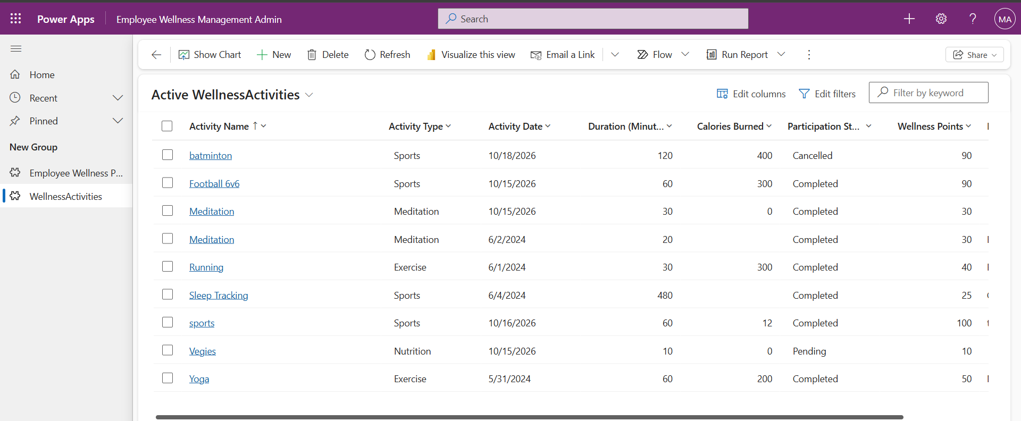
Figure 7: Active WellnessActivities view

7.3 Forms

Employee Wellness Profile form
A main form with two tabs: Personal and Health Details (see Section 10 for the changes made to this form). The Employee Code is shown in the form header.
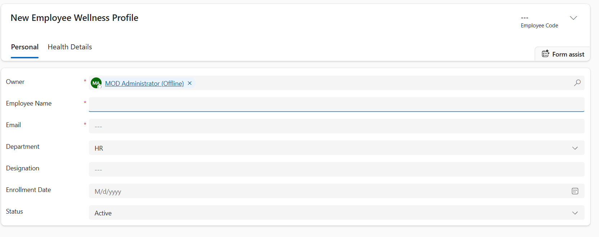
Figure 8: Employee Wellness Profile form - Personal tab
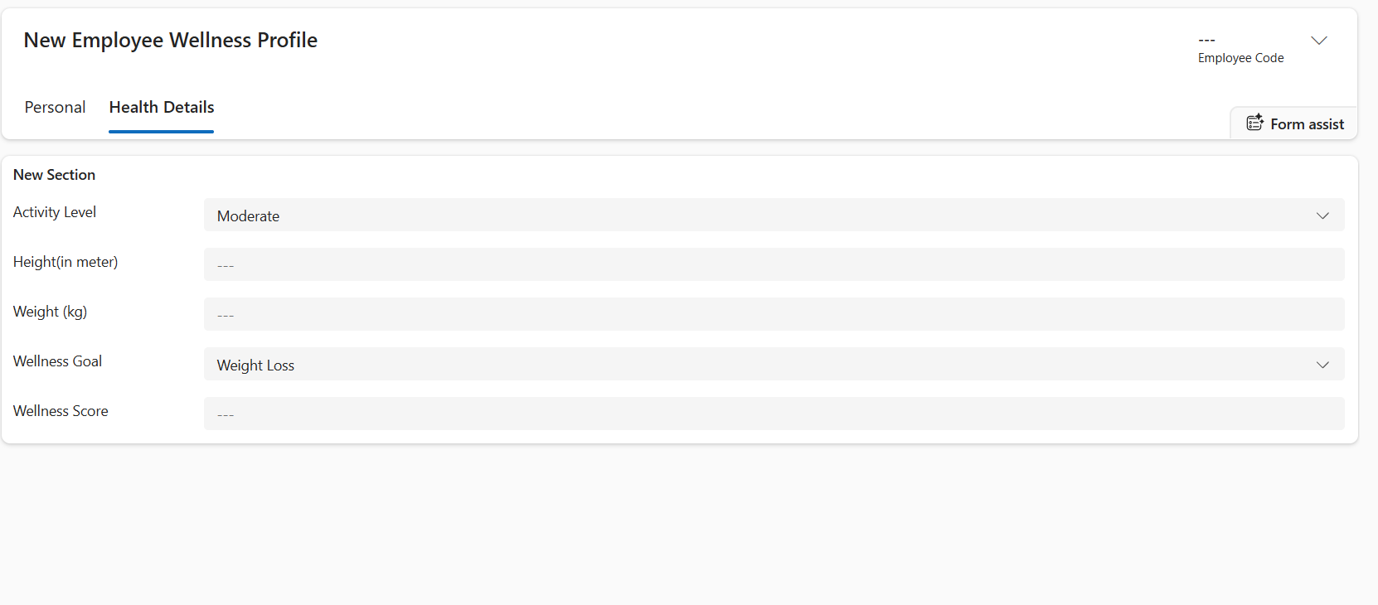
Figure 9: Employee Wellness Profile form - Health Details tab

WellnessActivity form
A main form with a single General tab containing Owner, Activity Type, Activity Date, Duration (Minutes), Calories Burned, Participation Status, Wellness Points and Remarks.
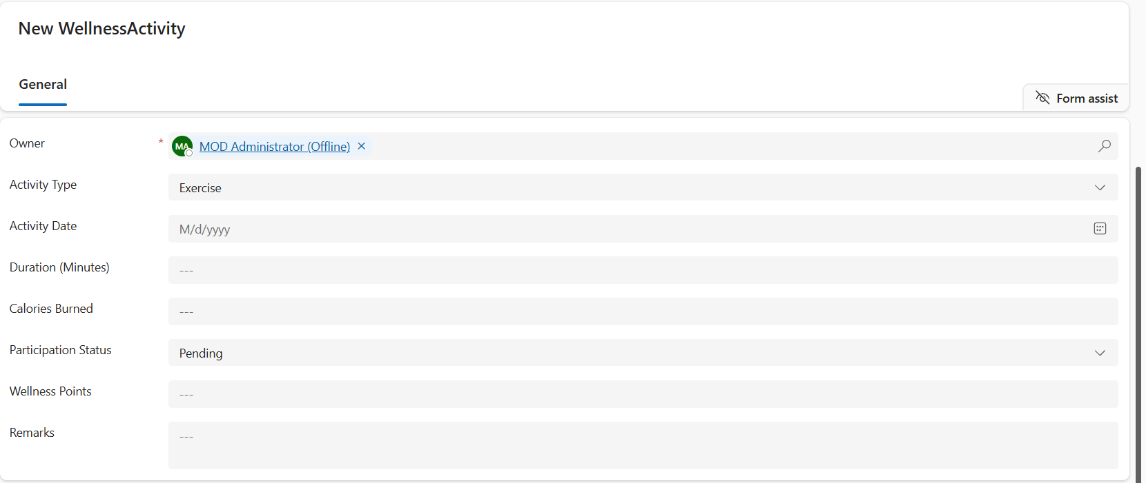
Figure 10: WellnessActivity form - General tab

8. Power Automate Flows
Four cloud flows in the Employee Wellness Solution automate notifications and background processing.
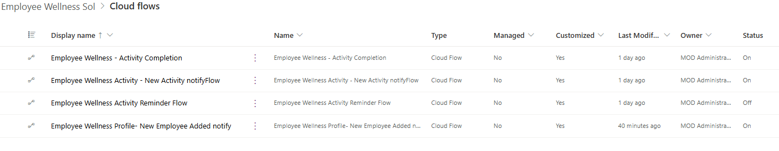
Figure 11: Cloud flows in the Employee Wellness Solution
Flow | Trigger | Purpose | Status
Employee Wellness Activity - New Activity notifyFlow | Dataverse: row added in WellnessActivity | Sends a confirmation email when an activity is created | On
Employee Wellness - Activity Completion | Activity lifecycle (completion) | Handles activity completion and notifies the employee | On
Employee Wellness Activity Reminder Flow | Recurrence (scheduled) | Sends reminders for activities that are still Pending | Off
Employee Wellness Profile - New Employee Added notify | Dataverse: row added in Employee Wellness Profile | Notifies on new profile and sets Enrollment Date to Created On | On

8.1 New Activity Notify Flow
Trigger: Microsoft Dataverse - When a row is added, modified or deleted. Change type: Added. Table: Wellness Activities. Scope: Organization.
Flow structure: New Wellness Activity, then Get Employee (using the Employee lookup's unique identifier), then Send Confirmation.
The employee receives an email containing:
- Greeting with the employee name and a confirmation that the activity was added.
- Activity details: name, type, date, duration, calories burned, wellness points and status (Pending).
- A reminder to open the Employee Wellness app and mark the activity as completed to update progress.

8.2 Activity Completion Flow
Handles the completion stage of the activity lifecycle. When an activity is completed, the flow processes the event and notifies the employee so that the completed activity is acknowledged and reflected in progress.

8.3 Pending Activity Reminder Flow
Runs on a recurring schedule and keeps pending activities visible to employees.
Flow structure: Recurrence, then List Pending Activities, then Apply to each, then Get Employee, then Send Reminder.
The list step filters the activities whose Participation Status is Pending.
This flow is currently turned Off and can be switched on when scheduled reminders are required.

8.4 New Employee Added Flow
Runs when a new Employee Wellness Profile is created. It also populates the Enrollment Date automatically so users never have to enter it by hand:
New Employee Profile, then Power Automate, then Update Employee Profile, then Enrollment Date = Created On.

9. Business Rules
Dataverse business rules enforce data quality on the server side, regardless of whether data is entered through an app, an import or an integration.

9.1 BR - Activity Date Validation
Property | Value
Table | WellnessActivity
Rule name | BR - Activity Date Validation
Condition | Check Act Date: Activity Date is less than Created On
Action | Set Field Value: Set Activity Date to Created On

In text form the rule reads:
IF Activity Date less than Created On
THEN Set Activity Date to Created On
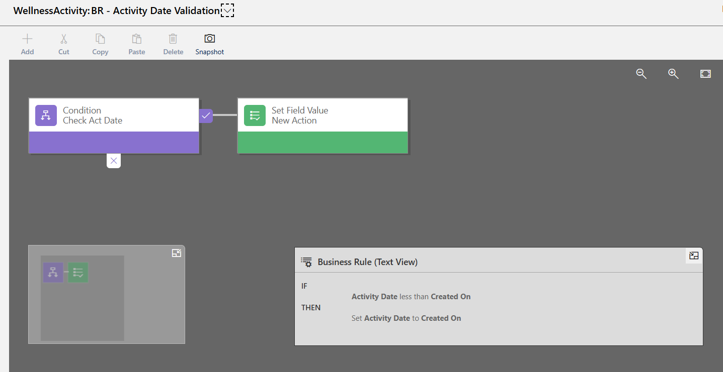
Figure 12: Business rule - Activity Date Validation
Because activities are meant to be scheduled for today or later, a date in the past is corrected automatically instead of being rejected.
Activity Date entered | Result
Earlier than the record creation date | Corrected to the creation date
Today | Accepted
Future date | Accepted

9.2 Other Data Validation
- Employee Name and Email are required on the Employee Wellness Profile.
- Activity Type and Participation Status can only take the predefined choice values.
- Duration (Minutes), Calories Burned and Wellness Points accept whole numbers only.
- Employee is a lookup, so an activity can only be linked to an existing profile.

10. Changes in Model-driven App New Form
The default Dataverse forms were customised to make data entry simpler for HR and Wellness Coordinators.
- New Employee Wellness Profile form: fields are split into two tabs, Personal (owner, name, email, department, designation, enrollment date, status) and Health Details (activity level, height, weight, wellness goal, wellness score). Employee Name and Email are required, Employee Code appears in the header, and sensible defaults such as Status = Active are pre-filled.
- New WellnessActivity form: a single General tab with the activity fields, where Participation Status defaults to Pending to match the Canvas app.
Screenshots are shown in Section 7.3 (Figures 8 to 10).

11. Future Enhancements
- Power BI dashboards covering total, completed, pending and cancelled activities, calories, points and trends.
- Leaderboards, team challenges and reward points.
- Teams notifications, wearable-device integration and role-based dashboards for HR.

12. Outcome
The Employee Wellness Management System replaces scattered spreadsheets with one Dataverse-based solution. Employees can log, complete and cancel wellness activities from a simple mobile app and see their progress instantly, while HR manages profiles and activities through the Model-driven app. Automated flows send confirmations and reminders, and a business rule keeps activity dates valid. The result is better data quality, higher employee engagement and a solid base for Power BI reporting and future wellness features.

