**调用的类为 Wl.WordsAnalyzer.AnalyzerContainer**

**SentenceAnalysisSimplifiedJson 返回 json 结果**

**调用范例**

**var agent = new Wl.WordsAnalyzer.AnalyzerAgent();**

**var title = @"Anti-broken 360° Full Protection PC Case Cover Tempered Glass Gifts For iPhone 5/5S/SE/6/6S/7 + Plus and * Android 4.0 work ? very hard or Symbian 3.0 -q ";**

**var jsonString = agent.SentenceAnalysisSimplifiedJson(title);**

**json 的结果如下**

**[{"Word":"Anti","Synonyms":["anti"]},{"Word":"-","Synonyms":[]},{"Word":"broken","Synonyms":["broken","busted","confused","crushed","disordered","humbled","humiliated","impoverished","low","rugged","unkept","upset"]},{"Word":"360°","Synonyms":["360"]},{"Word":"Full","Synonyms":["full","broad","entire","fully","good","replete","total","wax","wide"]},{"Word":"Protection","Synonyms":["protection","aegis","auspices","security","shelter","tribute"]},{"Word":"PC","Synonyms":["pc","microcomputer"]},{"Word":"Case","Synonyms":["case","caseful","casing","causa","cause","character","compositor","eccentric","encase","event","example","face","font","fount","incase","instance","lawsuit","pillowcase","sheath","shell","showcase","slip","subject","suit","type","typeface","typesetter","vitrine"]},{"Word":"Cover","Synonyms":["cover","address","back","binding","blanket","breed","brood","compensate","comprehend","concealment","continue","covering","covert","cross","deal","embrace","encompass","enshroud","extend","handle","hatch","hide","incubate","insure","masking","overcompensate","overlay","plow","report","screen","screening","shroud","top","track","traverse","treat","underwrite"]},{"Word":"temper","Synonyms":["temper","anneal","biliousness","chasten","harden","humor","humour","irritability","irritation","moderate","mollify","mood","normalize","peevishness","pettishness","pique","season","snappishness","surliness","toughness"]},{"Word":"Glass","Synonyms":["glass","chalk","crank","deoxyephedrine","glassful","glaze","ice","meth","methamphetamine","methedrine","shabu","spyglass","trash"]},{"Word":"gift","Synonyms":["gift","empower","endow","endowment","endue","give","giving","indue","invest","present","talent"]},{"Word":"For","Synonyms":[]},{"Word":"iPhone","Synonyms":["iphone"]},{"Word":"5/5S/SE/6/6S/7","Synonyms":["5/5s/se/6/6s/7"]},{"Word":"+","Synonyms":[]},{"Word":"Plus","Synonyms":["plus","addition","asset","positive","summation"]},{"Word":"and","Synonyms":[]},{"Word":"*","Synonyms":[]},{"Word":"Android","Synonyms":["android","humanoid"]},{"Word":"4.0","Synonyms":["4.0"]},{"Word":"work","Synonyms":["work","act","bring","crop","cultivate","employment","exercise","exploit","ferment","forge","form","function","go","influence","knead","lick","make","mold","mould","oeuvre","operate","play","process","run","shape","solve","sour","study","turn","workplace","wreak"]},{"Word":"?","Synonyms":[]},{"Word":"very","Synonyms":["very","identical","rattling","real","really","selfsame"]},{"Word":"hard","Synonyms":["hard","arduous","backbreaking","concentrated","difficult","firmly","grueling","gruelling","heavily","heavy","intemperate","intemperately","knockout","laborious","operose","punishing","severe","severely","strong","surd","toilsome","tough","unvoiced","voiceless"]},{"Word":"or","Synonyms":[]},{"Word":"Symbian","Synonyms":["symbian"]},{"Word":"3.0","Synonyms":["3.0"]},{"Word":"-","Synonyms":[]},{"Word":"q","Synonyms":["q"]}]**

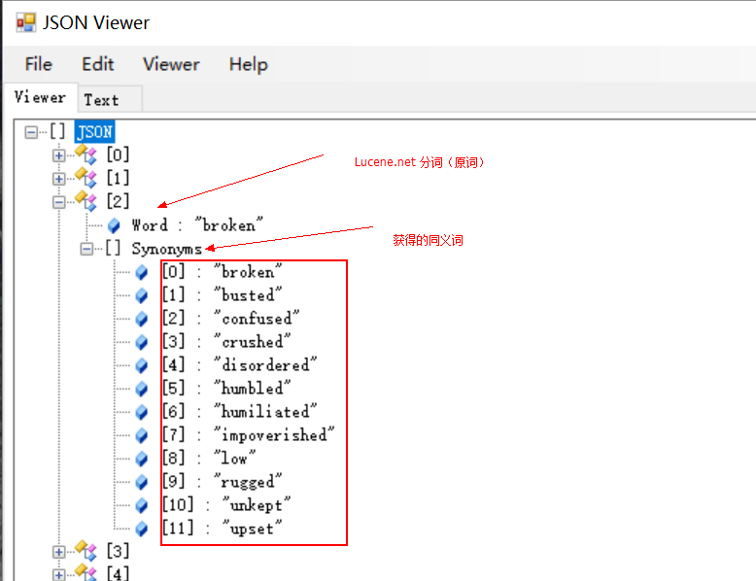

**项目中 lucene_dict 目录 为字典目录 ，组件运行 需要 拷贝到ｅ盘根目录下。**