**Motivation:**

is defined as the process of stimulating someone or oneself to take a desired course of action.

**Motive:**

Motive is defined as a reason for the expression of a particular ability.

**Nature of motivation:**

* Motivation is a continuous process
* Motivation is a psychological concept
* The entire individual is motivated
* Frustrated individual fails to motivated
* Goals lead to motivation

**Motive**

**Internal Motive**

**(Push motives)**

**starts from the ego needs of an individual**

**External Motive**

**(Pull motives)**

**external goals that influence one's behavior toward them.**

**Motivation**

**Positive Motivation**

**The process of attempting to influence the behaviors of employees through the means of reward**

**Factors(Pay,Incentives,Praise,Job Security,Supervision,Working condition,Fringe benefit etc.)**

**)**

**Negative Motivation**

**The act of forcing employees to work by means of threats and punishment.**

**Factors(Reprimand,Fines,Demotion,Lay off,Discharge,Punishment,Group Rejection etc.)**

**Factors of motivations are following-**

**(Factors leading primarily towards motivation/satisfaction)**

* Achievement
* Advancement
* Growth
* Recognition
* **Responsibility**
* **Work itself**

**(Factors leading primarily towards dissatisfaction)**

* **Company & administration**
* Job security
* Salary
* **Status**

**Freud`s theory of motivation**

(personality is formed through conflicts among three fundamental structures of the human mind)

* **Id:** The instinctual part of mind that responds immediately to wants and

desires. The id is chaotic animal like, **seeking pleasured avoiding pain**.

* **Ego:** The ego is the decision making part of the mind. It **uses reason**

**and logic**, and tries to get the unrealistic id to co-operate in real life.

* **Super ego:** The voice that corporates the **values & morals** which are

learned from one`s parents and society.

**Maslow`s Hierarchy theory**

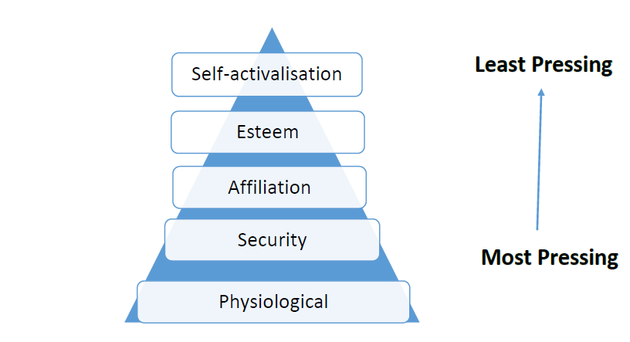

Food, **Cloth** Pay, Allowance

**Feel Safe**, No Pain

Security Plan, Membership

**Friendship**, Love

Work Group

**Recognition**, Prestige

Promotion, Awards

Personal Growth, **Realization**

**Herzberg`s two factor theory**

**Factors of satisfaction:-**

* Achievement
* Recognition
* The work itself
* Responsibility
* Advancement
* Growth

**Factors of dissatisfaction:-**

* Company policies
* Supervision
* Relation with supervisor & peers
* Work conditions
* Salary
* Status
* Security

**Douglas McGregor’s Theory X&Y**

Different views of human beings:

* Negative of human beings(X)
* Positive of human beings (Y)

**Assumptions of theory X:**

The typical person:

* Dislikes work and will avoid it, if possible
* Lacks personality(Jami), has little ambition and seeks security about all
* Most people must be coerced, controlled and threatened with punishment to get them to work

Example : **Class CR**

**Assumptions of theory Y:**

* People have potential. Under proper conditions, they learn to accept and seek responsibility
* People will exercise self- direction and self- control, if they are committed the organizational objectives
* People view work as being as natural as rest or play
* The average person can learn to accept and/ or seek responsibility
* People are not inherently lazy. They have become that way as a consequence of their experience

**David McClelland’s Needs Theory**

* **Need for Achievements**
* A tendency to set **moderately difficult achievement goals** and to take calculated risks.
* A strong desire for concrete **performance feedback on tasks**, and
* A single-minded preoccupation with **task accomplishment**.
* A strong desire to assume personal responsibility for **finding solutions to problems** or performing a task.
* **Need for Power:**
* A desire to direct and **control someone else**, and
* A concern for maintaining **leader-follower relations**.
* **Need for Affiliation:**
* A strong desire for **approval and reassurance from others**.
* A tendency to conform to the wishes and norms of others when pressured by people whose **leadership the value**, and
* A sincere **interest in the feelings of others**

**LEADERSHIP**

Directing, Influencing and Supporting people eagerly toward achieving group objectives.

**Traits of Good Leader**

* Inspiring
* Broad Minded
* Courageous
* Straight Forward
* Imaginative
* Intelligent
* Honest

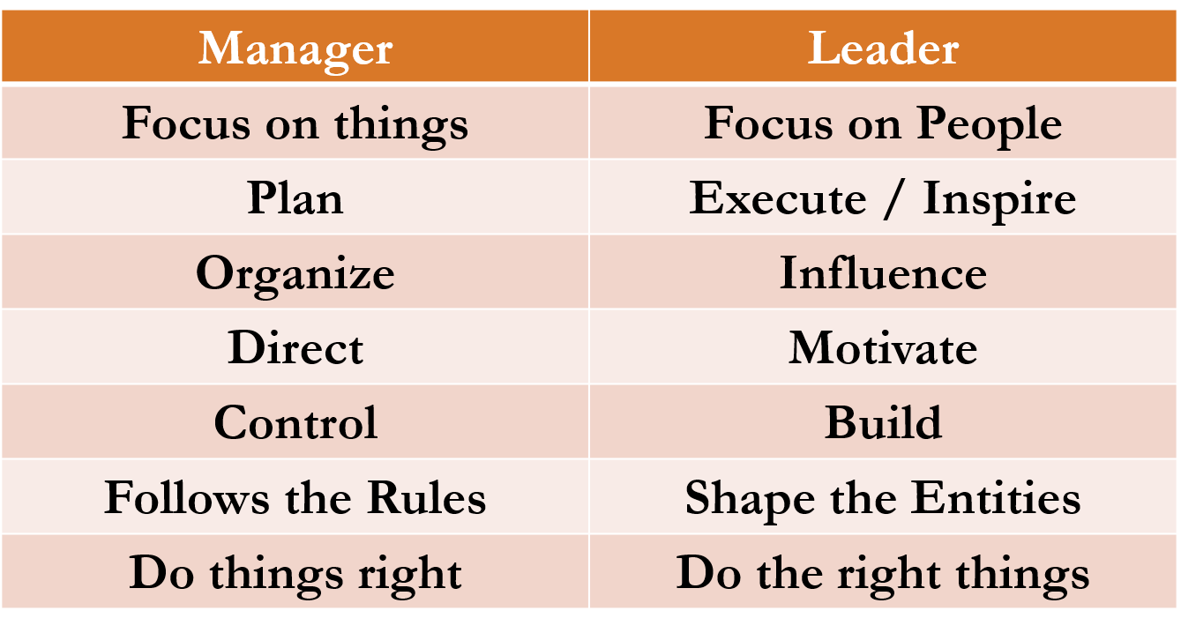

**Authoritarian Leadership:**

* Manager **retains power**
* Manager is **decision-making authority**
* Manager **does not consult employees** for input
* **Subordinates expected to obey orders** without explanations
* Motivation provided through **structured rewards and punishments**

**Authoritarian Traits:**

* **Sets goals individually**
* Engages primarily in one-way and downward communication,
* Controls discussion with followers
* **Dominate interaction.**

**When To Use Authoritarian Leadership?**

* New, **untrained employees**
* Employees are motivated
* **Employees do not respond to any other leadership style**
* **Limited time for decision making**
* Manager’s power is challenged by an employee

**Paternalistic Leadership:**

The way a paternalistic leader works is by acting **as a parental figure by taking care of their subordinates** as a parent would.

* Workers are totally committed to Leader
* Strong and Long Term relationship between worker and leader
* Based on complete trust and Loyalty

**Democratic Leadership:**

The democratic style encompasses the notion that **everyone**, by virtue of their human status, **should play a part in the group's decisions.**

**Function of a democratic leader:**

* Motivates subordinates to work, and improves their attitudes towards work.
* Promotes healthier relations between workers and management.
* Minimizes employee-grievances.
* Raises the employee morale.

**Laissez-faire Leadership**

The laissez-faire leadership style is where **all the rights and power to make decisions is fully given to the worker.**

* Laissez-faire **leaders allow followers to have complete freedom to make decisions** concerning the completion of their work.
* It allows followers a self-rule, while at the same time **offering guidance and support when requested**.
* The laissez-faire leader using guided freedom provides the followers with all materials necessary to accomplish their goals, but does not directly participate in decision making unless the followers request their assistance.

**This is an effective style to use when:**

* Followers are highly skilled, experienced, and educated.
* Followers have pride in their work and the drive to **do it successfully on their own.**
* **Outside experts**, such as staff specialists or consultants are being used.
* Followers are **trustworthy and experienced**.

**This style should *not* be used when:**

* The leader cannot or will **not provide regular feedback to their followers**.

**Transactional leadership:**

Transactional leaders focus their leadership on motivating followers through a system of rewards and punishments.

There are **two factors** which form the basis for this system,

* + **Contingent reward** provides rewards, materialistic or psychological, for effort and recognizes good performance.
  + **Management-by-exception** The leader intervenes when subordinates do not meet acceptable performance levels and initiates corrective action to improve performance. Management by exception helps reduce the workload of managers being that they are only called-in when workers deviate from course.

**Transformational leadership:**

A transformational leader is a type of person in which the leader is not limited by his or her followers' perception.

* The main objective is to work to ***change* or *transform* his or her followers' *needs* and *redirect* their thinking.**

Schultz and Schultz identify **3 characteristics** of a transformational leader:

* **Charismatic leadership** has a broad field of knowledge, has a self-promoting personality, high/great energy level, and willing **to take risk and use irregular strategies** in order to stimulate their followers to think independently
* **Individualized consideration**
* **Intellectual stimulation**

**Bureaucratic leadership:**

* Manager manages **“by the book¨**
* Everything must be **done according to procedure or policy**
* If it isn’t covered by the book, the manager refers to the next level above him or her

**When to use Bureaucratic??**

* Performing routine tasks
* Need for standards/procedures
* Use of dangerous or delicate equipment
* Safety or security training being conducted