**Security services:**A service that enhances the security of data processing systems and information transfers. A security service makes use of one or more security mechanisms.

**Cryptosystem:**

A cryptographic system (cryptosystem) consists of a pair of data transformations, namely encryption and decryption.

**Cryptoanalysis:**

The art of **breaking** ciphers, i.e. retrieving the plaintext without knowing the proper key.

**Major goals of security:**

* **Confidentiality**

-Secrecy, privacy

* **Integrity**
* **Availability**

-Denial of service

* **Other goals**

-Authenticity, non-repudiation, authority, utility, accountability, etc.

**A conventional cryptosystem:**

**Encryption**

**Process E**

Plaintext Message (M)

Encryption

Key (K)

**Decryption**

**Process D**

Decryption

Key (K')

Plaintext Message (M)

Ciphertext C=EK(M)

**Shannon characteristics:**

* + The amount of secrecy should determine the amount of labor appropriate for the encryption and decryption
  + The set of keys and encryption algorithm should be free of complexity
  + The implementation of the process should be as simple as possible
  + Errors in encryption should not propagate and cause corruption of further information in the message.
  + Ciphertext size should not be larger than plaintext

**Confusion:**

The change in ciphertext triggered by an alteration in the plaintext should be unpredictable.

**Diffusion:**

Change in the plaintext should affect many parts of the ciphertext

**Block diagram for depict the symmetric cryptosystem along with the ways of the key distribution:**

Key (K)

**Encryption**

**Process E**

Plaintext Message (M)

**Decryption**

**Process D**

Plaintext Message (M)

Ciphertext C=EK(M)

**Benefits of an asymmetric cryptosystem:**

* Different keys are used for encryption and decryption purposes.
* The pair of keys are mathematically related and consist of a public key that can be published without doing harm to the system's security and a private key that is kept secret.
* Also known as public key cryptosystems
* The public key is used for encryption purposes and lies in the public domain.
* Anybody can use the public key to send an encrypted message.
* The private key is used for decryption purposes and remains secret.
* An example of a public cryptosystem is the RSA cryptosystem.

**Encryption**

**Process E**

Plaintext Message (M)

Public key (K)

**Decryption**

**Process D**

Private key (K')

Plaintext Message (M)

Ciphertext C=EK(M)

**For RSA algorithm from ed = 1mod ¢(n) show that for a single value of e, there may exist many values of d, where symbols have their usual meanings:**

For the RSA algorithm,when we have ed ≡ 1 (mod φ(n)), it means that e and d are multiplicative inverses modulo φ(n).In other words,e and d are chosen such that their product,when taken modulo φ(n),results in 1.

Since φ(n) is the Euler's totient function, it calculates the number of positive integers that are coprime with n (i.e., they share no common factors with n). Therefore, there are many possible pairs of e and d that satisfy the condition ed ≡ 1 (mod φ(n)) because there are many potential values of φ(n) for different n values.

Due to the multiplicative property of modular arithmetic, for each valid value of e, there will be multiple possible values of d that satisfy the equation. This property ensures the reversible nature of the RSA encryption and decryption process, allowing for secure communication between parties.

**Chosen-plaintext attack:**

The attacker selects a plaintext and ciphers it using the crypto-techinque he attacks.The plaintext may be chosen to ease the task of key finding.

**Ciphertext-only attack:**

The attacker gets a ciphertext and tries to find the corresponding plaintext.

**Known-plaintext attack:**

The attacker has some plaintext and its matching ciphertext. The task is to find a key corresponding to this match.

**How the RSA algorithm suffers from chosen plaintext attacks:**

* **Public Key Exposure:** In the RSA algorithm, the encryption process uses the public key (n, e) to encrypt the plaintext. The attacker can obtain the public key since it is meant to be publicly available for encryption purposes.
* **Chosen Plaintexts:** The attacker can choose specific plaintext messages and encrypt them using the public key. They then observe the resulting ciphertexts generated by the RSA encryption.
* **Cryptanalysis:** Armed with the chosen plaintexts and their corresponding ciphertexts, the attacker can analyze the patterns in the encryption process to deduce information about the private key (d). With a sufficient number of chosen plaintexts and ciphertexts, the attacker can potentially perform mathematical operations to reveal the private key.
* **Private Key Recovery:** Once the attacker successfully deduces the private key (d), they can use it to decrypt any ciphertext encrypted with the corresponding public key (n, e). This means the attacker can decrypt any future encrypted messages sent using the same RSA key pair.

**Working procedure of Caesar cipher:**

**ci=E(pi)=pi+3 mod 26**

**How caesar cipher is an example of substitution ciphers:**

For example, let's use a Caesar cipher with a key of k=3 (shift each letter three positions to the right) to encrypt the plaintext message "HELLO":

Plaintext: H E L L O

Numerical: 7 4 11 11 14

Shifted: 10 7 14 14 17 (Add 3 to each numerical value)

Ciphertext: K H O O R (Convert back to letters)

The encrypted ciphertext is "KHOOR."

Caesar cipher is an example of substitution cipher because it substitutes each letter in the plaintext with another letter in the ciphertext based on a fixed rule (the key "k"). It maintains a one-to-one correspondence between the letters of the plaintext and the ciphertext, making it a straightforward and easily breakable encryption technique, especially with modern computational capabilities. However, it was historically significant as one of the earliest known encryption methods.

**Properties of digital signatures:**

* **Signature is Authentic:** Convinces recipient that the signer deliberately signed the document.
* **Signature is unforgeable:** The signer, nobody else, deliberately signed the document.
* **Signature is not reuseable:** Part of the document, can not be moved to a different document.
* **Signed document is unalterable:** After signing, document can’t be altered.
* **Signature can’t be repudiated:** The signer can’t later claim he/she didn’t sign the document.

**How RSA algorithm can be used to implement product cipher:**

**Key Generation:**

* Generate two large prime numbers, p and q.
* Compute the RSA modulus, n, by taking the product of p and q: n = p * q.
* Choose a public exponent, e, that is relatively prime to φ(n), where φ(n) is Euler's totient function φ(n) = (p-1) * (q-1).
* Compute the private exponent, d, such that e * d ≡ 1 (mod φ(n)).

**Asymmetric Encryption (RSA Encryption):**

* Encrypt the plaintext using the recipient's public key (n, e) through RSA encryption. This step provides confidentiality for the message.

**Symmetric Encryption (Optional):**

* Generate a symmetric encryption key, such as AES (Advanced Encryption Standard), for use in the next encryption step.
* Encrypt the output of the RSA encryption (the ciphertext) using the symmetric key. This step provides an additional layer of security and confidentiality.

**Decryption:**

* The recipient uses their private key (n, d) to decrypt the RSA-encrypted ciphertext, recovering the original symmetric encryption key and the intermediate ciphertext.

**Symmetric Decryption:**

* Decrypt the intermediate ciphertext using the recovered symmetric key to obtain the final plaintext message.

**Using RSA as part of a product cipher allows the benefits of both asymmetric and symmetric encryption. Asymmetric encryption handles key distribution and provides secure communication between parties, while symmetric encryption offers efficient and fast encryption and decryption of the actual message data.**

**By combining these encryption methods, the product cipher takes advantage of RSA's strong key management and secure communication properties while achieving efficient encryption and decryption using symmetric encryption for the bulk of the data. This approach is often used in secure communication protocols to achieve a balance between security and performance.**

**Block Ciphers**

**Techniques:**

Block ciphers encrypt fixed-size blocks of data (e.g., 64 or 128 bits) using a symmetric key. The plaintext is divided into blocks, and each block is encrypted separately using the same key. Popular block cipher algorithms include AES (Advanced Encryption Standard) and DES (Data Encryption Standard).

**Pros:**

* Suitable for bulk data encryption.
* Strong security when used with a secure mode of operation (e.g., CBC, CTR).
* Can handle random access to data blocks.

**Cons:**

* Slower for real-time data streaming.
* Requires padding for messages not divisible into block size.
* Vulnerable to certain attacks like block reordering.

**Stream Ciphers**

**Techniques:**

Stream ciphers encrypt data one bit or byte at a time using a keystream generated from a secret key. The keystream is combined with the plaintext using bitwise XOR operation. RC4 and ChaCha20 are examples of stream cipher algorithms.

**Pros:**

* Faster and more efficient for real-time data encryption.
* No need for padding.
* Can be more suitable for low-resource devices.

**Cons**:

* More prone to certain attacks like known-plaintext attacks.
* Less secure for bulk data encryption.
* Vulnerable to key re-use and related-key attacks.

**Trends for Maintaining Security:**

* Increasing Key Size
* Use of Authenticated Encryption
* Post-Quantum Cryptography
* Constant Review and Updates
* Hardware-based Security
* Multi-Factor Authentication
* Blockchain and Distributed Ledger Technologies

**ElGamal Algorithm**

The ElGamal encryption algorithm is an asymmetric encryption scheme that allows secure communication between two parties. It is based on the difficulty of computing discrete logarithms in a finite cyclic group. The algorithm involves the following steps:

**Key Generation:**

Choose a large prime number "p" and a primitive root "g" modulo "p."

Select a random private key "x" in the range [1, p-2].

Calculate the public key "y" as **y = g^x mod p**.

**Encryption** (By Alice)**:**

To encrypt a message "m," the sender selects a random secret integer "k" in the range [1, p-2].

Compute the ciphertext pair:

**C1 ≡ g^k mod p** (the ephemeral public key).

**C2 ≡ (m * y^k) mod p** (where "*" denotes modular multiplication).

**Decryption** (By Bob)**:**

To decrypt the ciphertext pair (C1, C2), the recipient uses their private key "x."

Compute the shared secret as **s ≡ C1^x mod p**.

Calculate the modular inverse of the shared secret s^(-1) mod p.

The original message "m" can be recovered as **m ≡ (C2 * s^(p-2)) mod p**.

**Signature Generation:**

To sign a message "m," the signer (usually named Alice) follows these steps:

1. Generate a random secret integer "k" in the range [1, p-2].
2. Calculate the ephemeral public key C1 as C1 ≡ g^k mod p.
3. Compute the signature components:

**r ≡ C1 mod (p-1)** (Note: Ensure that r is not 0. If it is, choose a different "k" and repeat).

**s ≡ (m - x * r) * k^(-1) mod (p-1),**

(where k^(-1) is the modular inverse of "k" modulo (p-1). If s is 0, choose a different "k" and repeat.)

The digital signature on the message "m" is the pair (r, s).

**Signature Verification:**

To verify the digital signature (r, s) on message "m" with the public key "y":

1. Compute the ephemeral public key C1 as **C1 ≡ g^m * y^r mod p**.
2. Calculate the expected signature component v as **v ≡ (r - C1) mod (p-1)**.

The signature is valid if v is equal to s. If they are equal, the signature is authentic and the message has not been tampered with.

**Probabilistic Encryption:**

ElGamal encryption is said to be a probabilistic encryption algorithm because it generates different ciphertexts for the same plaintext message each time it is encrypted. The randomness introduced during the encryption process (by selecting random "k" values) ensures that the same message is encrypted differently each time, making it less susceptible to frequency analysis and other deterministic attacks.

The use of random values in the encryption process adds an element of unpredictability, even when encrypting the same plaintext with the same public key. This probabilistic nature enhances the security of the encryption scheme, as it prevents attackers from observing patterns in the ciphertext that might be present in deterministic encryption schemes.

In summary, the ElGamal encryption algorithm is based on the hardness of computing discrete logarithms and uses randomness to generate different ciphertexts for the same plaintext. This probabilistic property enhances its security and makes it a popular choice for secure communications.

**Major Characteristics of Cryptographic Hash Function:**

1. **Deterministic:** For the same input, the hash function always produces the same fixed-size output (hash value). This determinism ensures consistency in the hashing process.
2. **Fixed Output Size:** Regardless of the input size, cryptographic hash functions produce a fixed-size output, typically in bytes. This property allows hash values to have a uniform length, making them suitable for various applications.
3. **Pre-image Resistance:** Given a hash value, it should be computationally infeasible to find the original input (pre-image) that produced that hash. This property ensures that the hash function works as a one-way function.
4. **Second Pre-image Resistance:** Given an input, it should be computationally infeasible to find another input that produces the same hash value (second pre-image). The hash function should resist finding a different input with the same hash.
5. **Collision Resistance:** It should be computationally infeasible to find any two distinct inputs that produce the same hash value (collision). This property ensures that it is challenging to tamper with data by finding another input with the same hash.
6. **Avalanche Effect:** A small change in the input should result in a significantly different hash value. This property ensures that even slight modifications in the data lead to completely different hash outputs.

**Why Cryptographic Hash Function is One-Way?**

Cryptographic hash functions are designed to be one-way, meaning it is computationally infeasible to reverse the hashing process and find the original input from its hash value. This characteristic is crucial for the security of various cryptographic applications, such as password hashing and digital signatures. If a hash function were not one-way, attackers could easily retrieve sensitive information, passwords, or private keys by reversing the hash.

By being one-way, cryptographic hash functions provide a level of security where the original data remains concealed, and only the hash value is stored or transmitted. This property ensures the integrity and authenticity of data without revealing sensitive information. The one-way nature of cryptographic hash functions is a fundamental requirement in modern cryptography and forms the basis for many secure cryptographic protocols and applications.

**Firewalls:**

Firewalls are network security devices or software that act as a barrier between a trusted internal network and untrusted external networks, such as the internet. Their primary function is to monitor and control incoming and outgoing network traffic based on predefined security rules. Firewalls help prevent unauthorized access to the internal network and protect it from various cyber threats.

**Characteristics of Various Malicious Code:**

1. **Viruses:** Self-replicating programs that attach themselves to clean files or programs, spreading to other files when the infected file is executed.
2. **Worms:** Self-replicating programs that spread independently through computer networks, exploiting security vulnerabilities without needing to attach to host files.
3. **Trojan Horses:** Malicious programs disguised as legitimate software, tricking users into executing them, allowing unauthorized access or causing harm.
4. **Ransomware:** Malware that encrypts the victim's data, demanding a ransom in exchange for the decryption key.
5. **Spyware:** Software that secretly gathers user information, monitoring online activities without the user's consent.
6. **Adware:** Software that displays unwanted advertisements and gathers user data to target ads.
7. **Rootkits:** Stealthy software designed to conceal the presence of malicious code, granting unauthorized access to a system.
8. **Botnets:** Networks of compromised computers controlled by a central server (botmaster) to carry out malicious activities.
9. **Keyloggers:** Software that records keystrokes, capturing sensitive information like passwords and credit card details.
10. **Logic Bombs:** Code that remains inactive until a specific condition is met, triggering a malicious action.
11. **Backdoors:** Unauthorized access points created by attackers to bypass normal authentication mechanisms.
12. **Droppers:** Malware components responsible for delivering and installing other malicious software on a system.

These malicious code types vary in their methods, intents, and effects, but they all pose serious security risks to computer systems and networks. Organizations and individuals use various security measures, including firewalls, to protect against these threats.

**AES algorithm:**

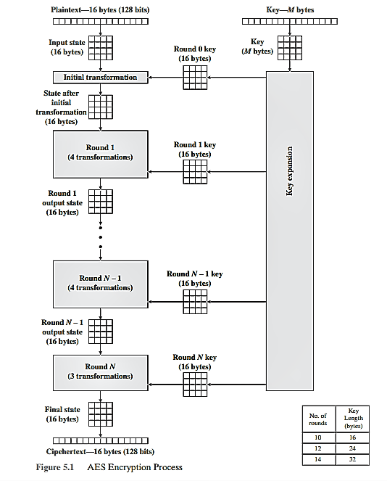

**DES algorithm:**

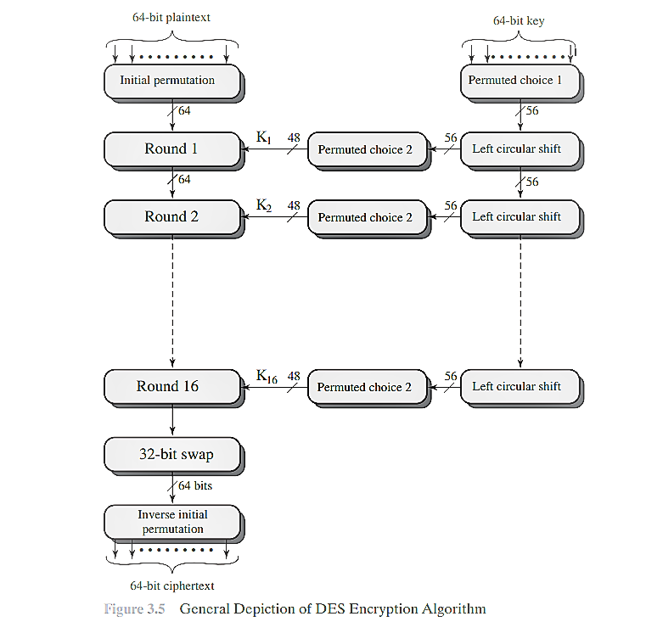

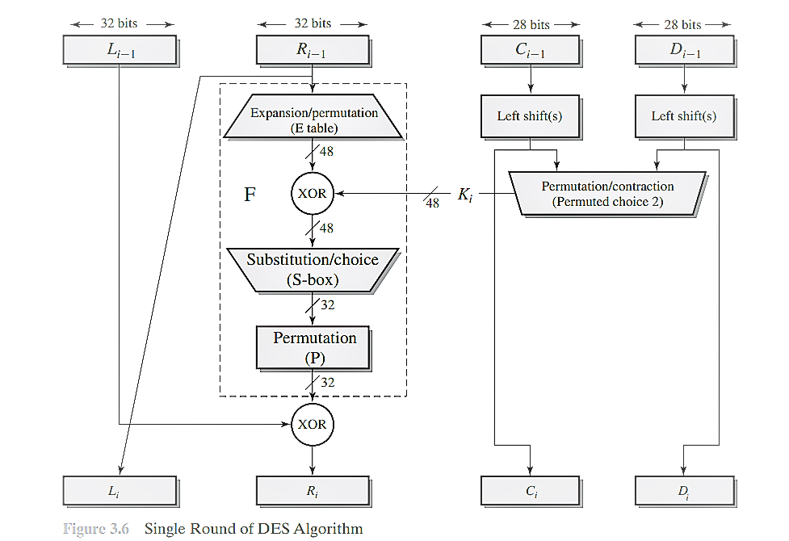

**Comparative Study between AES and DES:**

1. **Security:** AES offers higher security compared to DES. AES uses longer key lengths (128, 192, or 256 bits) and more rounds (10, 12, or 14) to resist attacks, whereas DES has a fixed 56-bit key length and 16 rounds, making it more vulnerable to brute-force attacks.
2. **Key Length:** AES supports key lengths of 128, 192, and 256 bits, providing more options for stronger encryption. In contrast, DES has a fixed 56-bit key length, which is relatively weaker in today's computing environment.
3. **Block Size:** AES operates on blocks of 128 bits, whereas DES operates on 64-bit blocks. The larger block size of AES provides better diffusion and avalanche effects.
4. **Performance:** AES is generally faster in software implementations due to its efficient operations on 32-bit words. DES, being older and designed for 16-bit hardware, may be slower in some software implementations.
5. **Standardization:** AES is an international standard adopted by various organizations, including the U.S. government, providing a globally recognized encryption standard. DES is an older standard, and its use is discouraged due to its vulnerabilities.
6. **Cryptanalysis:** DES has been extensively studied over the years, and vulnerabilities have been found. AES has undergone rigorous cryptanalysis, and no practical attacks have been discovered on its full version.

In conclusion, AES is more secure, versatile, and widely adopted compared to DES. It provides better performance and stronger encryption with various key lengths, making it the preferred symmetric encryption algorithm for modern cryptographic applications.

**The characteristics of good viruses:**

* Are hard to detect
* Are hard to destroy
* Spread widely
* Can re-infect cleaned files
* Are easy to create
* Are machine independent

**Triple DES vs. DES:**

Triple DES (3DES) is an improvement over the original DES algorithm. It applies DES three times in succession with two or three unique keys to provide increased security. The main advantages of 3DES over DES are:

**Key Length:** DES has a fixed key length of 56 bits, which is relatively weak against modern attacks. 3DES uses either a 112-bit key (using two keys) or a 168-bit key (using three keys), significantly increasing the effective key length and making it more resistant to brute-force attacks.

**Security:** DES has been shown to be vulnerable to certain cryptanalytic attacks. By applying DES three times with different keys, 3DES provides a higher level of security and complexity, reducing the chances of successful attacks.

**Backward Compatibility**: 3DES can be used with existing DES infrastructure by employing only two keys, making it backward compatible. This allows organizations to transition to stronger security without completely replacing their legacy systems.

**Transition Strategy:** During the transition from DES to more secure algorithms, 3DES serves as an intermediate step, providing a higher level of security compared to DES while still being widely supported.

**Multiple DES:**

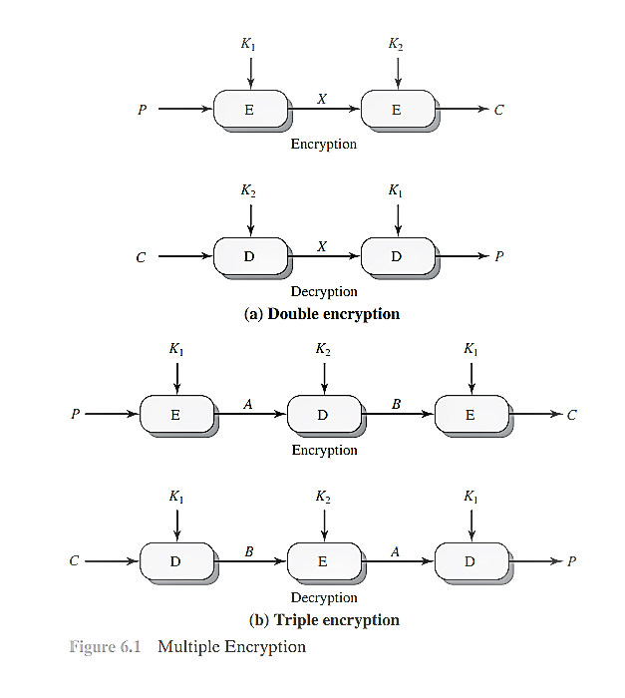

**Primitive Element of ElGamal Cryptosystem:**

In the ElGamal cryptosystem, a primitive element (also known as a generator) is a specific element of the finite field over which the encryption algorithm operates. It is chosen to generate a cyclic subgroup of the field, which ensures that every element in the subgroup can be reached by repeatedly applying the primitive element.

Let "p" be a large prime and "α" be an element in the finite field Fp. "α" is a primitive element if the powers of "α" generate all nonzero elements in the field. In other words, the set {α^1, α^2, α^3, ..., α^(p-1)} includes all nonzero elements in Fp.

The use of a primitive element in ElGamal allows the encryption and decryption processes to be carried out efficiently using modular exponentiation. It simplifies the key generation and encryption steps, ensuring that every element in the finite field can be reached and utilized for secure encryption.

**Ingredients of a cryptosystem:**

1. **Plaintext Space:** The set of all possible plaintext messages that can be encrypted.
2. **Ciphertext Space:** The set of all possible ciphertexts that can be produced by the encryption algorithm.
3. **Encryption Algorithm:** A mathematical function that transforms plaintext into ciphertext using a specific key.
4. **Decryption Algorithm:** A mathematical function that transforms ciphertext back into plaintext using the corresponding key.
5. **Key Space:** The set of all possible keys that can be used in the encryption and decryption processes.
6. **Key Generation Algorithm:** A procedure to generate keys for encryption and decryption.
7. **Security Requirements:** The properties that the cryptosystem must satisfy, such as confidentiality, integrity, authenticity, and non-repudiation.

**RSA:**

**Encryption:**

To encrypt a message "M," the sender uses the recipient's public key (n, e) and performs:

**Ciphertext (C) ≡ M^e (mod n).**

**Decryption:**

The recipient, possessing the private key "d," decrypts the ciphertext "C" using the following operation:

**Plaintext (M) ≡ C^d (mod n).**

**El-Gamal:**

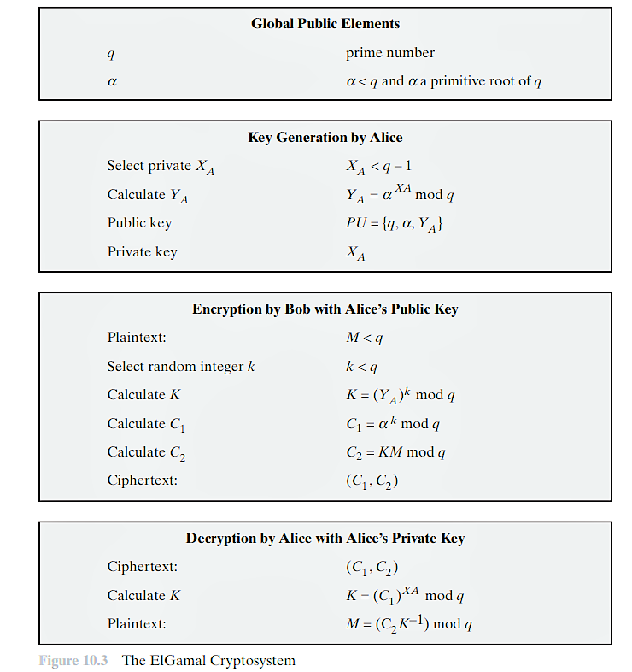

**Commutative Encryption:**

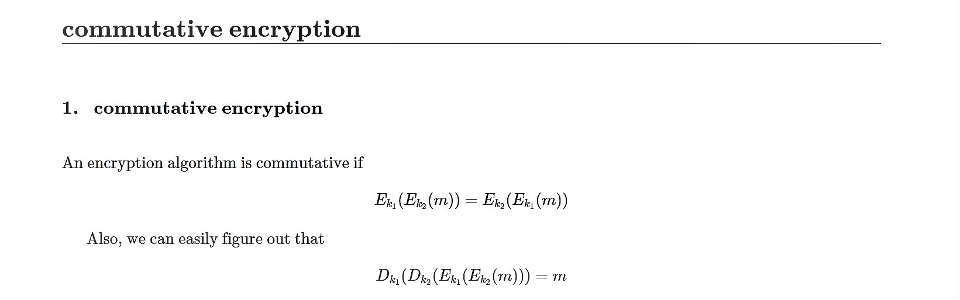

**Why Combine Digital Signature and Public Key Cryptography:**

Digital signature and public key cryptography can be combined to provide a secure and efficient method for verifying the authenticity and integrity of messages in a digital environment.

1. **Authentication:** Public key cryptography allows the sender to sign a message using their private key, which serves as a unique identifier. The recipient can verify the signature using the sender's public key, ensuring the message's authenticity.
2. **Integrity:** Digital signatures use cryptographic techniques to bind the signature to the message, making it tamper-evident. Any changes to the message will invalidate the signature, ensuring data integrity.

**How Digital Signature and Public Key Cryptography are Combined:**

1. **Key Generation:** The sender generates a key pair, consisting of a private key and a corresponding public key. The private key is kept secret, while the public key is shared openly.
2. **Signing:** To sign a message, the sender uses their private key to create a digital signature. The signature is a cryptographic representation of the message and is unique to the sender's private key.
3. **Verification:** The recipient receives the message and its associated digital signature. Using the sender's public key, the recipient verifies the signature's authenticity and the message's integrity.
4. **Trust:** Public key infrastructure (PKI) or a trusted third party may be used to ensure the authenticity of public keys, establishing trust in the digital signatures.
5. **Security:** The security of the combined method relies on the strength of the public key cryptography, making it computationally infeasible for an attacker to forge a valid signature without knowing the private key.

By combining digital signature and public key cryptography, users can securely exchange messages, ensure non-repudiation (the sender cannot deny sending the message), and guarantee the integrity of data in digital communications and transactions.

**ElGamal Cryptosystem(Book)**

ElGamal is an asymmetric encryption algorithm that uses the properties of the discrete logarithm problem for security. Let's explain the ElGamal cryptosystem with a simple example:

**Key Generation:**

Select a large prime number, "p" (e.g., p = 23).

Choose a primitive root modulo "p," denoted as "α" (e.g., α = 5).

Pick a random private key, "x" (e.g., x = 6).

Compute the public key, "y," as **y ≡ α^x (mod p)** = 5^6 mod 23 = 8.

**Encryption:**

Choose a random secret integer, "k" (e.g., k = 3).

Compute the ephemeral public key, "C1," as **C1 ≡ α^k (mod p)** = 5^3 mod 23 = 10.

Calculate the shared secret, "s," as **s ≡ y^k (mod p)** = 8^3 mod 23 = 5.

Represent the plaintext message, "M," as a numerical value (e.g., M = 15).

Compute the ciphertext, "C2," as **C2 ≡ M * s (mod p)** = 15 * 5 mod 23 = 20.

**Decryption:**

Retrieve the ciphertext components, "C1" and "C2."

Compute the shared secret, "s," as **s ≡ C1^x (mod p)** = 10^6 mod 23 = 5.

Compute the modular inverse of "s" to get "s^(-1)" as s^(-1) ≡ 5^(-1) mod 23 = 19.

Obtain the plaintext message, "M," as **M ≡ C2 * s^(-1) (mod p)** = 20 * 19 mod 23 = 15.

**Relation with Discrete Logarithm Problem:**

The security of the ElGamal cryptosystem relies on the difficulty of solving the discrete logarithm problem (DLP). In the example, the discrete logarithm problem is finding "x" given "α," "y," and "p" such that α^x ≡ y (mod p).

In the key generation process, the public key "y" is derived from "α^x," making it computationally infeasible to determine "x" from "y" without knowing the private key "x." The strength of ElGamal lies in the difficulty of solving the discrete logarithm problem in large prime fields.

The relationship with DLP makes ElGamal a secure and efficient public-key cryptosystem used for encryption and digital signatures.

**Threats to Email:**

1. **Phishing:** Deceptive emails masquerade as legitimate entities to trick users into revealing sensitive information or login credentials.
2. **Malware Attachments:** Emails may contain malicious attachments like viruses or ransomware that can infect the recipient's system.
3. **Spam:** Unsolicited and bulk emails flood inboxes, consuming resources, and potentially delivering malicious content.
4. **Spoofing:** Attackers forge email headers to make messages appear from a trusted source, enabling phishing or spreading misinformation.
5. **Man-in-the-Middle (MITM) Attacks:** Emails can be intercepted during transit, allowing attackers to read or modify the content.
6. **Email Bombs:** Overwhelming an email account with an enormous volume of messages to disrupt communication.
7. **Data Breaches:** Breached email servers expose sensitive data, leading to identity theft or unauthorized access.
8. **Social Engineering:** Emails employ psychological manipulation to persuade users into taking actions that compromise security.
9. **Email Spoofing:** Attackers forge the "From" address to appear as a known contact, leading to impersonation.
10. **Zero-Day Exploits:** Newly discovered vulnerabilities in email clients or servers can be exploited before patches are available.
11. **Business Email Compromise (BEC):** Targeting organizations, attackers use fraudulent emails to deceive employees into financial transactions.
12. **Email Phreaking:** Manipulating email servers or relays to redirect, block, or modify messages.

To mitigate these threats, users should employ strong passwords, enable multi-factor authentication, avoid clicking suspicious links or attachments, and use reliable antivirus and email security solutions. Regular user education on email security practices is essential.

**Sensitive Data:**

Sensitive data refers to any information that, if disclosed, accessed, or modified without authorization, could cause harm, privacy violations, financial loss, or reputational damage to individuals or organizations. This type of data requires protection from unauthorized access, disclosure, or tampering to maintain its confidentiality, integrity, and availability.

**Factors that can Make Data Sensitive:**

1. **Personal Identifiable Information (PII):** Data that directly or indirectly identifies an individual, such as names, addresses, Social Security numbers, or biometric data.
2. **Financial Information:** Credit card numbers, bank account details, and financial transactions are sensitive as they can lead to financial loss if exposed.
3. **Health Records:** Medical history, diagnoses, treatments, and other health-related information require protection due to privacy regulations and potential harm if misused.
4. **Intellectual Property (IP):** Trade secrets, proprietary algorithms, patents, and copyrighted material are valuable assets that must be safeguarded.
5. **Legal or Compliance Data:** Information subject to legal constraints or compliance requirements, including contracts, legal documents, or sensitive communications.
6. **National Security Data:** Classified or sensitive government information concerning defense, intelligence, or homeland security.
7. **Personal Communications:** Private emails, messages, or conversations that should not be disclosed without consent.
8. **User Credentials:** Usernames, passwords, or access tokens that provide entry to systems or accounts.
9. **Geolocation Data:** Information about an individual's location or movements, which can impact privacy and safety.
10. **Third-Party Data:** Data shared with or received from external entities that require protection to maintain trust.
11. **Reputational Data:** Sensitive data related to an organization's reputation, such as customer reviews or internal assessments.
12. **Biometric Data:** Fingerprints, facial recognition data, or other biometric identifiers that uniquely identify individuals.

**Homomorphic Encryption:**

Homomorphic encryption is a cryptographic property where certain mathematical operations can be performed on encrypted data without decrypting it. In other words, the result of performing operations on encrypted data will be equivalent to the result of performing the same operations on the plaintext data. Homomorphic encryption enables computations on encrypted data, preserving privacy and security.

**RSA and ElGamal as Homomorphic Cryptosystems:**

Both RSA and ElGamal are homomorphic cryptosystems with respect to multiplication. Let's demonstrate this property for both algorithms:

**RSA Homomorphism:**

RSA encryption is based on modular exponentiation, and it exhibits homomorphism under multiplication. Suppose we have two plaintext messages, M1 and M2, and their corresponding ciphertexts, C1 and C2, encrypted with the same RSA public key (n, e).

**Encryption:**

**C1 ≡ M1^e (mod n)**

**C2 ≡ M2^e (mod n)**

**Homomorphism:**

If we multiply the ciphertexts (C1 * C2), the result will be equivalent to the encryption of the product of the plaintexts (M1 * M2):

**C1 * C2 ≡ (M1^e) * (M2^e) (mod n) ≡ (M1 * M2)^e (mod n)**

**ElGamal Homomorphism:**

ElGamal encryption is based on modular exponentiation and exhibits homomorphism under multiplication. Suppose we have two plaintext messages, M1 and M2, and their corresponding ciphertexts, (C1, C1'), and (C2, C2'), encrypted with the same ElGamal public key (p, α, y).

**Encryption:**

**C1 ≡ αk (mod p)**

**C1' ≡ yk * M1 (mod p)**

**C2 ≡ αk' (mod p)**

**C2' ≡ yk' * M2 (mod p)**

**Homomorphism:**

If we multiply the ciphertexts component-wise ((C1 * C2) and (C1' * C2')), the result will be equivalent to the encryption of the product of the plaintexts (M1 * M2):

**C1 * C2 ≡ (α^k * α^k') (mod p) ≡ α(k + k') (mod p)**

**C1' * C2' ≡ (yk * M1 * yk' * M2) (mod p) ≡ y(k + k') * (M1 * M2) (mod p)**

Both RSA and ElGamal allow multiplication of ciphertexts to produce the encryption of the product of the corresponding plaintexts. However, it is important to note that homomorphic properties may vary for different operations or variations of the algorithms.

**Parameters Making Computer Networks Vulnerable:**

Computer networks face various vulnerabilities due to factors that can be exploited by attackers to compromise security. Some critical parameters include:

1. **Weak Authentication:** Inadequate or weak password policies, default credentials, and lack of multi-factor authentication open doors to unauthorized access.
2. **Unpatched Software:** Failure to apply timely security patches and updates leaves network devices vulnerable to known exploits.
3. **Insufficient Encryption:** Lack of end-to-end encryption or weak encryption protocols can lead to data interception and unauthorized access.
4. **Insecure Protocols:** Use of outdated or insecure protocols, like HTTP instead of HTTPS, exposes sensitive data to eavesdropping.
5. **Social Engineering:** Human vulnerabilities, like phishing, encourage users to disclose sensitive information or install malware unknowingly.
6. **Weak Access Control:** Inadequate access control mechanisms allow unauthorized users to gain access to critical resources.
7. **DDoS Attacks:** Distributed Denial of Service attacks overwhelm network resources, leading to service disruption.
8. **Malware and Ransomware:** Infected systems and files disrupt network operations and hold data hostage.
9. **Misconfigured Firewalls and ACLs:** Incorrectly configured firewalls and access control lists allow unauthorized traffic.
10. **Insecure IoT Devices:** Vulnerable Internet of Things devices can be exploited to gain network access or launch attacks.
11. **Man-in-the-Middle Attacks:** Attackers intercept and modify communication between network nodes.
12. **Data Breaches:** Weak data security and poor data handling practices expose sensitive information to unauthorized users.
13. **Physical Security:** Lack of physical security measures can lead to unauthorized access to network equipment.
14. **Insider Threats:** Malicious or negligent actions by insiders can compromise network security.
15. **Inadequate Monitoring and Logging:** Absence of real-time monitoring and logging hinders threat detection and incident response.

**Dimensions of Reliability and Integrity of Database:**

1. **Reliability:** The reliability of a database refers to its ability to consistently deliver accurate and valid results over time. There are three key dimensions of reliability:

* **Data Consistency:** Ensuring that data remains consistent and coherent across the entire database, free from conflicts or contradictions.
* **Data Availability:** Ensuring that the database is accessible and operational when needed, minimizing downtime and service disruptions.
* **Data Durability:** Ensuring that data remains intact and recoverable even in the face of hardware failures, system crashes, or other catastrophic events.

1. **Integrity:** The integrity of a database refers to the assurance that data is accurate, complete, and protected from unauthorized modifications. The dimensions of integrity include:

* **Data Accuracy:** Ensuring that data in the database is correct and free from errors or inaccuracies.
* **Data Completeness:** Ensuring that all required data is present and no essential information is missing.
* **Data Security:** Protecting data from unauthorized access, modification, or deletion, preserving its integrity.
* **Data Validation:** Applying validation rules to ensure that data entered into the database adheres to specified criteria and constraints.

**Requirements for Computer Network Vulnerability:**

1. **Weak Authentication:** Inadequate password policies and lack of multi-factor authentication.
2. **Unpatched Software:** Failure to apply security patches and updates.
3. **Insufficient Encryption:** Lack of end-to-end encryption or weak encryption protocols.
4. **Social Engineering:** Phishing attacks and human error leading to security breaches.
5. **Weak Access Control:** Inadequate access control mechanisms and privilege management.
6. **DDoS Attacks:** Distributed Denial of Service attacks overwhelming network resources.
7. **Malware and Ransomware:** Infected systems and files disrupting network operations.
8. **Misconfigured Firewalls and ACLs:** Incorrectly configured security devices allowing unauthorized traffic.
9. **Insecure IoT Devices:** Vulnerable Internet of Things devices exploited to gain network access.
10. **Man-in-the-Middle Attacks:** Attackers intercepting and modifying communication between network nodes.
11. **Data Breaches:** Weak data security and poor data handling practices exposing sensitive information.
12. **Physical Security:** Lack of physical security measures leading to unauthorized access to network equipment.
13. **Insider Threats:** Malicious or negligent actions by insiders compromising network security.
14. **Inadequate Monitoring and Logging:** Absence of real-time monitoring and logging hindering threat detection.

**Avishek(1807053)**