1. Return the FirstName, LastName, ProductName and Sales Price for all products sold in month of October 2022

Output: -

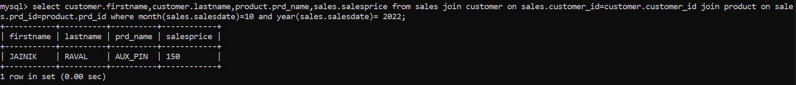

1. Return the Customer ID, FirstName, and LastName of those individuals in the Customer table who have made no Sales purchases.

Output: -

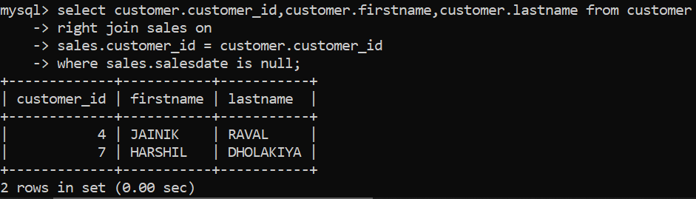

1. Return the FirstName, LastName, SalePrice, Recommended SalePrice, and the difference between the SalePrice and Recommended SalePrice for all Sales. The difference must be returned as a positive number.

Output: -



1. Add the following Customer and Sale information to the database. (using store procedure) FirstName : Mansi , LastName : Joshi, City: Mumbai , State : MH, Zip:400001 , ProductID:3 , SalePrice:205, SaleDate:05/12/2022

Output: -

1. Return the Product Category and the average Sale Price for those customers who have purchased two or more products.

Output: -

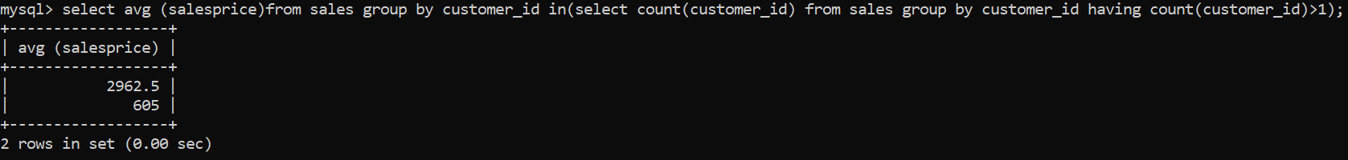

1. Update the Sale Price to the Recommended Sale Price of those Sales occurring between 6/10/2022and6/20/2022.

Output: -

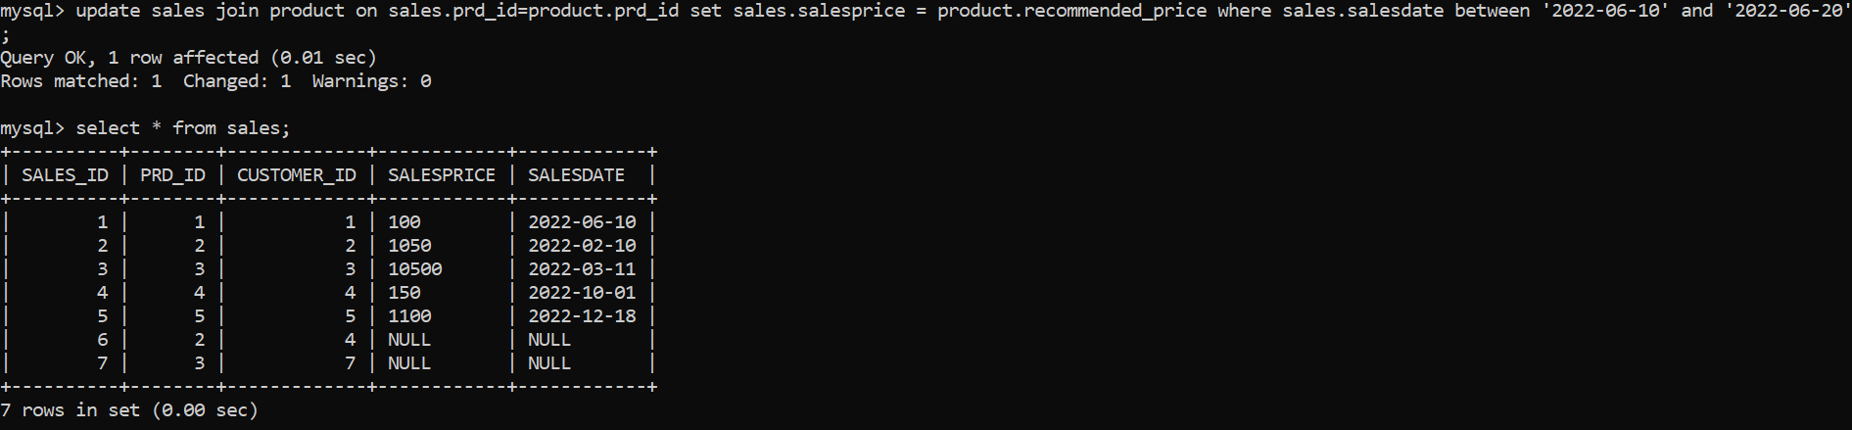

1. Number of Sales by Product Category where the average Recommended Prices 10 or more dollars greater than the average Sale Price.

Output: -

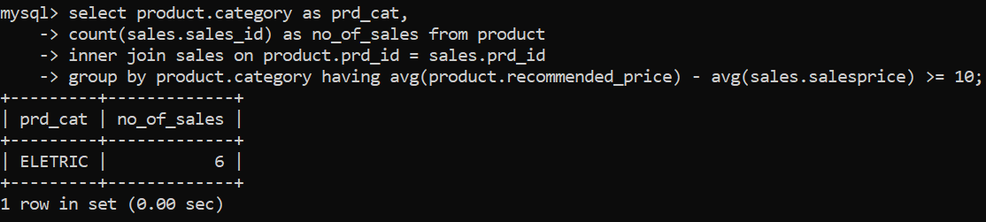

1. Largest order taken by each salesperson, date wise.

Output: -

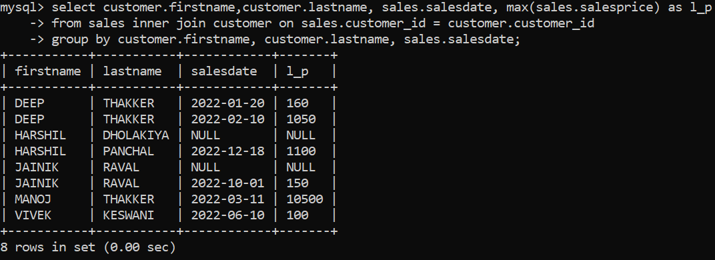

1. Without using a declared iterative construct, return Sale Date and the running total for all sales, ordered by the Sale Date in Ascending Order.

Output: -

