**Investigation**

The Current System

I have conducted an interview with the financial staff, management and the owner of Digital Funhouse asking him questions about the current system and why they want to replace it. The transcript of the interview can be found below:

**What does your current system do? (Owner)**

We currently use our paper-based system to keep track of our stock, to manage our finances and to store customer and employee details.

**How does your system track your stock? (Management)**

We make a note of how much stock we have before we open the store. After the store closes, we count how much of our stock we have sold, and then we do some calculations to find out how much stock we have remaining. If we are running low on stock, then we make deliveries to get more stock.

**How does your system manage your finances? (Finance)**

We have dedicated members of staff who keep track of our earnings and our expenses. They would store all of the information regarding our finances on paper and they would make calculations to find out how much profit we have made.

**How does your system store details of employees and customers? (Management)**

When customers make a rental purchase, they write their details on paper which we store if we need to contact them regarding their purchase. The same goes for our employees. We store their details on paper as well. A member of staff is in charge of keeping the details safe and having it available when required.

**Why are you looking to upgrade to a new system? (Owner)**

Back when our business was first established, we used the paper-based system as that was the only possible way to run our business at that time. Now other businesses use computer-based systems to operate. We stayed with the paper-based system because it was working, and we were able to do everything that we needed to do. Video games have become a popular form of home entertainment which has led to an increase in customers and a faster decrease in stock, which is not a bad thing, but it meant that we had to work a lot harder to maintain the business. I am looking for a new system so that we can work faster which would help us deal with the increased workload.

Mr Truth has said that he wants to upgrade to a new system because the current system is slow and that it is not allowing the business to deal with the increased workload due to an increase in workload because of how businesses similar to Digital Funhouse are becoming popular.

Currently, this business uses a paper-based system to track their stock, manage their finances and to store details of customers and employees. Employees have to make a note of how much stock they have before and after a day of work and they have to make deliveries when stock is running low. They also have to make calculations regarding their finances to identify their expenses and profits.

Customer and employee details are stored on paper and they are kept secure by a member of staff in charge of the information. This business would like the new system to do everything mentioned whilst making business operations more efficient.

I have also made observations of the current system myself by observing how the staff use the system on a normal day at work. From the observations, I have deduced that the current system is inefficient because the staff are not able to serve the customers fast enough and there are a lot of customers coming into the store. Customers are coming into the store quicker than the time it takes for staff to use the current system to accommodate for the customers. The management staff are also struggling with making deliveries as stock is decreasing quickly due to the surge of customers and they cannot keep track of stock and make deliveries quick enough.

Similar Systems

**Netstock**

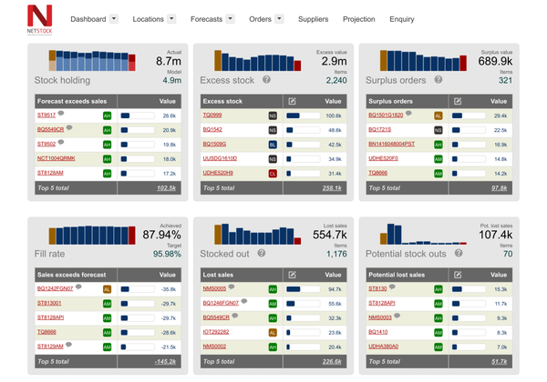

Netstock is a business inventory management system. It makes use of several features such as:

* Dashboards to have a quick overview of your stock.
* Classifying items that are valuable and sell quickly so that you can choose what to focus on.
* Forecast generation to predict how well products will sell.
* The ability to order recommended items in one click.

**Zoho Inventory**

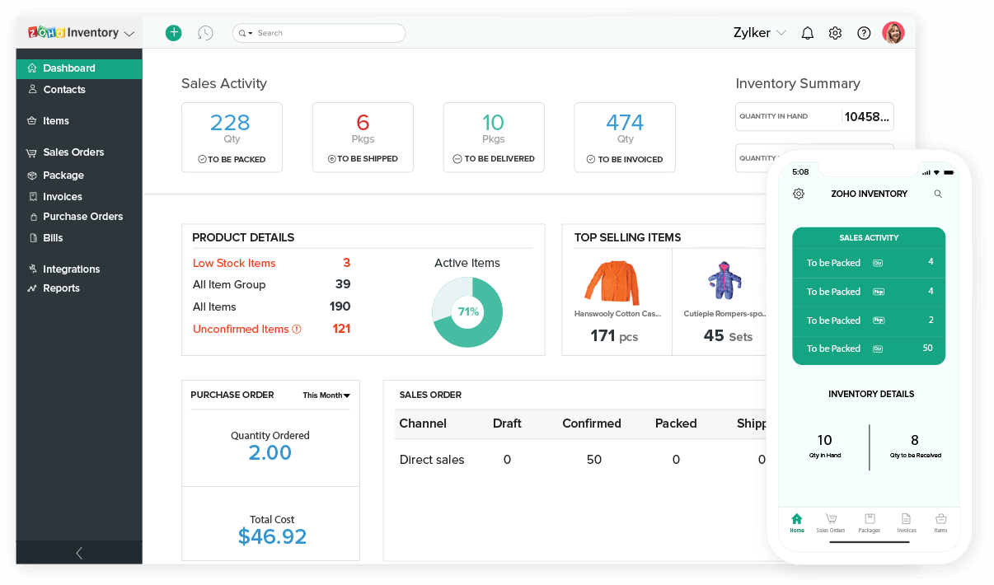

Zoho is an inventory management system that makes use of features such as:

* Item grouping and bundling
* Invoicing
* Automatic deliveries
* Finance management
* Barcode scanning
* Report generation

**EZRentOut**

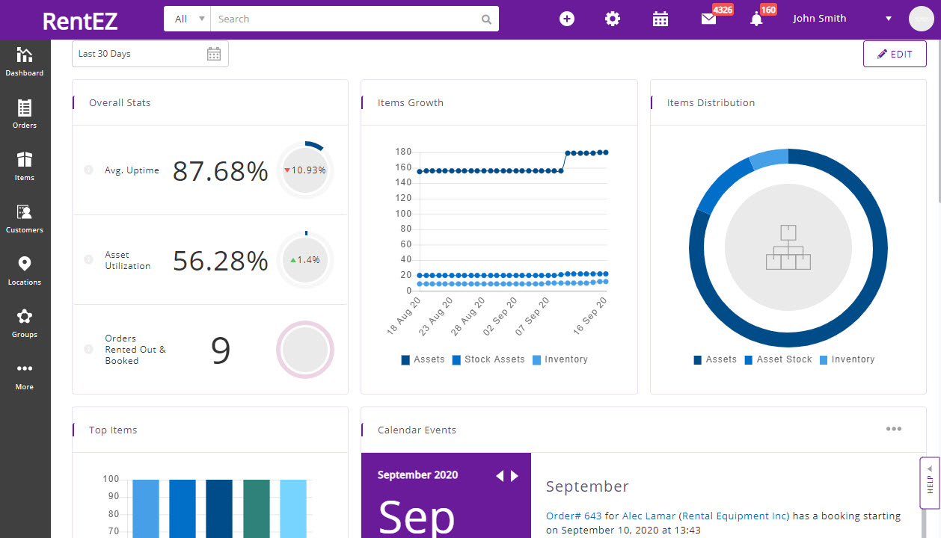

EZRentOut is an equipment rental system that has features for businesses that offer rental services such as:

* Rental price management
* Invoicing
* Customer management

**Rentware**

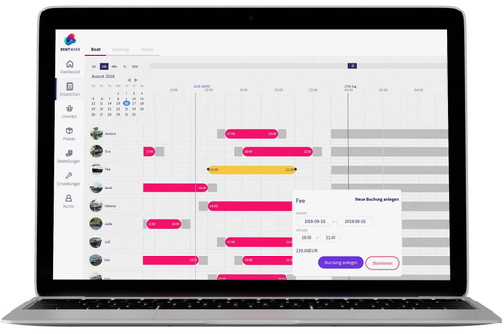

Rentware is a rental system that has features such as:

* Price management
* Inventory management
* Customer management

**Financial Force**

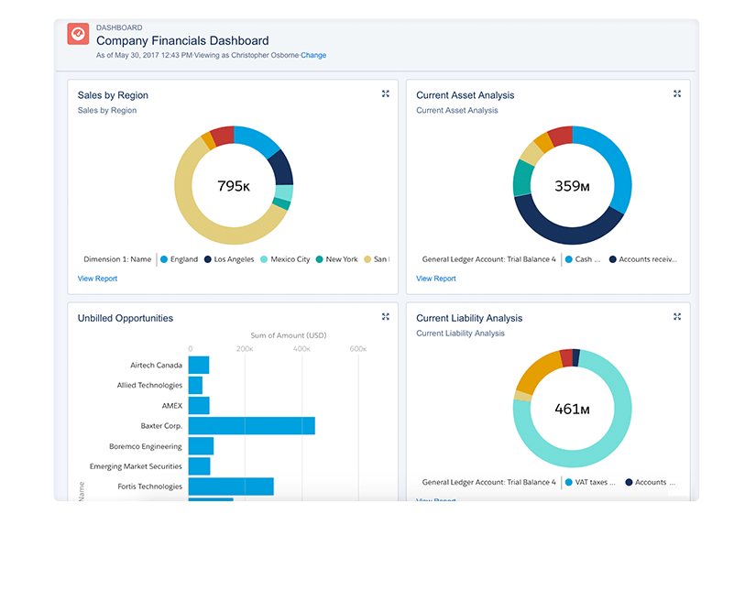

Financial Force is a finance management system that has features such as:

* Financial Reporting
* Budgeting & Forecasting
* Cash management

After researching systems that are similar to the one that I plan on creating, I have discovered that there are systems that keeps control over a business’s inventory. These systems commonly have features such as real time stock management, invoice creation, automated deliveries, report generation and integration with other programs. These systems hold information about every item in a business’ inventory. The number of stock is reduced when the item has been purchased. A receipt is generated after the transaction is complete. When the number of stock is low a delivery is made to get more stock.

After looking at systems that manages the process of renting items, I have found that these systems commonly have features such as inventory and customer management, late fee calculation and billing. Similarly, it holds information about all the items that are available to be rented and it keeps track of how many items are available. It also stores customer details which allows the customer to be contacted for their rented item.

I have looked at systems that manages finance and I have found that the most common features are managing expenses and profits as well as generating reports and calculating employee wages. These systems store details about employees and they calculate their pay based on the hours they worked and the pay rate. They also manage how much money is gained from the items sold and how much is lost due to expenses.

After looking at these systems I find that these systems have the features that will be useful for this business however, they all have a lot of unnecessary features which I do not plan on using for my system. I plan on implementing all of the features I have mentioned above including the generation of reports as I did not consider that before looking at these systems and I feel that this feature would be useful for this business.

Stakeholders

This business requires input from its customers, employees, management staff and external suppliers. Customers need to give their details so that they can be contacted. Employees need to give their details as well as the hours that they have worked so that they can be paid. Management staff needs to make orders for more stock and the suppliers need to provide this business with their stock.

With the current system, employees need to create invoices for their customers with information about their purchase and they need to keep customer details stored so that customers can be contacted. Management staff need to calculate an employee’s pay from the hours they have worked, and they need employee details to be able to create cheques. They also need to keep track of how much money they are spending and earning.

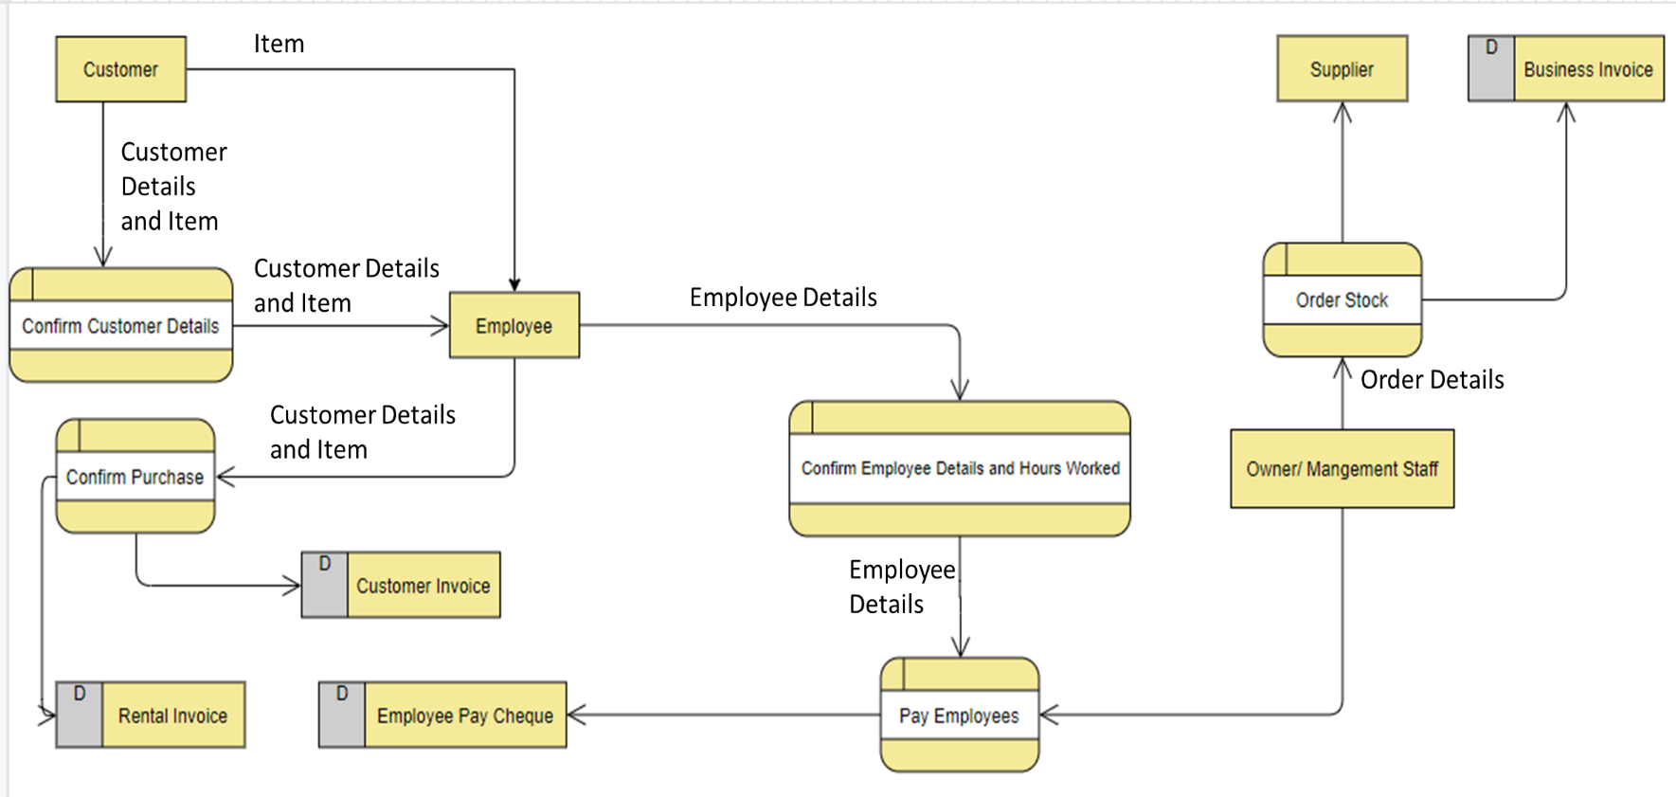Current System Functionality

**System Inputs**

* The system receives the item that the customer wants when the customer gives the item to the cashier.
* The system receives customer details and the item that the customer wants to rent when the customer gives their details and the item to the cashier.
* The system receives the number of hours a member of staff has worked when an employee makes a note of the hours they have worked.
* The system receives details about an order that the business needs to make when the business needs deliveries to be made.

**System Processes**

* The system confirms the customers details and the details are given to the cashier when the customer has inputted their details so that they can rent an item.
* The system confirms the purchase a customer has made when the cashier confirms that the customer details and that payment has been received.
* The system calculates an employee’s wage when the financial staff has the number of hours worked and the details of the employee.
* The system makes an order for more stock when the management staff gives their order details to the supplier.

**System Outputs**

* The system outputs an invoice for the customer after their purchase has been confirmed when the cashier makes an invoice for the customer.
* The system outputs a rental invoice for the customer after their rental purchase has been confirmed when the cashier makes a rental invoice for the customer.
* The system outputs an employee pay cheque when the financial staff have calculated the wage and created the pay cheque.
* The system outputs a business invoice after an order for the business has been confirmed when the supplier gives the business the invoice.

**System Limitations**

* The system cannot make orders automatically when stock is low.
* The system cannot calculate an employees’ work hours or the amount of pay automatically.
* The system cannot automatically generate invoices.

Problem Definition and Proposed Solution

I am going to create a system that will help Digital Funhouse operate more efficiently and to ease the pressure of this business and its employees. Currently, they are facing issues with an increase in demand from customers which is putting a lot of strain on the employees as they are using a paper-based system. This system is not as effective as it used to be as it now takes employees longer to perform business operations due to an increase in customers. The new system will mainly be able to manage items and stock, handle finances and deal with rental purchases more efficiently than the current system.

To create this new system, I will be using SQL. With SQL, I can create databases that will be useful for storing information such as item information, customer and staff details, and expenses. The databases created using SQL are easy to handle and there is not a lot of programming required to create these databases.

In addition to SQL, I will be using Python for this system. Python will be a necessary for this system because it is a fast and productive programming language due to its syntax being easy to understand which means you can get more work done without too much code. Python will also enable me to use SQL within its own IDE so I have a platform where SQL commands can be run. Given that the current system is slow, using Python will be a huge improvement to the productivity and efficiency of operations performed by this business.

Objectives

* Customer details can be added, edited and deleted.
* Notify customers about the remaining days on their rented item.
* Bill customers when they have not returned their item.
* Create a customer and rental invoice.
* Manage the business’ inventory.
* Manage a customer’s rental purchase.
* Make automatic deliveries when inventory is low.
* Item details can be added edited and deleted.
* Manage the finances of the business.
* Calculate an employee’s wage.
* Create reports about items and money.
* Staff details can be added, edited and deleted.
* Allow management staff to access roles of other non-management staff.
* Create business invoices.