Theoretical background

1. Depth of storage:

Sampling rate $f_{s}$– sample per second

Time base $T_{B}$– how many second per division. Shorter time base settings (faster display of the signal on the screen) typically lead to a higher sampling rate because the oscilloscope must sample more frequently to capture the waveform accurately within the shorter time frame.

$N_{x}$: number of divisions on the screen in the x axis

$N_{y}$: number of divisions on the screen in the y axis

The depth of the storage can be calculated as:

$$DST=f_{s}×TB×n_{x}$$

**Nyquist Criterion**: To avoid aliasing, the sampling rate must be at least twice the maximum frequency present in the signal. This ensures that the waveform is accurately represented without “overlapping” frequencies, which can cause distortion.

1. Resolution if the analogue to digital converter

ADC : $2^{n}=256 quantization levelsor incrment$

Hence, if the voltage sensitivity is set too low and the signal is represented by only a few divisions, only a part of the 255 increments is used to represent the signal. In this way we will loose resolution. To choose an appropriate setting of the voltage sensitivity we have to make sure that the signal uses as much of the screen as possible without being cut off by the limits of the screen.

1. Leakage effect

The frequency components in a signal is infinitive however, the windows of the machine DSO is limted so this lead to the loss of some ordinary frequency -> leakage effect

A rectangular time window leads to a significant leakage.

Other window functions with a slow rise and decay of the signal amplitude can reduce the leakage effect. An example for such a window function is the “von Hann” window which will be used in our experiment.

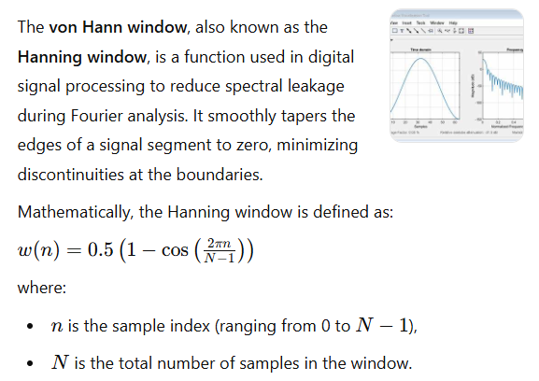

The leakage effect can be avoided when the window length is an integer multiple of the period of the signal even when a rectangular time window is used, compare fig. 1.2.

Prepare for the experiment

1. Experiment 1
   1. Purpose

To understand how depth of storage (DST) works on a DSO and

calculate it based on the DSO settings.

To observe aliasing

* 1. Steps

**Disable the Anti-Aliasing Option on the DSO**:

**Set Up a Sine Wave Signal**:

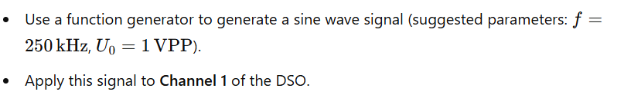

**Adjust Time Base Settings**:

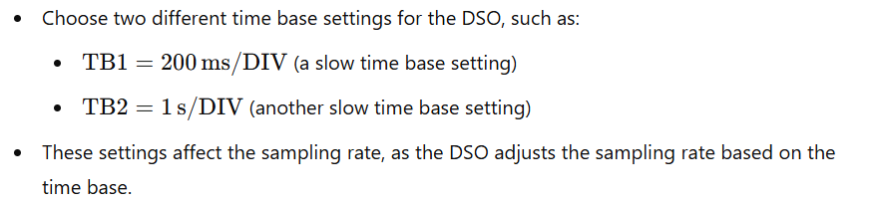

**Check the Sampling Rate on the DSO**:

* On the DSO model (Agilent DSO5014), press the “Main/Delayed” button to view the sampling rate,
* Observe how the DSO’s sampling rate changes with different time base settings.

**Calculate Depth of Storage (DST)**: 

**Consider Aliasing**:

1. Experiment 2
   1. Purpose of Experiment 2

The main goals of Experiment 2 are:

To determine the resolution of the DSO's ADC by observing how it quantizes the input signal.

To understand how voltage settings affect ADC resolution, particularly how different settings can either improve or reduce the ability to accurately represent the signal.

* 1. Steps Involved in Experiment 2

**Set Up a Low-Amplitude Sine Wave Signal**:

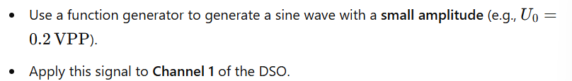

Choose Appropriate Time Base Setting: - no aliasing

**Use Two Different Voltage Settings**:

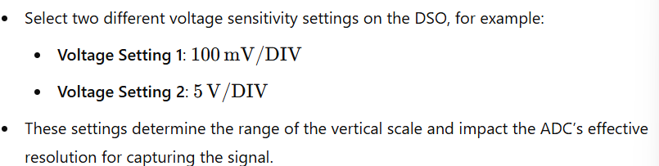

Calculate the ADC Resolution:

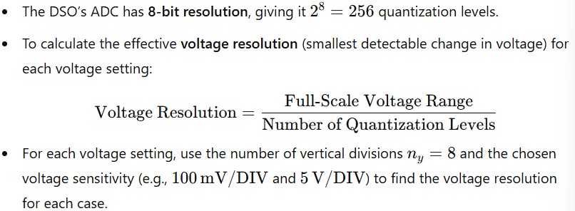

1. Experiment 3
   1. Purpose of Experiment 3

The main goals of Experiment 3 are:

To determine the frequency resolution of the FFT and observe how different time base settings affect it.

To study the leakage effect when analyzing a sine wave and learn how using a von Hann window can reduce this effect for clearer frequency analysis.

* 1. Steps Involved in Experiment 3

Part A: Determining Frequency Resolution Without Leakage

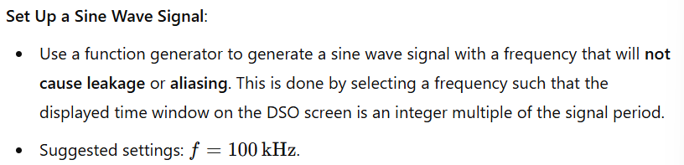

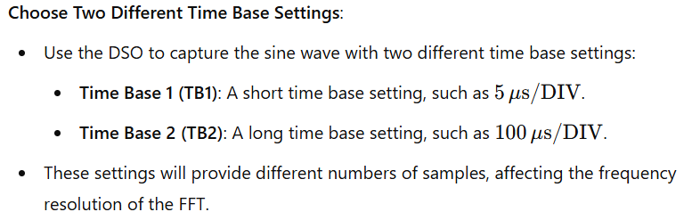

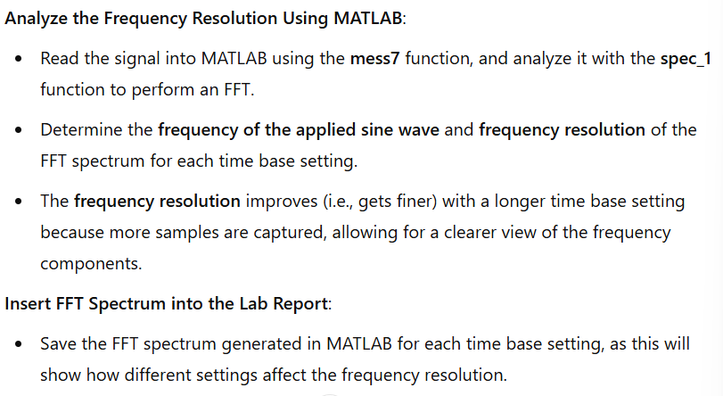

Part B: Studying the Influence of the von Hann Window

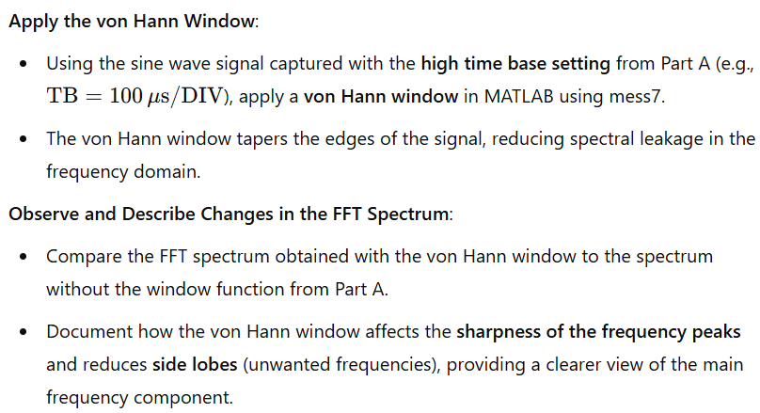

1. Experiment 4

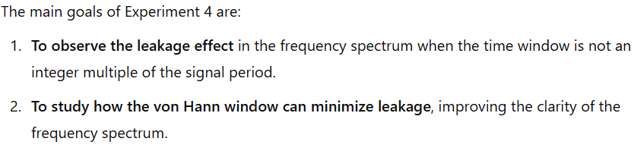

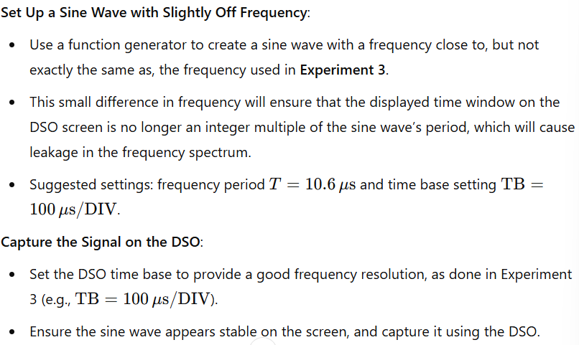

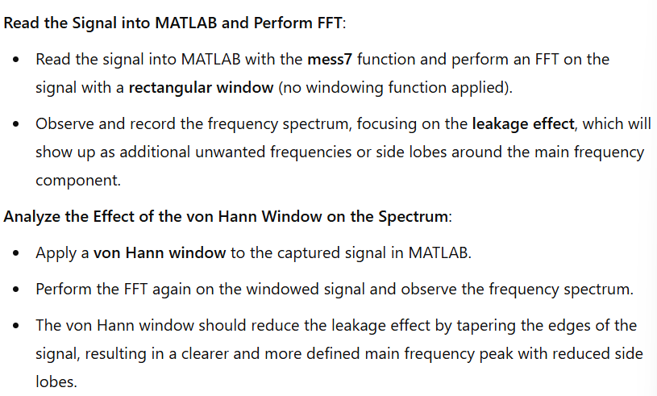

1. Experiment 5

