Computer Aided Lab A

Name of Student:

Le Hoang Khang

Nguyen Phuong Tu Anh

Mentor:

10.30. – 11.20.2024

Contents

1 Introduction 3

2 Theoritical part 3

2.1 RC low pass filter 3

2.2 Charging and Discharging of Capacitor 3

2.3 Operational amplifier 3

2.3.1 History 3

2.3.2 Inverting operational amplifier 3

2.3.3 Integrating operational amplifier 3

2.3.4 Derivating opeartional ampliefier 3

2.3.5 Adding operational amplifier 3

3 Experiment 3

3.1 Measurement of exp 1 3

3.1.1 Description of experiment 3

3.1.2 Results – diagram, table, graphics 3

3.1.3 Discussion of results 3

3.2 Measurement of exp 1 3

3.2.1 Description of experiment 3

3.2.2 Results – diagram, table, graphics 3

3.2.3 Discussion of results 3

3.3 Measurement of exp 3 3

3.3.1 Description of experiment 3

3.3.2 Results – diagram, table, graphics 3

3.3.3 3.1.3. Discussion of results 3

4 Summary and Outlook 4

5 References 4

# Introduction

# Theoritical part

## RC low pass filter

## Charging and Discharging of Capacitor

## Operational amplifier

### History

### Inverting operational amplifier

### Integrating operational amplifier

### Derivating opeartional ampliefier

### Adding operational amplifier

# Experiment

## Measurement of exp 1

### Description of experiment

In this exercise, the fundamental frequency response of an RC low pass filter circuit is analyzed. A low pass filter circuit, consisting of a resistor () and a capacitor (), is constructed and connected to a wave generator and a digital storage oscilloscope (DSO) as shown in the figure below.

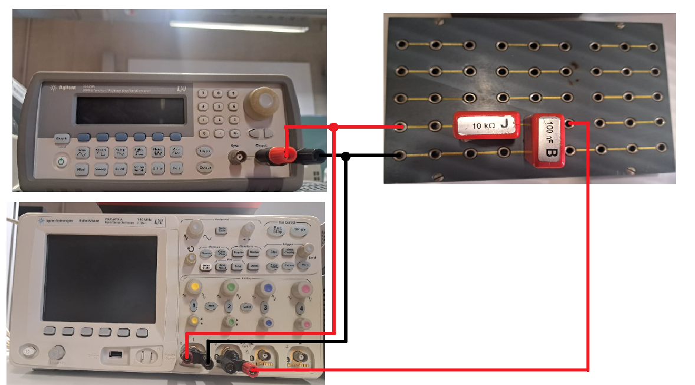

Figure 1 Exercise 1 set up

The wave generator serves as the source, providing varying frequencies and wave types for the exercise, while the oscilloscope captures both the input and output waveforms of the system. Channel 1 of the oscilloscope is connected to both the input of the wave generator and the input of the RC circuit, and Channel 2 is connected to the output of the RC circuit. All grounds for the wave generator, oscilloscope, and RC filter are connected together.

A sine wave input of varying frequency is applied, starting at a low frequency with a peak-to-peak amplitude of 10 V. The frequency is then adjusted to achieve specific amplitude ratios (A) between the input and output, with target ratios of 1, 0.9, 0.8, 0.7, 0.6, 0.5, 0.3, 0.2, and 0.1. The ratio A value is obtained by:

Where is peak to peak voltage of the input wave and is the peak-to-peak voltage of the output wave. Additionally, the phase shift between the input and output signals is measured by DSO tool.

The objective is to observe how the amplitude ratio and phase shift vary as the frequency increases, continuing measurements until the amplitude ratio reaches the specified thresholds. The data is then plotted to illustrate the amplitude ratio and phase shift as functions of frequency. From these plots, the circuit's cut-off frequency—where the output amplitude falls to approximately 70.7% of the input—is determined and compared with the theoretical value. The phase shift at this cut-off frequency is also recorded.

### Results – diagram, table, graphics

### 3.1.3. Discussion of results

## Measurement of exp 1

### Description of experiment

#### Exercise 2 part a

In this lab, the lab aims to analyze the step response of RC circuit. The response of a positive square wave signal input is considered in this experiment. This exercise used the previous set up with the change of the wave generator instead of sine wave, now the square wave is applied. The square wave has an amplitude and a frequency significantly below the circuit’s cut-off frequency (). This ensures that the charging and discharging behavior of the capacitor is clearly observable [2]. Using a digital storage oscilloscope (DSO), the input and output signals are recorded, focusing on the rising and falling edges of the output waveform. The time constant () is determined by measuring the time taken for the output voltage in each case falling edge and rising edge.

For falling edge, the capacitor is in discharging mode. The input voltage equal to zero (, the output of the capacitor is given by:

Where is the initial voltage of the capacitor, is the time constant. For , . So, for the falling edge the time between the initial voltage and its 36,8% is the time constant of the discharging mode the RC circuit.

For the rising edge, the capacitor is in charging mode. The input voltage equal to , where is the supply voltage for a fully charged capacitor. The output voltage is given by:

Where is the initial voltage of the capacitor, is the time constant. For , . So, for the rising edge the time between the supply voltage and its 63,2% is the time constant of the charging mode the RC circuit.

These measured values are compared with the theoretical time constant to validate the circuit's behavior. The output signal is expected to show a smoothed, delayed version of the square wave, illustrating the RC filter’s smoothing effect and providing insights into its transient response characteristics.

#### Exercise 2-part b

In Exercise 2 Part b, the step response of the RC low pass filter is re-examined, but this time the input is a positive square wave with a significantly higher frequency compared to the cut-off frequency of the circuit and same amplitude to the previous wave. This setup highlights the behavior of the filter when it is subjected to rapid signal changes. At such high frequencies, the capacitor in the RC circuit does not have sufficient time to fully charge or discharge during each cycle of the square wave.

For further examination of the circuit in Exercise 2 Part b, the positions of the resistor and capacitor are swapped as recommended by the supervisor to gain deeper insights into the behavior of the RC circuit and its interaction with the operational amplifier. In this configuration, the circuit operates as a high-pass filter, emphasizing high-frequency components while attenuating low-frequency signals. In addition to using a high-frequency positive square wave, different waveforms such as sine and triangular waves are also applied to analyze the circuit’s response to various input signal types.

### Results – diagram, table, graphics

### Discussion of results

## Measurement of exp 3

### Description of experiment

#### Exercise 3 part a

In the exercise 3-part a, the lab aim to analyzing the frequency response of an inverting operational amplifier circuit. Initially, an amplifier circuit is set up as Firgure ,,, with resistor .

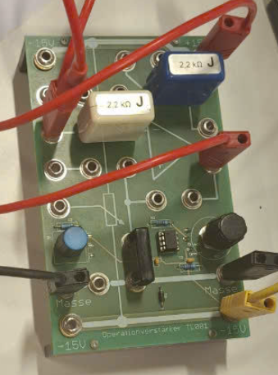 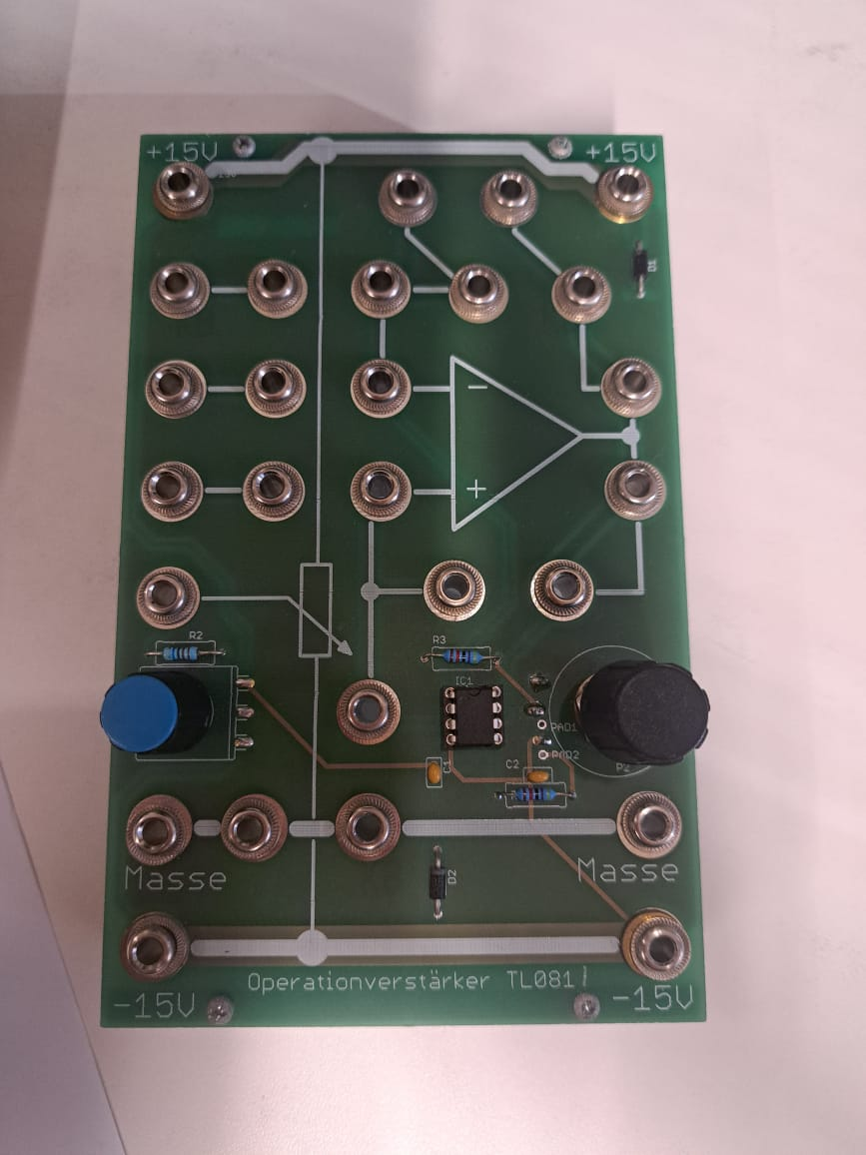

Figure 2 a) the lab set up for the amplifier circuit b) initial amplifier circuit

To creates a dual power supply with both positive and negative output voltages, a programmable power supply (PG) is used. This setup involves connecting the negative terminal of Channel 1 to the positive terminal of Channel 2, effectively creating a midpoint that serves as the reference or "ground" (masse). This configuration provides a power source with a range of ±15V, or other voltage levels depending on the PG settings. The positive terminal of Channel 1 is connected to the +15V input of the amplifier circuit, supplying the positive voltage. Similarly, the negative terminal of Channel 2 is connected to the −15V input of the amplifier circuit, supplying the negative voltage. The midpoint connection between the two channels is linked to the "masse" port of the amplifier circuit to establish a common ground. The set up for the lab is shown in figure bellow.

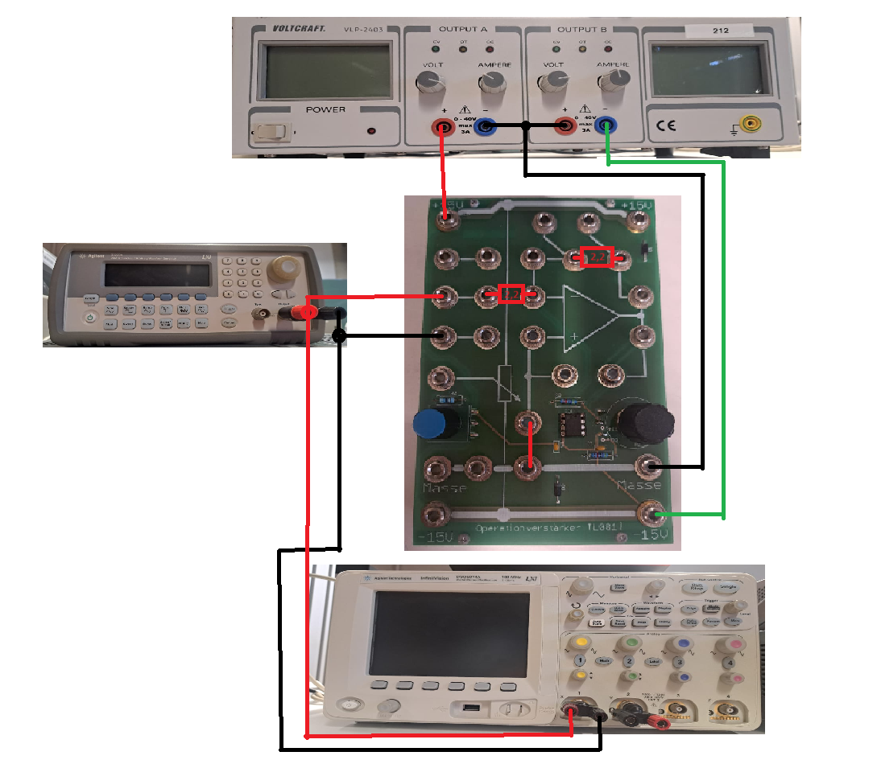

Figure 3 the lab set up

The measurement process mirrors that of Exercise 1. The wave generator provides varying frequencies and waveforms, while the oscilloscope captures input and output waveforms. Channel 1 connects to the wave generator and amplifier circuit input, and Channel 2 connects to the amplifier circuit output, with all grounds linked. A sine wave with a peak-to-peak amplitude of 10 V is applied at varying frequencies. The amplitude ratio is measured for specific values (1, 0.9, 0.8, etc.), along with the phase shift. Measurements continue until the amplitude ratio reaches the target thresholds. Results are plotted to illustrate amplitude ratio and phase shift versus frequency, determining the cut-off frequency (where amplitude is 70.7% of the input) and its corresponding phase shift, which are compared to theoretical predictions.

#### Exercise 3 part b

Repeating Exercise 3 Part a with a modification, the second resistor is replaced with instead of the original value. This change increases the gain of the inverting operational amplifier, which is determined by the ratio gain =-10.

### Results – diagram, table, graphics

### 3.1.3. Discussion of results

# Summary and Outlook

# References

1. <https://www.electronics-tutorials.ws/filter/filter_2.html>
2. EC book
3. <https://www.electronics-tutorials.ws/capacitor/cap_1.html>
4. <https://www.electronics-tutorials.ws/opamp/opamp_1.html>