Computer Aided Lab A

Name of Student:

Le Hoang Khang

Nguyen Phuong Tu Anh

Mentor:

10.30. – 11.20.2024

Contents

1 Introduction 3

2 Theoritical part 3

2.1 Depth of storage and sampling rate 3

2.1.1 Digital Storage Oscilloscope 3

2.1.2 Depth of storage 3

2.1.3 Sampling rate 3

2.2 Resolution of analogue to digital converter 3

2.3 Leakage effect 3

2.3.1 History of digital signal processing – người lập nền móng cho DSP 3

2.3.2 Frequency domain – nói về cách lấy mẫu, Nyqust, sampling rate f = 2fmax á 3

2.3.3 Fourier transform – Fast Fourier Transform 3

2.3.4 Leakage effect 3

3 Experiment 3

3.1 Measurement of exp 1 3

3.1.1 Description of experiment 3

3.1.2 Results – diagram, table, graphics 4

3.1.3 3.1.3. Discussion of results 4

3.2 Measurement of exp 1 4

3.2.1 Description of experiment 4

3.2.2 Results – diagram, table, graphics 5

3.2.3 Discussion of results 5

3.3 Measurement of exp 3 5

3.3.1 Description of experiment 5

3.3.2 Results – diagram, table, graphics 8

3.3.3 3.1.3. Discussion of results 8

4 Summary and Outlook 8

5 References 8

# Introduction

Digital Storage Oscilloscopes are widely used to measure voltage signals. For the correct interpretation of the results, it is important to be aware of their properties and possible errors that can occur when the DSO is not used properly. In this experiment you will verify some important properties of the DSO using digital signal processing techniques.

Phát triển ý này lên, giới thiệu về các thuật ngữ SP cũng như tầm quan trọng của DSP, DSO,

ứng dụng của chúng trong đời thường và

mục tiêu của project/ lab này là gì

# Theoritical part

## Digital Storage Oscilloscope

### Digital Storage Oscilloscope

<https://en.wikipedia.org/wiki/Oscilloscope>

Giới thiệu về oscilloscope

Công dụng của Osciloscope

Tầm quan trọng của oscilloscope

Chapter 1. fourier transform and oscilloscope – oscilloscope book

Resolution of analogue to digital converter

### Depth of storage

Dùng troong file của thầy á, em tìm ko thấy tài liệu

Này chắc định nghỉa + công thức và các thành phần liên quan tới nó.

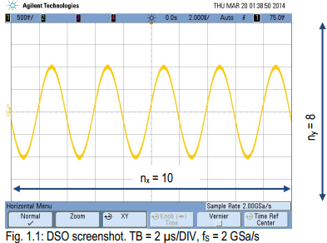

Cho hình này vào lun nha chị

## Foiurier transform

### Fourier transform – Fast Fourier Transform

#### Fourier transfrom – công thức

<https://en.wikipedia.org/wiki/Fourier_transform>

<https://lpsa.swarthmore.edu/Fourier/Xforms/FXformIntro.html>

Định nghĩa

công thức

công dụng

Từ Introduction => Fourier transform (chị soạn bên máy chị rồi, giờ chị soạn tiếp từ chỗ này nhe)

#### Wave form

Ở đây mình giới thiệu về sine wave và square wave  
<https://ccrma.stanford.edu/~jos/st/Sinusoids.html>

A **square wave** is a [non-sinusoidal periodic waveform](https://en.wikipedia.org/wiki/Non-sinusoidal_waveform) in which the amplitude alternates at a steady [frequency](https://en.wikipedia.org/wiki/Frequency) between fixed minimum and maximum values, with the same duration at minimum and maximum. In an ideal square wave, the transitions between minimum and maximum are instantaneous.

The square wave is a special case of a [pulse wave](https://en.wikipedia.org/wiki/Pulse_wave) which allows arbitrary durations at minimum and maximum amplitudes. The ratio of the high period to the total period of a pulse wave is called the [duty cycle](https://en.wikipedia.org/wiki/Duty_cycle). A true square wave has a 50% duty cycle (equal high and low periods).

Square waves are often encountered in [electronics](https://en.wikipedia.org/wiki/Electronics) and [signal processing](https://en.wikipedia.org/wiki/Signal_processing), particularly [digital electronics](https://en.wikipedia.org/wiki/Digital_electronics) and [digital signal processing](https://en.wikipedia.org/wiki/Digital_signal_processing). Its [stochastic](https://en.wikipedia.org/wiki/Stochastic) counterpart is a [two-state trajectory](https://en.wikipedia.org/wiki/Two-state_trajectory).

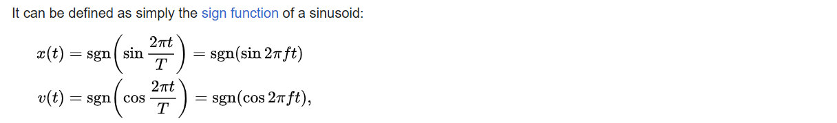

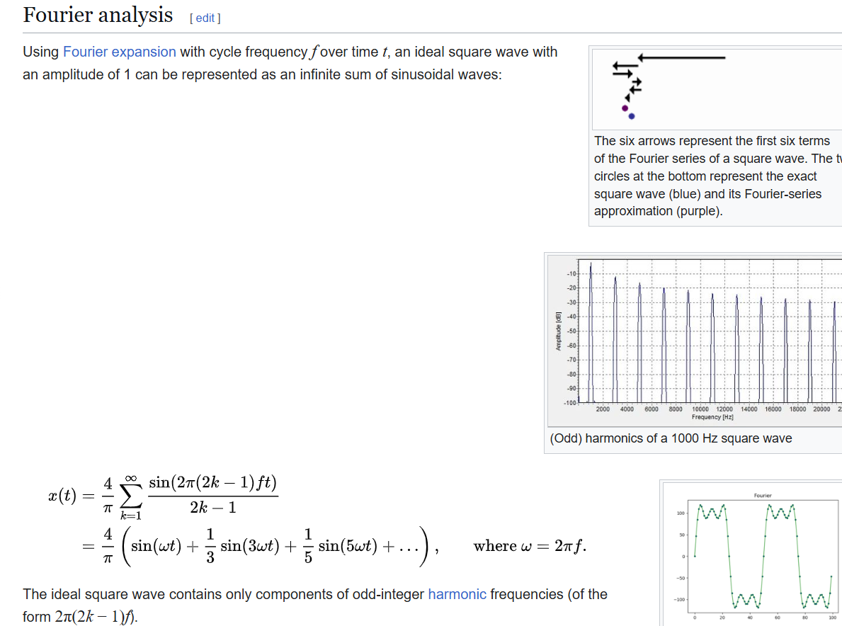

An ideal mathematical square wave changes between the high and the low state instantaneously, and without under- or over-shooting. This is impossible to achieve in physical systems, as it would require infinite bandwidth.

### Sampling rate and aliasing

Sampling rate

Định nghỉa

Công thức

Công dụng

<https://de.wikipedia.org/wiki/Nyquist-Shannon-Abtasttheorem>

<https://webdemo.inue.uni-stuttgart.de/webdemos/02_lectures/uebertragungstechnik_1/sampling_theorem/index.php?id=2>

Alias

Định nghỉa

Công thức

Công dụng

<https://de.wikipedia.org/wiki/Alias-Effekt>

<https://en.wikipedia.org/wiki/Aliasing>

### Leakage effect

<https://de.wikipedia.org/wiki/Leck-Effekt>

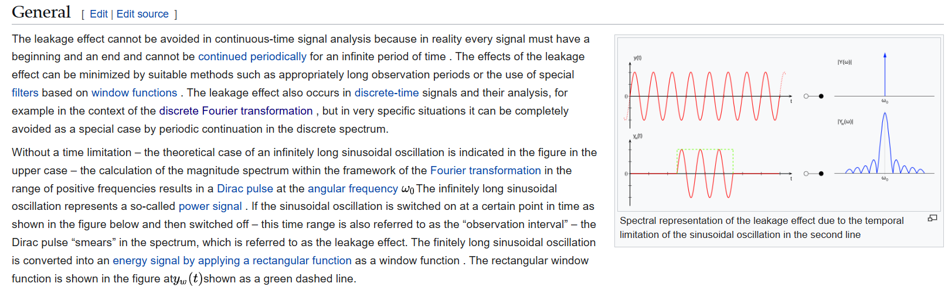

# Experiment

In this lab, MATLAB 2011a along with the Mess7 toolbox is used to analyze and store signal data in both the time and frequency domains (using the FFT method). The toolbox offers a user-friendly interface for visualizing signals and storing analysis results. The connection between the laptop and the oscilloscope has been pre-configured by the supervisor, which allows recorded signals from the oscilloscope to be directly transferred to the toolbox for analysis and displayed on the laptop screen. The analyzed results can then be saved in the designated directory, "D:\gbip," for future use. To start the toolbox, select “mess7” from the laptop’s start menu.

## Measurement of exp 1

### Description of experiment

Finding the digital storage oscilloscope's (DSO) depth storage (DST) is the main goal of this investigation. The experiment also demonstrates the phenomenon of aliasing under specific scenarios. First, the DSO's anti-aliasing feature must be turned off before the experiment can begin. To accomplish this, go to the "Utility/Options/Preferences/Anti-aliasing" directory and make sure the appropriate box is not ticked. There are two primary observations in the experiment, and they both use the same wavelength (400 kHz) at which the aliasing effect first appears. A generator provides a signal with an amplitude of 1V and wavelength 400kHz. Time bases of 1s/DIV and 2s/DIV are employed to record the experiment, which will then be assessed for analysis.

### Results – diagram, table, graphics

This is the result of the experiment 1. The table notes the recorded of the lab and the figure illustrates the recorded signal.

Table 1.

|  |  |
| --- | --- |
| Number of divisions displayed on DSO screen (on horizontal/ time axis) $n_{x}$ | 10 |
| Signal frequency $f$ (function generator) | 400,13kHz |
| Signal amplitude $U_{0}$ (function generator) | 1 |
| Time base 1 of DSO $T_{B1}$ [time/DIV] | 1s |
| Sampling frequency 1, $f_{s1}$ | 400kSa/s |
| Calculated storage depth $DST_{1}$ | 4M |
| Time base 2 of DSO $T_{B2}$ [time/DIV] | 2 |
| Sampling frequency 2, $f_{s2}$ | 200kSa/s |
| Calculated storage depth $DST_{2}$ | 4M |

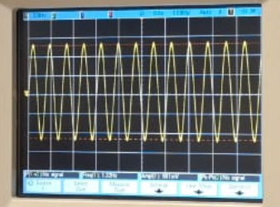

Figure 1.

### 3.1.3. Discussion of results

## Measurement of exp 1

### Description of experiment

The essence of the experiment is to investigate the impact of the step size and the quantization of the ADC or reconstructing the recorded signal. The Analog to Digital Converter (ADC) integrated in the DSO has 8-bit resolution. This means that the voltage range represented on Y axis of the DSO is divided into 256 equal steps in granularity. In order to eliminate the chances of obtaining the aliasing effects and conduct the experiment, a small amplitude signal of 0.2Vpp at a frequency of 100kHz was inputted into the circuit. Two different settings on the y-axis (100mV/DIV and 5V/DIV) were applied to the recorded phenomena for the purpose of the investigation. In order to increase the clarity of the signal the screen was freezing by clicking the run and stop button and later the voltage of the DSO was changed in such a way as to increase the inferred signal so that step changes in the output voltage occurred. Later on, the stored signal was retrieved from mess7 toolbox for further processing.

.

### Results – diagram, table, graphics

This is the result of the experiment 2. The table notes the recorded of the lab and the figure illustrates the recorded signal.

Table 2

|  |  |
| --- | --- |
| Signal amplitude $U_{0}$ (function generator) | 0.2 |
| Number of increments of the 8-bit ADC | 256 |
| Number of division on the DSO screen (on vertical/voltage axis) $n_{y}$ | 8 |
| Voltage setting 1 of the DSO | 100mV/DIV |
| Calculated voltage resolution 1 | 0.003125V |
| Voltage setting 2 of the DSO | 5 |
| Calculated voltage resolution 2 | 0.156V |

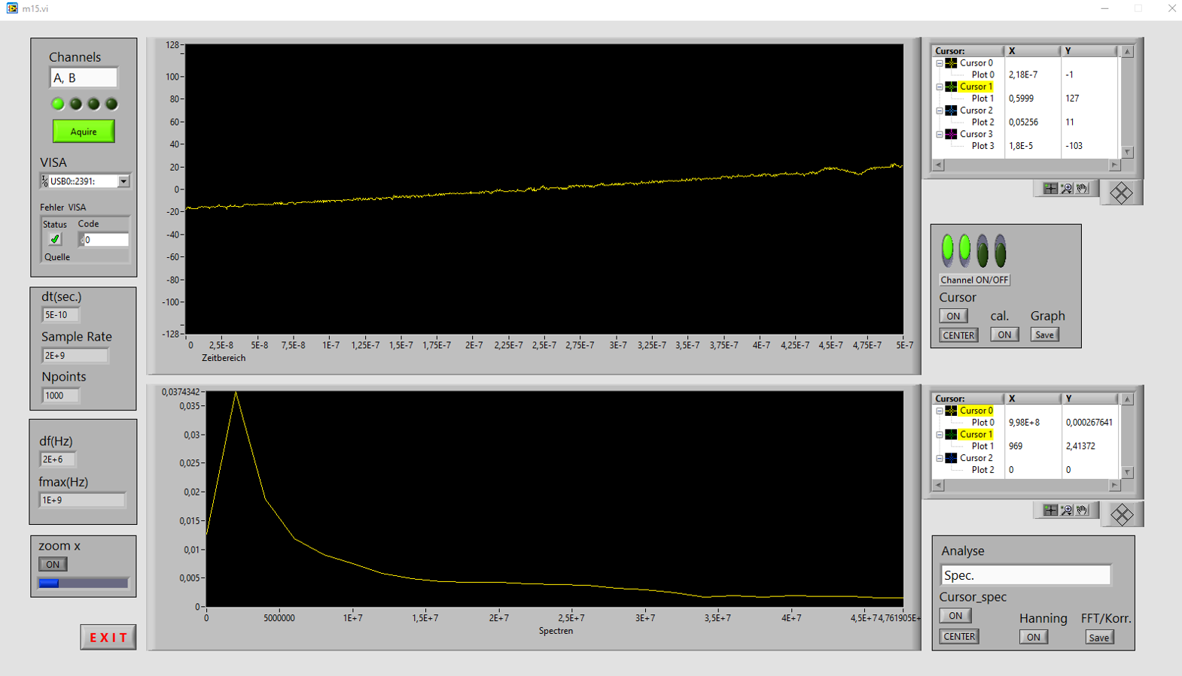

a)

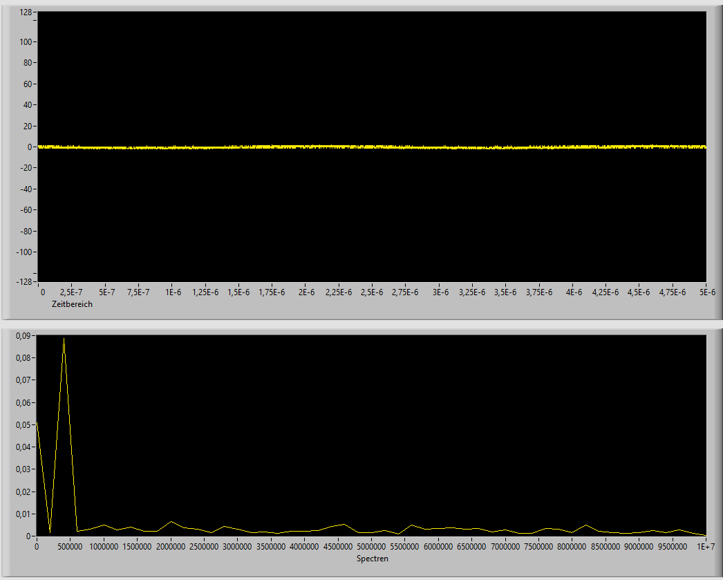

b)

Figure 2

### Discussion of results

## Measurement of exp 3

### Description of experiment

#### Exercise 3 part a

#### Exercise 3 part b

### Results – diagram, table, graphics

### 3.1.3. Discussion of results

# Summary and Outlook

# References