Computer Aided Lab A

Name of Student:

Le Hoang Khang

Nguyen Phuong Tu Anh

Mentor:

10.30. – 11.20.2024

Contents

1 Introduction 3

2 Theoritical part 3

2.1 Depth of storage and sampling rate 3

2.1.1 Digital Storage Oscilloscope 3

2.1.2 Depth of storage 3

2.1.3 Sampling rate 3

2.2 Resolution of analogue to digital converter 3

2.3 Leakage effect 3

2.3.1 History of digital signal processing – người lập nền móng cho DSP 3

2.3.2 Frequency domain – nói về cách lấy mẫu, Nyqust, sampling rate f = 2fmax á 3

2.3.3 Fourier transform – Fast Fourier Transform 3

2.3.4 Leakage effect 3

3 Experiment 3

3.1 Measurement of exp 1 3

3.1.1 Description of experiment 3

3.1.2 Results – diagram, table, graphics 4

3.1.3 3.1.3. Discussion of results 4

3.2 Measurement of exp 1 4

3.2.1 Description of experiment 4

3.2.2 Results – diagram, table, graphics 5

3.2.3 Discussion of results 5

3.3 Measurement of exp 3 5

3.3.1 Description of experiment 5

3.3.2 Results – diagram, table, graphics 8

3.3.3 3.1.3. Discussion of results 8

4 Summary and Outlook 8

5 References 8

# Introduction

Introduce about the eddy current sensor, a proximity sensor.

Introduce LC resonators.

Aim of the lab: apply the working principle of eddy current sensors, get experience working with LC resonators, study the influence of different materials on the LC-circuit and apply the LC-circuit as a proximity sensor.

# Theoritical part

## Eddy current and Ferromagnetic effect

What is the eddy current

Is it important ?

Working principle when will we have this add công thức

What is ferromagnetic effect

Is it important

Working principle

## Eddy current proximity sensors

What is this sensor

What is it working principle

Nói 1 chút về công thức của LC resonator làm sao để đo được

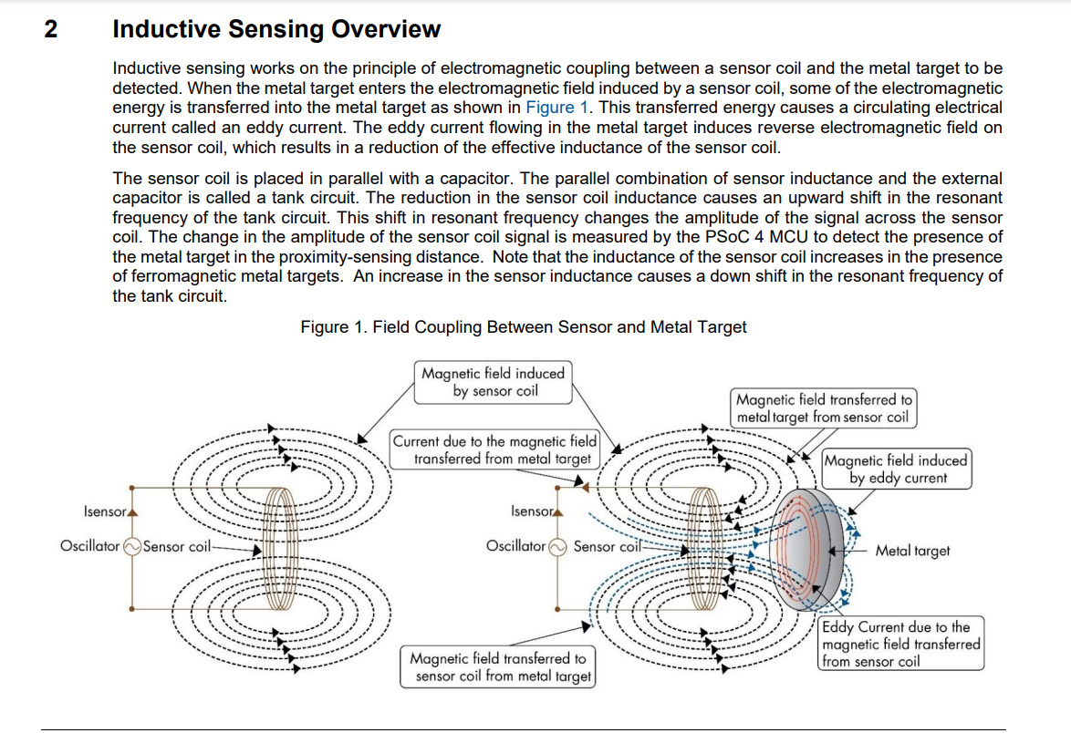

<https://www.infineon.com/dgdl/Infineon-AN219207_Inductive_Sensing_Design_Guide-ApplicationNotes-v04_00-EN.pdf?fileId=8ac78c8c7cdc391c017d0d358bd5662c>

# Experiment

## Measurement of exp 1

### Description of experiment

In this exercise, the aim is to understand the resonance behavior of an LC circuit. Furthermore, this experience collected data on the phase and voltage of the output signal to build up the resonance curve. To obtain this, first, a bandpass filter is set up, as shown in Figure 1. The output signal is connected to channel 1 of the oscilloscope for collecting and displaying the resulting signal.

Since the inductance L of the coil is fixed by the value of the coil provided, it is required to be measured with an LC-meter. The capacitance C is chosen to obtain a resonance frequency of approximately 1.5 kHz. Then, the frequency is modified for conducting the exercise until there is a resonance effect in the output signal. After that, the frequency of the input signal is adjusted to gain the amplitude relation A as 0.2Amax and 0.7 Amax. The maximum amplitude relation Amax can be calculated as:

$$A_{max}=\frac{U_{0}}{U_{in}}$$

Where:

$U_{in}$: supply voltage (input voltage) from wave generator.

$U_{0}$: output voltage ay resonance frequency.

​

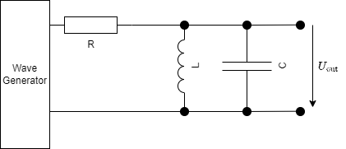

Figure 1

.

### Results – diagram, table, graphics

### 3.1.3. Discussion of results

## Measurement of exp 1

### Description of experiment

This exercise is designed to investigate the influence of plates positioned in proximity to a coil. The setup from Exercise 1 will be utilized for this purpose. Initially, the coil will be adjusted to a position where it is in direct contact with the plate, resulting in a zero distance between them. The experiment will commence with the input voltage set to 10 Vpp and a resonance frequency established at 1.64 kHz.

Subsequently, each plate will be placed in front of the coil to facilitate the measurement of the coil's behavior and the output signal of the bandpass filter. For each plate, the frequency of the input signal will be fine-tuned to attain the resonance effect in the output signal. The new resonance frequency will be documented and utilized for calculating the relative change in the resonant frequency associated with each plate.

$$Δf_{res,rel}=\frac{f_{res}^{*}-f_{res}}{f_{res}}$$

Where:

$f_{res}^{*}$: new resonant frequency (Hz)

$f_{res}$: old/initial resonant frequency (Hz).

To enhance understanding, a new initial resonant frequency is selected. The capacitance is adjusted to achieve the initial frequency of 10 kHz, and this process is repeated once more for each plate.

.

### Results – diagram, table, graphics

### Discussion of results

## Measurement of exp 3

### Description of experiment

#### Exercise 3 part a

#### Exercise 3 part b

### Results – diagram, table, graphics

### 3.1.3. Discussion of results

# Summary and Outlook

# References