- Definition and Overview

o Basic definition of a fuel cell [1]

Fuel cell is a type of storage energy transformation device. Containing 2 electrodes, 1 is anode and 1 is cathode, as in figure 1. 2 electrodes are separated by a membrane – which is called electrolyte for transferring ion, which processes to create electricity [1].

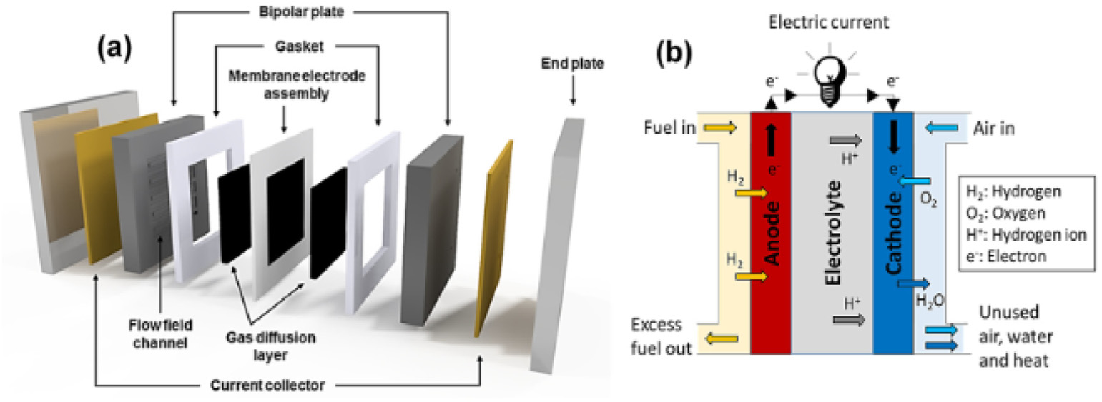

Figure 1. (a) Polymer electrolyte membrane fuel cell (PEMFC) main components and (b) the membrane electrode assembly schematic diagram (MEA) [4].

o Central chemistry of fuel cells

Based on the type of fuel cells, the fuel can be different but in conclusion, every fuel cell is based on the chemical reaction such as it created energy. The fuel is in ion or in stored energy mode, the substance in exciting state and then got pumping into the cell. Inside the cell, there is a membrane to separate the electrode and only let the ion to pass through the thin layer [2, 3].

For example: the hydrogen fuel cell, here is its central chemistry:

o Fuel cell performance

Table 1. Major type of fuel cell [4].

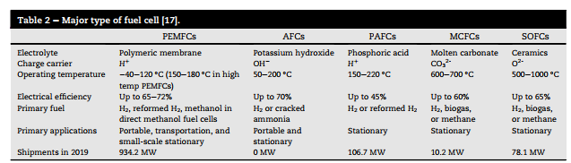

This is related to the type of fuel cell, we are focused in. In [4], there are 5 type of fuel cells mentioned. But in this project, the aim is to research about the hydrogen fuel cell so the first 3 types of cells are chosen. Relate to the table from [4], the performance of hydrogen cells is ranged from 45 to 72%. The highest and most reliable performance belongs to AFCs.

o Overview of types of fuel cells

There are some types of fuel cells in [1,5], mostly this project focuses on the hydrogen fuel cell. Based on the chemical substances and kind of membrane used as fuel, we can divide FC into several types:

1. Polymer electrolyte membrane fuel cells (PEMFCs)

PMEFCs also known as Proton Exchange Membrane Fuel Cell, converts hydrogen and oxygen into electricity and water as the product. This fuel cell operates at relative low temperature, high density power. However, there are some disadvantages this type of fuel cell has to face is high cost of platinum catalyst, membrane durability, hydrogen storage.

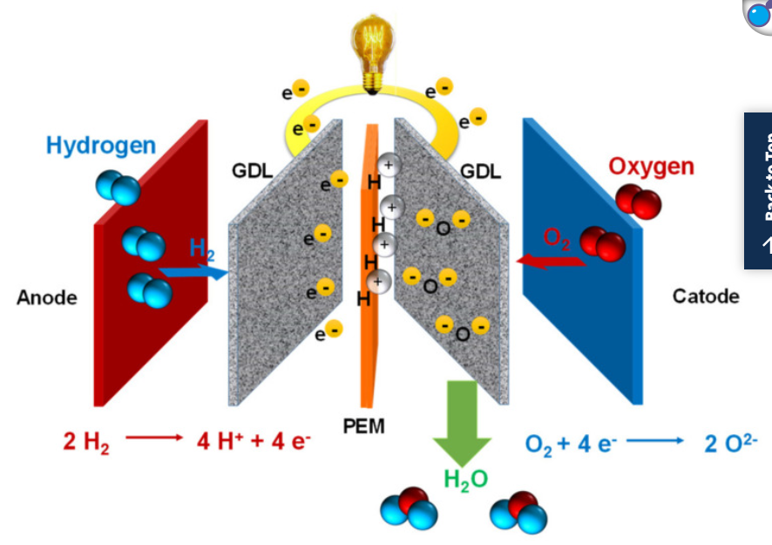[6]

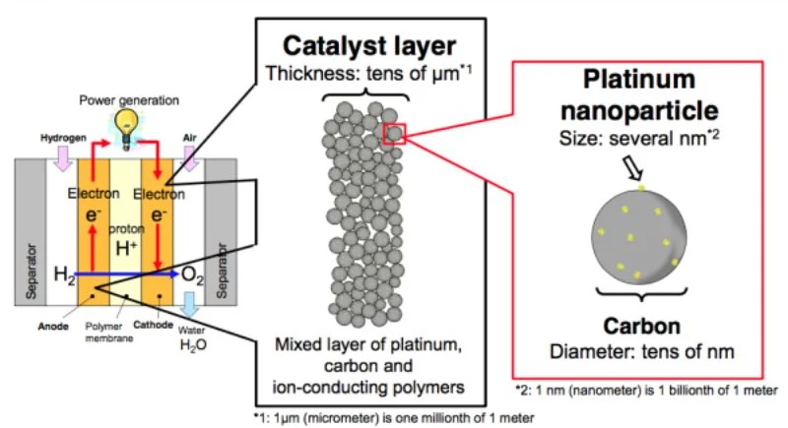[7]

1. Direct methanol fuel cells (DMFCs)

Direct methanol fuel cell converts hydrogen and oxygen directly into elec, water, carbon dioxide. It operates at low temperature from 70 to 90 degree. It using liquid fuel which make the storing process easy. However, the efficiency is effect by methanol crossover and high cost of catalysts.

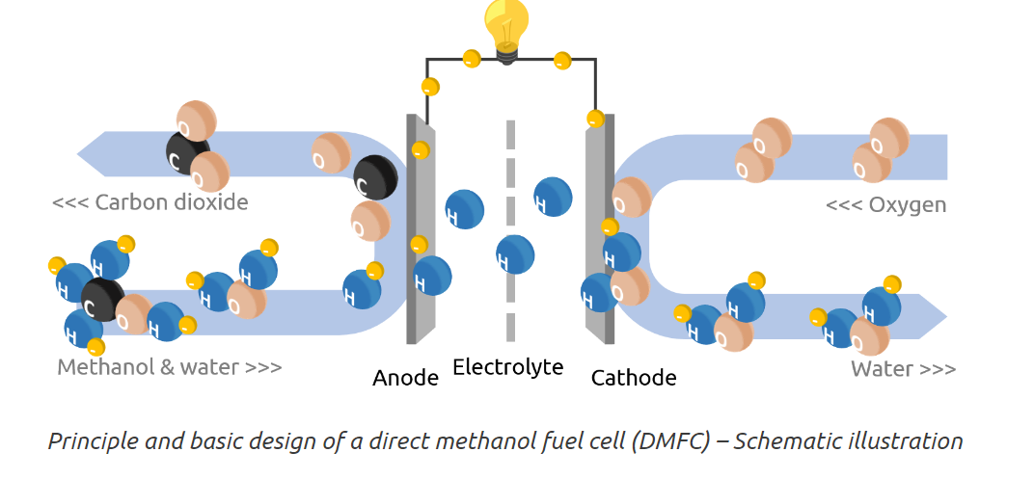[8]

1. Alkaline fuel cells (AFCs)

Alkaline Fuel Cells (AFCs) generate electricity by reacting hydrogen and oxygen through an alkaline electrolyte, such as potassium hydroxide. They have been widely used in space missions due to their high efficiency and ability to operate in low temperatures. AFCs are efficient in converting fuel to electricity but are sensitive to impurities in hydrogen, which can reduce performance. They are primarily suited for niche applications or where very pure hydrogen is available [8,9].

1. Phosphoric acid fuel cells (PAFCs)

Phosphoric Acid Fuel Cells (PAFCs) use phosphoric acid as the electrolyte and operate at around 150-200°C. They are highly tolerant of fuel impurities, making them suitable for stationary power generation and cogeneration systems. PAFCs offer moderate efficiency (about 40-50%) and produce both electricity and heat, which can be used in combined heat and power (CHP) applications. While they are more developed and commercially available compared to some other fuel cell types, PAFCs have lower power density, limiting their use in transportation

o Elements of a generic bipolar fuel cell

what is bipolar fuel cell – cathode and anode, it is made from graphite or metal and separate each individual cell. It is flat component with filigree channels that are applied to the surface of the plate. In today’s stacks, a bipolar plate consists of two individual plates (anode and cathode) that are firmly connected to one another. Hydrogen is distributed in the stack on the anode, oxygen and the end product water on the cathode [10].

To construct the bipolar cell, it is required high electrical conductivity and does not decrease significantly over the life span of the component. It is stack and between each stack is MEA – electrolyte component [11].

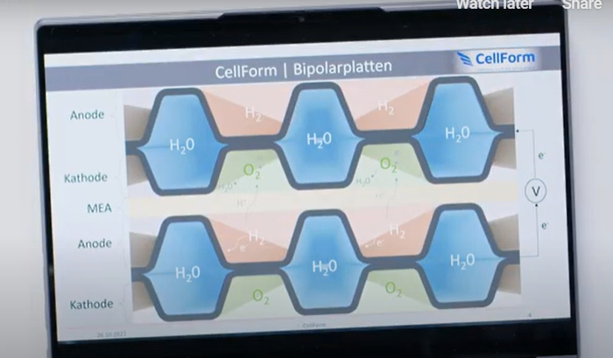[11]

o Advantages and disadvantages

Advantages of Fuel Cells:

* Clean Energy: Fuel cells emit only water and heat, reducing greenhouse gas emissions.
* High Efficiency: They are more efficient than conventional combustion engines.
* Scalability: Fuel cells can be used for a variety of applications, from small electronics to large vehicles and power plants.

Disadvantages of Fuel Cells:

* Cost: High production costs, especially for catalysts like platinum.
* Hydrogen Infrastructure: Limited availability and challenges with hydrogen production, storage, and distribution.

- PEM – Fuel Cell

o Central Chemistry

Hydrogen is split into protons and electrons at the anode. Protons move through the membrane while electrons flow through an external circuit, generating electricity. At the cathode, protons, electrons, and oxygen combine to form water.

o General Process

Hydrogen fuel and oxygen are used to generate electricity through electrochemical reactions.

o Structure/Parts/Components/Function

* Anode: Splits hydrogen into protons and electrons.
* Electrolyte (Proton Exchange Membrane): Conducts protons to the cathode.
* Cathode: Where protons, electrons, and oxygen react to form water.
* Catalyst: Typically, platinum, used to accelerate reactions.

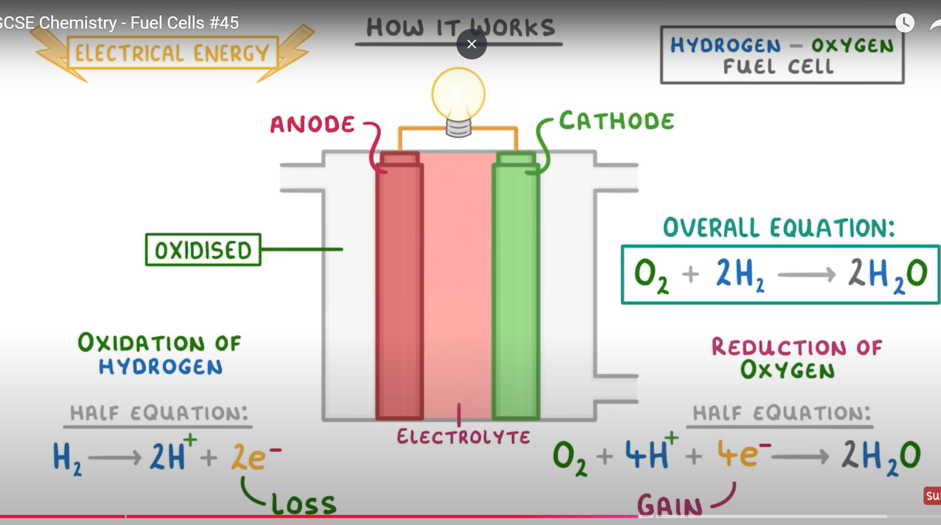[17]

- Hydrogen

o Production Methods [12,13]

* Steam Methane Reforming (SMR): Most common method, but emits CO₂.
* Electrolysis: Splits water into hydrogen and oxygen using electricity, especially clean if renewable energy is used.
* Biomass Gasification: Produces hydrogen from organic materials.
* Thermochemical Water Splitting: Using heat from solar or nuclear energy.

o Methods of Storage and Transportation [19]

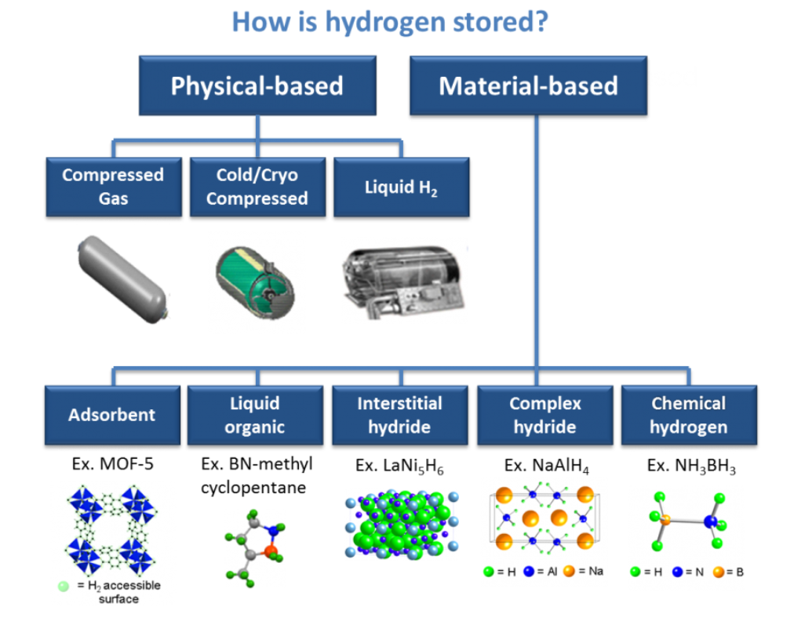

* Compressed Gas: Hydrogen is stored at high pressures in tanks.
* Liquefied Hydrogen: Hydrogen is cooled and stored as a liquid, requiring very low temperatures.
* Metal Hydrides: Hydrogen is absorbed into metals and released when needed.
* Chemical Storage: Hydrogen is stored within chemicals like ammonia and released through a reaction when needed.

Reference

1. <https://en.wikipedia.org/wiki/Fuel_cell#:~:text=February%202021),a%20pair%20of%20redox%20reactions>.
2. <https://www.energy.gov/eere/fuelcells/fuel-cell-basics#:~:text=Fuel%20cells%20work%20like%20batteries,)%E2%80%94sandwiched%20around%20an%20electrolyte>.
3. ChatGPT
4. Aminudin, M.A. et al. (2023) ‘An overview: Current progress on hydrogen fuel cell vehicles’, International Journal of Hydrogen Energy, 48(11), pp. 4371–4388. doi:10.1016/j.ijhydene.2022.10.156.
5. [Types of Fuel Cells | Department of Energy](https://www.energy.gov/eere/fuelcells/types-fuel-cells)
6. <https://pmc.ncbi.nlm.nih.gov/articles/PMC8468942/>
7. [https://eepower.com/tech-insights/unlocking-the-potential-of-platinum-free-catalysts-in-hydrogen-fuel-cells/#](https://eepower.com/tech-insights/unlocking-the-potential-of-platinum-free-catalysts-in-hydrogen-fuel-cells/)
8. <https://siqens.de/en/methanol-fuel-cell/#dmfc>
9. <https://www-sciencedirect-com.dbvista.idm.oclc.org/science/article/pii/S0360319921007965>
10. L
11. <https://hyfindr.com/en/hydrogen-knowledge/fuel-cell-bipolar-plates#:~:text=In%20today's%20stacks%2C%20a%20bipolar,product%20water%20on%20the%20cathode>.
12. <https://www.eia.gov/energyexplained/hydrogen/production-of-hydrogen.php#:~:text=Hydrogen%20can%20be%20produced%20from,hydrogen%20production%20methods%2C%20or%20pathways>.
13. <https://www.energy.gov/eere/fuelcells/hydrogen-production-processes>
14. <https://www.energy.gov/eere/fuelcells/fuel-cells#:~:text=They%20produce%20electricity%20and%20heat,is%20fed%20to%20the%20cathode>.
15. <https://www.youtube.com/watch?v=a4pXAmljdUA>
16. <https://www.youtube.com/watch?v=V3ChCroWttY>
17. <https://www.youtube.com/watch?v=8xeB_O_fyzM>
18. <https://www.energy.gov/eere/fuelcells/hydrogen-storage>
19. <https://www.rolandberger.com/publications/publication_pdf/roland_berger_hydrogen_transport.pdf>