Thesis “........... “

Project A

Name of Student: Le Hoang Khang

Mentor: Margarita Aleksandrova

10.30. – 11.20.2024

Please use by the discussions unpersonal tense ( “We” or “I” or “you” …are not acceptable for scientific reports)

Contents

- Introduction / Motivation......................................................................................................................1
- Theoretical part ...................................................................................................................................2
  - analytical methods.......................................................................................................................3
    - Photometry ( zum Beispeil) .............................................................................................3
Description of basic principle, used divase, general information dadsa
    - Infrared spectroscopy ( Zum Beispiel) ............................................................................4
  - analytical ( chemical) procedures...............................................................................................5
    - preparation of standart solution .......................................................................................5
    - chemical methods............................................................................................................5
- Experimental........................................................................................................................................6
  - Measurement of ..........................................................................................................................7
    - Description of experiment................................................................................................8
    - Results – diagram, table, graphics.................................................................................10
    - Discussion of results (data analysis)..............................................................................13
- Summary and Outlook.......................................................................................................................15
- References........................................................................................................................................16

- Introduction
The aim of this experiment was to .....

- Theoretical Part
2.1. Analytical methods
2.1.1. Photometry
When a beam of light is transmitted through a coloured solution, then this beam loses its intensity, in other words a part of the light is absorbed by the solution. Depending on the substance in question, this absorption occurs at a specific wavelength [1].
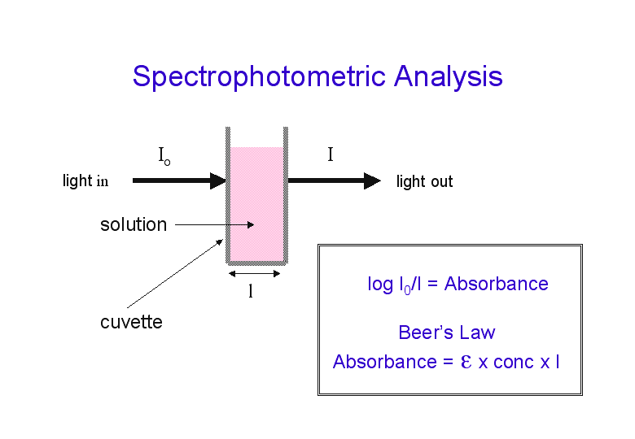
Fig.1: Basic principle of Photometry [2]

2.2. Chemical procedures
2.2.1 Preparation of standard solution
For the experiment, the standard sample solutions were prepared from a master standard solution which had a ion concentration of 1000mg/L. The concentrations of sample solutions ranged around the expected ion concentration. The volume of the master standard solution was determined using the following formula:
V_{st}.C_{st} =V_{sol}.C_{sol}

Where,
Cst: Concentration of the master standard solution mg/L
Vst: Volume of the master standard solution mg/L
Csol: Concentration of the standard sample solution mg/L
Vsol: Volume of the standard sample solution mg/L

Using formula (3), the required volumes of the master standard solution were determined as follows (table 1.)

Table 1: Preparation of standard solutions for calibration curve

Solution | Concentration, ppm | V_{Solution}, μl | V_{Water}, ml
1 | 10 | 5 | 10
2 | 100 | 50 | 1

- Experimental

3.1. Calibration curve of F⁻ in the range 10-100 ppm
The ion activity is interpolated by means of a calibration curve. The calibration curve is established with standard solutions. The expected ion activity of the sample should be within the range of the calibration curve. This curve is plotted as the electromotive force in milivolts versus the logarithm of the concentration in mg/l or mol/l. Measurements are therefore executed at fixed ionic strength. The ionic strength is fixed with a TISAB solution (Total Ionic Strength Adjustment Buffer).

3.1.2. Results
The calibration curve of nitrate measurement in the range 10-100 ppm is shown in Fig. 1
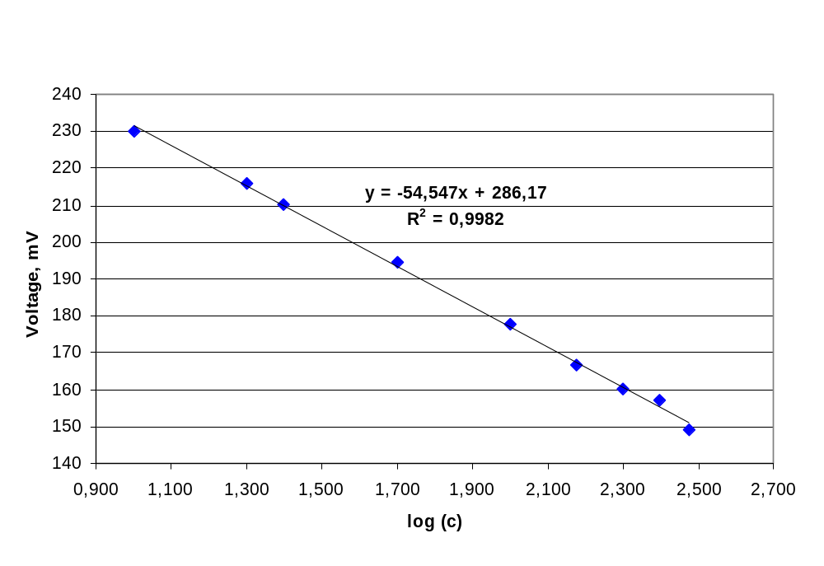
Fig.1: Calibration curve of nitrate measurement in the range 10 -100 ppm

From the graph above, it could be seen that.....

5. Conclusion

To determine the concentration of fluoride, Ion Selective Electrode Technique method was used. The accuracy of fluoride ISE in the range of tap water was discussed in the experiment.

From the 1st experiment, it was clear that .......

From the 2nd experiment, it could be said that.......

The 3rd experiment indicated that as the concentration of F⁻ remained at 1mg/l, selectivity of F⁻ dominated over the interfering effect of in varied concentrations from 5-60mg/l, but at higher concentration of (above 100mg/l), the voltage went down and it started to vary and gave different results for a particular value of . It was showed in the results of SC calculation as well: SC value of 20mg/L Nitrate interfering Fluoride solution was 0.0007, while of 100mg/L was 0.0028. Therefore, fluoride ISE was much more accurate for lower concentrations of interfering than the higher concentrations.....

6. References
[1]. Manuel of Photmeter Nova 60
[2]. Master Thesis, Sanjay Madhava, 04.2009. FH Karlsruhe

