Fuel Cell - Experimental characteristics and efficiency determination of hydrogen PEM fuel cell.

Project A

Name of Student: Thanh Nguyen Nguyen

Mentor:
Prof. Dr.-Ing. Karsten Pinkwart;
Dr. Margarita Aleksandrova
9.10. – 27.11.2024

Contents
1. Introduction 3
2. Theoretical Part 3
2.1 Definition and Overview 3
2.1.1 Basic definition of a fuel cell 3
2.1.2 Central chemistry of fuel cells 4
2.1.3 Fuel cell performance 4
2.1.4 Overview of types of fuel cells 5
2.1.5 Elements of a generic bipolar fuel cell 7
2.1.6 Advantages and disadvantages 8
2.2. Proton Exchange Membrane – Fuel Cell (PEMFC) 9
2.2.1 Central Chemistry 9
2.2.2 General Process 9
2.2.3 Structure, parts, components, and functions 9
2.2 Hydrogen 10
2.2.1 Production method 10
2.2.2 Storage and Transportation 11
3. Experimental part 12
3.1 Characteristic Curve of Hydrogen PEM - Fuel Cell 12
3.1.1. Description of experiment 12
3.1.2. Results 12
3.1.3 Discussion of results 14
3.2 Voltage regulated characteristics curve 15
3.2.1 Description of experiment 15
3.2.2 Results 15
3.2.3 Discussion of results 16
3.3 Experimental volume of H₂ 16
3.4 Determination of faraday and energetical efficiency of PEM fuel cell 17
3.4.1 Faraday efficiency 17
3.4.2 Energetical efficiency 18
3.4.3 Discussion 19
4. Conclusion 19
References 20

Introduction
The aim of this experiment was to study the features and efficiency of a hydrogen PEM (Proton Exchange Membrane) fuel cell. The research included measuring the energy efficiency and Faraday efficiency of the fuel cell in different conditions. By looking at the voltage-regulated characteristic curve and other performance indicators, the experiment aimed to give a better understanding of how the fuel cell works and its possible uses in energy storage and renewable energy systems.

Theoretical Part

2.1 Definition and Overview

2.1.1 Basic definition of a fuel cell
The basic operation of the hydrogen fuel cell is extremely simple. The first demonstration of a fuel cell was by lawyer and scientist William Grove in 1839, using an experiment along the lines of that shown in Figure 1 Basic principle of a fuel cell [1].a and 1.b. In Figure 1 Basic principle of a fuel cell [1].a, water is being electrolyzed into hydrogen and oxygen by passing an electric current through it. In Figure 1 Basic principle of a fuel cell [1].b, the power supply has been replaced with an ammeter, and a small current is flowing. The electrolysis is being reversed – the hydrogen and oxygen are recombining, and an electric current is being produced. [1]
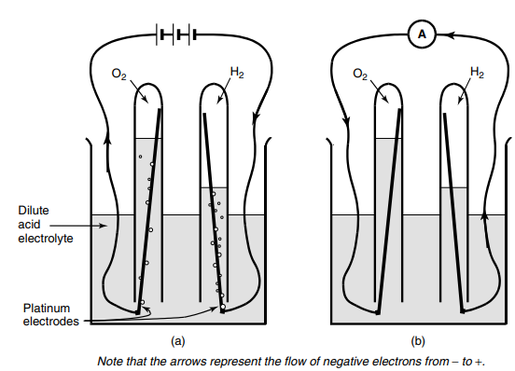
Figure 1 Basic principle of a fuel cell [1]

2.1.2 Central chemistry of fuel cells
At the anode of an acid electrolyte fuel cell, the hydrogen gas ionizes, releasing electrons and creating H⁺ ions (or protons). This is an oxidation reaction because hydrogen loses electrons. [1]
2H₂ ↔ 4H⁺ + 4e⁻
At the cathode, oxygen receives electrons (e⁻) and become O²⁻ ions. This is a reduction reaction because oxygen gains electrons. Together, O²⁻ and H+ ions from the electrolyte recombine and form water. [1]
O₂ + 4e⁻ ↔ 2O²⁻
4H⁺ + 2O²⁻ ↔ 2H₂O

2.1.3 Fuel cell performance
For fuel cell performance, theoretically, hydrogen fuel cells can have up to 83% efficiency and open circuit voltage of 1.23V. However, in operation, the voltage is less than this, often considerably less. [1]
Table 1 maximum EMF (or reversible open circuit voltage), and efficiency limit of hydrogen fuel cells [1]
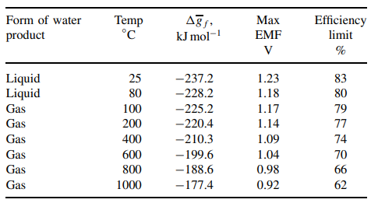
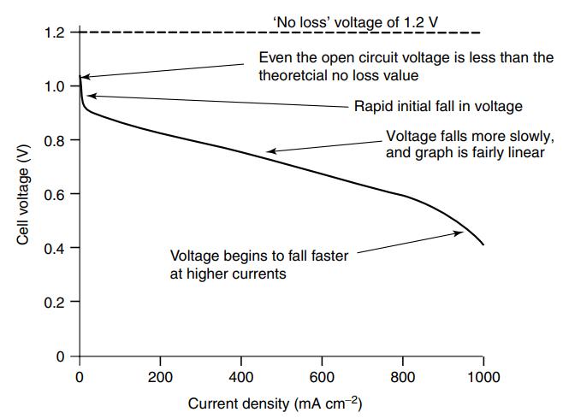
Figure 2 Graph showing the voltage for a typical low temperature, air pressure, fuel cell [1]
The characteristic shape of the voltage/current density graphs of Figure 2 Graph showing the voltage for a typical low temperature, air pressure, fuel cell [1]results from four type of losses.
Activation losses: A proportion of the voltage generated is lost in driving the chemical reaction that transfers the electrons to or from the electrode. These losses can be reduced by: raising the temperature, using effective catalysts, increasing the roughness of the electrodes, increasing reactant concentration, or raising the pressure. [1]
Fuel crossover and internal currents: cause mainly the waste of fuel passing through the electrolyte. This is not usually of great importance in terms of operating efficiency. [1]
Ohmic losses: resistance to the flow of electrons through the material of the electrodes and interconnections, as well as resistance to the flow of ions through the electrolyte. These losses can be reduced by: use of electrodes and other conducting lines with the high conductivity, making the electrolyte as thin as possible. [1]
Mass transport or concentration losses: caused by reduction in concentration of the reactants at the surface of the electrodes as the fuel is used. To improve this: increasing the rate of supply of reactant (O₂ and H₂) and quick removal of water. [1]

2.1.4 Overview of types of fuel cells
The two fundamental technical problems with fuel cells (ignoring the cost): the slow reaction rate and hydrogen is not a readily available fuel. To solve these problems, many different fuel cell types have been tried. The different fuel cell types are usually distinguished by the electrolyte that is used.The situation now is that six classes of fuel cell have emerged as viable systems for the present and near future. Basic information about these systems is given in the table below. [1]
Table 2 Data for different types of fuel cell [1]
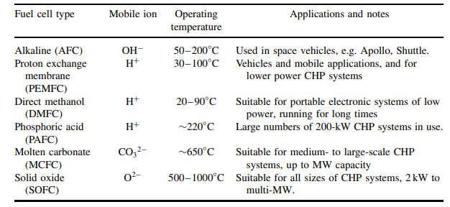
Proton Exchange Membrane (PEM) Fuel Cells use a solid polymer electrolyte that allows protons to move. They operate at low temperatures and need pure hydrogen. PEM cells are simple because of their solid polymer electrolyte, and they use platinum to speed up reactions. Recent improvements allow less platinum, lowering costs. PEM cells work well in small devices like portable electronics. A variant, the Direct Methanol Fuel Cell (DMFC), uses methanol instead of hydrogen and, while producing lower power, is useful for devices that need steady, long-lasting energy. [1]
Alkaline Fuel Cells (AFC) use a potassium hydroxide solution and work at low to moderate temperatures. Porous electrodes with platinum help AFCs achieve faster reaction rates and high efficiency. However, they cannot handle carbon dioxide, so they require pure hydrogen and oxygen, making them suitable for controlled environments, like space missions, such as Apollo and Shuttle Orbiter. [1]
The Phosphoric Acid Fuel Cell (PAFC) uses phosphoric acid as the electrolyte and operates at about 220°C. This helps achieve a reliable reaction rate and enables PAFCs to run continuously for long periods with little maintenance. However, they require equipment to convert natural gas to hydrogen, which adds to their size and cost. PAFCs are often used in stationary power systems. [1]
Solid Oxide Fuel Cells (SOFC) have a ceramic electrolyte and work at high temperatures, between 600 to 1000°C. The heat increases reaction speed, so expensive catalysts aren’t needed, and the fuel cell can even use natural gas directly. However, ceramic materials are costly and difficult to handle, making SOFCs complex and slow to start. They are mainly used for large-scale, stable power needs. [1]
The Molten Carbonate Fuel Cell (MCFC) uses a mixture of molten carbonates as the electrolyte and operates at high temperatures. It uses nickel as a catalyst, which is less costly, and can run on fuels like methane or coal gas. However, the molten electrolyte is corrosive and requires carbon dioxide in the air to work, adding to its complexity. MCFCs are ideal for industrial applications where efficiency and cost are important. [1]

2.1.5 Elements of a generic bipolar fuel cell
Because single fuel cells produce a low voltage (about 0.7 V), several cells are connected in a line to create a higher, useful voltage. This arrangement is called a "stack." Below in Figure 3 is a single cell covered by bipolar plates [1].

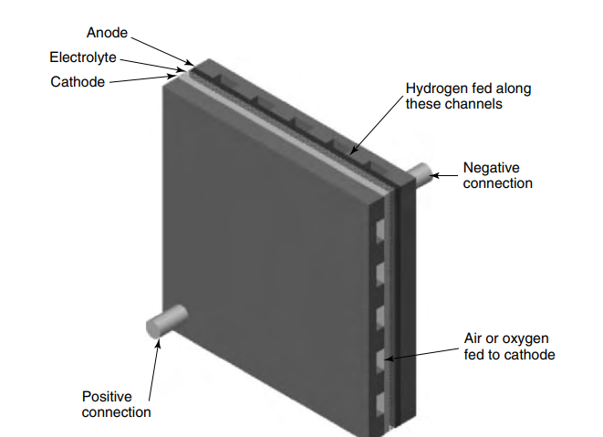
Figure 3 Single cell, with end plates for taking current from all over the face of the electrodes,
and also supplying gas to the whole electrode. [1]
Bipolar plates link the cathode of one cell to the anode of the next cell across their whole surfaces. They also allow gas flow, directing hydrogen to the anode and oxygen to the cathode, while keeping the gases apart using gas flow channels. There are electrical contact points, the areas on the bipolar plate that touch the electrodes directly. Larger contact points improve conductivity but can block gas flow, while smaller contact points need to be placed more frequently to keep efficiency high. Extra channels inside the bipolar plates allow cooling fluid to flow and control temperature, which is especially important for high-power or low-temperature fuel cells. An example of a fuel cells stack is shown below in Figure 4 [1].

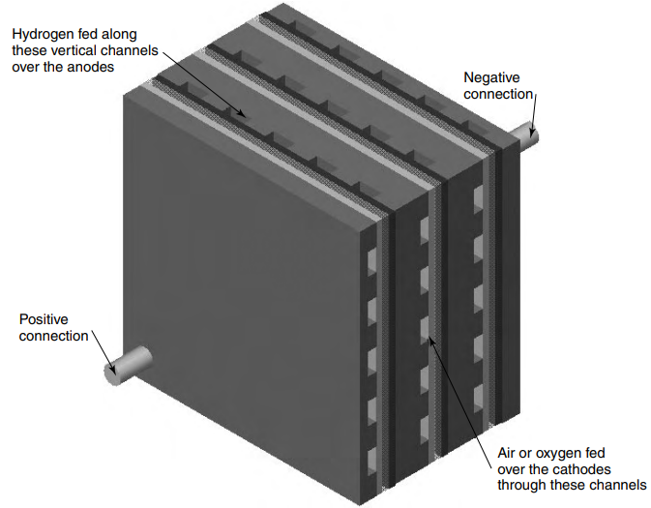
Figure 4 A three-cell stack showing how bipolar plates connect the anode of one cell to the
cathode of its neighbor [1]

2.1.6 Advantages and disadvantages
Fuel cells have several advantages compared to other energy technologies. They are generally more efficient than combustion engines, meaning they can produce more energy from the same amount of fuel. Fuel cells are also simple in design, with few moving parts, which makes them reliable and long-lasting. Another benefit is that they produce very low emissions; hydrogen fuel cells only produce water as a byproduct, so there is no pollution at the point of use. However, it is important to note that making hydrogen fuel currently still causes some CO₂ emissions. Fuel cells are also very quiet, which is helpful for portable power devices and local power systems where low noise is preferred. [1]
On the other hand, the main drawback of fuel cells is their high cost. The materials and manufacturing needed to make fuel cells are expensive, which makes them less affordable than other energy options. However, many believe that, when fossil fuels run out, hydrogen will become the world’s main fuel and energy carrier. [1]

2.2. Proton Exchange Membrane – Fuel Cell (PEMFC)

2.2.1 Central Chemistry
The central chemistry of the PEMFC is previously described in 2.1.2 Central chemistry of fuel cells of this report. The primary difference is the electrolyte material, which is made of polymer. The most well-known and well-established of polymer for the electrolyte membrane is Nafion, a widely used electrolyte developed by Dupont. [1]

2.2.2 General Process
Moving of protons through the electrolyte: The polymer electrolyte membrane, made from materials like Nafion, has hydrophilic (water-attracting) and hydrophobic (water-repelling) areas. When the membrane takes in water, the hydrophilic areas form clusters, creating paths that allow protons to move through these water-filled spaces. Meanwhile, the hydrophobic areas push water away, helping control the water levels within the membrane. [1]
Reactions at anode and cathode: Reaction rate is accelerated by platinum, which is distributed on finely divided carbon particles, increasing the surface area and improves the effectiveness. This design is intentional to maximize the surface area of platinum while minimizing its usage, as platinum is expensive. [1]
Water management: Proton conductivity in the polymer electrolyte membrane depends directly on the amount of water in the system. Enough water is needed for protons to move easily, but too much water can cause flooding, blocking the tiny openings in the electrodes and gas diffusion layers. As protons move from the anode to the cathode, they pull water molecules with them, which can dry out the anode at high current densities. Additionally, warm air can cause the cell to dry out faster than water is produced, making it hard to keep the balance of water just right. Typically, product water is removed using the air flowing through the cell. This airflow helps control water levels through evaporation. [1]
Cooling: The airflow at the cathode can also serve as a cooling method. By increasing the airflow rate beyond what is strictly required for the reaction, this approach achieves cooling in a straightforward way without the need for extra cooling equipment. This cooling approach is typically suitable for systems with power outputs of up to about 100 watts. For larger PEM fuel cells, between about 100 W and 1 kW, separation of the airflow used for reactions from that used for cooling. For even larger cells, this becomes impractical, and water cooling is preferred. [1]

2.2.3 Structure, parts, components, and functions
Polymer Electrolyte: The polymer electrolyte in PEM fuel cells, often made from a material like Nafion, allowing protons (H+ ions) to pass from the anode to the cathode while preventing electrons from crossing directly. The polymer has both hydrophilic (water-attracting) and hydrophobic (water-repelling) parts, helping to balance water retention for proton movement while preventing excess water that could lead to flooding. [1]
Electrodes: Both the anode and cathode electrodes are coated with a catalyst, usually platinum, finely divided and dispersed on carbon particles to ensure good reactant contact. This catalyst allows hydrogen molecules at the anode to split into protons and electrons, while at the cathode, it enables oxygen to combine with protons and electrons to form water. The carbon support material in the electrodes is bonded with a hydrophobic Teflon which aids in water management by pushing excess water to the surface, preventing flooding. [1]
Bipolar Plate: Most PEM fuel cells are constructed along the general lines of multiple cells connected in series with bipolar plates outlined in section 2.1.5 Elements of a generic bipolar fuel cell. However, there are many ways to build the bipolar plate and, in the materials, used to make it. This is important because the membrane electrode assemblies (MEAs) in PEM fuel cells are very thin. This means that the bipolar plates make up almost all the space in the fuel cell stack and typically about 80% of its weight. For functionalities, the bipolar plates conduct electricity, distribute gases, manage water and heat, and provide structure. [1]

Hydrogen

Production method
Desulphurization: Natural gas and petroleum liquids contain organic Sulphur compounds that normally must be removed before any further fuel processing can be carried out. Even if the fuel processor catalysts were tolerant to some Sulphur, it has been shown that levels of only 1 ppb are enough to permanently poison a PEM anode catalyst. [1]
Steam reforming: a mature technology, practiced industrially on a large scale for hydrogen production. The basic reforming reactions for methane and a generic hydrocarbon C_{n}H_{m} are shown below. They are endothermic, which means that heat needs to be supplied to the reaction to drive it forward to produce hydrogen and carbon monoxide. Higher temperature (700º C) is required. [1]
CH₄ + H₂O ↔ CO + 3H₂
C_{n}H_{m} + nH₂O ↔ nCO + (m/2 + n) H₂
Also, carbon monoxide can be converted to carbon dioxide at higher temperature during reforming process. [1]
CO + H₂O ↔ CO₂ + H₂
Electrolysers: Electrolysers use electricity to divide water (H₂O) into hydrogen and oxygen. They are the opposite of a fuel cell. [1]
At the negative electrode, protons are removed from the electrolyte, electrons are provided by the external electrical supply and hydrogen is formed via the following reaction. [1]
4H⁺ + 4e⁻ ↔ 2H₂
At the positive electrode, the water is oxidized (electrons removed) and oxygen is made via the below reaction. [1]
2O²⁻ ↔ O₂ + 4e−
Total reaction:
2H₂O ↔ O₂ + 4H⁺ + 4e−

Storage and Transportation
As a compressed gas: Storing hydrogen gas in pressurized cylinders is the most technically straightforward method and the most widely used one for small amounts of the gas. Hydrogen is stored in this way at thousands of industrial, research, and teaching establishments, and in most locations local companies can readily supply such cylinders in a wide range of sizes. Due to hydrogen low density nature, usually, less than 2% of the storage system mass is hydrogen itself. Transportation of hydrogen as a compressed gas must be done in small quantities and must be transported with great care. [1]
As a liquid: The storage of hydrogen as a liquid, at about 22 K, is currently the only widely used method of storing large quantities of hydrogen. The hydrogen container is a large, strongly reinforced vacuum (or Dewar) flask. One of the problems associated with cryogenic hydrogen is that the liquefaction process is very energy-intensive. The energy required to liquefy the gas under the very best of circumstances is about 25% of the specific enthalpy or heating value of the hydrogen. Overall, this method is a highly inefficient way of storing and transporting energy. However, transportation of hydrogen as liquid, generally, safer than with compressed gas. If there is a failure of the container, the fuel tends to vent to the atmosphere slowly. Certainly, hydrogen liquid tanks have been approved for use in cars in Europe. [1]
In Metal Hydride: Alloys of titanium, iron, manganese, nickel, chromium, and others, can react with hydrogen to form a metal hydride in a very easily controlled reversible reaction. The general equation is shown below. [1]
M + H₂ ↔ MH₂
The main advantage of this method is its safety, because hydrogen is not stored at a significant pressure, or under extreme temperature. Metal Hydrides can achieve higher hydrogen densities by volume than both compressed and liquid hydrogen. However, by weight, they are heavier. Transportation of hydrogen in metal hydride is particularly suited the form where weight is not a problem, such as on boat. [1]

Experimental part

Characteristic Curve of Hydrogen PEM - Fuel Cell

3.1.1. Description of experiment
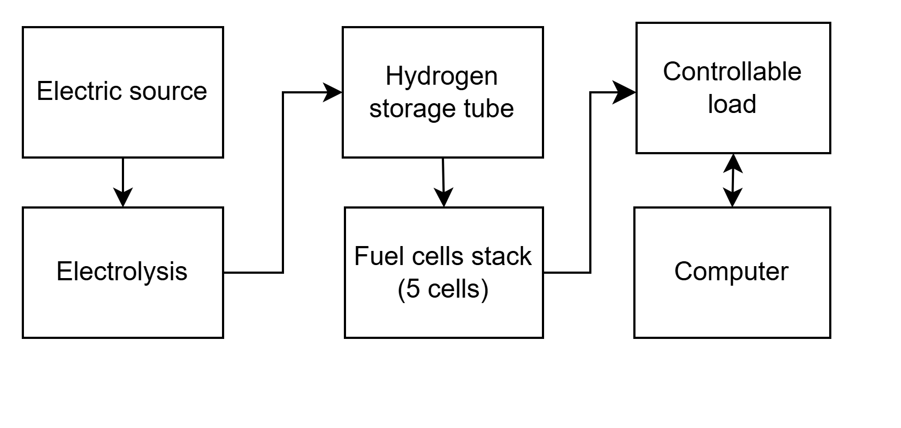
Figure 5 Diagram describing elements of the experiment
The experiment used an electric source to power an electrolysis system, which splits water into hydrogen and oxygen. The hydrogen was then stored in a tube until it was needed by a fuel cell stack made up of 5 hydrogen fuel cells. This stack changed the stored hydrogen into electric power, which was used to run a controllable load. A computer was connected to the load to increase or decrease it and record the matching voltage and current over time. This setup allowed for the study of the characteristic curve of a hydrogen Proton Exchange Membrane (PEM) fuel cell stack.

3.1.2. Results
With the data saved on the computer, a curve showing the relationship between the voltage and current output of the fuel cell stack was drawn, as shown below in Figure 6.

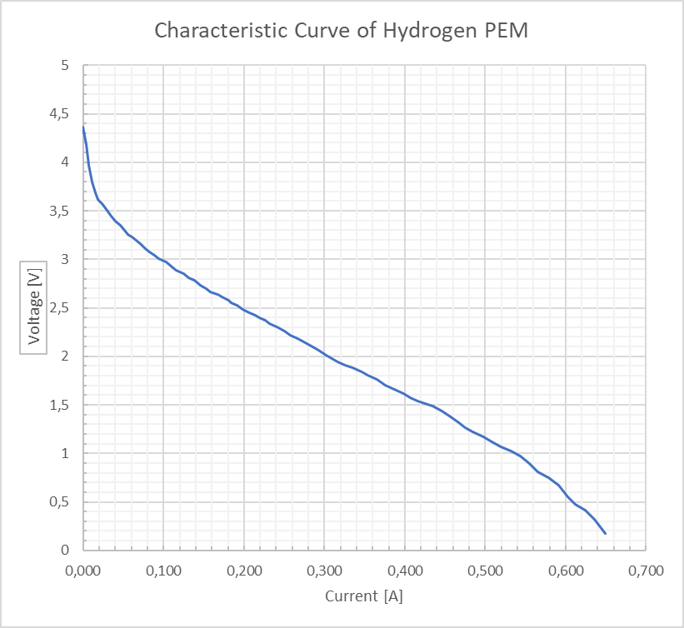
Figure 6 Characteristic Curve of Hydrogen PEM - Fuel Cell
The power was plotted as function of current as the graph in Figure 7 below.
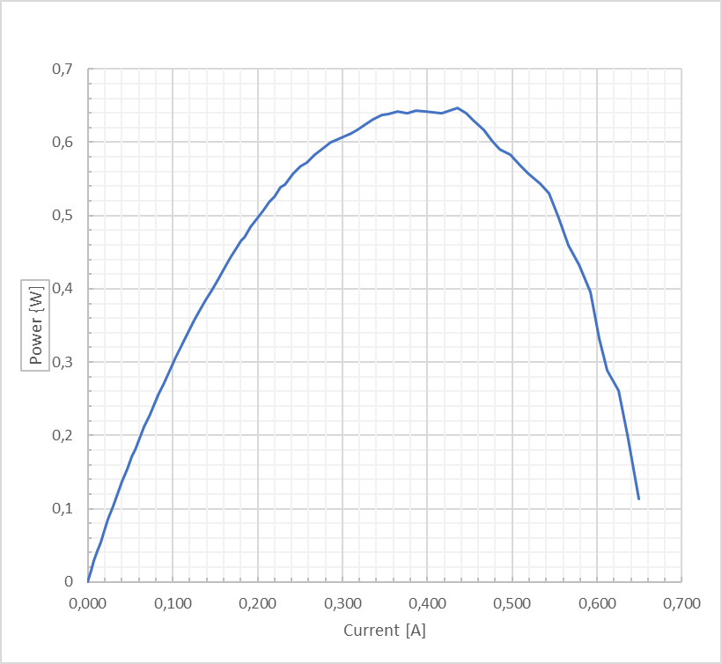
Figure 7 Graph of power against current

3.1.3 Discussion of results
In Figure 6 Characteristic Curve of Hydrogen PEM - Fuel Cell, the characteristic curve of a hydrogen Proton Exchange Membrane (PEM) fuel cell illustrates how voltage (vertical axis) and current (horizontal axis) are related in the fuel cell’s operation. Moving along the curve, the voltage decreases steadily as the current increases. This behavior is typical, where a greater load on the cell creates a higher current demand, affecting its voltage output. [1]
Activation losses: The initial, steep drop from around 4.4V to 3V at low current levels, in this case below 0.1A, is due to what are called activation losses. These losses occur because the fuel cell needs extra energy to initiate the chemical reactions inside it. [1]
Ohmic losses: As the current rises, a more gradual, linear drop in voltage, from 3V to 1V, come with a linear raise in current, from around 0.1A to 0.5A, which is mainly due to ohmic losses. These losses come from the internal resistance within the cell that grows as the current increases. This middle section of the curve reflects the primary operating region of the fuel cell. [1]
Concentration losses: Toward the right side of the curve, where the current is highest, approximately 0.65A, and voltage is lowest, around 0.2V, concentration losses occur. These losses happen when the fuel cell’s ability to supply reactants like hydrogen and oxygen does not meet the high demand. This part of the curve shows that the cell is nearing its operational limits, and efficiency is lower due to the reduced availability of fuel. [1]
Figure 7 shows the power-current relationship for a hydrogen Proton Exchange Membrane (PEM) fuel cell. At low current, the power output rises with increasing current. Between 0A and 0.2A, a steady increase in power, showing that more current can be drawn without significant power losses.
Optimal operating point: As the current continues to rise, the curve reaches a peak power output at around 0.35A to 0.45A, where the power is at its highest, approximately 0.65 W. This peak marks the optimal operating point for the fuel cell, where it produces the most power with a good balance between current and voltage. Operating the fuel cell near this peak allows for maximum performance, as it can produce power efficiently without experiencing major losses.
Beyond this peak, as the current goes higher, the power output begins to drop. As a result, the cell’s ability to maintain high power levels is reduced. For instance, at 0.6A, the power output has already dropped below 0.4W, showing that the cell’s efficiency is decreasing as it reaches higher current levels.
Toward the right side of the curve, at currents above 0.6A, the power output falls more quickly. This sharp decline suggests that the fuel cell is operating beyond its best range, and efficiency is heavily impacted. Operating in this region would result in significant performance losses.
In summary, the two curves help us understand the ideal operating conditions for the fuel cell. The peak in the power-current curve is around 0.35A to 0.45A, where the cell can produce the most power. This range also falls within the ohmic region in the voltage-current curve, where the voltage decreases in a steady, linear way when the current increases.

Voltage regulated characteristics curve

3.2.1 Description of experiment
In this experiment, the voltage was maintained at a constant level for each test, and the corresponding output power was observed. Seven specific voltage levels were selected for observation: 4.0 V, 3.5 V, 3.0 V, 2.5 V, 2.0 V, 1.5 V, and 1.0 V.

3.2.2 Results

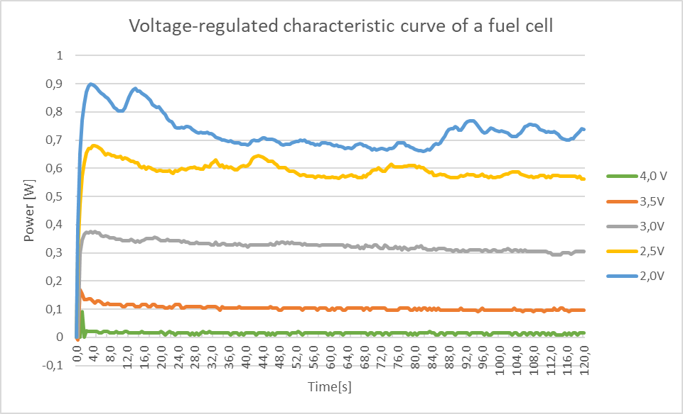
Figure 8 Voltage-regulated characteristic curve of a fuel cell
Table 3 Voltage-regulated stable current and power output
No. of experiment | Voltage, V | Duration, sec | Sampling rate | Current, A | Power, W | Power stable
1 | 4,00 | 120 | 0,5 | 0,0025 | 0,0100 | Yes
2 | 3,50 | 120 | 0,5 | 0,0286 | 0,1000 | Yes
3 | 3,00 | 120 | 0,5 | 0,1000 | 0,3000 | Yes
4 | 2,50 | 120 | 0,5 | 0,2200 | 0,5500 | Yes
5 | 2,00 | 120 | 0,5 | 0,3500 | 0,7000 | Yes
6 | 1,50 | 120 | 0,5 | 0,4667 | 0,7000 | No
7 | 1,00 | 120 | 0,5 | 0,5500 | 0,5500 | No

3.2.3 Discussion of results
In Table 3 Voltage-regulated stable current and power output, the voltage was kept steady by increasing the load, which made the fuel cell draw more current, leading to an increase in power output. At 4.0 V, only a small current was drawn, resulting in a stable but very low power output of 0.01 W. As the voltage was lowered, both the current and power increased, reaching a stable power of 0.7 W at 2.0 V. However, below 2.0 V, the power became unstable and did not increase further, marking the point at which the fuel cell could no longer maintain steady power.
This can be seen in Figure 8, where power fluctuations grow as the voltage decreases. At 2.0 V, power peaks at around 0.9 W but shows strong fluctuations, though it is still somewhat controllable. The most stable power can be seen at 3.0 V, where the fuel cell operates smoothly without large fluctuations.
This can be explained by the characteristic curve shown in Figure 6. As the voltage drops and current rises, the operating point moves out of the ohmic region and into the concentration loss region. In this region, the relationship between voltage and current is no longer linear, making it harder to keep the power stable. This shift explains the observed fluctuations, as the fuel cell struggles to keep a consistent power output when pushed beyond the ohmic region.

Experimental volume of H₂
In this experiment, the volume of H₂ generate by the electrolyzer is recorded and over time. The result is shown in Table 1 below.
Table 4 Volume of H₂ generated over time
Volume Hydrogen (cm³) | Time (s)
0 | 0
5 | 5
10 | 14
15 | 20
20 | 27
30 | 41
35 | 49
40 | 56
45 | 63
50 | 71
55 | 79
60 | 85
65 | 92

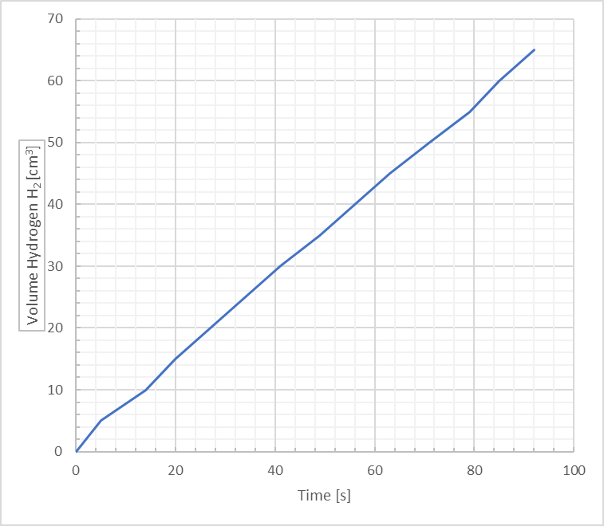
Figure 9 Volume of H₂ generated over time
The slope of the function of H₂ volume over time in Figure 9 is around 0.7 cm³/s.

Determination of faraday and energetical efficiency of PEM fuel cell

3.4.1 Faraday efficiency
To calculate Faraday efficiency, the volume of H₂ consumed by the fuel cells to generate electric current must be found. Below is the formular. [1]
F = 96485 (C/mol), Faraday constant
p = 1,013×105 Pa, pressure of atmosphere
Z = 2, number of electrons released per mol
R = 8,314 J/(K·mol), the ideal gas constant
I, current, in Ampere
T = 298 K, room temperature
t, time, in seconds
N, 5, number of cells

Then, the ratio of volume of H₂ consumed to volume of H₂ supplied to the cells represents the Faraday efficiency. [1]

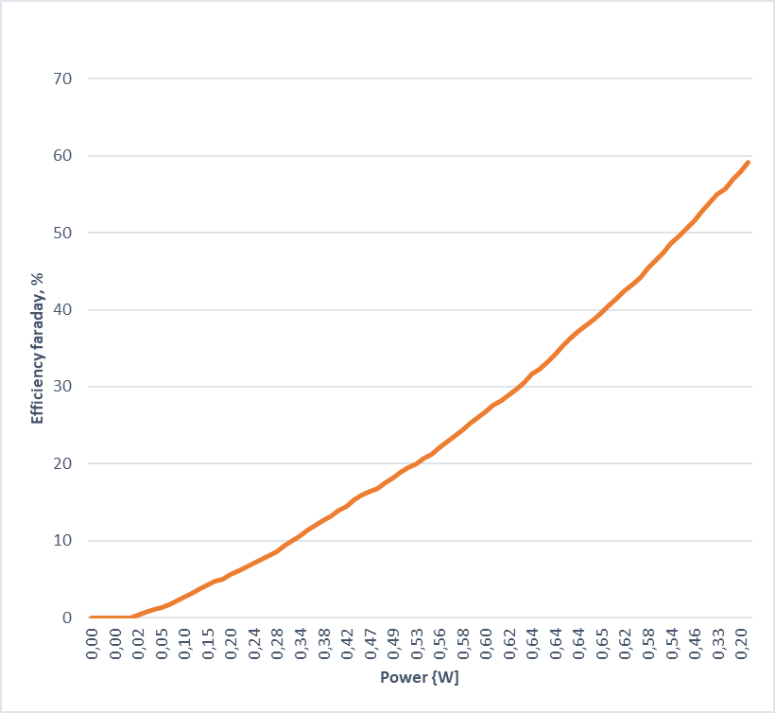
Figure 10 Faraday efficiency as a function of power

3.4.2 Energetical efficiency
Energetical efficiency is the percentage of total energy released by the chemical reaction of H₂ that has been converted to electrical energy. [1]
U, cell voltage, in Volt
I, cell current, in Ampere
t, time, in seconds
, volume of H₂, in m³
H_{v} = 10,8 × 106 (J/m³), lower heating values of H₂
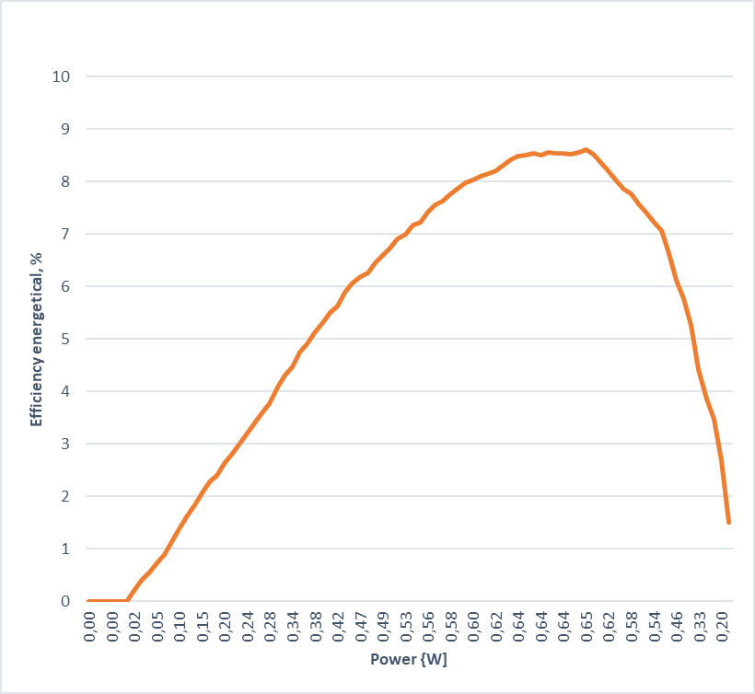
Figure 11 Energetical efficiency as a function of power

3.4.3 Discussion
The Faraday efficiency maximum is closed to 60%, compared to the energetical efficiency, only around 8,5%. This indicates that not 100% the H₂ supplied to the fuel cells has reacted with O₂, and after that not 100% of the reaction energy has been converted to electrical energy. Part of the H₂ has been lost in the transportation and part of the energy released from the chemical reaction has been converted to heat.

Conclusion
This experiment showed the key performance features and efficiency of a hydrogen Proton Exchange Membrane (PEM) fuel cell. By studying the voltage-regulated characteristic curves, we observed the relationship between voltage, current, and power output, identifying the cell’s most efficient range in the ohmic region. As the load increased and the current rose, the power output reached its highest point but became unstable beyond certain voltage levels, showing a shift into the concentration loss region.
The experiment also revealed the limits of stable operation, particularly at lower voltages where power output showed more fluctuations. The Faraday efficiency, calculated from the ratio of hydrogen used to hydrogen provided, showed the fuel cell's effectiveness in using the fuel. Additionally, the energetic efficiency showed how much of the hydrogen’s energy was converted into electrical output.
In summary, this study provided useful information about the best operating conditions for PEM fuel cells, including the stable voltage range for reaching maximum power and efficiency. These findings help to understand the potential use of PEM fuel cells in renewable energy systems, where stable and efficient operation is important.

References

[1] | Larminie, James; Dicks, Andrew , Fuel Cell Systems Explained, Wiley-VCH 2013.

