**LAB 2**

**Assignment: Company Database**

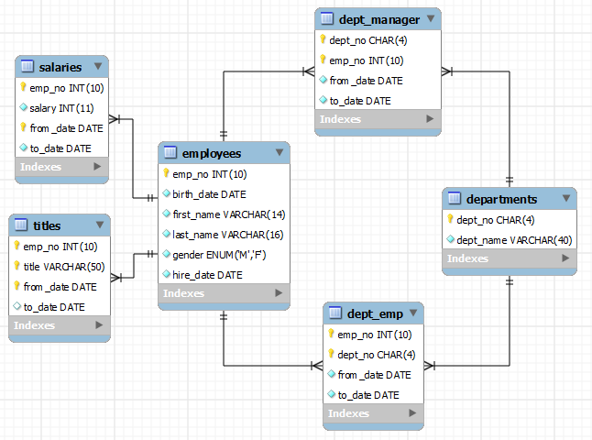There are 6 tables as follows:

Notations in Diagrams:

1. The attributes preceded by yellow key implies primary key columns.
2. Yellow key preceding more than one attributes in the same table signifies a composite key.
3. A line joining two tables signifies the parent child relationship between the tables. The end having crow feet symbol signifies the child table. The other side represents the parent table.

Write commands to implement the following:

1. Drop **Employees** table from the database yourRollNo_Company
2. Create **Employees** table again. Set *emp_no* as PRIMARY KEY. Set the default *gender* to ‘M’. Also ensure that *hire_date* is greater than *birth_date*.
3. Create table **salaries.** Set the composite key (*emp_no*, *from_date*) as PRIMARY KEY. The column *‘to_date’* should support NULL values. All other columns should be set to NOT NULL. Add the FOREIGN KEY constraint on *emp_no* pointing to primary key ‘*emp_no’* of the **employees** table.
4. Create table **titles.** Set the composite key (*emp_no, title, from_date*) as PRIMARY KEY. The column ‘*to_date’* should support NULL values. Add the FOREIGN KEY constraint on *emp_no* pointing to primary key ‘*emp_no’* of the **employees** table.
5. Create table **dept_manager**. Write statements to create the composite PRIMARY KEY (*dept_no, emp_no*). The column *‘to_date’* should support NULL values. Add the FOREIGN KEY constraint on *emp_no* pointing to primary key ‘*emp_no’* of the **employees** table. Add another FOREIGN KEY constraint on *dept_no* pointing to primary key ‘*dept_no’* of the **departments** table.
6. Identify the primary and foreign key(s) among the remaining tables. Use alter command to edit the already created tables.
7. Check the constraints by inserting the following data into the tables.

**Insert data in table titles:**

| 499991 | Staff | 1997-02-11 | 9999-01-01 |

| 499992 | Senior Staff | 1992-05-09 | 9999-01-01 |

| 499992 | Staff | 1987-05-10 | 1992-05-09 |

| 499993 | Engineer | 1997-04-07 | 9999-01-01 |

| 499994 | Engineer | 1993-02-22 | 1993-10-27 |

**Insert Data in table Salaries:**

|499991 | 43612 | 1997-02-11 | 1998-02-11 |

| 499991 | 45367 | 1998-02-11 | 1999-02-11 |

| 499992 | 56516 | 1991-05-09 | 1992-05-08 |

| 499992 | 59357 | 1992-05-08 | 1993-05-08 |

| 499992 | 63601 | 1993-05-08 | 1994-05-08 |

| 499993 | 43082 | 2001-04-06 | 2002-04-05 |

| 499993 | 44305 | 2002-04-05 | 9999-01-01 |

| 499994 | 40000 | 1993-02-22 | 1993-10-27 |

**Insert data in table dept_manager**

|499991 | d009 | 1985-01-01 | 1991-10-01 |

| 499993 | d002 | 1989-12-17 | 9999-01-01 |

| 499992 | d003 | 1985-01-01 | 1992-03-21 |

| 499993 | d004 | 1988-09-09 | 1992-08-02 |