**LAB 1**

**MySQL Commands**

1. To login from linux shell use:

mysql -u root -p

1. List all databases on the sql server

show databases;

1. Create a database on the sql server

create database [databaseName];

1. Switch to a database

use [db name];

1. To see all the tables in the database

show tables;

1. To see databases’s field format

describe [tableName];

1. Returns the columns and column information pertaining to the designated table.

show columns from [tableName];

**Assignment: Company Database**

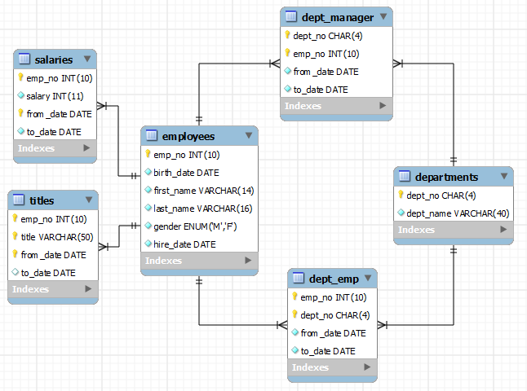There are 6 tables as follows:

1. In this lab you are required to work with three tables *viz* employees, departments and dept_emp.
2. Write a CREATE TABLE statement for all the *three* tables. Choose data types appropriate for mysql.

Insert the following data into the **employees** table:

| 499991 | 1962-02-26 | Pohua | Sichman | F | 1989-01-12 |

| 499992 | 1960-10-12 | Siamak | Salverda | F | 1987-05-10 |

| 499993 | 1963-06-04 | DeForest | Mullainathan | M | 1997-04-07 |

| 499994 | 1952-02-26 | Navin | Argence | F | 1990-04-24 |

| 499995 | 1958-09-24 | Dekang | Lichtner | F | 1993-01-12 |

| 499996 | 1953-03-07 | Zito | Baaz | M | 1990-09-27 |

| 499997 | 1961-08-03 | Berhard | Lenart | M | 1986-04-21 |

| 499998 | 1956-09-05 | Patricia | Breugel | M | 1993-10-13 |

| 499999 | 1958-05-01 | Sachin | Tsukuda | M | 1997-11-30 |

**Departments** Table:

| d009 | Customer Service |

| d005 | Development |

| d002 | Finance |

| d003 | Human Resources |

| d001 | Marketing |

| d004 | Production |

**dept_emp** table:

| 499991 | d009 | 1997-02-11 | 9999-01-01 |

| 499992 | d001 | 1995-05-31 | 9999-01-01 |

| 499992 | d003 | 1987-05-10 | 1995-05-31 |

| 499993 | d004 | 1997-04-07 | 9999-01-01 |

| 499994 | d004 | 1993-02-22 | 1993-10-27 |

| 499995 | d004 | 1997-06-02 | 9999-01-01 |

| 499996 | d004 | 1996-05-13 | 9999-01-01 |

| 499997 | d005 | 1987-08-30 | 9999-01-01 |

| 499998 | d003 | 1993-12-27 | 9999-01-01 |

| 499999 | d004 | 1997-11-30 | 9999-01-01 |