**END-SEMESTER PROJECT REPROT**

**TEXT SUMMARIZER USING MACHINE LEARNING**

**PROJECT TEAM MEMBERS:**

AMIT KUSHWAHA (2015021012)

DEEPAK KUMAR (2015021029)

NITIN SINGH (2015021067)

**UNDER GUIDANCE OF:**

SMT. MEENU (ASSISTANT PROFESSOR)



Department of Computer Science and Engineering

**MADAN MOHAN MALAVIYA UNIVERSITY OF TECHNOLOGY, GORAKHPUR (U.P.)-INDIA**

SESSION: 2018-2019

**TABLE OF CONTENTS:**

1. INTRODUCTION

2. TECHNOLOGY USED

3. TOOLS

4. WORKING

5. CONCLUSION

6. REFERENCES

**INTRODUCTION**

**1.1 OVERVIEW OF PROBLEM AREA:**

Today we know that machines have become smarter than us and can help us with every aspect of life, the technologies have reached to an extent where they can do all the tasks of human beings like household tasks, controlling home devices, making appointments etc. The field which makes these things happen is Machine Learning. Machine Learning trains the machines with some data which makes it capable of acting when tested by the similar type of data. The machines have become capable of understanding human languages using Natural Language Processing. Today researches are being done in the field of text analytics.

As the project title suggests, Text Summarizer is an application which helps in summarizing the text. We can upload our data and this application gives us the summary of that data in as many numbers of lines as we want. The product is mainly a text summarizing using Deep Learning concepts. The main purpose is to provide reliable summaries of web pages or uploads files depend on the user’s choice. The unnecessary sentences will be discarded to obtain the most important sentences.

Text summarization methods are greatly needed to address the ever-growing amount of text data available online to both better help discover relevant information and to consume relevant information faster. There is a great need to reduce much of this text data to shorter, focused summaries that capture the salient details, both so we can navigate it more effectively as well as check whether the larger documents contain the information that we are looking for.

**Why Text Summarization?**

In the modern Internet age, textual data is ever increasing; we need some way to condense this data while preserving the information and meaning. Text summarization is a fundamental problem that we need to solve. I would help in easy and fast retrieval of information, and use the retrieve information for our required purpose.

**Type of Summarization:**

Extractive summarization:

Copying parts/sentences of the source text and then combines those part/sentences together to render a summary. Importance of sentence is based on linguistic and statistical features

Abstractive summarization:

These methods try to first understand the text and then rephrase it in a shorter manner, using possibly different words. For perfect abstractive summary, the models has to first truly understand the document and then try to express that understanding in short possibly using new words and phrases, and are much harder than extractive. It have complex capabilities like generalization, paraphrasing and incorporating real-world knowledge.

Majority of the work has traditionally focused on Extractive approaches due to the easy of defining hard-coded rules to select important sentences than generate new ones. I But they often don’t summarize long and complex texts well as they are very restrictive. The traditional rule-based AI does poorly on Abstractive Text Summarization. It is inspired by the performance of Neural Attention Model in the closely related task of Machine Translation Rush et al. 2015 and Chopra et al. 2016 applied this Neural Attention Model to Abstractive Text Summarization and found that it already performed very well and beat the previous non-Deep Learning-based approaches.

**1.2 PROBLEM SPECIFICATION**

**“Creating short, accurate, and fluent summaries from larger text documents using Machine Learning”.**

The trainable Text Summarizer is expected to learn the patterns which lead to the summaries, by identifying relevant feature values which are most correlated with the classes “correct” or “incorrect”. When a new document is given to the system, the “learned” patterns are used to classify each sentence of that document into either a “correct” or “incorrect” sentence, producing an extractive summary. A crucial issue in this framework is how to obtain the relevant set of features; the next section treats this point in more detail.

Researchers and students constantly face the scenario where it’s impossible to read most if not all of the newly published papers to be informed of latest progress and when the work on a research project, the time spent on reading literature review seems endless. The goal of this project is to design a Summarizer that generates a summary that helps the text to read in short time and focus on key features. The most important task is to generate an efficient scoring algorithm that would produce the best results for a wide range of text types. The only means to arrive at it was to manually summarize and then evaluate sentences for common traits, which would take a lot of time, but using Machine learning we can develop an algorithm that can process text and generate summary from it so that we can use it according to our need.

Textual information in the form of digital documents quickly accumulates to huge amounts of data. Most of this large volume of documents is unstructured: it is unrestricted and has not been organized into traditional databases. Processing documents is therefore a perfunctory task, mostly due to the lack of standards. We cannot possibly create summaries of all of the text manually; there is a great need for automatic methods and Text Summarizer helps us to achieve that summary as result of its output to a given input as text to be processed.

**2. TECHNOLOGY USED**

**2.1 Machine Learning**

Machine Learning is an application of artificial intelligence that provides systems the ability to automatically learn and improve from experience without being explicitly programmed. Machine Learning focuses on the development of computer programs that can access data and use it learn for themselves. The process of learning begins with observations or data, such as examples, direct experience, or instruction, in order to look for patterns in data and make better decisions in the future based on the examples that we provide. The primary aim is to allow the computers learn automatically without human intervention or assistance and adjust actions accordingly.

**Some machine learning methods**

Machine learning algorithms are often categorized as supervised or unsupervised.

* **Supervised machine learning algorithms**can apply what has been learned in the past to new data using labelled examples to predict future events. Starting from the analysis of a known training dataset, the learning algorithm produces an inferred function to make predictions about the output values. The system is able to provide targets for any new input after sufficient training. The learning algorithm can also compare its output with the correct, intended output and find errors in order to modify the model accordingly.
* **Unsupervised machine learning algorithms**are used when the information used to train is neither classified nor labelled. Unsupervised learning studies how systems can infer a function to describe a hidden structure from unlabelled data. The system doesn’t figure out the right output, but it explores the data and can draw inferences from datasets to describe hidden structures from unlabelled data
* **Reinforcement machine learning algorithms**is a learning method that interacts with its environment by producing actions and discovers errors or rewards. Trial and error search and delayed reward are the most relevant characteristics of reinforcement learning. This method allows machines and software agents to automatically determine the ideal behaviour within a specific context in order to maximize its performance. Simple reward feedback is required for the agent to learn which action is best; this is known as the reinforcement signal

Machine learning enables analysis of massive quantities of data. While it generally delivers faster, more accurate results in order to identify profitable opportunities or dangerous risks, it may also require additional time and resources to train it properly. Combining machine learning with Artificial intelligence and cognitive technologies can make it even more effective in processing large volumes of information**.**

**2.2 Recurrent Neural Network (RNN)**

**2.2.1 Neural Network:**

A Neural Network is an information processing paradigm that is inspired by the way biological nervous system, such as the brain, process information. The key element of this paradigm is the novel structure of the information processing system. It is composed of a large number of highly interconnected processing elements (neurons) working in unison to solve specific problems. The neural network itself isn’t and algorithm, but rather a framework for many different machine learning algorithms to work together and process complex data inputs.

Neural networks, commonly known as Artificial Neural Networks (ANN) are quite a simulation of human brain functionality in machine learning (ML) problems. ANNs shall be noted not as a solution for all the problems that arise, but would provide better results with many other techniques altogether for various ML tasks. Most common use of ANNs are clustering and classification, which can be used for regression tasks as well, but there are better methods when it comes to that.

Neurons are the building unit of the neural networks, which imitates the functionality of a human neuron.Typical neurons uses sigmoid function which is demonstrated below. This function is used mostly due to its nature of being able to write the derivative in terms of function itself, which comes handy when minimizing error.

The circles are neurons or nodes, with their functions on the data and the lines/edges connecting them are the weights/information being passed along.Each column is a layer. The first layer of your data is the input layer. Then, all the layers between the input layer and the output layer are the hidden layers.If you have one or a few hidden layers, then you have a shallow neural network. If you have many hidden layers, then you have a deep neural network.In this model, you have input data, you weight it, and pass it through the function in the neuron that is called threshold function or activation function.Basically, it is the sum of all of the values after comparing it with a certain value. If you fire a signal, then the result is (1) out, or nothing is fired out, then (0). That is then weighted and passed along to the next neuron, and the same sort of function is run.We can have a sigmoid (s-shape) function as the activation function.As for the weights, they are just random to start, and they are unique per input into the node/neuron.In a typical "feed forward", the most basic type of neural network, you have your information pass straight through the network you created, and you compare the output to what you hoped the output would have been using your sample data.From here, you need to adjust the weights to help you get your output to match your desired output.The act of sending data straight through a neural network is called a feed forward neural network.Our data goes from input, to the layers, in order, then to the output.When we go backwards and begin adjusting weights to minimize loss/cost, this is called back propagation.This is an optimization problem. With the neural network, in real practice, we have to deal with hundreds of thousands of variables, or millions, or more.The first solution was to use stochastic gradient descent as optimization method. Now, there are options like AdaGrad, Adam Optimizer and so on. Either way, this is a massive computational operation. That is why Neural Networks were mostly left on the shelf for over half a century. It was only very recently that we even had the power and architecture in our machines to even consider doing these operations, and the properly sized datasets to match.For simple classification tasks, the neural network is relatively close in performance to other simple algorithms like K Nearest Neighbors. The real utility of neural networks is realized when we have much larger data, and much more complex questions, both of which outperform other machine learning models.

A deep neural network (DNN) is an ANN with multiple hidden layers between the input and output layers. Similar to shallow ANNs, DNNs can model complex non-linear relationships.The main purpose of a neural network is to receive a set of inputs, perform progressively complex calculations on them, and give output to solve real world problems like classification. We restrict ourselves to feed forward neural networks.

We have an input, an output, and a flow of sequential data in a deep network.Neural networks are widely used in supervised learning and reinforcement learning problems. These networks are based on a set of layers connected to each other.In deep learning, the number of hidden layers, mostly non-linear, can be large; say about 1000 layers.

Deep Learning models produce much better results than normal ML networks.We mostly use the gradient descent method for optimizing the network and minimising the loss function.We can use the Imagenet, a repository of millions of digital images to classify a dataset into categories like cats and dogs. Deep Learning nets are increasingly used for dynamic images apart from static ones and for time series and text analysis.

Training the data sets forms an important part of Deep Learning models. In addition, Backpropagation is the main algorithm in training.DeepLearning models.DeepLearning deals with training large neural networks with complex input output transformations.

One example of DL is the mapping of a photo to the name of the person(s) in photo as they do on social networks and describing a picture with a phrase is another recent application of DL.

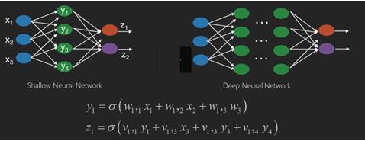

Neural networks are functions that have inputs like x1,x2,x3…that are transformed to outputs like z1,z2,z3 and so on in two (shallow networks) or several intermediate operations also called layers (deep networks).The weights and biases change from layer to layer. ‘w’ and ‘v’ are the weights or synapses of layers of the neural networks.The best use case of deep learning is the supervised learning problem.Here,we have large set of data inputs with a desired set of outputs.

Here we apply back propagation algorithm to get correct output prediction.The most basic data set of deep learning is the MNIST, a dataset of handwritten digits.We can train deep a Convolutional Neural Network with Keras to classify images of handwritten digits from this dataset.The firing or activation of a neural net classifier produces a score. For example,to classify patients as sick and healthy,we consider parameters such as height, weight and body temperature, blood pressure etc.A high score means patient is sick and a low score means he is healthy.Each node in output and hidden layers has its own classifiers. The input layer takes inputs and passes on its scores to the next hidden layer for further activation and this goes on till the output is reached.This progress from input to output from left to right in the forward direction is called forward propagation.Credit assignment path (CAP) in a neural network is the series of transformations starting from the input to the output. CAPs elaborate probable causal connections between the input and the output.CAP depth for a given feed forward neural network or the CAP depth is the number of hidden layers plus one as the output layer is included. For recurrent neural networks, where a signal may propagate through a layer several times, the CAP depth can be potentially limitless.

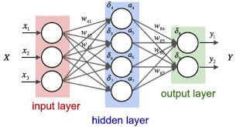

**2.2.2 Recurrent Neural Network**

A Recurrent Neural Network is a class of artificial neural network where connections between nodes form a directed graph along a sequence. This allows it to exhibit temporal dynamic behaviour for a time sequence. Unlike feedforward neural networks, RNNs can use their internal state to process sequences of inputs. This makes them applicable to tasks such as unsegmented, connected handwriting recognition or speech recognition.

For example: Let’s say task is to predict the next word in a sentence. Using Neural Network in simplest form, we have an input layer, a hidden layer and an output layer. The input layer receives the input, the hidden layer activations are applied and then we finally receive the output.

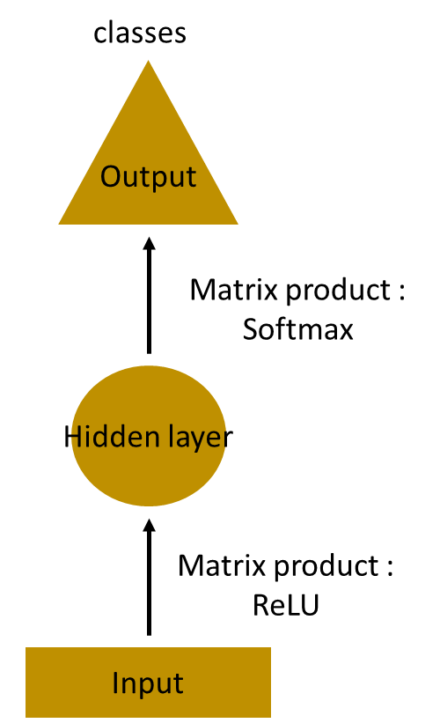

Let’s have a deeper network, where multiple hidden layers are present. So here, the input layer receives the input, the first hidden layer activations are applied and then these activations are sent to next hidden layer, and successive activations through the layers to produce the output. Each hidden layer is characterized by its own weights and biases. Since each hidden layer has its own weights and activations, they behave independently. Now the objective is to identify the relationship between successive inputs.

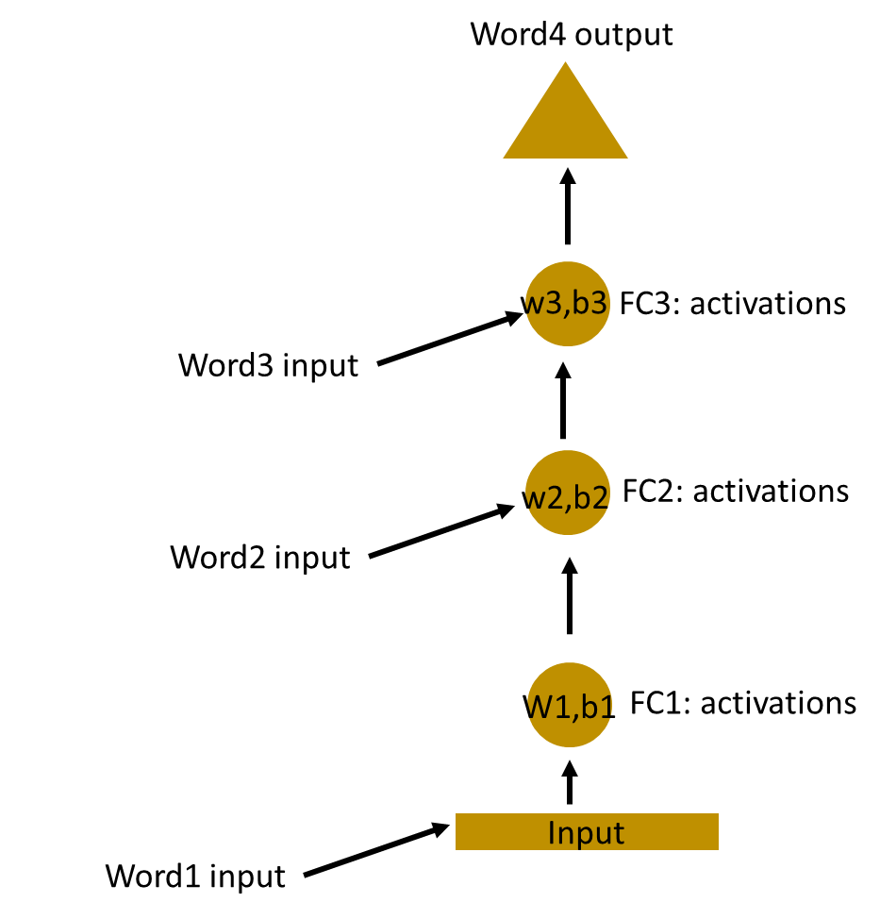

Here, the weights and bias of these hidden layers are different. And hence each of these layers behaves independently and cannot be combined together. To combine these hidden layers together, we shall have the same weights and bias for these hidden layers.

. 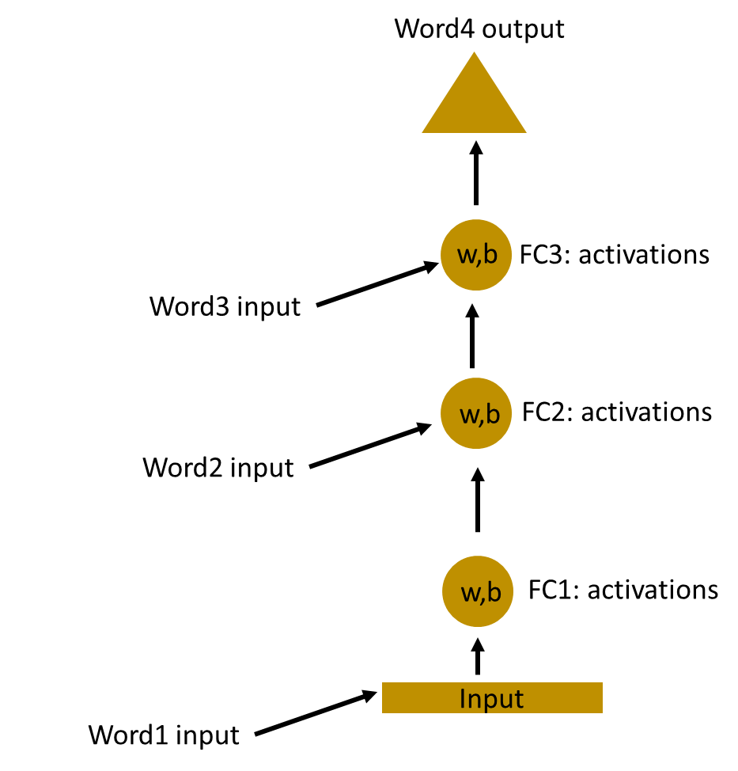

We can now combines these layers together, that the weights and bias of all hidden layers is the same. All these hidden layers can be rolled in together in a single recurrent layer.

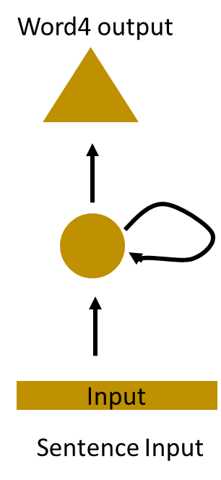

So it’s like supplying the input to the hidden layer. At all the time steps weights of the recurrent neuron would be the same since it’s a single neuron now. So a recurrent neuron stores the state of a previous input and combines with the current input thereby preserving some relationship of the current input with the previous input.

**RNN**Sare neural networks in which data can flow in any direction. These networks are used for applications such as language modelling or Natural Language Processing (NLP).The basic concept underlying RNNs is to utilize sequential information. In a normal neural network it is assumed that all inputs and outputs are independent of each other. If we want to predict the next word in a sentence we have to know which words came before it.RNNs are called recurrent as they repeat the same task for every element of a sequence, with the output being based on the previous computations. RNNs thus can be said to have a “memory” that captures information about what has been previously calculated. In theory, RNNs can use information in very long sequences, but in reality, they can look back only a few steps.

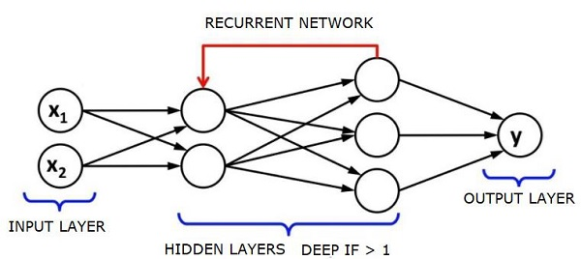

**2.3 Sequence to Sequence model using RNN:**

 In Sequence to Sequence model with attention two recurrent neural networks work together to transform one sequence to another. An encoder network condenses an input sequence into a vector, and a decoder network unfolds that vector into a new sequence. Unlike sequence prediction with a single RNN, where every input corresponds to an output, the seq2seq model frees us from sequence length and order, which makes it ideal for translation between two languages.

With a seq2seq model the encoder creates a single vector which, in the ideal case, encodes the “meaning” of the input sequence into a single vector — a single point in some N dimensional space of sentences.

#### Introduction

Natural Language Processing (NLP) is an area of artificial intelligence focused on allowing computers to understand, process, and analyze human language. NLP is widely used in the tech industry, serving as a backbone to search engines, spam filters, language translation and much more. NLP enables computers to transform human language into a form that it can read and understand, such as a vector or discrete symbol. For example, NLP can take in the sentence So hungry, need food and break it down into four arbitrary symbols: so represented as K45, hungry as J83, need as Q67, and food as P21, all of which can then be processed by the computer. Each unique word is represented by a different symbol; however, the downside is that there is no apparent relationship between the symbols designated to hungry and food. This hinders the NLP model from using what it learned about hungry and applying it to food, which are semantically related. Vector Space Models (VSM) help address this issue by embedding the words in a vector space where similarly defined words are mapped near each other. This space is called a Word EmbeddingWord2vec, a brainchild of a team of researchers led by Google is one of the most popular models used to create word embeddings. Word2vec has two primary methods of contextualizing words: the Continuous Bag-of-Words model (CBOW) and the Skip-Gram model, which i will summarize in this post. Both models arrive at a similar conclusion, but take nearly inverse paths to get there.

### The Encoder

The Encoder of a seq2seq network is a RNN that outputs some value for every word from the input sentence. For every input word the encoder outputs a vector and a hidden state, and uses the hidden state for the next input word.

### The Decoder

The decoder is another RNN that takes the encoder output vector(s) and outputs a sequence of words to create the translation.

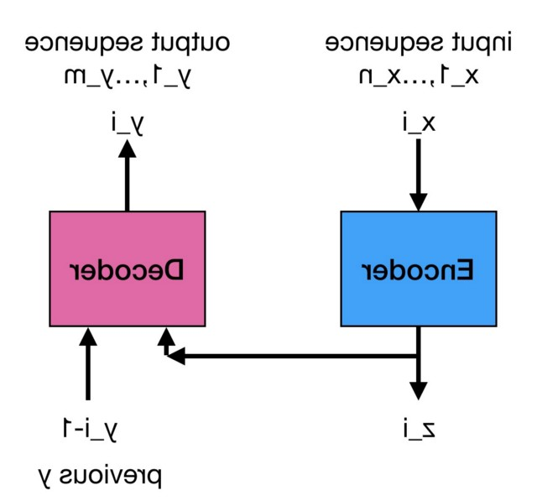

#### Simple Decoder: In the simplest seq2seq decoder we use only last output of the encoder. This last output is sometimes called the *context vector* as it encodes context from the entire sequence. This context vector is used as the initial hidden state of the decoder. At every step of decoding; the decoder is given an input token and hidden state. The initial input token is the start-of-string <SOS> token, and the first hidden state is the context vector (the encoder’s last hidden state).

#### Attention Decoder

If only the context vector is passed between the encoder and decoder, that single vector carries the burden of encoding the entire sentence. Attention allows the decoder network to “focus” on a different part of the encoder’s outputs for every step of the decoder’s own outputs. First we calculate a set of attention weights. These will be multiplied by the encoder output vectors to create a weighted combination. The result should contain information about that specific part of the input sequence, and thus help the decoder choose the right output words.

Calculating the attention weights is done with another feed-forward layer , using the decoder’s input and hidden state as inputs. Because there are sentences of all sizes in the training data, to actually create and train this layer we have to choose a maximum sentence length (input length, for encoder outputs) that it can apply to. Sentences of the maximum length will use all the attention weights, while shorter sentences will only use the first few.

The encoder-decoder model is composed of encoder and decoder like its name. The encoder converts an input document to a latent representation (vector), and the decoder generates a summary by using it

### Long-Short Term Memory

### 

Long Short-Term Memory (LSTM) networks are an extension for recurrent neural networks, which basically extends their memory. Therefore it is well suited to learn from important experiences that have very long time lags in between.The units of an LSTM are used as building units for the layers of a RNN, which is then often called an LSTM network.LSTM’s enable RNN’s to remember their inputs over a long period of time. This is because LSTM’s contain their information in a memory, that is much like the memory of a computer because the LSTM can read, write and delete information from its memory.This memory can be seen as a gated cell, where gated means that the cell decides whether or not to store or delete information (e.g if it opens the gates or not), based on the importance it assigns to the information. The assigning of importance happens through weights, which are also learned by the algorithm. This simply means that it learns over time which information is important and which not.In an LSTM you have three gates: input, forget and output gate. These gates determine whether or not to let new input in (input gate), delete the information because it isn’t important (forget gate) or to let it impact the output at the current time step (output gate).

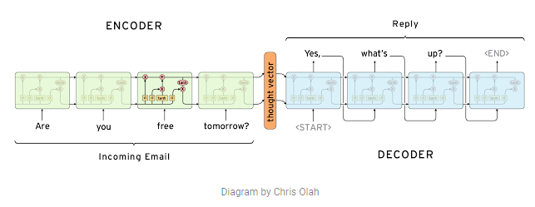

**3.TOOLS**

**3.1 DATA MANIPULATION**

**3.1.1 Pandas**

Pandas is a Python package providing fast, flexible, and expressive data structures designed to make working with “relational” or “labelled” data both easy and intuitive. It aims to be the fundamental high-level building block for doing practical, real world data analysis in Python. Additionally, it has the broader goal of becoming the most powerful and flexible open source data analysis / manipulation tool available in any language. It is already well on its way toward this goal.

Pandas is well suited for many different kinds of data:

Tabular data with heterogeneously-typed columns, as in an SQL table or Excel spreadsheet, Ordered and unordered (not necessarily fixed-frequency) time series data. Arbitrary matrix data (homogeneously typed or heterogeneous) with row and column labels. Any other form of observational / statistical data sets. The data actually need not be labelled at all to be placed into a pandas data structure

The two primary data structures of pandas, Series (1-dimensional) and Data Frame (2-dimensional), handle the vast majority of typical use cases in finance, statistics, social science, and many areas of engineering.

Here are just a few of the things that pandas does well:

* Easy handling of missing data (represented as NaN) in floating point as well as non-floating-point data
* Size mutability: columns can be inserted and deleted from Data Frame and higher dimensional objects
* Automatic and explicit data alignment: objects can be explicitly aligned to a set of labels, or the user can simply ignore the labels and let Series, Data Frame, etc. automatically align the data for you in computations
* Powerful, flexible group by functionality to perform split-apply-combine operations on data sets, for both aggregating and transforming data
* Make it easy to convert ragged, differently-indexed data in other Python and NumPy data structures into Data Frame objects
* Intelligent label-based slicing, fancy indexing, and sub setting of large data sets
* Intuitive merging and joining data sets
* Flexible reshaping and pivoting of data sets
* Hierarchical labelling of axes (possible to have multiple labels per tick)
* Robust IO tools for loading data from flat files (CSV and delimited), Excel files, databases, and saving / loading data from the ultrafast HDF5 format

**3.2 MODELLING**

**3.2.1 Scikit Learn (SKLearn)**

Scikit-learn (formerly scikits.learn) is a free software machine learning library for the Python programming language. It features various classification, regression and clustering algorithms including support vector machines, random forests, gradient boosting, k-means, and is designed to interoperate with the Python numerical and scientific library NumPy.

The scikit-learn project started as scikits.learn, a Google Summer of Code project by David Cournapeau. Its name stems from the notion that it is a "SciKit" (SciPy Toolkit), a separately-developed and distributed third-party extension to SciPy. The original codebase was later rewritten by other developers. In 2010 Fabian Pedregosa, Gael Varoquaux, Alexandre Gramfort and Vincent Michel, all from INRIA took leadership of the project and made the first public release on February the 1st 2010. Of the various scikits, scikit-learn as well as scikit-image were described as "well-maintained and popular" in November 2012.

**3.2.3 Keras**

Keras is a high-level neural networks API, written in Python and capable of running on top of TensorFlow. It was developed with a focus on enabling fast experimentation. Being able to go from idea to result with the least possible delay is key to doing good research.

Use Keras if you need a deep learning library that:

* Allows for easy and fast prototyping (through user friendliness, modularity, and extensibility).
* Supports convolutional networks and recurrent networks, as well as combinations of the two.
* Runs seamlessly on CPU and GPU.

**Guiding principles:**

* **User friendliness:** Keras is an API designed for human beings, not machines. It puts user experience front and centre. Keras follows best practices for reducing cognitive load it offers consistent & simple APIs, it minimizes the number of user actions required for common use cases, and it provides clear and actionable feedback upon user error.
* **Modularity:** A model is understood as a sequence or a graph of standalone, fully-configurable modules that can be plugged together with as few restrictions as possible. In particular, neural layers, cost functions, optimizers, initialization schemes, activation functions, regularization schemes are all standalone modules that you can combine to create new models.
* **Easy extensibility:** New modules are simple to add (as new classes and functions), and existing modules provide ample examples. To be able to easily create new modules allows for total expressiveness, making Keras suitable for advanced research.
* **Work with Python:** No separate models configuration files in a declarative format. Models are described in Python code, which is compact, easier to debug, and allows for ease of extensibility.

**5. WORKING**

**5.1 Preparing the Data**

* Convert to lowercase.
* Replace contractions with their longer forms.
* Remove any unwanted characters (this step needs to be done after replacing the contractions because apostrophes will be removed. Notice the backward slash before the hyphen. Without this slash, all characters that are ‘between’ the characters before and after the hyphen would be removed. This can create some unwanted effects. To give you an example, typing “a-d” would remove a, b, c, d.).
* Stop words will only be removed from the descriptions. They are not very relevant in training the model, so by removing them we are able to train the model faster because there is less data. They will remain in the summaries because they are rather short and I would prefer for them to sound more like natural phrases.

**5.2 Modelling**

To generate model we use Sequence to Sequence model with attention using Recurrent Neural Network. With training data RNN is provided to generate the model that will be used to predict. The model generated is saved as file and utilized to predict for input summary. And with that we can use testing data to test and predict the accuracy and loss using the model available. To train we run the input sentence through the encoder, and keep track of every output and the latest hidden state. Then the decoder is given the <SOS> token as its first input, and the last hidden state of the encoder as its first hidden state. “Teacher forcing” is the concept of using the real target outputs as each next input, instead of using the decoder’s guess as the next input. Using teacher forcing causes it to converge faster but [when the trained network is exploited, it may exhibit instability](http://minds.jacobs-university.de/sites/default/files/uploads/papers/ESNTutorialRev.pdf). We can observe outputs of teacher-forced networks that read with coherent grammar but wander far from the correct translation - intuitively it has learned to represent the output grammar and can “pick up” the meaning once the teacher tells it the first few words, but it has not properly learned how to create the sentence from the translation in the first place.

**5.3. Testing**

Model generated using Recurrent Neural Network is saved as file. This model is then used for testing for accuracy and loss, data which we used to train is split in train and test part and Test part is used to test for the accuracy given by the model generated after training it on train data.

**5.4. Prediction**

Finally user can get result from input text provided by them. Model generated is used to predict, as text provided input is converted to summarize text that act as final output which is displayed through interface through which user and machine are communicating.

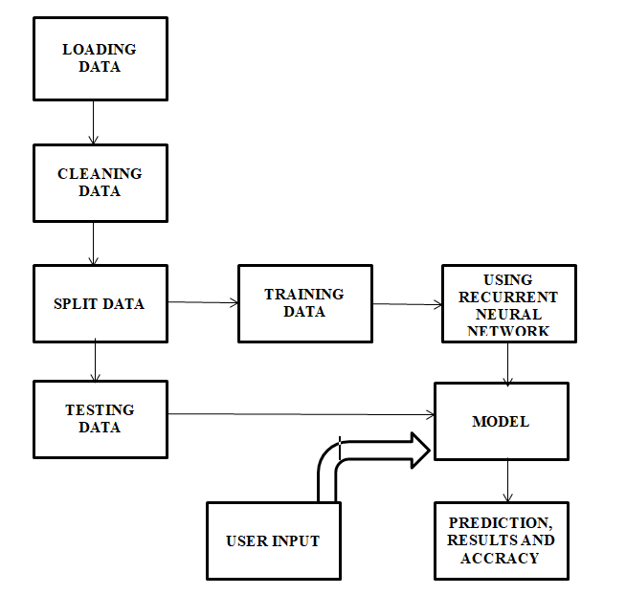

**WORKING MODEL**

**6.Conclusion**

People need to learn much from texts, but they tend to want to spend less time while doing this. It aims to solve this problem by supplying them the summaries of the text from which they want to gain information. Goals of this project are that these summaries will be as important as possible in the aspect of the texts intention. The user will be eligible to select the summary length. Supplying the user, a smooth and clear interface to use the facility in order to latest technology and applying it for saving time and increasing efficiency and productivity of their work.

Machine Learning provides us important technique to handle situation which are related to human behaviour and used on daily basis that allow us to save time and money and focus on important goal. Text summarizer provides users to help use of machine learning algorithm and to use for their benefit as reading is an important part of life. And to read less and gain more information from the document and text we have to handle in our life we need to be faster and focus on important piece of information rather than wasting our whole time on reading unnecessary text and to avoid this text summarizer provides us feature that we can use to apply in real life.

**7.Refrences**

* <https://www.wikipedia.org/>
* <https://towardsdatascience.com/text-summarization-with-amazon-reviews-41801c2210b>
* Deep Learning with Keras by Antonio Gulli and Sujit Pal