TECHWIZ 7 • END-TO-END WEB SOLUTIONS
MarketLink
Farm Fresh, Just a Click Away

PROJECT DOCUMENTATION
A unified platform connecting local Farmers with Customers
Project Name | Market Link
Category | End-to-End Web Solutions
Document | Project Documentation (Problem Definition, Design, Testing, Installation)
Version | 1.0
Team Members | Rimsha Sajid
Institute | Aptech Garden Centre
Submission Date | 28/09/2026

Customer • Farmer • Administrator

Table of Contents
1. Introduction 1
1.1 Purpose of the Document 1
1.2 Project Overview 1
1.3 Definitions 1
2. Problem Definition 1
2.1 Background 1
2.2 Problems Identified 1
2.3 Proposed Solution 1
2.4 Objectives 1
2.5 Scope 1
2.6 Constraints and Out-of-Scope Items 1
3. Map and Geolocation Module 1
3.1 Why a Map is Needed 1
3.2 Technology 1
3.3 How Location Data is Stored 1
3.4 How "Nearby" Search Works 1
3.5 Map Features by Role 1
3.6 Directions 1
3.7 Privacy and Limitations 1
4. Design Specifications 1
4.1 System Architecture 1
4.2 Technology Stack 1
4.3 Functional Modules 1
4.4 Role Permission Summary 1
4.5 Non-Functional Requirements 1
4.6 Security Design 1
4.7 User Interface Design 1
4.8 Sitemap 1
5. Diagrams 1
5.1 System and Order Lifecycle Overview 1
5.2 Entity Relationship Diagram 1
5.3 Customer Flowchart 1
5.4 Farmer Flowchart 1
5.5 Administrator Flowchart 1
6. Database Design 1
6.1 Key Relationships 1
7. Test Data and Test Cases 1
7.1 Test Data Used 1
7.2 Test Cases 1
8. Installation Instructions 1
8.1 Prerequisites 1
8.2 Steps 1
8.3 Common Problems 1
8.4 Hosted Version 1
9. User Credentials 1
10. Project Plan and Team Responsibilities 1
10.1 Development Phases 1
10.2 Team Responsibilities 1
11. Deployment and Demonstration 1
12. Assumptions, AI Tools and Future Scope 1
12.1 Assumptions 1
12.2 AI Tools Acknowledgement 1
12.3 Future Scope 1

1. Introduction

1.1 Purpose of the Document
This document describes the Market Link Web application in detail: the problem it solves, the proposed solution, its design, database structure, testing approach, installation procedure and user credentials. It is intended for evaluators, developers, testers and stakeholders, and follows the deliverables listed in the Market Link Software Requirements Specification (SRS).

1.2 Project Overview
Market Link is a full-stack Web application that connects local farmers-market Farmers with customers. Farmers publish their weekly stock and prices and manage pre-orders; customers discover nearby markets on an interactive map, browse products, place pre-orders for pickup and leave reviews. An Administrator manages the platform. Payment is settled in person at pickup, and delivery is out of scope.

1.3 Definitions
Term | Meaning
Customer | A registered shopper who browses products and places pre-orders.
Farmer | A registered seller who lists stock and fulfils pre-orders.
Admin | Platform manager who approves Farmers, manages markets and moderates content.
Pre-order | A reservation of items for pickup on a chosen date and time slot.
Market | A physical farmers market with a fixed location, days and timings.
Pickup slot | A time window offered by a Farmer during which a customer collects an order.

2. Problem Definition

2.1 Background
Local farmers markets are growing in popularity as shoppers look for fresh, seasonal and locally grown produce. However, customers rarely know in advance which Farmers will attend a market on a given day, what stock they have, or at what price. Availability is communicated informally through chalkboards, printed flyers or word of mouth, so customers often arrive to find popular items sold out or a Farmer absent.
Farmers, in turn, have no easy way to publicise weekly inventory, take pre-orders before market day, or build lasting relationships with regular customers.

2.2 Problems Identified
- Customers cannot check which Farmers attend a market or what products and prices are available.
- There is no way to reserve items, causing wasted trips when produce is sold out.
- Farmers lack a digital channel for stock, pricing, operating days and pickup windows.
- Market and stall locations are not available in one place, so customers rely on memory or word of mouth.
- Farmers cannot track sales history, best-sellers or revenue because transactions are informal.
- Customers cannot see ratings or reviews to judge the reliability of a Farmer or product.

2.3 Proposed Solution
Market Link provides one centralised platform where Farmers list weekly stock and manage pre-orders, customers discover markets on a map and reserve items for pickup, and an Administrator oversees approvals, markets, moderation and reports.

2.4 Objectives
- Build a responsive full-stack Web application connecting Farmers and customers.
- Let Farmers manage weekly stock, pricing and incoming pre-orders digitally.
- Let customers discover markets and Farmers through an interactive map.
- Provide a complete pre-order and pickup workflow without online payment.
- Provide role-based access for Customer, Farmer and Admin.
- Ensure the platform is secure, scalable and works across browsers and devices.

2.5 Scope
In scope: registration and login with role-based access, market and Farmer discovery with map, weekly stock and pricing management, product search and filtering, cart and pre-order for pickup, order status tracking, Favorites, reviews and ratings, notifications, Admin approvals, market management, moderation and reports, and an optional basic FAQ chatbot.

2.6 Constraints and Out-of-Scope Items
- No payment gateway: payment for pre-orders is made in person at pickup.
- No delivery or courier logistics: pickup at the market only.
- No verification of Farmer identity, licensing or organic/food-safety certification.
- Must be compatible with major browsers and responsive on desktop, tablet and mobile.
- Images and videos must respect licensing and copyright restrictions.

3. Map and Geolocation Module

3.1 Why a Map is Needed
The core problem of Market Link is that customers do not know where markets and Farmers are, or which are close to them. A map turns addresses into something a customer can see and act on: which markets are nearby, where a Farmer's stall stands inside a market, and how to reach the pickup point. This directly reduces wasted trips, which is the main benefit of the platform.

3.2 Technology
The map uses OpenStreetMap tiles displayed through the Leaflet.js library. It is free and needs no billing account or API key. Google Maps API is an alternative permitted by the SRS.

3.3 How Location Data is Stored
Every Market and every Farmer stall store a latitude and longitude in the database, together with a text address. Admin sets Market coordinates by clicking a point on the map; a Farmer sets the stall location by placing or dragging a pin during profile setup.

3.4 How "Nearby" Search Works
The customer does not search the map manually. The process is automatic:
- The browser asks the customer for permission to use their location (Geolocation API).
- The customer's coordinates are sent to the server with the request for markets.
- The server calculates the distance between the customer and each Market using the Haversine formula on stored latitude and longitude.
- Markets within a chosen radius (for example 10 km) are returned, sorted from nearest to farthest.
- The map shows a marker for each Market; the list beside it shows name, distance, operating days and Farmers present.
If the customer denies location permission, they can instead choose a city or area from a dropdown, or type an area name in a search box, and the map centres there.

3.5 Map Features by Role
Role | Map feature
Customer | View nearby markets and Farmer stalls as markers; open a marker to see name, days and stock link; get directions to the pickup point; save preferred market locations.
Farmer | Place or drag a pin to set the stall location at registration and in the profile.
Admin | Add or edit a Market by clicking on the map to capture its coordinates.
Public pages | Contact Us page shows the team location on an embedded map.

3.6 Directions
The Get Directions button opens the chosen map provider with the Market or stall coordinates as the destination, so no separate routing service is required.

3.7 Privacy and Limitations
- The customer's location is used only to compute distance and is not stored permanently.
- The map needs an internet connection to load tiles.
- OpenStreetMap tile servers have a fair-use policy; heavy traffic would need a tile provider account.

4. Design Specifications

4.1 System Architecture
Market Link follows a standard multi-tier Web architecture. The browser sends requests to the Web/application server, which runs server-side logic and queries the database. Responses travel back along the same path.
Layer | Responsibility | Technology
Presentation | Responsive user interface, dashboards, forms, map | React.js, Bootstrap/Tailwind CSS, Leaflet.js
Application | Authentication, role-based access, business logic, REST APIs | Node.js, Express.js, JWT, bcrypt
Data | Persistent storage of users, products, orders, reviews | MySQL
Services | Email notifications, optional FAQ chatbot | Nodemailer, rule-based bot

4.2 Technology Stack
Component | Choice
Frontend | React.js, HTML5, CSS3, Bootstrap/Tailwind, JavaScript
Backend | Node.js with Express.js
Database | MySQL
Authentication | JSON Web Tokens with crypt password hashing
Maps | OpenStreetMap with Leaflet.js

4.3 Functional Modules

Customer Module
- Registration (name, contact number, email, address) and secure login.
- Browse nearby markets by location and day; view Farmers at each market and Farmer profiles.
- Search and filter products by category, price, market and day; view product details.
- Cart and pre-order with pickup date and time slot; payment at pickup.
- Order status tracking (placed, accepted, ready for pickup, completed); modify or cancel before cutoff.
- Order history with quick reorder; Favorite Farmers and products with restock alerts.
- Reviews and ratings after a completed order; optional AI FAQ assistant.

Farmer Module
- Registration and profile management; approval by Admin before listing products.
- Add, edit, view and delete products; weekly stock template; mark sold out.
- View incoming pre-orders; accept, decline and mark ready for pickup.
- Set order cut-off times and pickup slots.
- Sales insights: total orders, pending orders, revenue summary and best-sellers.
- View and respond to customer reviews.

Admin Module
- Dedicated secure login and dashboard with platform metrics.
- Approve or suspend Farmers; activate or deactivate customers.
- Add, edit or remove markets with map coordinates.
- Moderate product listings and reviews.
- Platform-wide reports; manage categories and publish announcements.

Common Features
- Role-based access control; search, sort and filter; responsive design.
- E-mail or in-app notifications for order confirmation and ready for pickup.
- Feedback and ratings; About Us; Contact Us with map; sitemap on the home page.

4.4 Role Permission Summary
Action | Customer | Farmer | Admin
Register / Login | Yes | Yes | Yes (separate)
Browse markets and products | Yes | No | No
Add to cart / place pre-order | Yes | No | No
Add / edit products | No | Yes | No
Accept / decline orders | No | Yes | No
Approve Farmers | No | No | Yes
Manage markets | No | No | Yes
Leave review | Yes | No | No
Respond to review | No | Yes | No
Moderate content / view reports | No | No | Yes

4.5 Non-Functional Requirements
Requirement | How it is addressed
Safe to use | No unnecessary or malicious file downloads.
Accessibility | Legible fonts, clear navigation, dark mode and font-size options.
User-friendliness | Simple menus, breadcrumbs, helpful validation messages.
Performance | Pagination of product lists, optimised images, indexed queries.
Scalability | Layered architecture, stateless APIs using JWT.
Security | Hashed passwords, JWT sessions, role-based route protection, input validation.
Availability | Cloud hosting with minimal downtime.
Compatibility | Latest browsers; responsive on mobile, tablet and desktop.

4.6 Security Design
Area | Measure
Passwords | Stored only as crypt hashes; never in plain text.
Sessions | JWT issued at login with an expiry time; sent with every protected request.
Access control | Middleware checks the role in the token before every Customer, Farmer or Admin route.
Data ownership | A customer can see only their own orders; a Farmer only orders for their own stall.
Input handling | Server-side validation and parameterised queries to prevent injection.
Account status | Suspended Farmers and deactivated customers are blocked at login.

4.7 User Interface Design
The interface uses a fresh, earthy theme that matches the farm-fresh identity: green as the primary colour, warm cream backgrounds, and orange or brown accents for highlights. The layout is mobile-first, with a top navigation bar for Customers, a sidebar dashboard for Farmers and Admin, cards for products and markets, and a dark mode toggle. Loading spinners, toast messages and clear validation messages guide the user.
Screen | Main content | Used by
Home | Hero banner, nearby markets, featured products, sitemap link | All
Register / Login | Role-based forms and validation | All
Markets | List and map of nearby markets with distance | Customer
Farmer Profile | Stall details, stock, ratings, location | Customer
Products | Search box, filters, product cards | Customer
Cart and Checkout | Items, pickup date and slot, place pre-order | Customer
My Orders | Status tracking, cancel, reorder, review | Customer
Farmer Dashboard | Totals, pending orders, revenue, best-sellers | Farmer
Manage Products | Add, edit, delete, sold out, weekly template | Farmer
Incoming Orders | Accept, decline, mark ready | Farmer
Admin Dashboard | Platform metrics, approvals, reports | Admin
Manage Markets | Add or edit markets with map coordinates | Admin

4.8 Sitemap
The sitemap will also be shown on the home page of the application, as required by the SRS.
Section | Pages
Public | Home, About Us, Contact Us, Register, Login, Sitemap
Customer | Dashboard, Markets and Map, Farmer Profile, Products, Cart, Checkout, My Orders, Favorites, Reviews, Profile
Farmer | Dashboard, Profile and Location, Manage Products, Weekly Stock, Incoming Orders, Sales Insights, Reviews
Admin | Dashboard, Manage Farmers, Manage Customers, Manage Markets, Moderation, Reports, Categories and Announcements

5. Diagrams

5.1 System and Order Lifecycle Overview
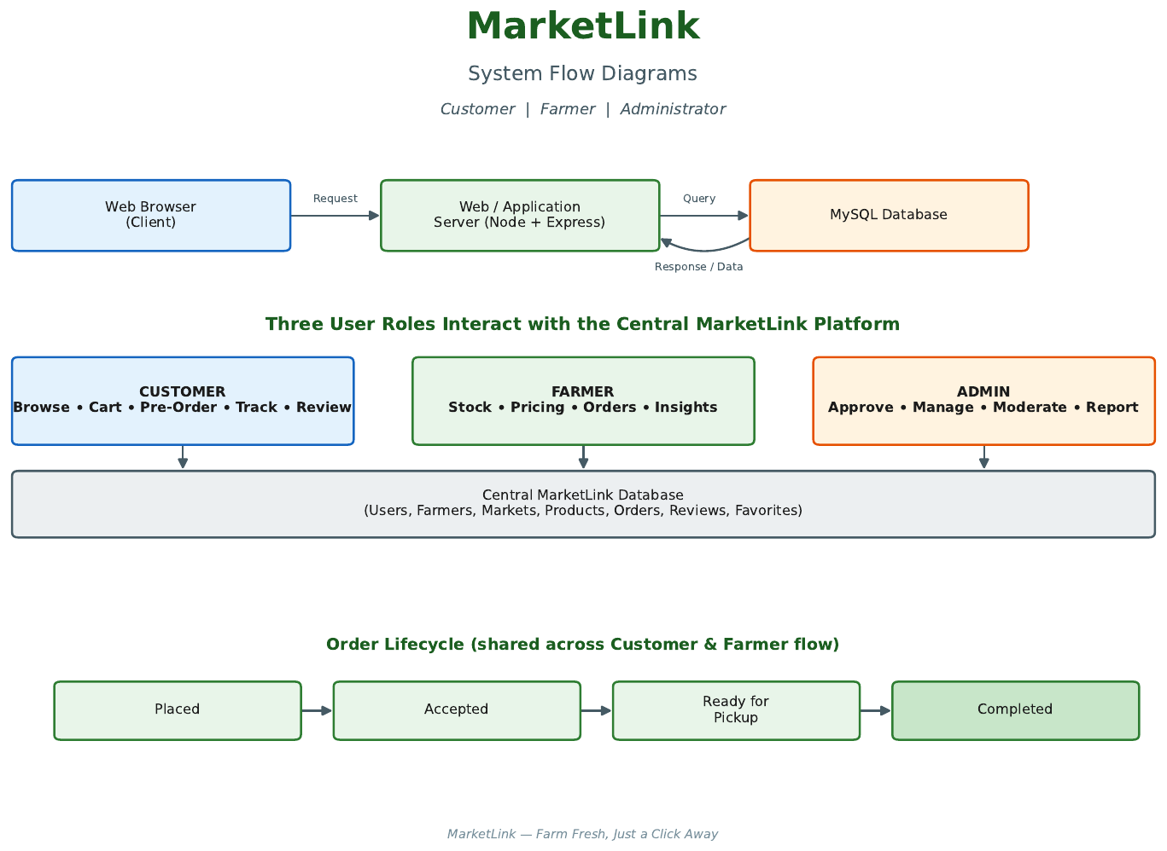
Figure 1: System architecture, user roles and order lifecycle

5.2 Entity Relationship Diagram
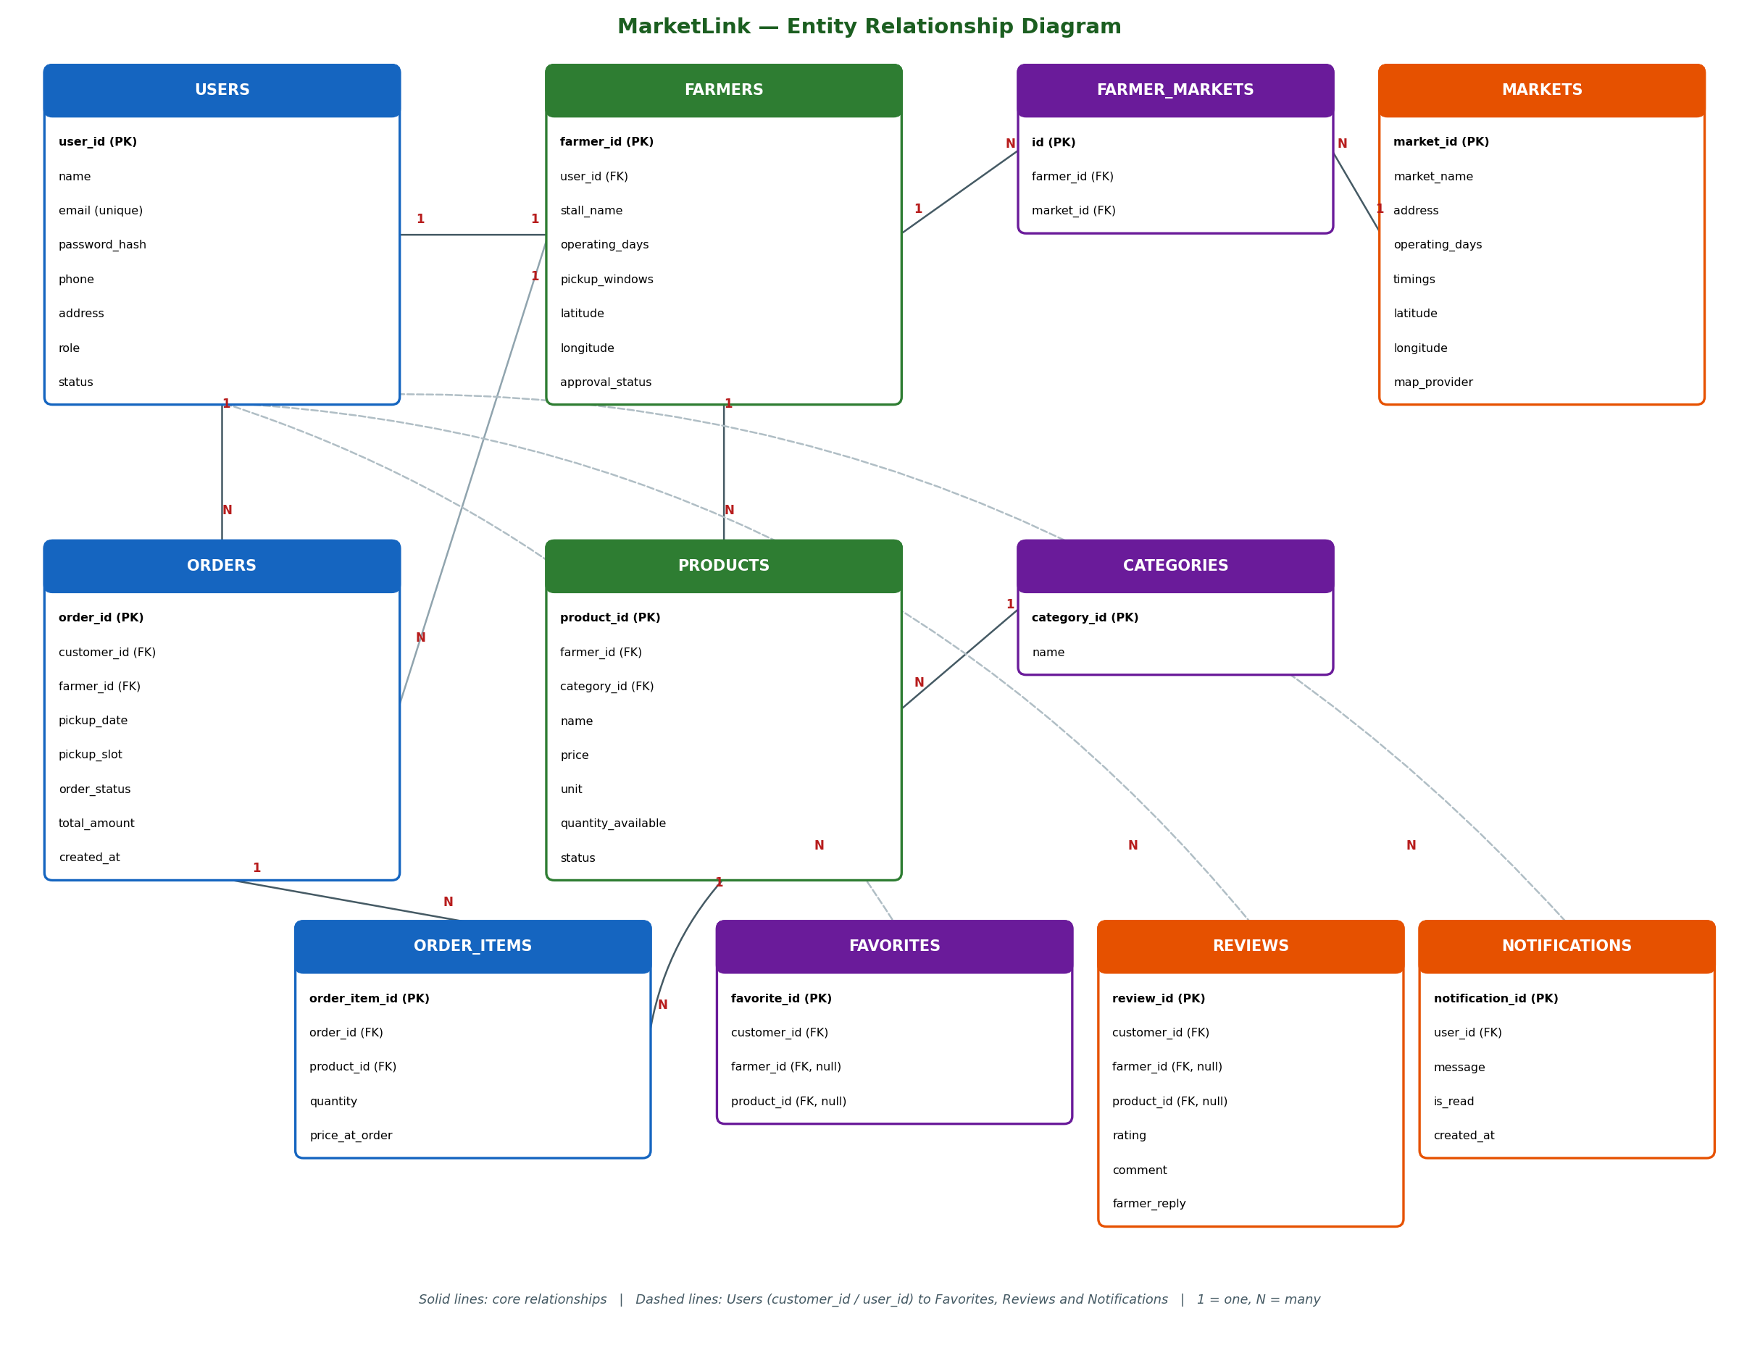
Figure 2: Entity relationship diagram

5.3 Customer Flowchart
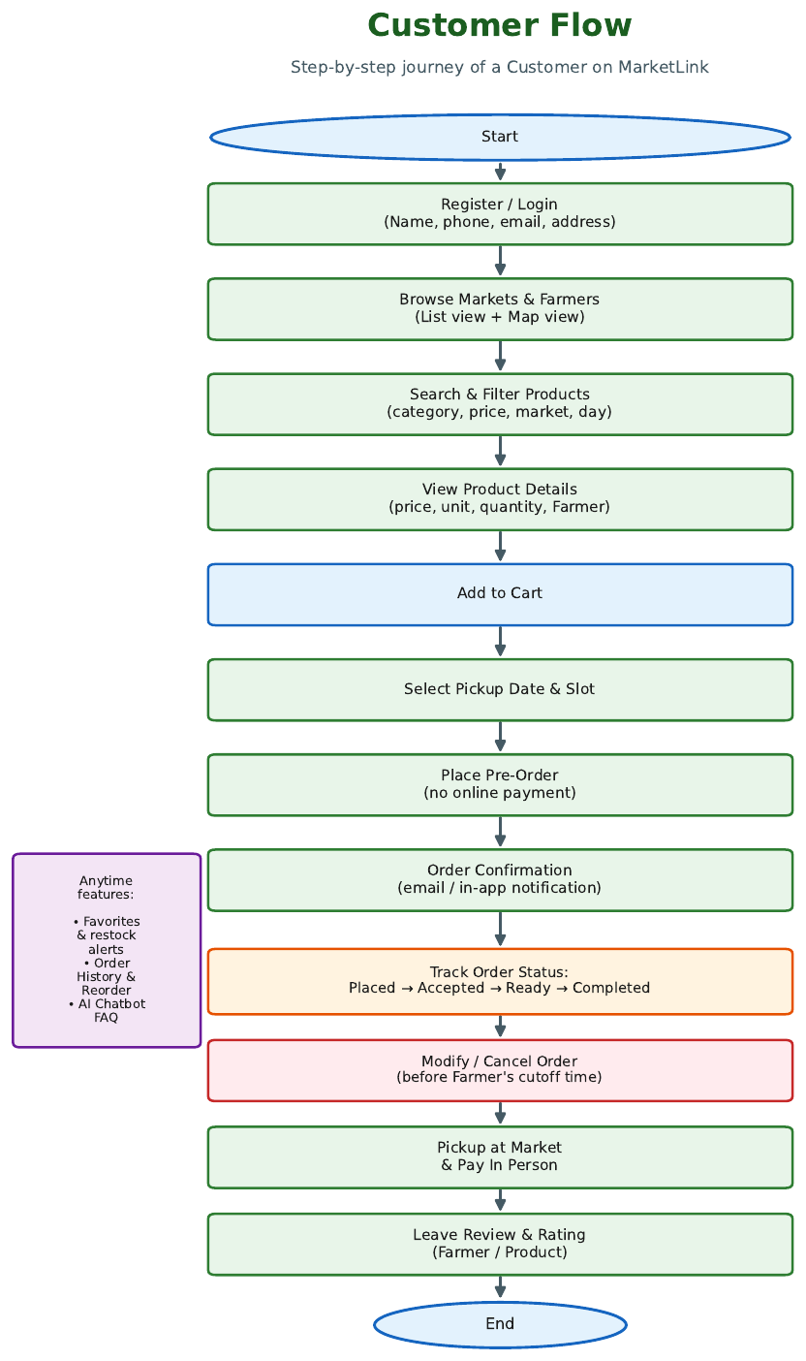
Figure 3: Customer flow

5.4 Farmer Flowchart
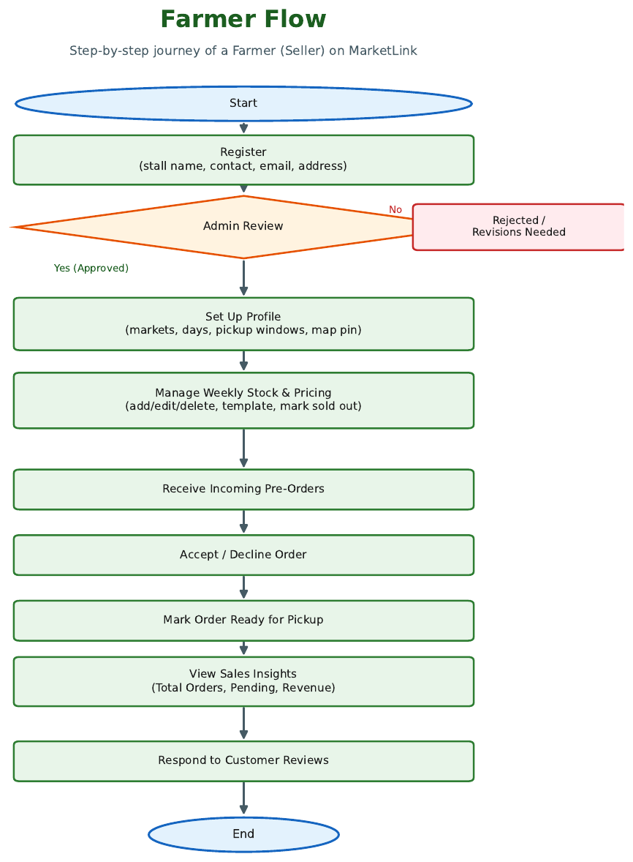
Figure 4: Farmer flow

5.5 Administrator Flowchart
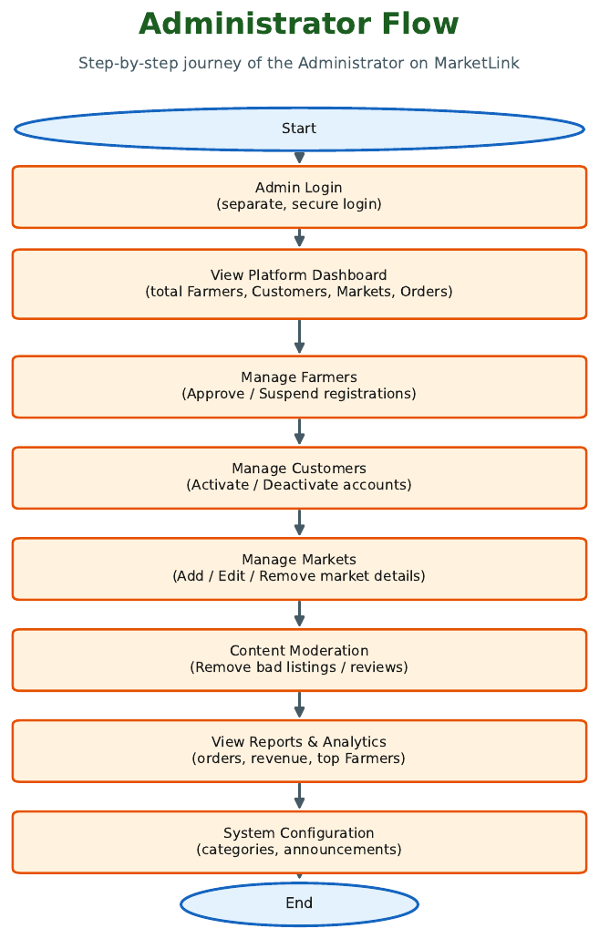
Figure 5: Administrator flow

6. Database Design
The ER diagram is shown in Figure 2. The main tables are listed below. PK = primary key, FK = foreign key; data types follow MySQL.
Table | Main attributes | Notes
Users | user_id (PK), name, email (unique), password_hash, phone, address, role, status, created_at | role: customer / farmer / admin
Farmers | farmer_id (PK), user_id (FK), stall_name, description, operating_days, pickup window, cutoff_hours, latitude, longitude, approval_status | approval: pending / approved / suspended
Markets | market_id (PK), market_name, address, operating_days, timings, latitude, longitude, map_provider | Coordinates set by Admin on map
Farmer_Markets | id (PK), farmer_id (FK), market_id (FK) | Many-to-many link
Categories | category_id (PK), name | Vegetables, fruits, dairy, baked goods
Products | product_id (PK), farmer_id (FK), category_id (FK), name, description, price, unit, quantity_available, image_url, status | status: available / sold_out / hidden
Orders | order_id (PK), customer_id (FK), farmer_id (FK), pickup_date, pickup_slot, order_status, total_amount, created_at | status: placed / accepted / ready / completed / cancelled
Order_Items | order_item_id (PK), order_id (FK), product_id (FK), quantity, price_at_order | Price stored at order time
Favorites | favorite_id (PK), customer_id (FK), farmer_id (FK, null), product_id (FK, null) | Saved Farmers or products
Reviews | review_id (PK), customer_id (FK), farmer_id (FK, null), product_id (FK, null), rating, comment, farmer_reply, review_date | Rating 1 to 5
Notifications | notification_id (PK), user_id (FK), message, is_read, created_at | In-app alerts
Reports | report_id (PK), generated_by (FK), report_type, generated_at | Admin reports

6.1 Key Relationships
- One User has one Farmer profile (Farmer role); one Farmer sells at many Markets and each Market hosts many Farmers.
- One Farmer has many Products; one Category groups many Products.
- One Customer places many Orders; one Order has many Order_Items, each referring to one Product.
- One User has many Favorites, Reviews and Notifications.

7. Test Data and Test Cases

7.1 Test Data Used
Note: replace the sample values below with the exact records seeded in your database script.
Entity | Sample records
Markets | 3 markets, e.g. Central Farmers Market, Riverside Sunday Market, Green Park Market (with latitude, longitude, days, timings)
Farmers | 5 to 6 approved Farmers plus 1 pending Farmer for the approval test
Categories | Vegetables, Fruits, Dairy, Baked Goods
Products | 10 to 15 products with price, unit, quantity and image; 1 product marked sold out
Customers | 3 to 4 customers, one with existing order history
Orders | Orders in each status: placed, accepted, ready, completed, cancelled
Reviews | A few ratings and comments, one with a Farmer reply

7.2 Test Cases
ID | Module | Scenario | Expected result
TC01 | Auth | Register a customer with valid details | Account created; redirected to login/dashboard
TC02 | Auth | Login with wrong password | Error shown; no access
TC03 | Auth | Customer opens an Admin URL | Access denied by role check
TC05 | Admin | Approve pending Farmer | Farmer can now add products
TC07 | Farmer | Mark product sold out | Product cannot be added to cart
TC08 | Map | Allow location on Markets page | Nearby markets shown sorted by distance
TC10 | Customer | Search and filter by category and price | Only matching products listed
TC11 | Order | Place pre-order with pickup slot | Order created as placed; confirmation shown
TC13 | Order | Cancel order before cutoff | Order set to cancelled; stock restored
TC14 | Order | Cancel order after cutoff | Cancellation blocked
TC15 | Farmer | Accept order then mark ready | Customer sees status updates and notification
TC18 | UI | Open site on mobile screen | Layout adapts; no horizontal scrolling

8. Installation Instructions
These steps assume the stack described in Section 4. Adjust folder and file names to match the final submitted project.

8.1 Prerequisites
- Node.js (LTS version) and npm.
- MySQL Server 8.x with a client such as MySQL Workbench.
- A modern browser (Chrome, Firefox, Edge) and an internet connection for map tiles.
- A code editor such as Visual Studio Code (optional).

8.2 Steps
- Extract the submitted ZIP file to a folder on your computer.
- Open MySQL and create a new database named market link.
- Import the SQL script file (.sql) provided in the database folder into the marketlink database. This creates all tables and loads the test data.
- Open the backend folder. Copy the sample environment file to a file named .env and fill in the database host, user, password and database name, the JWT secret, the server port and the email (SMTP) settings.
- In a terminal inside the backend folder, run npm install, then npm start. The server should report that it is running and connected to the database.
- In a second terminal inside the frontend folder, run npm install, then npm start.
- Open the address shown in the terminal (normally http://localhost:3000) in your browser.
- Log in using the credentials in Section 9 to verify each role.

8.3 Common Problems
Problem | Fix
Cannot connect to database | Check .env values and that MySQL is running.
Port already in use | Change the port in .env or stop the other program.
Map is blank | Check internet connection and browser location permission.
Emails not sent | Verify SMTP settings; in-app notifications still work.

8.4 Hosted Version
Live URL: [insert hosted application URL here]

9. User Credentials
Note: these must exactly match the accounts created by your database script. Update this table before submission.
Role | Name | Email / Username | Password
Admin | Platform Admin | admin@marketlink.com | Admin@123
Farmer | Green Valley Farm | farmer1@marketlink.com | Farmer@123
Farmer | Sunrise Dairy | farmer2@marketlink.com | Farmer@123
Farmer (pending) | New Harvest Stall | farmer3@marketlink.com | Farmer@123
Customer | Customer One | customer1@marketlink.com | Customer@123
Customer | Customer Two | customer2@marketlink.com | Customer@123

10. Project Plan and Team Responsibilities

10.1 Development Phases
Phase | Activities | Output
1. Planning and Design | Requirements checklist, database design, ER diagram, wireframes, task division | Checklist, ER diagram, wireframes
2. Backend | Setup, authentication, role middleware, APIs for products, markets, orders, reviews, admin | Tested REST APIs
3. Frontend | Customer, Farmer and Admin screens, responsive layout, dark mode | Working user interface
4. Integration | Map integration, notifications, optional chatbot, sitemap | Connected application
5. Testing | Role-wise test cases, edge cases, browser and mobile checks | Test report and test data
6. Documentation | Project report, installation guide, credentials, SQL scripts, ReadMe | Final documents
7. Deployment | Hosting, live URL test, demonstration video, final ZIP | Submission package

10.2 Team Responsibilities
Member | Area | Main tasks
[Member 1] | Backend and database | Schema, authentication, all APIs, admin approval logic
[Member 2] | Customer and Farmer frontend | Registration, browsing, cart, orders, Farmer dashboard and stock
[Member 3] | Maps, Admin and extras | Map module, Admin panel, reviews, notifications, reports, chatbot

11. Deployment and Demonstration
- Frontend hosted on Verel or Netlify; backend on Render or Railway; MySQL database on a hosted provider.
- The live URL is tested end to end for all three roles after deployment.
- A demonstration video (.mp4) shows the Customer, Farmer and Admin flows, including the map, orders and reviews.
- The final ZIP contains the project, ReadMe file with assumptions, SQL scripts and this documentation.

12. Assumptions, AI Tools and Future Scope

12.1 Assumptions
- Payment is handled offline at pickup; the system only records order totals.
- Farmers are approved by the Admin based on the information they submit; no external verification is done.
- Customers have a smartphone or computer with internet access.
- Map coordinates entered by Farmers and Admin are accurate.

12.2 AI Tools Acknowledgement
As required by the SRS, the AI tools used during this project are acknowledged here: [list tools used, e.g. Claude for planning and drafting guidance, and any code assistants or design tools, and state what each was used for]. The design, implementation and testing were carried out by the team, who can explain all decisions.

12.3 Future Scope
- Online payment integration and delivery options.
- Verification of Farmer licences and certificates.
- Mobile application and push notifications.
- Recommendation of products based on order history.

