OneAI Assist — Admin User Guide & Operational Manual
Complete Administrator Documentation, Credentials & Verification Screenshots

Login URL | http://localhost:3000/login
Admin Email | admin@primemarketingexperts.com
Default Password | password123
Assigned Role | ADMIN (Agency Administrator)
Tenant Workspace | Prime Marketing Experts (tenant_pme_ff9xl)

1. System Access & Credentials
To access the OneAI Assist workspace as an agency administrator, navigate to http://localhost:3000/login in any web browser.
Log in using email: admin@primemarketingexperts.com and password: password123. Administrators have full access to workspace settings, AI bot tuning, WhatsApp templates, and lead management.
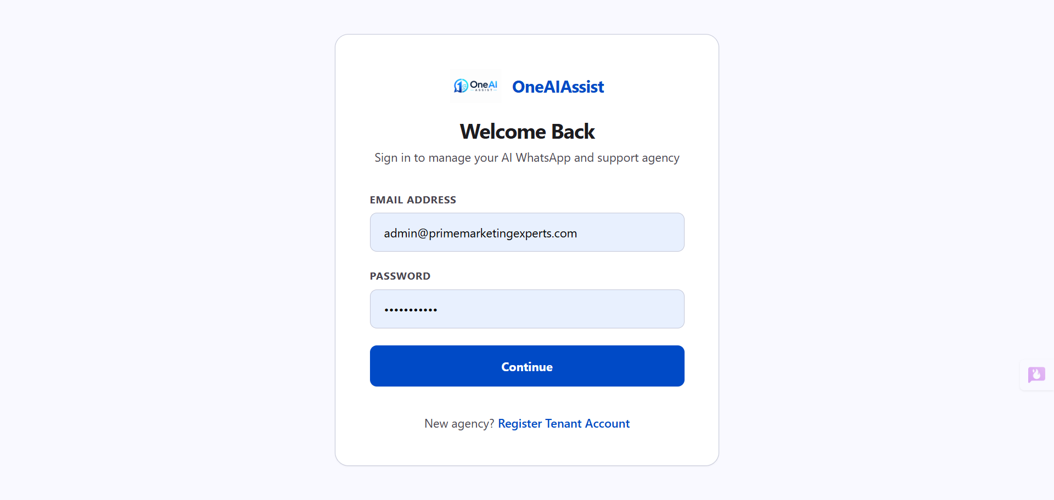
Figure 1: Login Screen with OneAIAssist Logo and Credentials Form

2. Dashboard Overview & Key Performance Metrics
The main agency overview page at http://localhost:3000/dashboard provides real-time visibility into active customer conversations, monthly leads, policies sold, and bot resolution metrics.
All KPI cards and activity feed items are dynamically loaded from underlying PostgreSQL database records for Prime Marketing Experts.
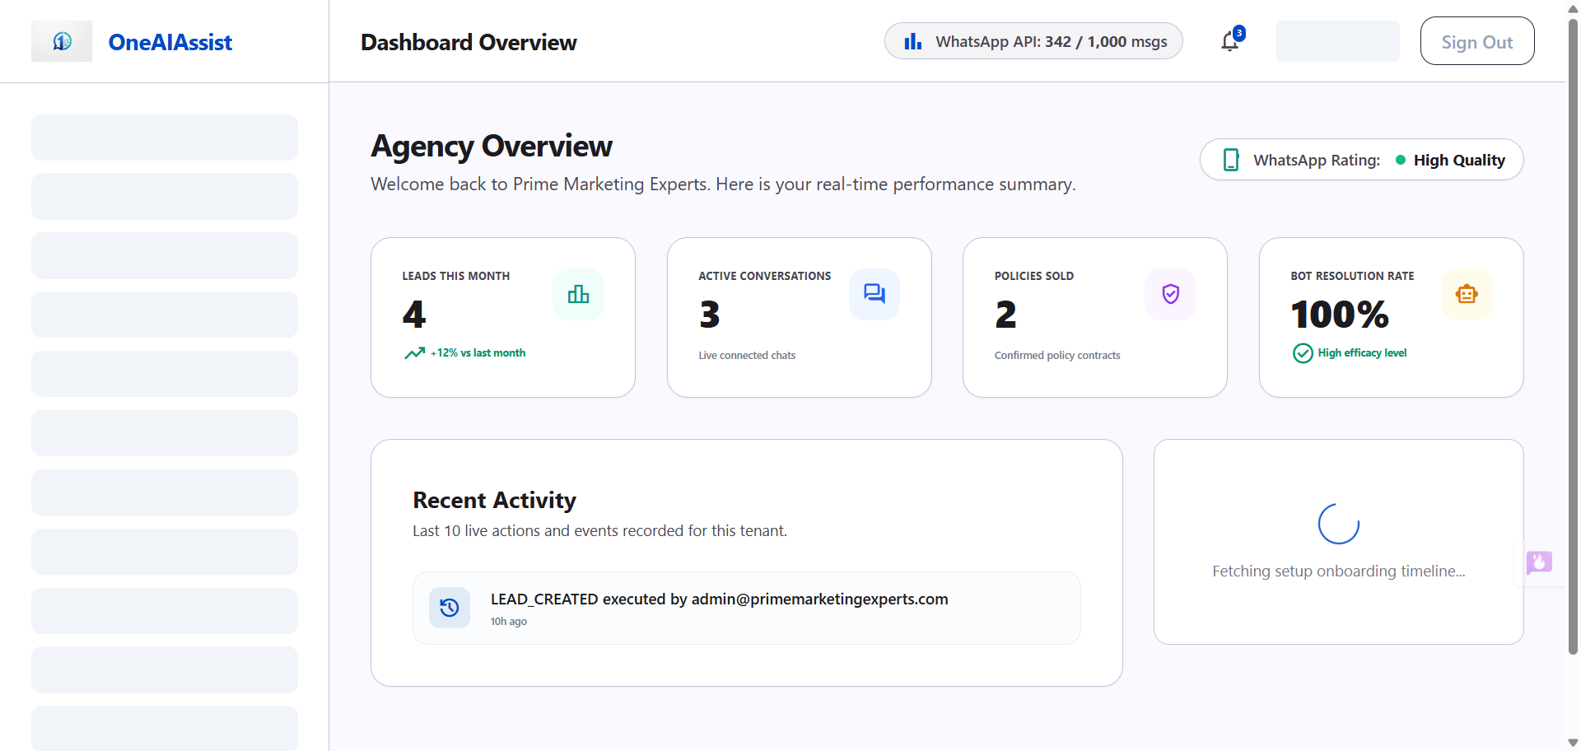
Figure 2: Agency Dashboard Overview displaying live KPI metrics and branding logo

3. WhatsApp Business Integration & QR Connect
The Agency Settings page at http://localhost:3000/dashboard/settings enables administrators to connect their WhatsApp Business phone number using QR code scanning or 8-character pairing codes.
Once connected, the engine handles automated lead intake, RAG policy Q&A, and live agent handoffs seamlessly.
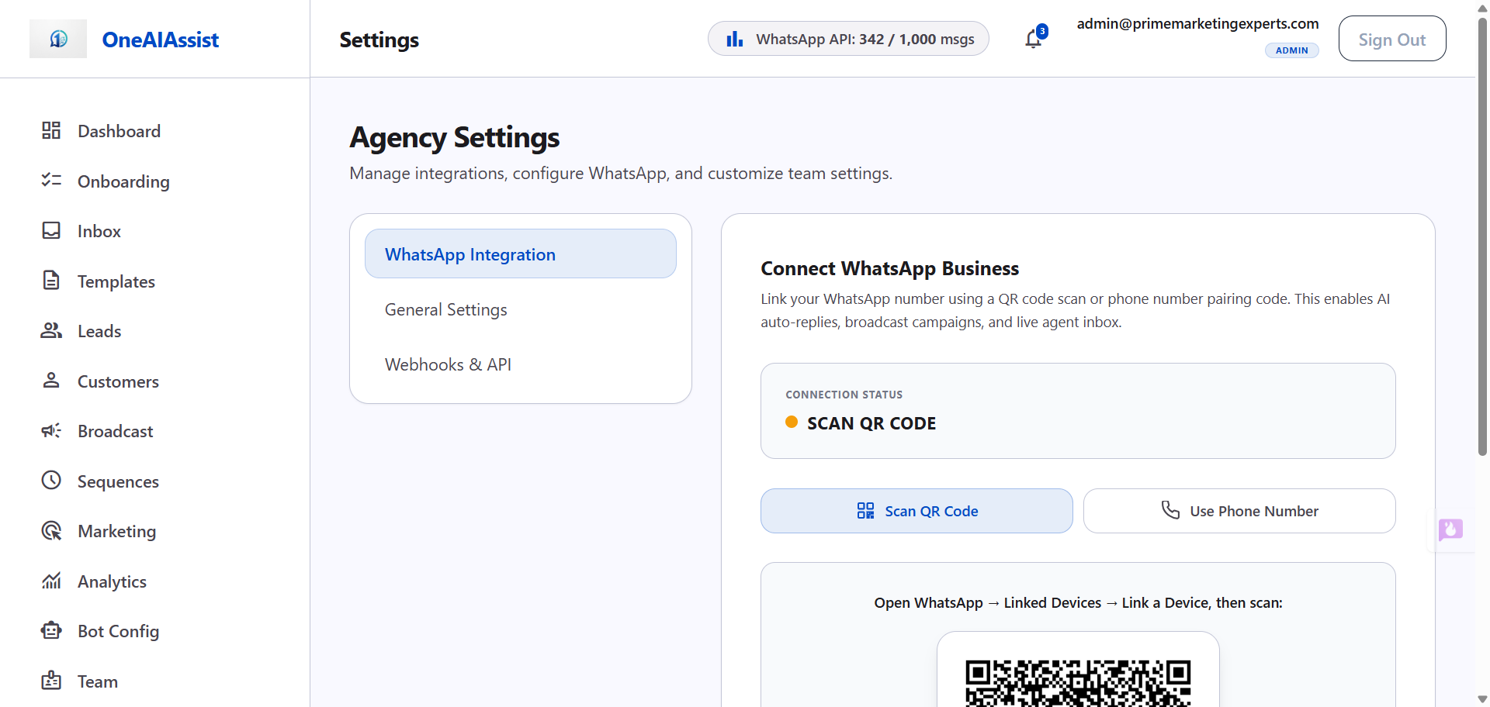
Figure 3: Agency Settings — WhatsApp Business Connection with Scannable QR Code

4. AI Bot Studio & Flow Builder
The Bot Configuration Studio at http://localhost:3000/dashboard/bot-config features a drag-and-drop intake question flowchart canvas.
Admins can configure validation rules, required fields, and conditional skip logic branching for automated customer qualification.
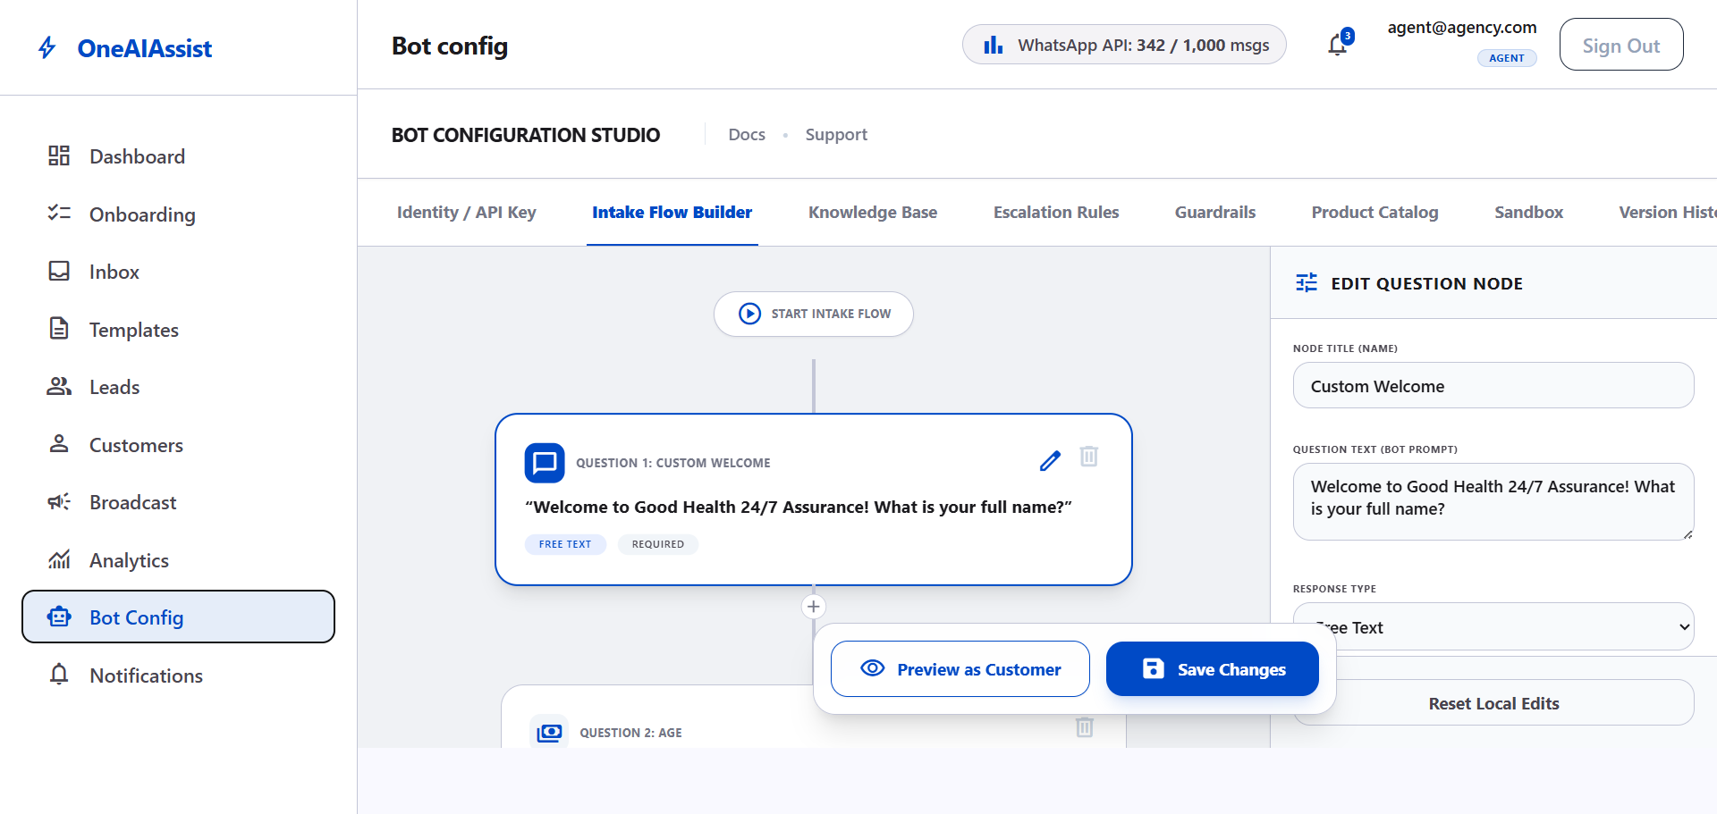
Figure 4: Bot Configuration Studio — Interactive Intake Question Flow Builder Canvas

5. Knowledge Base & Vector RAG Document Index
The Knowledge Base tab under http://localhost:3000/dashboard/bot-config allows administrators to upload insurance policy PDFs (e.g. Apex Health Care plans).
PDF text is extracted, chunked, and embedded into pgvector / Pinecone vectorstore using Google text-embedding-004 to power intelligent customer answers.
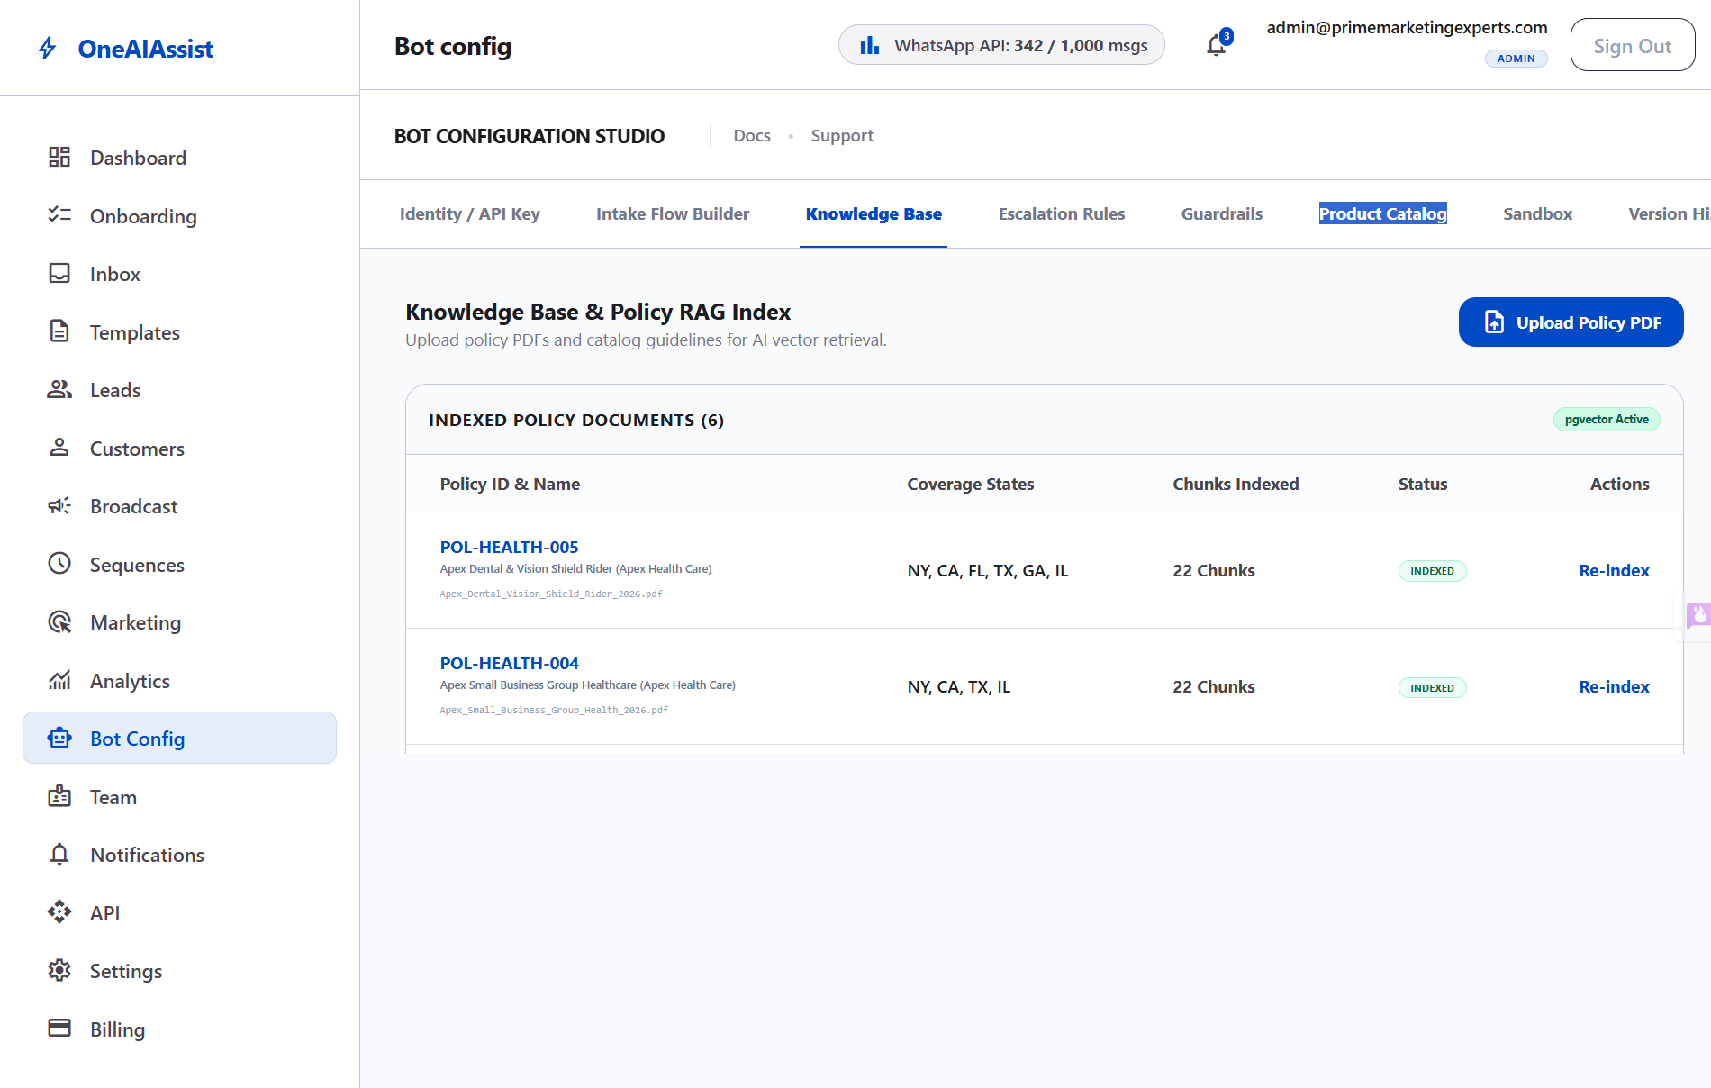
Figure 5: Knowledge Base Tab displaying indexed U.S. Health Insurance policy documents

6. Insurance Product Catalog
The Product Catalog tab lists all managed health insurance products, states covered, monthly premium ranges, and maximum sum insured amounts.
Data is dynamically fetched from database PolicyCatalogItem records to ensure accurate quote generation.
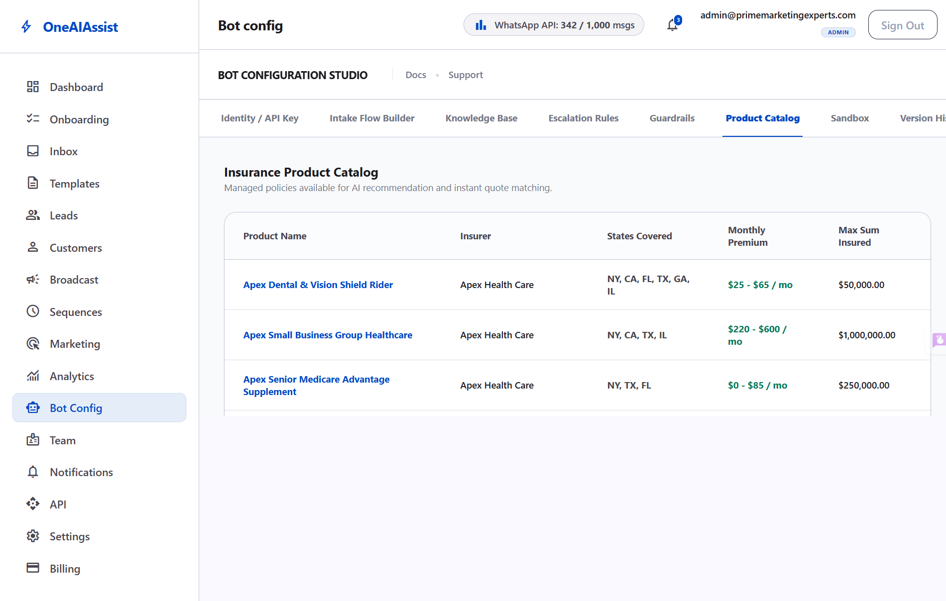
Figure 6: Insurance Product Catalog displaying managed policies and monthly premiums

7. WhatsApp Template Manager
The Template Manager at http://localhost:3000/dashboard/templates allows creating and approving marketing, utility, and authentication message templates with variable placeholders.
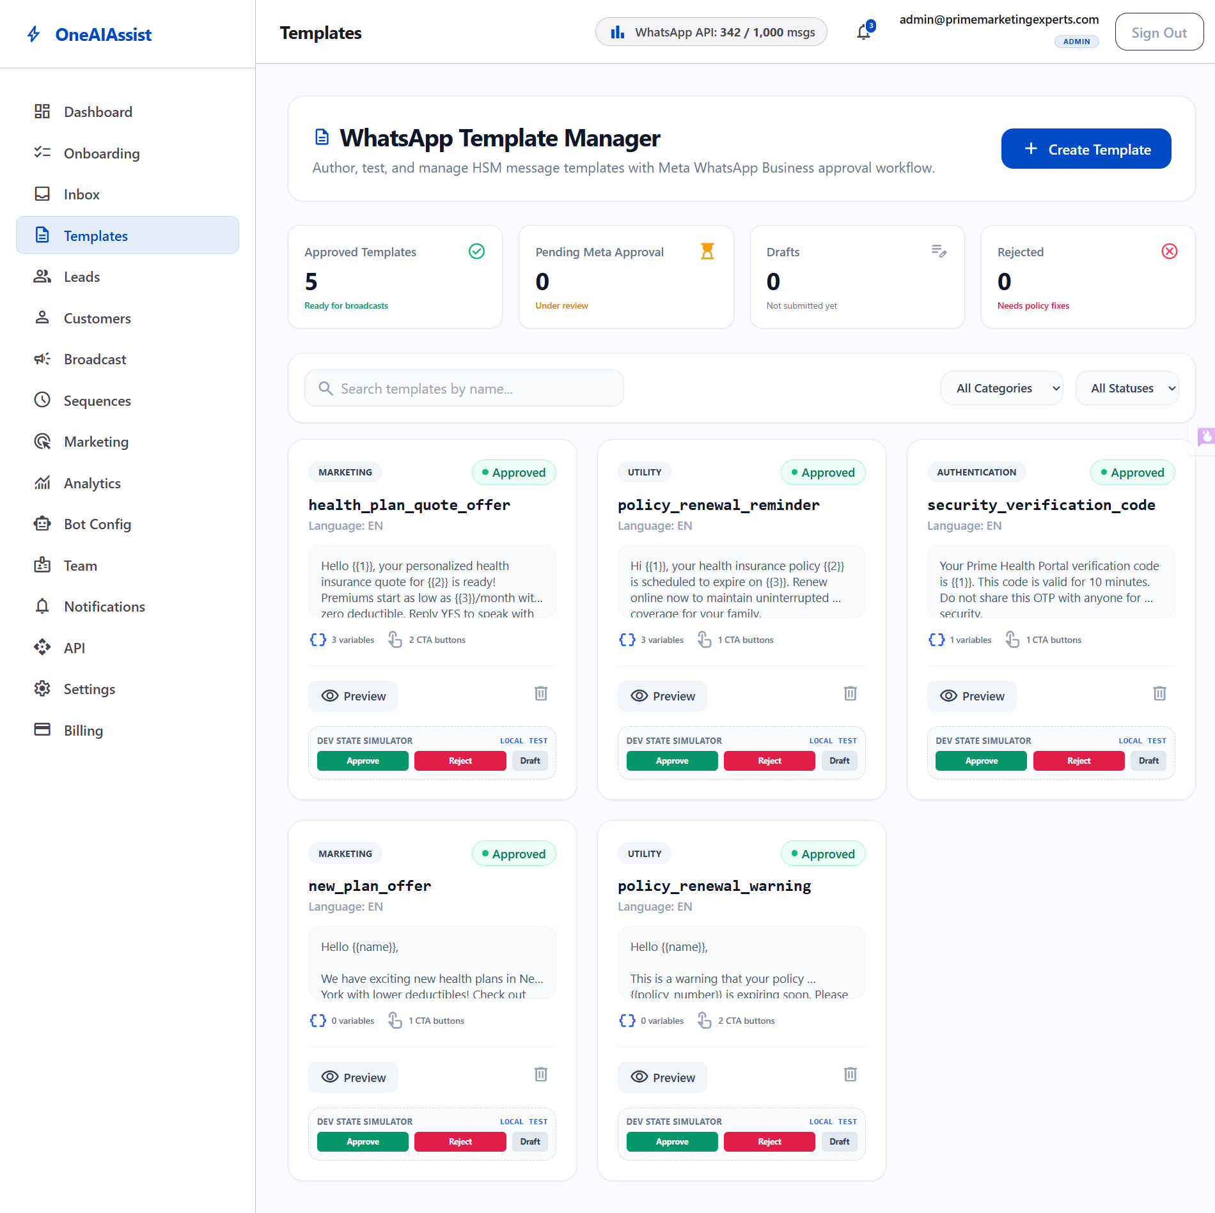
Figure 7: WhatsApp Template Manager displaying approved message templates

8. Broadcast Campaign Center
The Broadcast Center at http://localhost:3000/dashboard/broadcast lets admins launch targeted bulk WhatsApp messaging campaigns based on customer tags and pipeline stages.
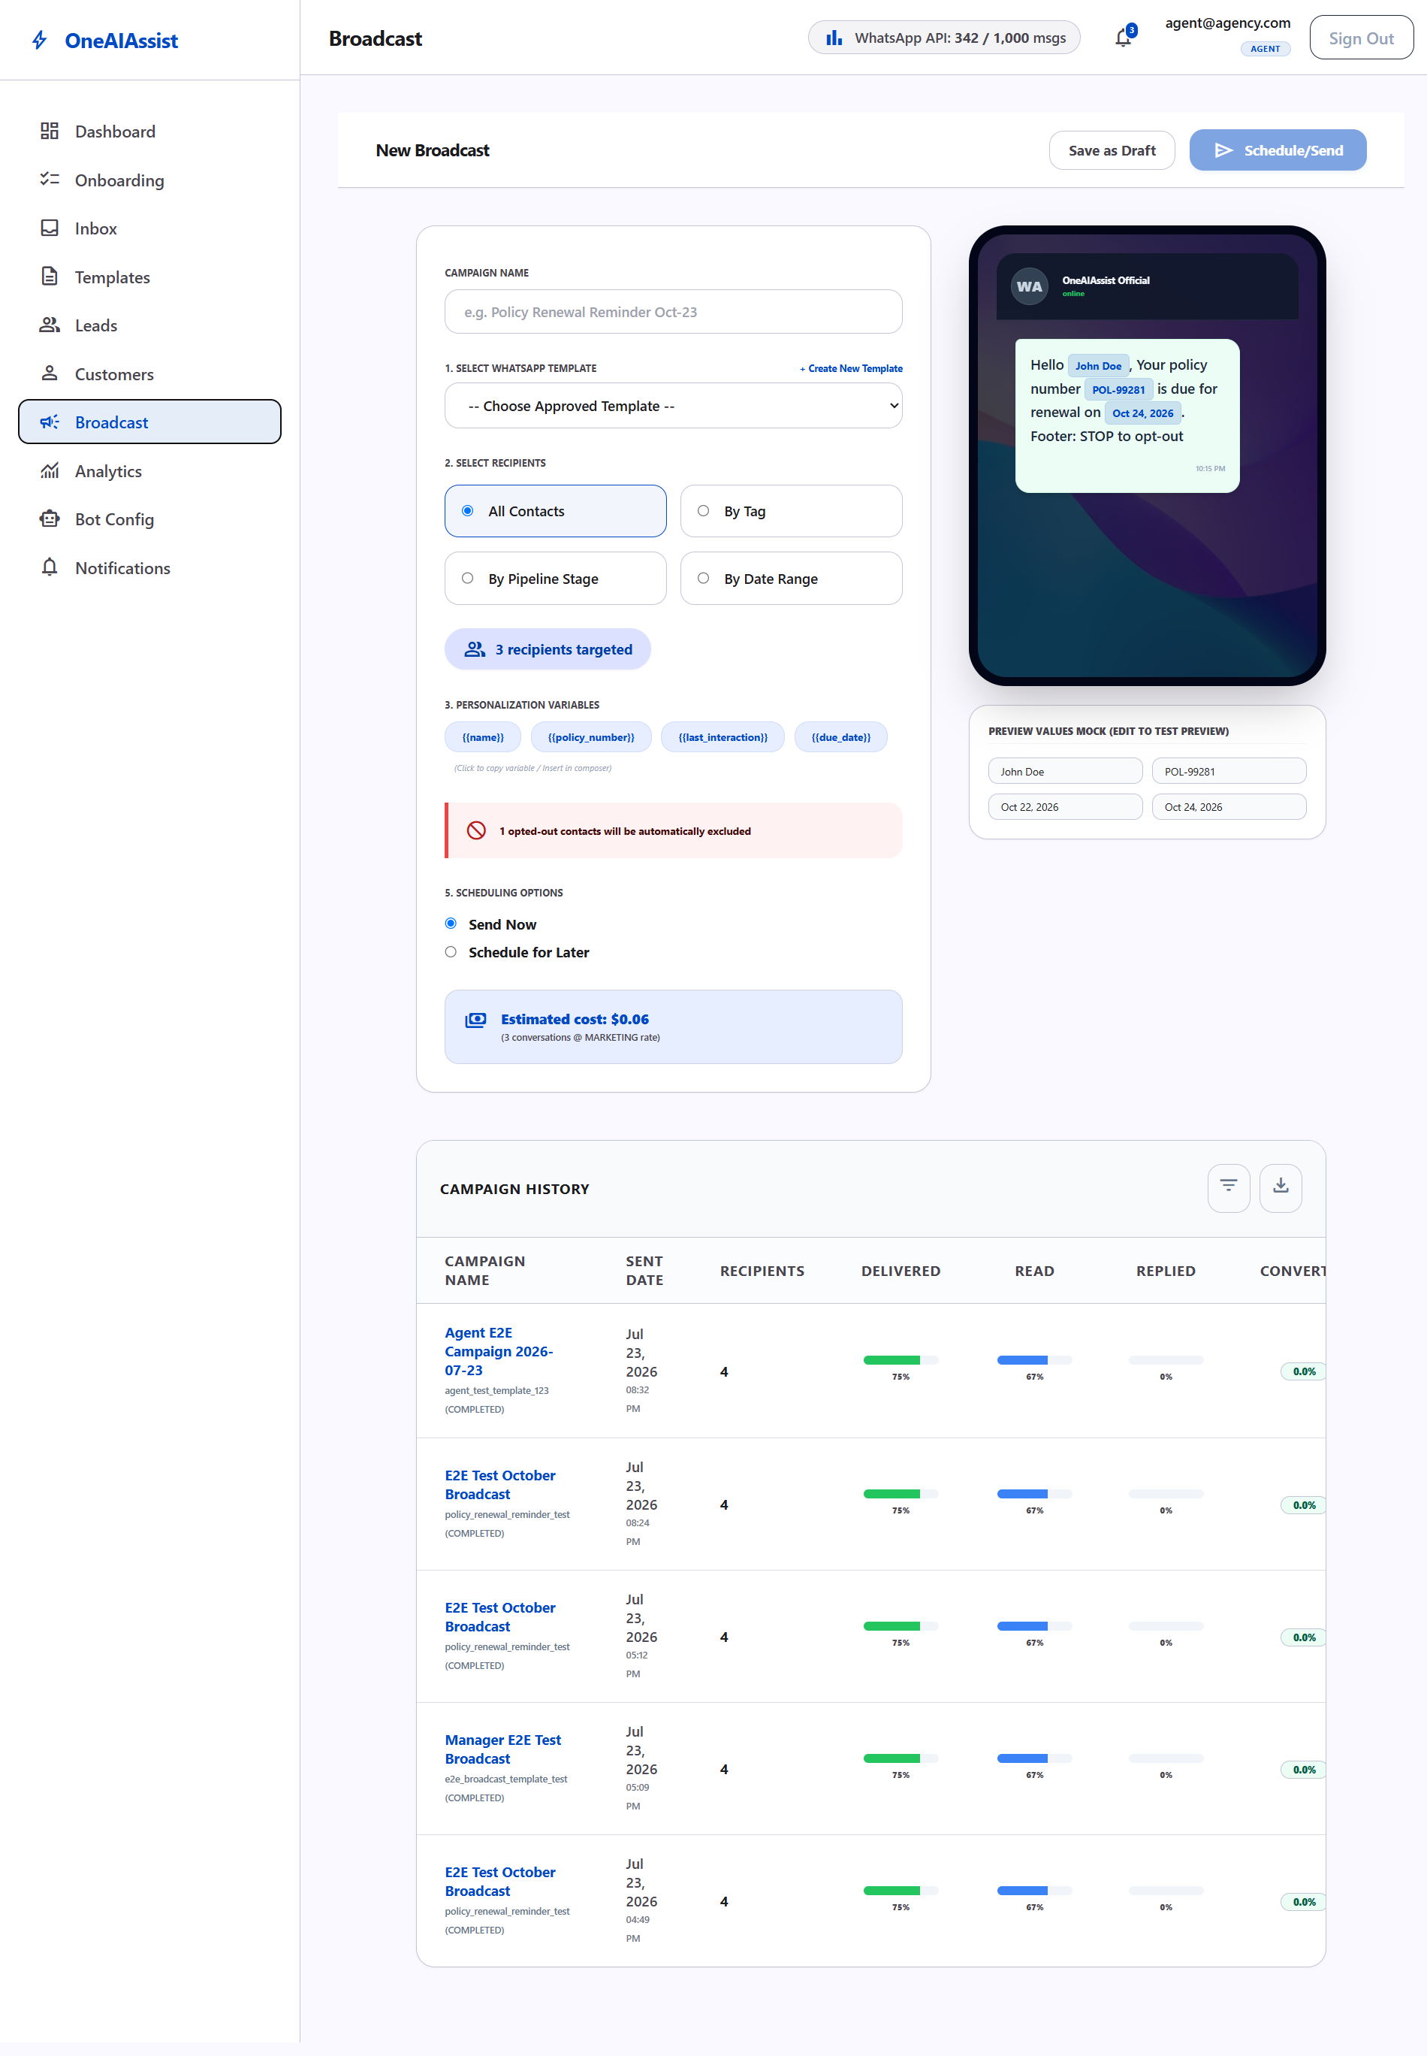
Figure 8: Broadcast Campaign Center for target bulk messaging

9. Lead Pipeline & CRM Management
The Lead Pipeline at http://localhost:3000/dashboard/leads tracks customer opportunities from initial inquiry to policy activation in dual Kanban and table views.
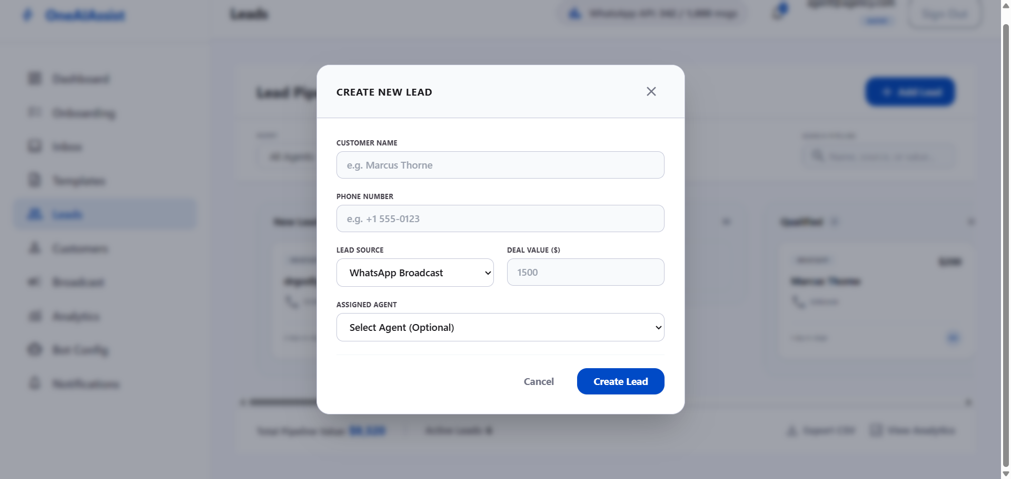
Figure 9: Lead Pipeline Kanban Board with + Add Lead Dialog

10. Customer Directory & 360° Profile View
The Customer Directory at http://localhost:3000/dashboard/customers maintains all customer contact records, opt-in consent statuses, and historical policy engagements.
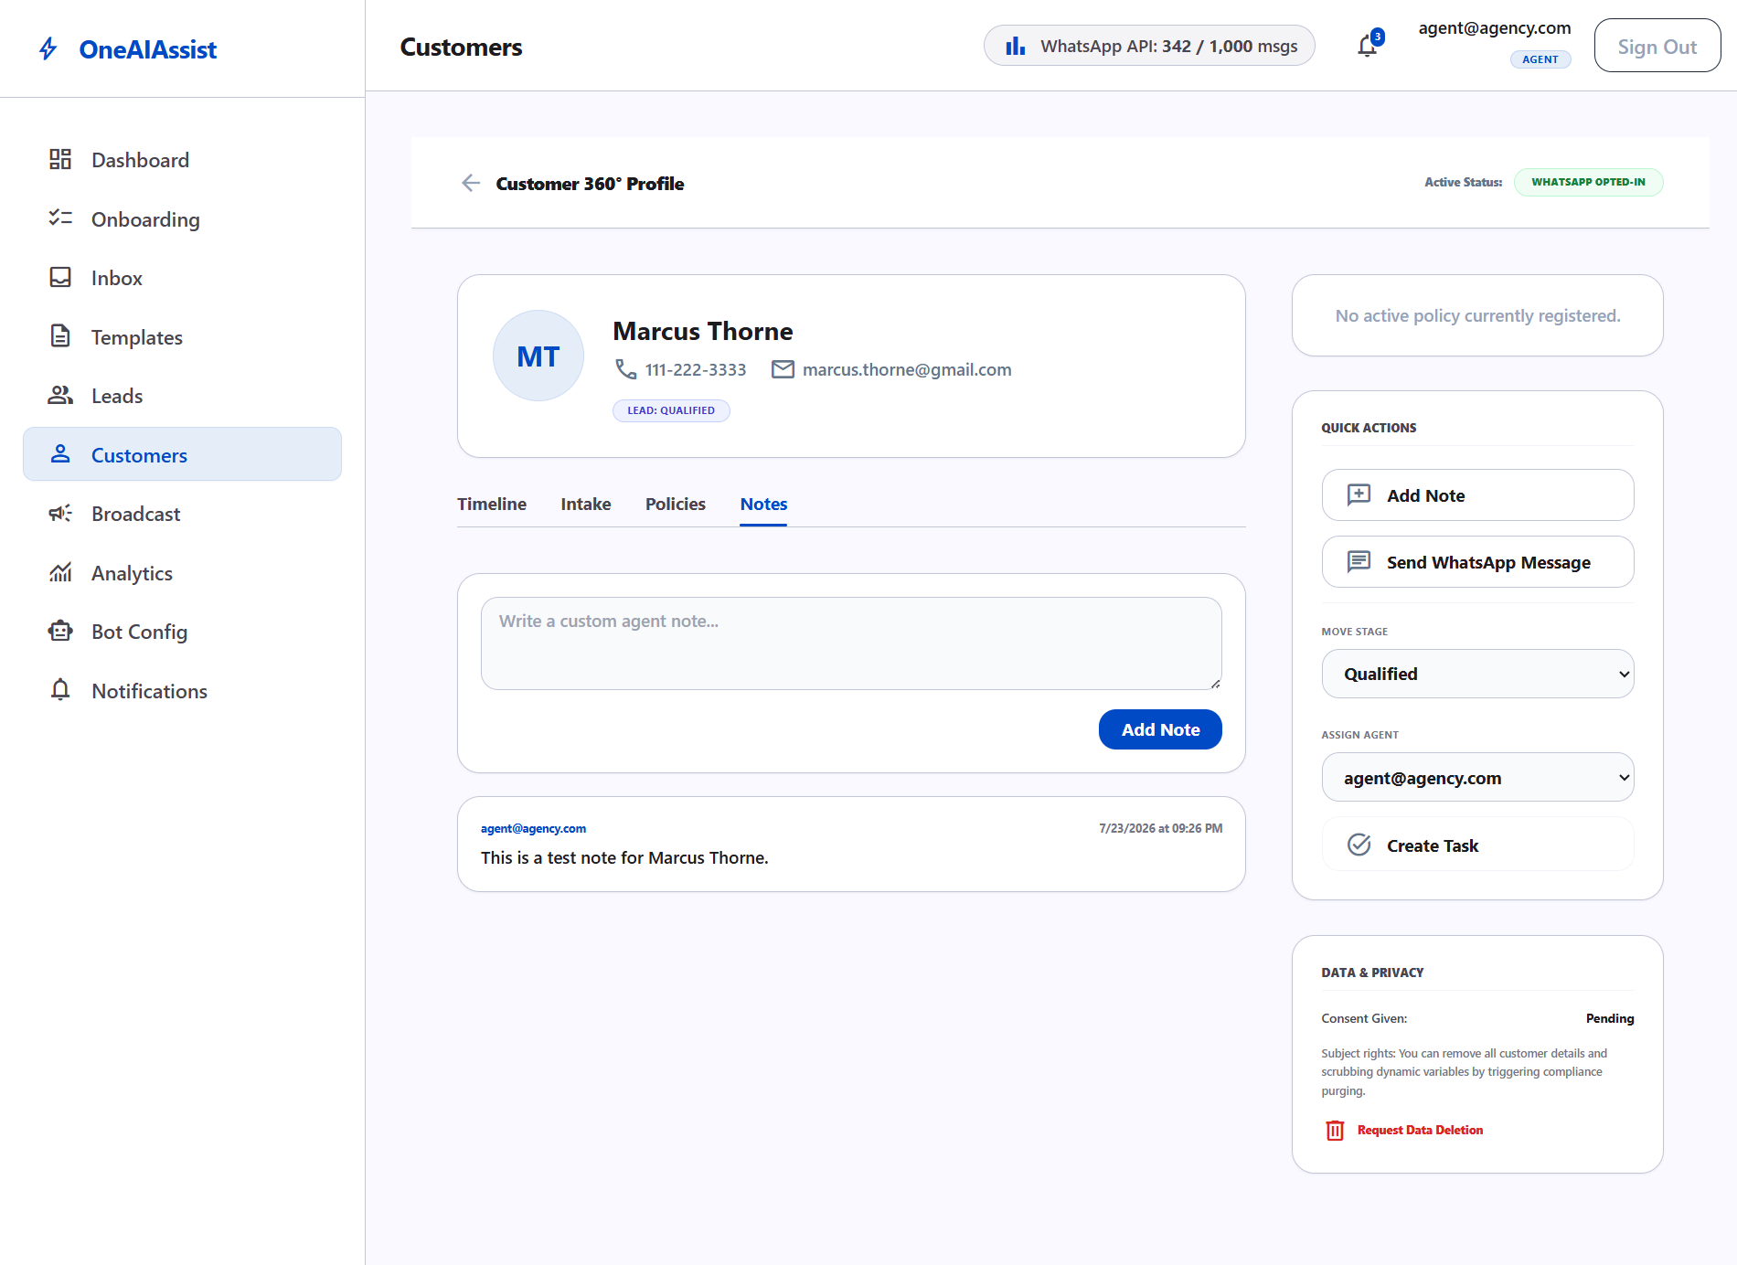
Figure 10: Customer 360° Profile View with policy history

