TEAM PHSS
PRELIMINARY DESIGN REPORT
Rapid-Response Defibrillator Drone
Problem Understanding and Assumptions
Core Problem Statement & Mission Objectives
The core objective of this project is to engineer a fully autonomous, heavy-lift hexacopter capable of delivering a 2.5 kg Automated External Defibrillator (AED) to a target location within a 5.0 km operational radius. The mission profile demands high-speed transit, autonomous target acquisition, and safe payload deployment without requiring human interaction at the drop zone.
To satisfy the rigorous demands of emergency medical logistics, the drone must achieve the following specific performance metrics:
- Transit Speed: Maintain a continuous ground speed of 70 km/h (19.44 m/s) to ensure rapid response times during the critical "golden minutes" of a cardiac emergency.
- Environmental Resilience: The propulsion and avionics architecture must be engineered to operate reliably in active rainfall and overcome sustained headwinds.
- Deployment Safety: The payload must be lowered via an autonomous winch system from a safe hovering altitude (20 meters) to prevent dangerous rotor downwash from impacting medical responders or bystanders.
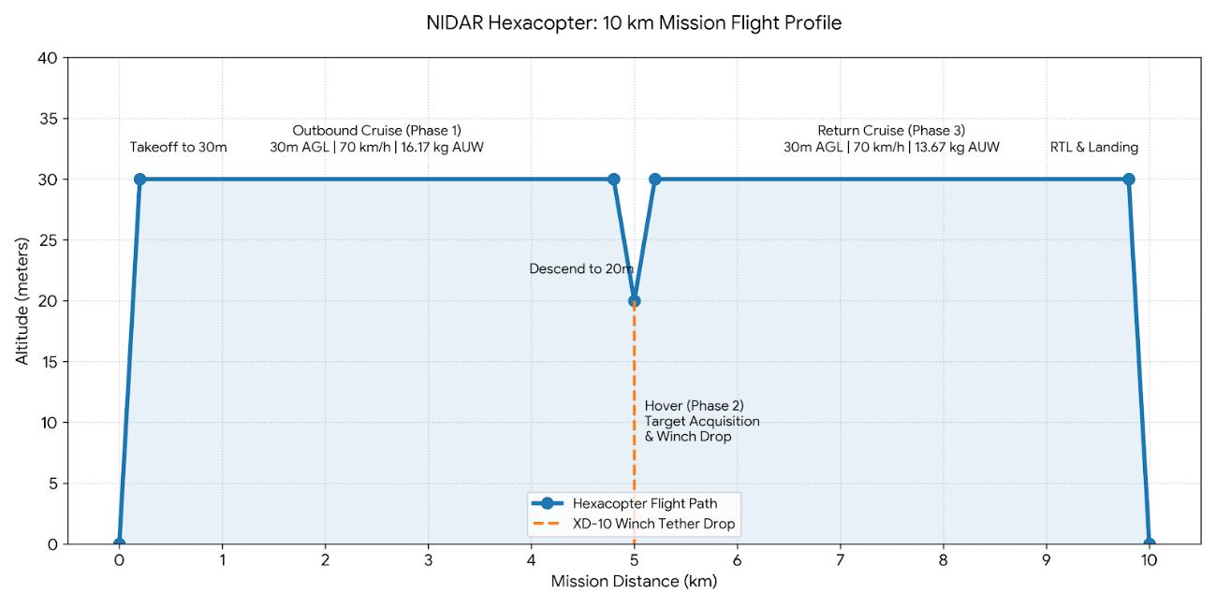
Engineering Assumptions
To construct a viable physics and aerodynamic model for the UAV, several baseline assumptions were established regarding the operating environment and hardware characteristics:
- Aerodynamic Drag Modeling: The UAV's chassis, combined with the slung 2.5 kg AED payload and the XD-10 mechanical winch system, forms an irregular bluff body. For mathematical modeling, the equivalent frontal area ($A$) is assumed to be $0.25{\text{ m}}^{2}$ with a conservative Drag Coefficient ($C_{d}$) of $1.0$.
- Environmental Degradation: To simulate the adverse effects of rain on the airfoil's boundary layer and effect on motor, the motor efficiency curve (g/W) is artificially degraded by 15% across all flight regimes. Even though the motors selected are waterproof and it is highly unlikely the the efficiency will degrade by 15% in normal situations but to consider extreme situations and prove the working of our designed drone in such conditions we have taken this into consideration.
- Air Density: Calculations assume a standard sea-level air density ($ρ$) of $1.225{\text{ kg/m}}^{3}$. The negligible density variation between the 30-meter cruise altitude and the 20-meter drop altitude is ignored for steady-state power profiling.
- Headwind Limits: The 70 km/h ground speed requirement must be met dynamically. We assume the UAV will encounter varying headwind scenarios, capping the maximum safe operational headwind at 5 m/s (18 km/h) to prevent the 23x8.8 propellers from exceeding their true airspeed stall limit of 26.24 m/s.
- Winch Mechanics: The XD-10 winch system (utilizing the mechanical release hook) lowers the payload at a maximum rate of 0.6 m/s. We assume a 120-second total hover duration at the drop zone to allow for a 33-second descent, a 33-second retraction, and a 54-second optical target acquisition buffer.
- Dropping Location: We have assumed to know the drop location before hand.

Concept Selection and Trade-offs
Airframe Architecture: Multirotor vs. Fixed-Wing VTOL
- The primary conceptual trade-off for the AED delivery system centered on selecting the optimal airframe architecture to fulfill the 5 km operational radius while meeting strict safety and payload deployment requirements. The evaluation focused heavily on the comparative advantages of a Hexacopter Multirotor against a Hybrid Fixed-Wing Vertical Take-Off and Landing (VTOL) platform.
- While VTOL drones dramatically outperform multirotors in endurance by achieving 1.5 to 3 times longer flight times through aerodynamic efficiency in forward flight, the multirotor architecture was selected as the superior platform for this specific urban emergency medical mission. The decision to reject the VTOL concept was driven by three critical engineering and operational constraints:
- The Transition Corridor Vulnerability
- Payload Deployment and Hover Stability
- Maneuverability in Confined Airspace
Propulsion Trade-off: Hobbywing X6 vs. T-Motor P60 The selection of the propulsion system required balancing raw thrust capability against hardware weight and efficiency. The two primary candidates evaluated for the hexacopter were the Hobbywing XRotor X6 Plus (KV150/170) and the T-Motor P60 Pin KV170.
- T-Motor P60 (Rejected): The P60 is a highly regarded agricultural UAV motor offering a maximum thrust of 8.4 kg per axis. It features an impact-resistant and waterproof design, which is highly advantageous for the required rain-operation parameters of this mission. However, for a 16.17 kg hexacopter required to dynamically pitch into 10 m/s wind gusts while carrying an underslung payload, a system ceiling of 50.4 kg of thrust (8.4 kg × 6) provides an inadequate thrust-to-weight ratio for safe urban maneuvering.
- Hobbywing X6 (Selected): The Hobbywing X6 provides a significantly higher maximum thrust of 11.8 kg per axis (at 46V, sea level), yielding a total system thrust of 70.8 kg. Furthermore, it carries an IPX6 safety rating, ensuring it meets the mission's strict rainfall requirements. The massive thrust ceiling (providing a >4:1 TWR) ensures the flight controller retains total control authority and pitch stability when aggressively correcting against wind shear during the 70 km/h transit and the critical 20-meter drop phase.
Power Source Trade-off: 14S 22000mAh vs. 14S 12000mAh LiPo The battery sizing fundamentally dictates the All-Up Weight (AUW) and dynamic responsiveness of the aircraft. In high-voltage heavy-lift platforms, 14S batteries are standard. We evaluated a massive 22000mAh pack against a leaner 12000mAh pack.
- 14S 22000mAh (Rejected): A larger capacity battery theoretically provides longer flight times, but it introduces severe weight penalties. In a multirotor system, carrying excessive battery weight that is not strictly required for the mission profile creates a cascading engineering failure: the motors must work harder to lift the heavier battery, which draws more current, generates more heat, and diminishes the aerodynamic efficiency required to hit the 70 km/h ground speed target.
- 14S 12000mAh (Selected): Our mathematical power profiling proved that the 10 km round-trip mission consumes exactly 504.6 Wh of energy. The GenX 14S 12000mAh battery holds 621.6 Wh, providing an 18.8% energy reserve. By selecting the smaller 12000mAh pack, we shed critical dead weight from the AUW. This maximizes the thrust-to-weight ratio, ensuring the drone can overcome aerodynamic drag and blade stall margins in 5 m/s headwinds without suffering the severe voltage sag or thermal stress associated with lifting an oversized 22000mAh pack.

Weight Assumptions:
Component | Specification / Assumption | Mass (kg)
Propulsion (6x) | Hobbywing X6 (KV170) with 24x8 folding propellers | 4.32
Power Source | GenX 14S LiPo (51.8V nominal, 12,000 mAh, 20C) | 3.39
Airframe & Avionics | Chassis, Pixhawk, wiring, landing gear | 4.00
Winch System | 10 kg capacity spool, motor, manual release hook | 1.76
Payload | Automated External Defibrillator (AED) | 2.50
Total All-Up Weight (AUW) | $$W_{mass}$$ | 15.97

Powertrain Viability & Thrust Margins
- Maximum System Thrust: 70.8 kg (11.8 kg per X6 axis)
- Thrust-to-Weight Ratio (TWR): 70.8 kg / 15.97 kg = 4.43:1
- Electrical Headroom: The GenX battery provides a 240A continuous discharge limit, which safely covers the ~49 Amp hover requirement and any extreme power spikes caused by the winch dynamically loading the chassis during the drop.
The powertrain easily absorbs the additional 1.5 kg winch mass while maintaining an aggressive 4.43:1 TWR, providing excellent stability during the high-stress loiter/drop phase.

The Propeller Pitch Limitation
Before analyzing thrust vectors, we must establish the physical speed limit of the 23x8.8 propeller. A multirotor cannot fly faster than the pitch speed of its blades; exceeding this causes the propellers to enter a zero-thrust vacuum state (stall).
Using an estimated 80% loaded motor efficiency under aerodynamic resistance:
$$RPM=KV×V_{nominal}×0.80$$
$$RPM=170×51.8×0.80=7044\text{ RPM}$$
$$V_{pitch}=\frac{RPM×\text{Pitch (inches)}×0.0254}{60}$$
$$V_{pitch}=\frac{7044×8.8×0.0254}{60}=26.24\text{ m/s}$$
The maximum theoretical airspeed of the drone is 26.24 m/s (94.5 km/h).
[ NOTE ASSUMPTIONS :]
Environmental & Aerodynamic Constants:
- Air Density ($ρ$): $1.225{\text{ kg/m}}^{3}$ (Standard sea-level)
- Frontal Area ($A$): $0.25{\text{ m}}^{2}$ (Estimated bluff body including payload)
- Drag Coefficient ($C_{d}$): $1.0$
- Target Ground Speed ($V_{g}$): $70\text{ km/h}$ ($19.44\text{ m/s}$)
- Total Weight Force ($W$):
$$W=m⋅g=15.97\text{ kg}×9.81{\text{ m/s}}^{2}=156.67\text{ N}$$
- Required Airspeed ($V_{a}$):
$$V_{a}=V_{g}+V_{w}=19.44\text{ m/s}+V_{w}$$
$V_{w}$ = velocity of headwind
- Aerodynamic Drag ($D$):
$$D=\frac{1}{2}ρC_{d}AV_{a}^{2}=0.5×1.225×1.0×0.25×V_{a}^{2}=0.153125⋅V_{a}^{2}\text{ [N]}$$
- Total Thrust Vector ($T_{total}$):
$$T_{total}=\sqrt{W^{2}+D^{2}}$$
- Pitch Angle ($θ$):
$$θ=\arctan\left(\frac{D}{W}\right)$$
- System Throttle Requirement:
$$\text{Throttle}=\frac{T_{total}}{T_{max}} \left(T_{max}=70.8\text{ kg}=694.5\text{ N}\right)$$
- Aerodynamic Pitch Speed Limit:
$$V_{pitch}=26.24\text{ m/s} \left(94.46\text{ km/h}\right)$$

Metric | Case 0: No Wind (0 m/s) | Case 1: Light Wind (2 m/s) | Case 2: Moderate Wind (5 m/s) | Case 3: Fresh Breeze (7 m/s) | Case 4: Strong Wind (10 m/s)
Target Ground Speed ($V_{g}$) | 19.44 m/s (70 km/h) | 19.44 m/s (70 km/h) | 19.44 m/s (70 km/h) | 19.44 m/s (70 km/h) | 19.44 m/s (70 km/h)
Required Airspeed ($V_{a}$) | 19.44 m/s (70 km/h) | 21.44 m/s (77.2 km/h) | 24.44 m/s (88.0 km/h) | 26.44 m/s (95.2 km/h) | 29.44 m/s (106.0 km/h)
Parasitic Drag Force ($D$) | 57.88 N (5.90 kgf) | 70.40 N (7.18 kgf) | 91.48 N (9.33 kgf) | 107.05 N (10.91 kgf) | 132.72 N (13.53 kgf)
Total Thrust Vector ($T_{total}$) | 167.01 N (17.02 kgf) | 171.74 N (17.51 kgf) | 181.42 N (18.49 kgf) | 189.76 N (19.34 kgf) | 205.30 N (20.93 kgf)
Pitch Down Angle ($θ$) | 20.28° | 24.20° | 30.28° | 34.34° | 40.27°
Thrust per Motor | 2.84 kgf | 2.92 kgf | 3.08 kgf | 3.22 kgf | 3.49 kgf
Powertrain Load / Throttle | 24.0% | 24.7% | 26.1% | 27.3% | 29.6%
Airspeed Margin ($V_{pitch}-V_{a}$) | +6.80 m/s | +4.80 m/s | +1.80 m/s | -0.20 m/s | -3.20 m/s
Mission Feasibility | PASS | PASS | PASS | FAIL (Aero Stall) | FAIL (Aero Stall)

Power Profiling
Electronic Component | Phase 1: Cruise (16.17 kg) | Phase 2: Hover (16.17 kg) | Phase 3: Return (13.67 kg)
Motor 1 (Front Right) | 521.5 W | 414.5 W | 451.2 W
Motor 2 (Front Left) | 521.5 W | 414.5 W | 451.2 W
Motor 3 (Mid Right) | 521.5 W | 414.5 W | 451.2 W
Motor 4 (Mid Left) | 521.5 W | 414.5 W | 451.2 W
Motor 5 (Rear Right) | 521.5 W | 414.5 W | 451.2 W
Motor 6 (Rear Left) | 521.5 W | 414.5 W | 451.2 W
XD-10 Winch System | 2.0 W (Idle Brake) | 30.0 W (Motor Active) | 2.0 W (Idle Brake)
Downward LiDAR (TFmini) | 2.0 W | 2.0 W | 2.0 W
Vision Camera (OAK-D) | 5.0 W | 5.0 W | 5.0 W
Pixhawk Flight Controller | 3.5 W | 3.5 W | 3.5 W
GPS / RTK Module | 1.5 W | 1.5 W | 1.5 W
Telemetry / Radio Link | 3.0 W | 3.0 W | 3.0 W
Companion PC | 7.0 W | 7.0 W | 7.0 W
Total Instantaneous Power | 3,153 W (~60.9 Amps) | 2,539 W (~49.0 Amps) | 2,731 W (~52.7 Amps)

Energy Consumption
Mission Phase | Duration (Hours) | Avg. Power (Watts) | Energy Consumed (Wh)
1. Outbound Cruise (5 km) | 0.0714 h | 3,153 W | 225.1 Wh
2. Hover & Winch Drop | 0.0333 h | 2,539 W | 84.5 Wh
3. Return Cruise (5 km) | 0.0714 h | 2,731 W | 195.0 Wh
Total Mission Burn | 0.1761 h (10.5 mins) | -- | 504.6 Wh

Battery Margin Conclusion:
The GenX 14S 12000mAh battery provides 621.6 Wh of energy. The entire 10 km mission, including the new sensor power loads, consumes 504.6 Wh. The drone successfully lands with 117.0 Wh (18.8%) of emergency reserve remaining.

Software and Algorithm design
Software and Algorithm Design
High-Level Flight & Mission State Machine The core autonomy of the hexacopter is governed by a deterministic, multi-phase state machine. This architecture ensures the vehicle executes the 10 km round-trip delivery safely while dynamically managing the transition between high-speed forward flight and precision hovering.
The state machine is divided into six distinct operational phases, as illustrated in the mission profile below:
- Phase 0: Pre-Flight & Takeoff The flight controller conducts system health checks (IMU alignment, GPS/RTK lock, LiDAR calibration, XD-10 winch brake engagement). Upon clearance, the hexacopter ascends vertically to a safe cruising altitude of 30 meters Above Ground Level (AGL) to clear suburban obstacles.
- Phase 1: Outbound Transit (Cruise) The vehicle pitches forward to accelerate to the target ground speed of 70 km/h (19.44 m/s). During this 5 km leg, the system carries the full 15.97 kg All-Up Weight. The algorithm continuously monitors airspeed via telemetry; if headwinds exceed the 5 m/s safety margin, the system dynamically throttles ground speed to prevent the 23x8.8 propellers from exceeding their 26.24 m/s aerodynamic stall limit.
- Phase 2: Target Acquisition & Descent Upon arriving at the GPS coordinates of the drop zone, the drone decelerates to a halt and descends from 30 meters to the designated 20-meter drop altitude. The onboard companion computer activates the downward-facing OAK-D Lite vision camera to scan for a clear drop area, while the TFmini LiDAR establishes a centimeter-accurate ground distance vector.
- Phase 3: Precision Hover & Winch Deployment The hexacopter enters a strict station-keeping hover at 20m. The XD-10 winch is commanded to unspool the 2.5 kg AED at a rate of 0.6 m/s (approx. 33 seconds). The state machine holds the tether in the deployed position for an allocated safety buffer (54 seconds) to allow bystanders to manually unhook the mechanical release.
- Phase 4: Retraction & Return Transit Once the payload is released, the winch retracts the empty tether (33 seconds). The drone ascends back to the 30-meter cruising altitude and executes a 180-degree yaw. It then accelerates back to 70 km/h for the 5 km return leg, operating at a reduced mass of 13.67 kg.
- Phase 5: RTL & Landing The vehicle arrives at the original launch coordinates, descends, and powers down the propulsion system.
Contingency & Fail-Safe Logic Running parallel to the primary state machine is a continuous fail-safe evaluation loop. If the GenX battery voltage drops below the critical threshold during transit, the system triggers an emergency Return-to-Launch (RTL) or immediate safe landing. During Phase 3, if the 25m tether becomes entangled in a tree or obstacle, the system can trigger the XD-10’s electronic "One-Click Rope Fuse" to sever the line, preventing the drone from being pulled to the ground.

Aerodynamic-Aware Trajectory & Velocity Management
To operate safely at the physical limits of the propulsion hardware, software stack employs an active trajectory management algorithm. This module continuously fuses GPS ground speed, IMU acceleration, and pitot-tube airspeed data to adjust flight parameters dynamically, prioritizing aerodynamic stability over rigid waypoint adherence.
Dynamic Airspeed Capping (Blade Stall Mitigation)
The 23x8.8 propellers are mathematically constrained by an aerodynamic pitch limit of 26.24 m/s. If the true airspeed ($V_{a}$) exceeds this limit, the blades will stall, causing catastrophic loss of lift.
- The Algorithm: The flight controller continuously computes true airspeed using the equation $V_{a}=V_{g}+V_{w}$ (where $V_{g}$ is ground speed and $V_{w}$ is headwind).
- The Execution: Under standard conditions, the drone maintains a $V_{g}$ of 19.44 m/s (70 km/h). If the system detects a headwind exceeding the 5.0 m/s safety margin (e.g., a 7.0 m/s gust), the trajectory planner autonomously overrides the mission speed and reduces $V_{g}$ to 18.0 m/s or lower. This guarantees the true airspeed never breaches a hard-coded 25.0 m/s ceiling, preserving a 1.24 m/s buffer against blade stall at all times.
3.2.2 Wind Vectoring and Heading Alignment in Hover
During the critical Phase 3 (20-meter payload drop), the 16.17 kg hexacopter and the 2.5 kg underslung AED are highly susceptible to wind shear. A crosswind striking the drone laterally increases drag and exacerbates the pendulum swing of the 25-meter tether.
- The Algorithm: The onboard flight controller utilizes an Extended Kalman Filter (EKF) to estimate the real-time wind vector (direction and magnitude) by measuring the discrepancy between GPS ground track and IMU attitude data (we can also use optical flow sense to detect change in pixels).
- The Execution: Once the wind vector is calculated, the drone automatically commands a yaw rotation to point its nose directly into the prevailing wind. By aligning the vehicle's narrowest profile to the wind and utilizing pitch (rather than roll) to maintain station-keeping, the algorithm minimizes asymmetric aerodynamic drag, reduces rear-motor saturation, and drastically damps the lateral deflection of the winch tether.
3.2.3 Jerk-Limited Pitch Profiling (S-Curve Acceleration)
Transitioning a 15.97 kg mass from a static hover to a 70 km/h sprint requires aggressive pitch angles (up to 30°). A linear, sudden acceleration command would cause the underslung XD-10 winch mass to swing violently backward, shifting the center of gravity and potentially destabilizing the Pixhawk's attitude controller.
- The Execution: The trajectory planner applies a jerk-limited (S-curve) velocity profile. By capping the maximum rate of change of acceleration (jerk) and enforcing strict pitch-rate limits, the drone smoothly ramps up to 70 km/h. This gradual transition keeps the center of mass stable and prevents the winch mechanism from acting as a disruptive pendulum during Phase 1 and Phase 3 transitions.
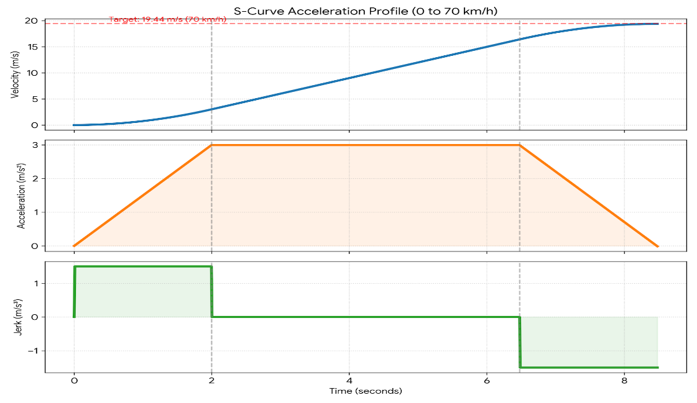
- Or we can have external claw like structure with rubber cushion which holds the payload till the drone reaches the drop off point. After reaching the point, when the drone hovers the claws will release and the winch will start lowering the payload.
Perception & Drop-Zone Target Acquisition
The transition from a high-speed transit profile to a precision 20-meter hover requires shifting authority from the global RTK-GNSS navigation stack to the local onboard perception sensors. This module guarantees the safety and accuracy of the payload drop.
3.3.1 Visual Target and Hazard Detection The downward-facing OAK-D Lite vision camera streams stereoscopic RGB and depth data directly to the companion computer. A dual-pipeline computer vision algorithm processes this feed:
- Fiducial Tracking: The primary pipeline searches for a predefined visual marker (e.g., an ArUco marker) deployed by medical first responders. Once identified, the algorithm computes a 2D pixel offset from the camera’s principal point and translates it into a localized XYZ coordinate frame to adjust the drone's hover position.
- Bystander Proximity (Safety Interlock): A secondary lightweight neural network (e.g., MobileNet) runs inference to detect human forms directly beneath the drone. If a person enters the immediate drop radius, the system triggers a software interlock, pausing the winch descent to prevent the 2.5 kg AED from striking a bystander.
Tether Deployment State Machine
The XD-10 winch operation is governed by a dedicated state machine running on the companion computer, communicating with the winch via PWM.
- Descent: The winch spools out at its mechanical limit of 0.6 m/s.
- Ground Detection: Because the mechanical hook cannot electronically sense touchdown, the software utilizes a differential altitude check. By cross-referencing the spooled cable length against the LiDAR-confirmed 20 m AGL height, the drone knows exactly when the payload has made ground contact.
- Release Buffer: The system halts spooling and holds the tether slack for a predetermined 54-second window, providing first responders ample time to unclip the AED.

Onboard Communication & Middleware Architecture
To manage the complex interplay between computer vision, trajectory generation, and hardware actuation, the software architecture utilizes a distributed, node-based middleware ecosystem.
ROS 2 and PX4-Autopilot Integration The onboard companion computer runs a Robot Operating System 2 (ROS 2) environment. This framework handles the computationally expensive tasks: processing the OAK-D Lite vision pipelines, calculating the S-curve kinematic profiles, and managing the winch state machine. The Pixhawk flight controller, running PX4-Autopilot firmware, is strictly reserved for real-time, low-latency attitude control and motor mixing.
micro-XRCE-DDS Bridge Communication between the ROS 2 environment on the companion computer and the PX4 flight controller is facilitated via the micro-XRCE-DDS middleware bridge.
- Telemetry Subscriptions: The companion computer subscribes to standard px4_msgs, pulling high-rate vehicle odometry tracking, IMU, and RTK-GNSS data into the ROS 2 environment to feed the perception and wind-vectoring algorithms.
- Offboard Control Publishing: During the critical descent and payload drop phases, the ROS 2 system takes command via PX4's offboard flight mode. The companion computer dynamically publishes highly precise trajectory setpoints (accounting for jerk-limits and pendulum damping) back to the Pixhawk, ensuring the hexacopter executes the complex maneuvers required for the AED delivery with mathematical precision.
SIMULATION AND RESULTS
We can do advanced simulations in gazebo with ROS2 framework. The team has succesfull created a world.
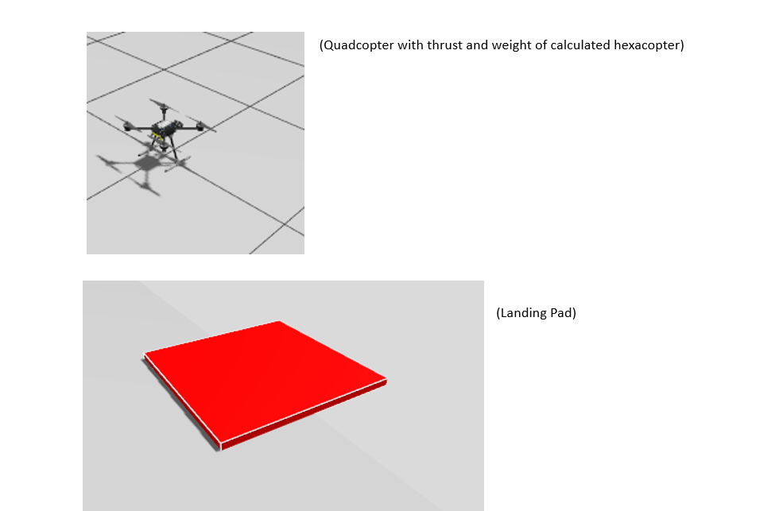
[Note – we have successfully created a gazebo world but could not proceed with simulations]
AVIONICS SUBSYSTEM ARCHITECTURE
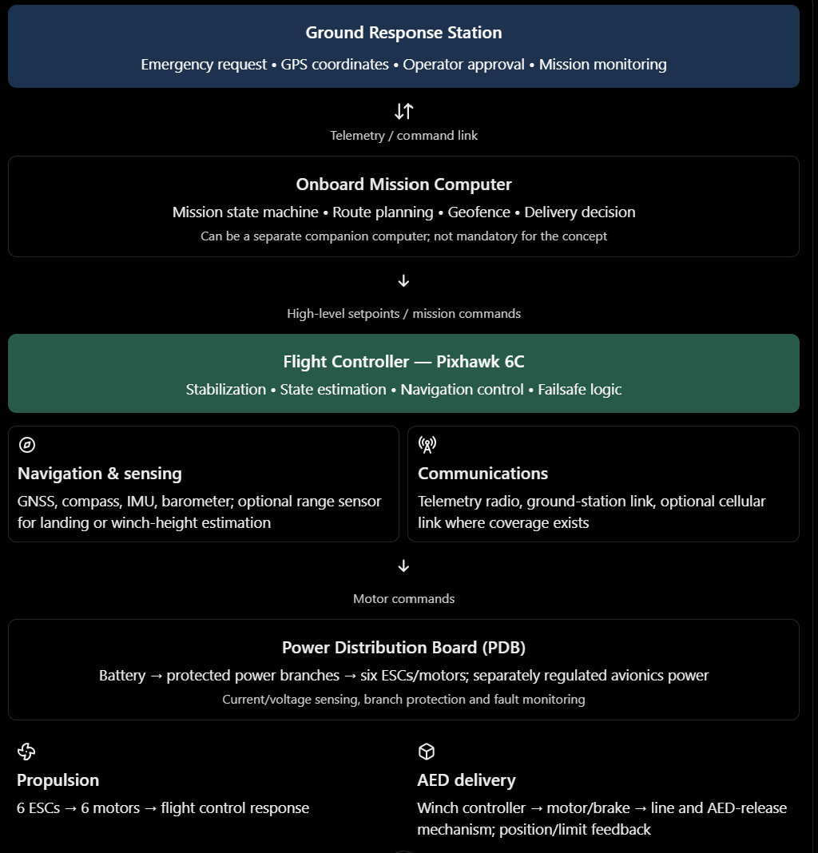

Pre-Validated Emergency Dispatch Architecture
To minimize response delay during cardiac emergencies, the drone operates in a continuously monitored Ready Standby Mode at the ground station. During standby, the flight controller initializes its sensors and navigation systems, while battery health, communication links, propulsion-system status and critical faults are monitored.
When emergency coordinates are received, the mission controller validates the destination, geofence constraints, navigation availability and current safety conditions. Since routine initialization and health monitoring have already occurred, the system avoids repeating the entire preflight sequence. If all launch-critical conditions remain valid, autonomous takeoff is authorized immediately after dispatch validation. If a critical fault or unsafe condition is detected, launch is inhibited and the ground station is alerted.
The design targets a 1–3 second dispatch-validation interval, subject to verification during software simulation and system integration. This approach reduces avoidable delays while retaining essential safety interlocks.
Docked Standby Power and Seamless Flight-Power Transition System.
Since the drone operates in a continuously monitored Ready Standby Mode at the ground station and it requires power to keep the flight controller, gps, communications and other avionics powered in standby, they will consume energy before the emergency happens. And for a five-minute emergency-response mission, we want to preserve as much flight energy as possible.
Therefore we use Docked Standby Power and Seamless Flight Power Transition System.
A source selector or power multiplexer can make the transfer automatic. Such circuits can block reverse current and switch between regulated sources without interrupting the load

Normal Standby
The drone is physically docked. The ground dock powers the onboard flight electronics, navigation sensors and communications. The main battery's high-voltage-to-avionics converter remains disabled to minimize its standby consumption.

Emergency coordinates arrive
The mission controller checks that the message is valid, the destination is permitted and the continuously monitored flight-readiness conditions remain acceptable.

Flight power is enabled
A control signal enables the converter connected to the 14S battery. The dock continues supplying the avionics while the flight converter starts up, so the flight controller does not have to reboot.
Power transfers to the battery
After the flight supply reports a stable, valid output, the source selector transfers the avionics load to it. The controller verifies the selected source and supply voltage.

Dock disconnects and the drone launches
The docking contacts or connector release. A sensor confirms that the drone is physically free of the dock, after which final arming interlocks are checked and takeoff begins.

Cruise to delivery site
The flight controller follows the planned route and maintains stable flight. The mission computer, if fitted, manages the high-level mission while the Pixhawk handles real-time flight stabilization.

Approach and delivery
The drone slows down and reaches a safe hover or delivery position within a 5m x 5m area. The winch is enabled only after position, altitude, line status and ground-clearance checks pass.

Subsystem | Function / interface
Ground response station | Receives coordinates, displays status and allows an authorized dispatch confirmation.
Mission manager | Mission state machine, geofence, route/return decision, AED delivery sequencing.
Pixhawk 6C | Attitude/position estimation, hexacopter control, arming checks, failsafe actions.
Navigation | GNSS/compass, onboard IMUs/barometer, downward rangefinder or vision.
Propulsion | Six ESC/motor units under synchronized control.
Power distribution | Main battery branch to ESCs, protected avionics DC-DC supply, separate winch motor branch and sensing.
Winch controller | Controls motor speed and brake; reads encoder, limit switches and tension/current feedback.

SAFFETY, RISKS AND FAILSAFE STRATEGY
Hazard / failure | Detection | Mitigation / safe response
Battery undervoltage / pack fault | Voltage/current, cell monitor if available, sag trend | Block launch below threshold; reserve for recovery; avoid using winch power after critical warning unless needed for safe delivery/recovery.
One ESC/motor fault | ESC telemetry/fault log, command-response mismatch, attitude deviation | Preflight test all six systems; test degraded-rotor response in simulation; choose controlled landing/abort envelope. Do not assume hexacopter redundancy guarantees safe flight.
GNSS loss / poor accuracy | Fix quality, innovation/estimator checks, position jumps | Do not initiate precision winch delivery; abort or use a separately validated navigation contingency.
Radio / telemetry loss | Heartbeat timeout and command age | Use preconfigured failsafe; choose return, hold or land based on position, battery, airspace and local hazards. Never continue delivery without confirmed conditions.
Winch jam / line snag | Encoder vs commanded motion, current rise, tension anomaly | Stop drive; apply brake; inhibit release; alert operator and execute safe aircraft recovery.
Brake or latch failure | Brake feedback, line tension, latch state | Normally-applied brake; positive mechanical retention; independent limit switches; ground proof test; no single software signal should release the AED.
Wind / cable swing / crowd movement | Wind estimate, visual observation/range sensing, position error | No lowering unless stability and exclusion-zone conditions pass; climb/reposition or abort if people enter the danger area.
Rain / water ingress | Weather limits, power/communications anomalies | Seal connectors and electronics; respect component IP limits; validate the complete aircraft, not just the motor system, for rain.
EMI / power dip from winch | Voltage logs, Pixhawk reboot/communication errors, compass change | Separate motor branch, filtering, appropriate wiring and converter; conduct winch-on EMI and brownout tests.
Unsafe termination over people | Geofence, vehicle state and fault classification | Define controlled contingency zones and landing options. Motor cut-off is not a default termination strategy over populated areas.

Regulations:
Before every operation, we check the current DigitalSky airspace map and applicable flight-planning process. The published framework distinguishes green, yellow and red zones, with restrictions and permissions depending on the zone and current rules. Temporary restrictions can also apply.
The drone will not be operated in a manner that endangers people or property and must remain clear of manned aircraft with a safe minimum separation from people, route constraints, safe delivery zones, emergency landing areas and weather limits. Avoid flying over uninvolved crowds where practicable. A winch can reduce the need to land close to the patient as it can just hover over and the winch can lover the AED down.

ETHICAL CONSIDERATIONS:
Human safety and beneficence
The ethical goal is to shorten access time to an AED without creating new hazards. Speed is beneficial only when risks to patients, responders, bystanders and other airspace users remain acceptably controlled. The system must refuse launch when critical safety conditions are not met and provide a safe recovery plan.
Privacy and data minimization
Emergency coordinates can reveal a person's address and medical circumstances. Collect only data needed for dispatch, navigation, delivery confirmation and incident investigation. Restrict access by role, protect data in transit and at rest where supported, set retention/deletion periods, and avoid audio/video recording unless operationally necessary and legally justified. Prevent secondary use of patient-location data.
Fairness and equal access
The benefits of the technology should not be restricted unnecessarily to wealthy, urban, or well-connected communities.
Two AED requests arrive, one from a city and one from a remote village. The system should use clinically relevant urgency, delivery feasibility, and safety constraints rather than automatically preferring the city.
Accountability
The drone may autonomously navigate, monitor its battery, and control the winch. However, the people designing, operating, and managing the system remain responsible for its safe use and accountable if it selects the wrong landing position.

Aerodynamic Reasoning
Blade Tip Separation on the 1400 mm Wheelbase
Operating 23-inch (584.2 mm) rotors on a 1400 mm diagonal motor-to-motor frame provides exactly 700 mm of separation between adjacent rotor axes.
This yields an adjacent blade-tip clearance of 115.8 mm (19.8% of the rotor diameter). Maintaining this clearance well above the standard 10% aerodynamic threshold drastically reduces mutual blade-vortex interaction (BVI), suppresses tip-vortex ingestion between counter-rotating rotor pairs, and mitigates cyclic blade loading and acoustic noise penalties.
Disk Loading and Induced Power Demand
The swept area per 23-inch rotor is:
$$A=\frac{π}{4}×D^{2}=0.268{\text{ m}}^{2}$$
This provides a total actuator disk area of 1.608 ${\text{m}}^{2}$ across all six rotors.
Based on the mission parameters, the vehicle operates between an empty return weight of 13.67 kg (134.1 N) and a fully loaded All-Up Weight of 16.17 kg (158.6 N). This confines the disk loading strictly between 83.4 ${\text{N/m}}^{2}$ and 98.7 ${\text{N/m}}^{2}$.
This exceptionally low disk loading minimizes the induced downwash velocity required to hover:
$$v_{i}=\sqrt{\frac{T}{2ρA}}$$
Reducing $v_{i}$ directly decreases the induced power demand ($P_{i}=T×v_{i}$), thereby maximizing the electrical efficiency of the Hobbywing X6 motors during the critical 120-second payload drop phase.
Aerodynamic Decoupling of Fuselage and Inflow Field
The central canopy profile (300 mm diameter) occupies less than 5% of the total projected vehicle disc plane. By concentrating the high-profile cargo—the 178 mm battery and 230 mm AED enclosure—strictly below the chassis, the rotors are permitted to operate with completely undisturbed inflow. This prevents the bluff body of the payload from choking the rotor suction plane.
2. Structural Reasoning
Cantilever Bending and Boom Stress Margins
The 1400 mm wheelbase relies on extended 30 mm carbon-fiber arm tubes, which act as cantilever beams anchored to the folding hinges.
While nominal hovering requires only ~26 N of thrust per motor, the structural safety factor must account for the Hobbywing X6's absolute maximum thrust limit of 11.8 kgf (115.7 N) during emergency maneuvers.
Using a high-modulus 3K woven carbon-fiber tube ($D_{o}=30\text{ mm}$, $t=1.5\text{ mm}$), the section modulus is:
$$Z=\frac{π\left(D_{o}^{4}-D_{i}^{4}\right)}{32D_{o}}$$
Under absolute peak thrust ($F=115.7\text{ N}$), the maximum bending stress ($σ=\frac{M}{Z}$) applied by the moment arm ($l$) remains comfortably within the allowable fatigue limits of the carbon composite matrix. This yields a structural operating safety factor greater than 3.0, ensuring the booms will not fracture under aggressive jerk-limited S-curve accelerations.
Torsional and Dynamic Aeroelastic Stability
The 23-inch blades generate extreme aerodynamic pitching and twisting moments on the motor mounts during the 70 km/h forward transit and active yaw corrections in 5 m/s crosswinds.
The circular hollow section (CHS) of the 30 mm boom provides a maximized polar moment of inertia ($J$), directly resisting torsional flutter and motor mount twist. This ensures the thrust vectors remain rigidly aligned with the flight controller's mathematical attitude model.
Center of Gravity (CG) and Inertial Decoupling
- Symmetric Vertical Neutrality: The primary localized masses—the 3.59 kg GenX battery, the 1.5 kg XD-10 automated winch, and the 2.5 kg AED pod—are stacked perfectly along the central vertical axis ($X=0,Y=0$). This eliminates lateral inertial coupling, preventing asynchronous motor saturation.
- Pendulum Damping: Suspending this massive payload cluster beneath the rotor plane heavily biases the vehicle's vertical Center of Gravity ($Z_{cg}$) below the total aerodynamic Center of Lift ($Z_{CL}$). This creates a highly stable "bottom-heavy" architecture, generating a passive restoring moment that naturally damps pitch and roll disturbances induced by turbulent urban headwinds.

Scalability and Production Costs
Fleet Scalability and the Digital Beacon Infrastructure Scaling the platform from a single prototype to a municipal emergency response fleet requires minimizing marginal deployment costs and eliminating friction for the end-user. The most significant scalability bottleneck for autonomous delivery is target acquisition at the drop zone. Distributing physical ArUco markers to every household or requiring bystanders to possess specialized hardware is operationally and financially unfeasible.
To resolve this, the ecosystem relies on a Digital Beacon Concept of Operations (ConOps). When a bystander calls emergency services, the dispatch software automatically transmits an SMS link to the caller’s smartphone. Activating this link maximizes the phone's screen brightness and strobes a high-contrast digital fiducial pattern. The bystander places the phone on the ground, allowing the drone's downward-facing OAK-D Lite camera to establish a deterministic 6DoF lock from 20 meters above. This software-centric approach allows the delivery network to scale across an entire smart city instantly, leveraging the existing public smartphone infrastructure at zero additional hardware cost to the municipality.

Prototype Bill of Materials (BOM) The financial viability of the platform is established through commercial off-the-shelf (COTS) component integration. By avoiding proprietary, vendor-locked hardware, the production cost per unit is strictly controlled, facilitating rapid fleet expansion for state emergency services.

Component / Subsystem | Specification | Qty | Est. Unit Cost (INR) | Total Cost (INR)
Propulsion Motors | Hobbywing XRotor X6 Plus (KV170) | 6 | ₹ 15,500 | ₹ 93,000
Airframe Chassis | 1400mm Carbon Fiber Hexacopter Frame | 1 | ₹ 38,000 | ₹ 38,000
Power Source | GenX 14S 12000mAh Solid State LiPo | 1 | ₹ 28,000 | ₹ 28,000
Delivery Mechanism | XD-10 Autonomous Winch (with rope fuse) | 1 | ₹ 45,000 | ₹ 45,000
Flight Controller | Pixhawk 6X / Cube Orange+ Standard Set | 1 | ₹ 32,000 | ₹ 32,000
Navigation | RTK-GNSS Module (e.g., Here4) | 1 | ₹ 24,000 | ₹ 24,000
Vision Sensor | OAK-D Lite (Downward Camera) | 1 | ₹ 14,500 | ₹ 14,500
Altitude Sensor | Benewake TFmini Plus LiDAR | 1 | ₹ 4,200 | ₹ 4,200
Companion PC | ROS 2 Processing Node (e.g., Pi 4 / Jetson) | 1 | ₹ 8,500 | ₹ 8,500
Telemetry Data Link | 900MHz / 2.4GHz Encrypted Radio | 1 | ₹ 12,000 | ₹ 12,000
Miscellaneous | Power Distribution, Cabling, AED Enclosure | 1 | ₹ 10,800 | ₹ 10,800
Total Prototype Hardware Cost |  |  |  | ₹ 310,000

Manufacturing Trade-offs and Mass Production At a prototype cost of approximately ₹3.1 Lakhs, the hexacopter represents a highly competitive price point for a heavy-lift medical UAV. Moving from prototype to mass production (volumes exceeding 100 units) will yield an estimated 15% to 20% reduction in the unit cost of carbon fiber chassis components and custom wiring harnesses. The selection of the Hobbywing X6 propulsion system—while representing the largest single line-item expense—eliminates the need for custom motor R&D, ensuring the supply chain remains resilient and globally scalable.
Scalibility: We can initially target government medical services especially located at higher altitudes because of easy manuverability of drone in these region because of lack of urban areas. Due to lack of roads and transport infrastructure this idea has a high chance to work and people are prone to cardiac arrest at higher altitude so they may require the payload as fast as possible

