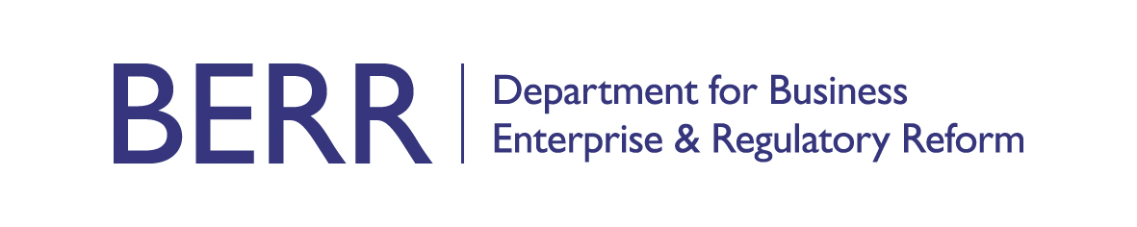

Model letter for employers to acknowledge notification of adoption leave
This letter should be used when only the statutory levels of leave and pay are provided.
(Employer must respond within 28 days of receipt of employees’ notification).

Date:

Dear [name of employee],

Congratulations and thank you for telling me that you will be adopting a child. I am writing to you about your adoption leave and pay.

As we have discussed, you are eligible for 52 weeks’ adoption leave / you are not eligible for adoption leave [delete as appropriate].

Given your chosen start date of [insert date], your adoption leave will end on [insert date].

If you want to change the date your leave starts you must, if at all possible, tell me at least 28 days before your proposed new start date or 28 days before [insert date leave starts] (your original start date), whichever is sooner. Please contact me if you wish to discuss this.

If you decide to return to work before [insert date leave ends], you must give me at least eight weeks’ notice.

As we discussed you are eligible for 39 weeks’ Statutory Adoption Pay / not eligible for Statutory Adoption Pay [delete as appropriate].

Your adoption pay will be £[insert amount] from [insert date] to [insert date]

or

The SAP1 form (enclosed) explains why you do not qualify for Statutory Adoption Pay. You should contact your adoption agency to find out if you can get any other help.

During your adoption leave we are both able to make reasonable contact with each other to help with staying in touch. We are also able to agree that you can do up to ten days’ work during your adoption leave without it affecting either your adoption leave or your SAP. Before you begin your adoption leave we should discuss how we will keep in touch during your time off.

If you decide not to return to work, you must still give me proper notice. Your decision will not affect your entitlement to SAP.

If you have any questions about any aspect of your adoption entitlements please do not hesitate to get in touch with me. I wish you well.

Yours sincerely,

