Events Administration – Screen Content

- EA – LSD Payments Password Setting

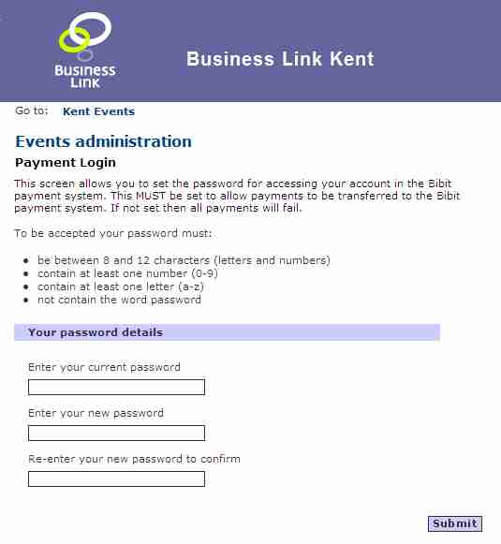
1 Current password – if at the stage of LSD implementation the configuration was set to include booking online payments then a password will be required in order to access your account within the Bibit payment system. Note as Events Administrator you will have to had set up a registered user and password to access the Events administration functions.

2 New password – use this entry field if this is the first time you have entered the system or you wish to change an existing password.

3 Re-enter new password – re-key the password to ensure you have it correctly remembered and entered.

- EA - Administration Home

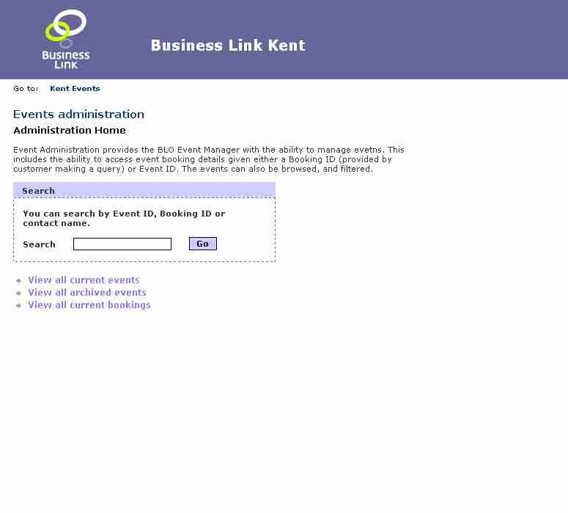
3
4
2
1

1 Search - key in the Event ID as given on email, web site, or marketing flyer will take you through to Events details. Alternatively key in the booking ID as allocated when the booking is made which links to Event details shown by booking ID. Third option is to key in free text attendee names, correspondent names, business names and event titles.

2 View all current Events – lists all Events from the present day forward in chronological order

3 View all archived Events – lists all Events from the present day back in descending chronological order. See archived Events screen.

4 View all current bookings – enables admin to list and track all the current bookings. This includes payment status, this enables the Events admin to reconcile payments with bookings.

- EA – Show All Current Events

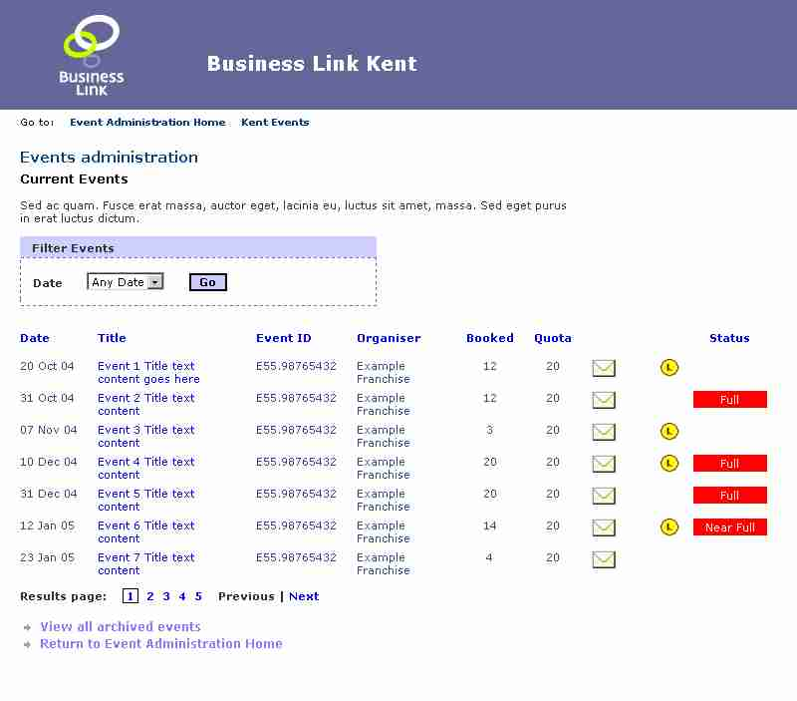
1
2
3
4
5
6
1 Date order - you can filter showing all dates, or events for a given month. Future releases will enable chronological ascending and descending date order, and the functionality to enable listing by date range.

2 Title linking - clicking on the title will take you through to the event details admin screen.

3 Archive events link - click on title will take you to Archive Events the archive of past events, showing date, title, ID.

4 Sort by heading – clickable column headings (similar to windows explorer) will sort the results by column heading into groups.

5 Event place availability – a flag set automatically by the system using criteria input by you the administrator using local TeamSite CMS.

6 Send email to correspondent – you can send an email to the Event Organiser to provide full details automatically of the attendees prior to running the event.

- EA – Show Archived Events

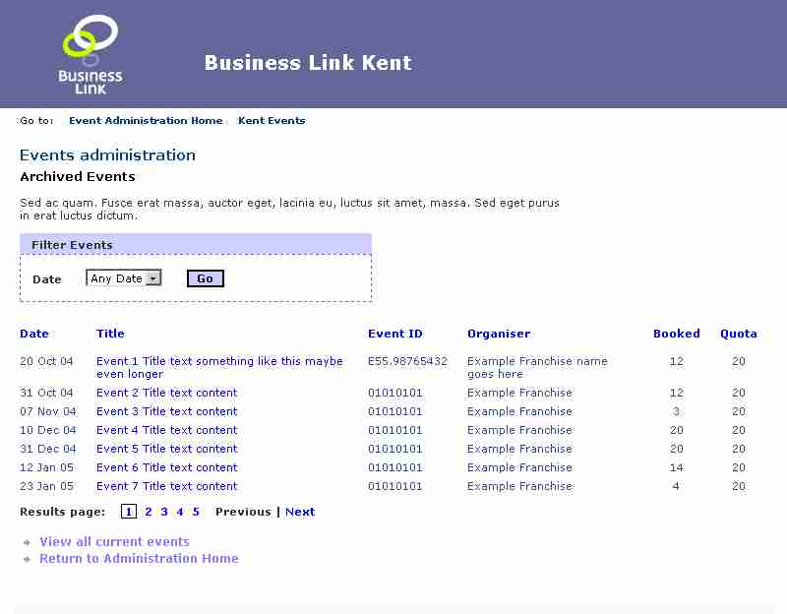
1
2
3
4
5
6
1 Date range - you can filter showing all dates, or events for a given month. Future releases will enable chronological ascending and descending date order, and the functionality to enable listing by date range.
2 Title - clicking on the title will take you through to the event details admin screen.

3 Page counter – clicking on this will enable you to show blocks of events at a time skipping back and forth.

4 Sort by heading – clickable column headings (similar to windows explorer) will sort the results by column heading into groups. Default is to sort by reverse date order.

5 View all current events – clicking on this header will take you back to the previous Current Events screen.
6 Quota - a value input to the system using criteria input by you the administrator using local TeamSite CMS. A percentage value set against this is used to trigger the status flag in the Current Events screen.

- EA – List Current Bookings

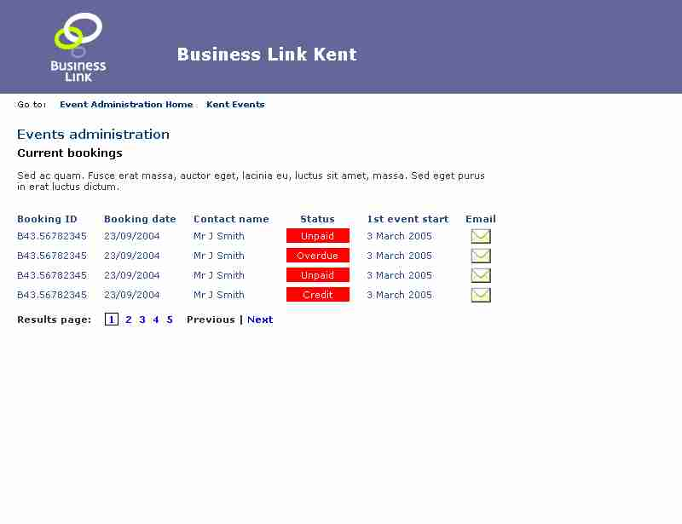
1
2
3
4

1 Booking ID reference – this screen enables you to track bookings by ID, specifically in terms of whether they have been paid or not. As Events Administrator you can use this in combination with your accounts sales ledger and cash received book to check off who has paid and which Ids/Attendees are still outstanding.

2 Page counter – clicking on this will enable you to show blocks of events at a time, with the facility to skip back and forth.

3 Payment Status – having set the time period beyond which the system will flag up if there is no payment received (e.g. 2 weeks before the event runs) the system will initially flag if ‘Unpaid’, then ‘Overdue’. Over payment or the need for a refund will result in a flag of ‘Credit’ status. These fields can be manually overridden in the local TeamSite CMS.

4 Email correspondent – using this facility you can click on and send the booking contact e.g. registered correspondent an email. This could be for a variety of purposes the most obvious being to notify them of none payment.

- EA – Booking Search Results

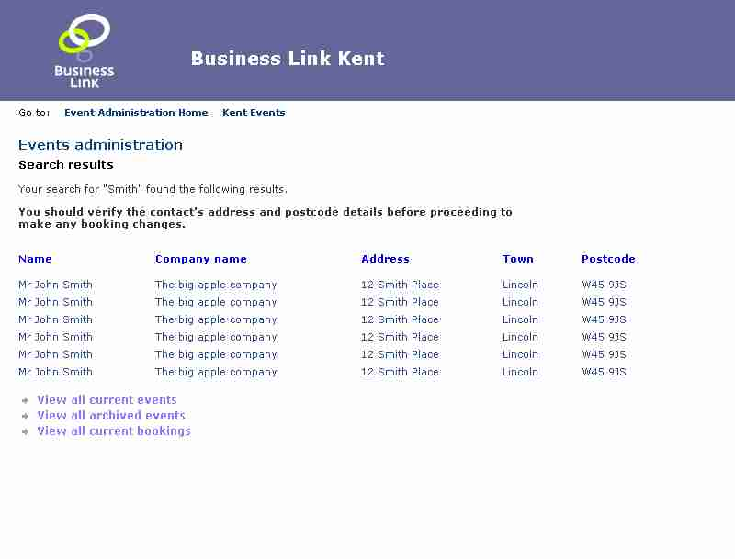
1
2
3
4
5
1 Search by Name result – using the Correspondent name as the basis for search in the Events Administrator landing page, this will result in a listing of all people with that name but with the company name as a unique combination for identification purposes.

2 View all current events - clicking on this header will take you back to the Current Events screen.

3 Sort by heading – clickable column headings (similar to windows explorer) will sort the results by column heading into groups. Default is to sort by reverse date order.

4 Archive events link - click on title will take you to Archive Events the archive of past events, showing date, title, ID.

- View all current bookings - enables admin to list and track all the current bookings. This includes payment status, this enables the Events admin to reconcile payments with bookings.

- EA - List Event Details Page 1

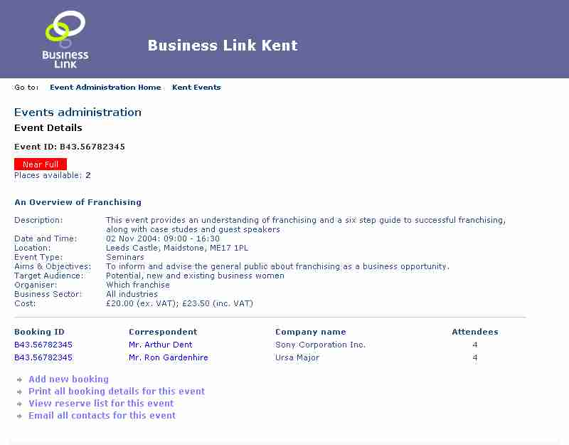
1
2
4
5
6
7
3

1 Event Description – you can access this screen either through the Events administration landing page search or through the Current Events or Archived Events. The screen presents a full description of a given Event.

2 Booking ID reference – a list of all bookings for the event broken down into correspondent and company name. Clicking on the booking ID will take you through to the Booking Details screen to ‘Amend details’ or ‘Remove Event’.
3 Add reserve list link – a link will appear here when the event is full to allow the Event Administrator to add correspondent details as required for future follow up should a place become free on the Event.

4 Add new booking – this will take you through to the latter part of the search/booking processes prompting you to complete details as requested e.g. correspondent details and add attendees.
5 Print all booking details – this will generate for you a printer friendly page containing all the event booking details.
6 View reserve list for this event – a link to the reserve list admin will only appear when the quota is used up and there are one or more entries in the reserve list.
7 Email all contacts – this will enable you to broadcast a message to all correspondents e.g. cancellation or change in location.

- EA – Payment, Correspondent and Attendee Booking Details

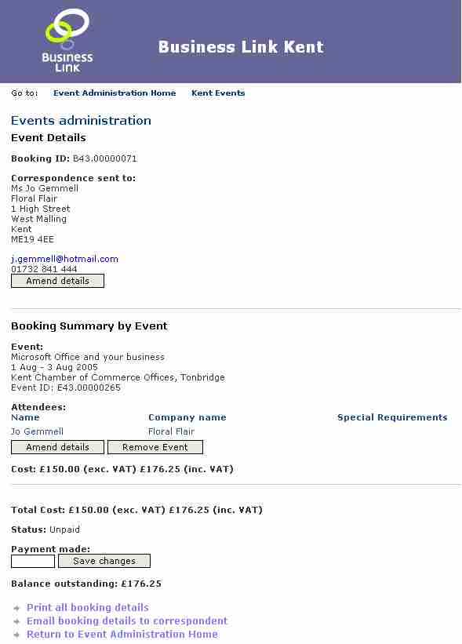
1
2
5
6
4
3

1 Amend correspondent details – enables you to open a page showing the correspondent details, similar to User booking, to make changes.

2 Amend booking details – this opens a screen similar to attendee details which you can then use to make changes.

3 Payment entry – this allows you to manually enter payment where this has been taken offline such as by cheque. Using a ‘-‘ sign you can also enter refunds. This facility needs to be used in combination with your normal accounts systems.
4 Remove/Delete Event – this removes the Event along with all the booked attendees.
5 Print all booking details - this will generate for you a printer friendly page containing all event booking details.
6 Email booking details to correspondent – this enables you to send a copy of booking if the correspondent requires copy of changes or has lost the original booking confirmation.

EA – List Event Details Page 2

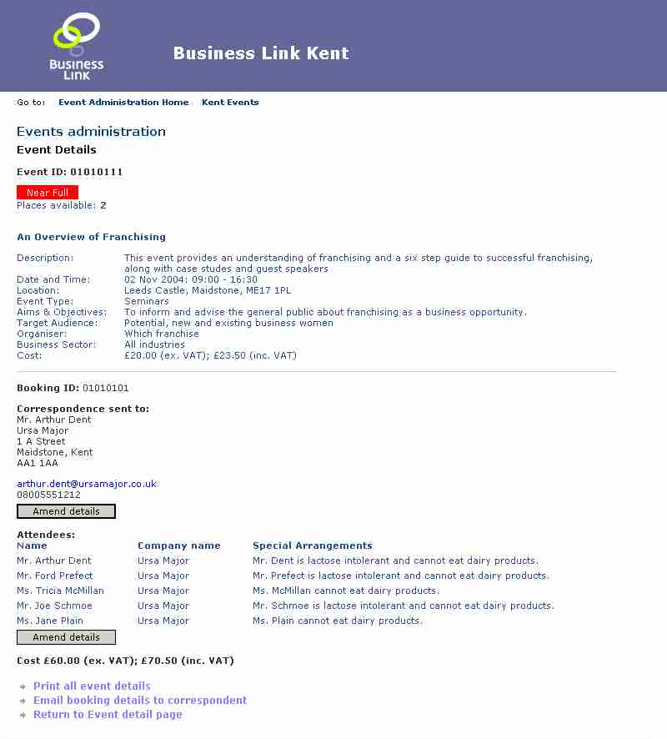
1
2
3
4

1 Amend correspondent details – enables you to open a page showing the correspondent details, similar to the User booking screen, to make necessary changes.

2 Amend attendee details – this opens a screen showing attendee details with which you can then make changes.
3 Print all booking details - this will generate for you a printer friendly page containing all event booking details.
4 Email booking details to correspondent – this enables you to send a copy of booking if the correspondent requires copy of changes or has lost the original booking confirmation.

- EA – View Reserve List/Booking

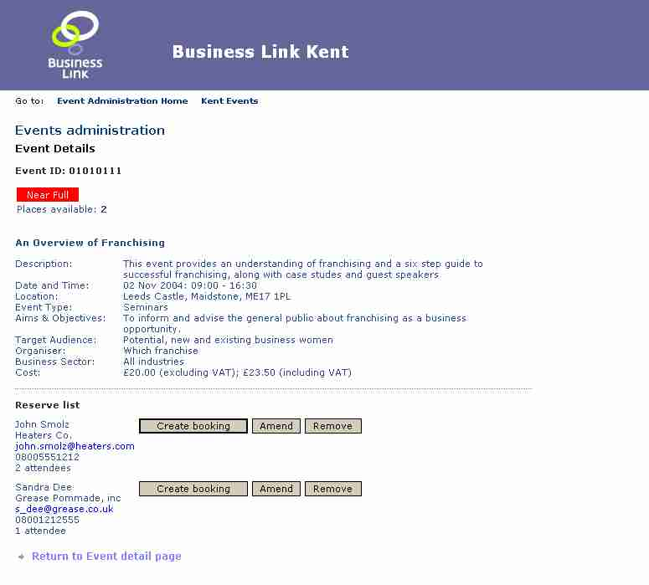
1
2
3
4

1 Reserve list names – this gives you a list of correspondents who have requested they go on the reserve list (in date order of reservation) along with contact details and the numbers of places required.

2 Create booking – this will take you through to the booking processes prompting you to complete details as requested e.g. correspondent details and add attendees.

3 Amend booking details - this will enable you to Amend the details input to the booking.

4 Remove from reservation list – should the correspondent no longer need places then this function allows you to delete the reservation.

- EA - Reserve List Booking

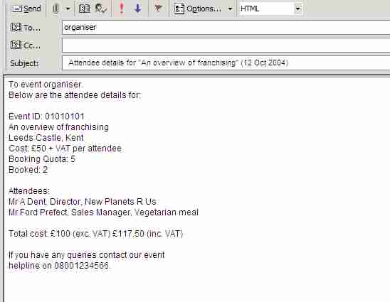
1

1 Email body text – this is one example of a pre-configured email set within the LSD CMS system. There are several variations of this screen to be found within the system depending on the function and corresponding message.

- EA – Batch Email

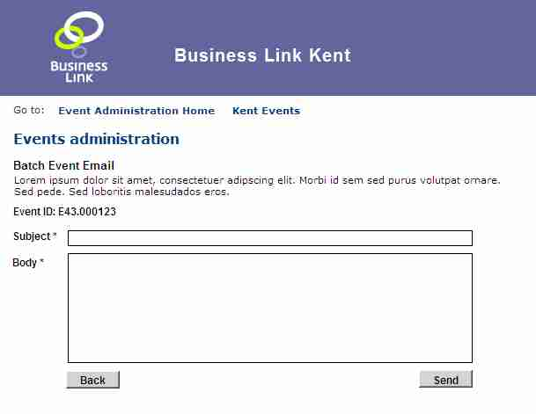
1
2

This screen is shown when you click on ‘Email all contacts for this event’ as displayed on the lower line of the List Event Details Page 1 screen. The purpose of this facility is to enable you to broadcast the same message to all correspondents for a particular Event/Booking such as a change in venue or cancellation.

1 Amend correspondent details – enables you to open a page showing the correspondent details, similar to the User booking screen, to make necessary changes.

2 Amend attendee details – this opens a screen showing attendee details with which you can then make changes.

