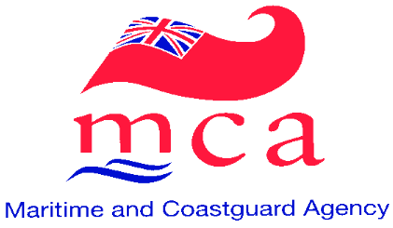

TO WHOM IT MAY CONCERN

REQUESTS FOR VALIDATION OF ENTRIES IN DISCHARGE BOOKS
RELATING TO THE SERVICE OF NON-UK SEAFARERS ON UK SHIPS

The Maritime and Coastguard Agency, as the Flag State Administration for ships registered in the United Kingdom, is responsible for all matters relating to such United Kingdom ships and the seafarers serving on them irrespective of their nationality.

It has recently come to the attention of the Maritime and Coastguard Agency that some non-UK seafarers have approached United Kingdom Consulates and Embassies seeking to have their sea-service on UK ships validated by a UK consul or similar officer. These approaches appear to arise from the requirements of certain national administrations that all service by their nationals on ships of other Flag States must be validated by the Flag State concerned.

Under regulation 25(1) of the United Kingdom’s Merchant Shipping (Crew Agreements, Lists of Crew and Discharge of Seamen) Regulations 1991 the entering, in a Discharge Book or Certificate of Discharge, of details of the sea-time of a non-UK seafarer serving on a UK ship is only required to be undertaken by the master of that ship or one of the ship’s officers who has been authorised by the master to make such entries. Such sea-time records in respect of service on UK ships do not require validation/authentication by the UK administration or any other person or authority. Any requests for validation/authentication made to a UK consul or an officer of the Maritime and Coastguard Agency will therefore accordingly be politely refused.

Captain Roger Towner
Registrar General of Shipping and Seamen and
Head of Seafarer Services & Ship Registration
Maritime & Coastguard Agency
Spring Place
105 Commercial Road
Southampton
Hampshire
SO15 1EG

