Businesslink.gov.uk
Site information version 1.0
Site proposition, structure and best practice

Revision history
Version | Date | Author | Summary of changes
1.0 | 1/3/06 | Chris Lockie | Creation of site information from text in style guide 1.13. All information updated.
Table of contents
1 Introduction 3
2 Foreword by Jonathan Hollow - Portal Editor 3
3 Copyright 4
4 The essence of the proposition 4
4.1 Why have we prepared this note and who is it for? 4
4.2 Who is our target market? 4
4.3 Why are we doing this? 4
4.4 What does this mean practically? 5
4.5 How are we doing this? 5
4.6 What is the “best practice” element of our site proposition? 6
5 Our structure 7
5.1 Basic site structure diagram 7
5.2 Overview 7

Introduction
This is the guide covering the site proposition, structure and best practice of the businesslink.gov.uk website. It covers what the businesslink.gov.uk project originally set out to achieve, how it is set out and who it is designed to help.
For information on writing for the site and style guidelines, please refer to the document Style guide version 2.0.
For information on specific tools and special areas of the website, please refer to the document Tools guide version 1.0.

Foreword by Jonathan Hollow - Portal Editor

Businesslink.gov.uk is, as far as I know, the only UK government website to have commissioned and published 1.3 million words of original, plain English content. At the time of writing our core site content totals around 4,600 pages - every one written specially for the web. The value of this style guide is that it distils the wisdom and experience of the writers and editors involved. The guides on the site were written by a unique partnership of some of the UK's leading business publishers, departmental colleagues approving the material, and a highly skilled central team of editors and proofreaders. Over the course of the project, not only have we confronted and resolved many linguistic twists and puzzles, but also we have had to consolidate and communicate our knowledge of a writing style that really works for the web. Many of the principles in this style guide come from direct testing with our customers - over 90 user-testing sessions have been carried out to date.

This style guide will be a valuable document for many different groups of people:

- The content team working at the Small Business Service on the development and maintenance of content, and the writers and editors working for our content consortia will need to know every principle on every page, since writing and editing in line with this guide is our daily business.

- Product managers working on the tools for the site will need to understand the key style principles and the style rules for individual tools – to help the enhancement of those tools and the consistent development of new tools and services. They will use this in conjunction with the Design Style Guide.

- Approvers working in stakeholder departments, although their focus is on the factual accuracy of the content, will find the style guide a useful reference point that explains why particular editorial decisions are made.

- Other government departments may find it useful to adapt key sections of the style guide for their own online or offline writing programmes, since many principles here (for example those about link descriptions, telephone numbers, or how to explain regulatory obligations) can be transferred to other government websites. If you are using our style guide, I'd ask you to let me know so that we can keep in touch as it continues to develop.

It is a long guide, because our site covers a wide range of subjects in many different formats. I have two tips that will help you to squeeze the best out of it: I recommend that you print out (and perhaps pin up) section 3 (a two-page summary of what we aim to achieve for our customers, and the key principles of how we go about it) and appendix 3, the desktop style guide which summarises some of the trickier, pickier points of style that have challenged us throughout the project.

And if you take one thing from this style guide, I would like you to remember the spirit of this piece of unsolicited feedback that came through our site feedback mechanism in April 2005. What shines through from this piece of customer feedback is that the site was speaking in exactly the language the customer needed. They perceived it had the authority of government, but without the formality, baggage and lack of realism so many member of the public associate with government departments:

“At last, it all starts to make sense. This website is almost as good as it can be. Thank you all for the time and trouble you have put into this. It makes paying tax almost a pleasure, in comparison with nervously navigating a minefield of regulations while trying not to let Government know that actually my priority is running the business. I feel like Government respects me now, rather than treating me as a tax dodger or sweat shop owner.”
Jonathan Hollow Portal Editor, businesslink.gov.uk jonathan.hollow@sbs.gsi.gov.uk June 2005

Copyright

© Crown copyright 2005 - the text in this style guide is subject to Crown copyright protection.

Use of Crown copyright material
The text in this style guide may be reproduced free of charge in any format or medium, provided it is reproduced accurately and not used in a misleading context.

Where any of the information in this style guide is being republished or copied to others, you must receive our permission in writing, identify the businesslink.gov.uk style guide as the source of the material, and acknowledge its copyright status.

The essence of the proposition
“The first place to go to find out what you need to know or do, how to get it done and who can help you start-up, grow and manage your business.”

Why have we prepared this note and who is it for?

The Business Link portal (Businesslink.gov.uk) is the online channel for Business Link. This section is a reminder of the key principles and values to bear in mind when creating content, tools, page design and navigational constructs for the site. It is intended for all those involved in production and development and should be kept close to hand.

Who is our target market?

Essentially the information and services we are providing should be relevant to all businesses - and those wanting to set up in business - but with a focus on key individuals in small to medium-sized enterprises, including:

- owner managers
- owner directors
- administrators and managers in medium businesses

The information we provide is for businesses all over the UK. Where there are differences between the nations, for example in regulations, we only cover England in any detail and offer prompt hand-offs to sites run by the devolved government agencies, for customers in Wales, Scotland and Northern Ireland. All content is provided in English.

Why are we doing this?

To address customers’ key needs by:

- providing a single point of access to government information and services
- providing greater control over, and confidence in, your dealings with government
- providing a better understanding of what government can do to help
- allowing businesses to deal with government more efficiently
- helping businesses find out what applies and what to do about it
- making it easier to find the right advisory services
- making it easier for businesses to understand how to grow
- helping them become an informed user of other (including commercial) services

To provide benefits for our partners in government by:

- improving compliance and greater take-up of support activities
- helping meet policy objectives (especially around efficiency)
- providing opportunities for collaboration with government partners (joining-up)
- increasing traffic to our partners’ transactional services

This is not “just another portal”, it must earn the right to be the first place businesses go to when facing problems or challenges and it must move the customer forward by answering the problem or referring them to someone who can.

What does this mean practically?

Through the Business Link portal we provide information, guidance and action support, enabling businesses to handle their business challenges and manage their dealings with central and local government more successfully. The site is intended to:

- Be uniquely authoritative and credible as all regulatory content has been approved and openly endorsed by the responsible government departments and agencies, and is painstakingly kept up-to-date.
- Provide a combination of compliance assistance - ie what regulations apply to the customer’s business and what do they have to do about them - and business support - ie what help is available from government or private/voluntary sector and how to get it.
- Give completely free information that does not try to sell you anything (well, almost nothing, we do encourage online filing by selling the benefits and detailing the incentives).
- Steer clear of giving personal advice, instead highlighting things the customer needs to think about or do - providing unbiased, objective, insightful information, guidance and action-support, pointing them to sources of expert advice.
- Provide 24/7 access, interactivity and tailoring, powerful searching, downloading/printing forms you would otherwise have to order by post, online filing and calculations.
- Be a single entry point to government for business. However, many customers should have a large portion of their needs met without having to leave the site.
- Refer the user to helplines, printed publications, face-to-face services where appropriate (ie personalised diagnostics of complex business issues).
- Refer the user as directly as possible to wherever they are most likely to find the help or solution they need - very careful not to endorse any non-government providers referred to - help users become informed users/buyers of services.
- Contain really good site search, sector overviews and key profiling/tailoring tools.

How are we doing this?

- We thoroughly test everything with customers.
- Our tone is clear, practical and authoritative NOT cold or patronising.
- We recognise the diversity of the SME market - we are not assuming anything other than an interest in business and shortage of time.
- The content is concise and arranged in one-screen chapters, getting to the point quickly. It can be skimmed easily, using a mixture of formats like dos and don’ts/checklists/graphics to provide variety and quality.
- It is written and presented from the SME's perspective, not from the way the government is organised.
- We use the best format for the job eg a decision tree instead of plain text if dealing with something best handled via a series of yes/no questions.
- Above all, the content is relentlessly action-focused helping busy and pressurised SMEs (or those thinking of starting up) get things done, not just inform them, ie it's practical assistance through brilliant basics.

What is the “best practice” element of our site proposition?

- Best practice was approved as a key part of our site proposition in March 2005. The key definition is in the “spectrum” diagram below.
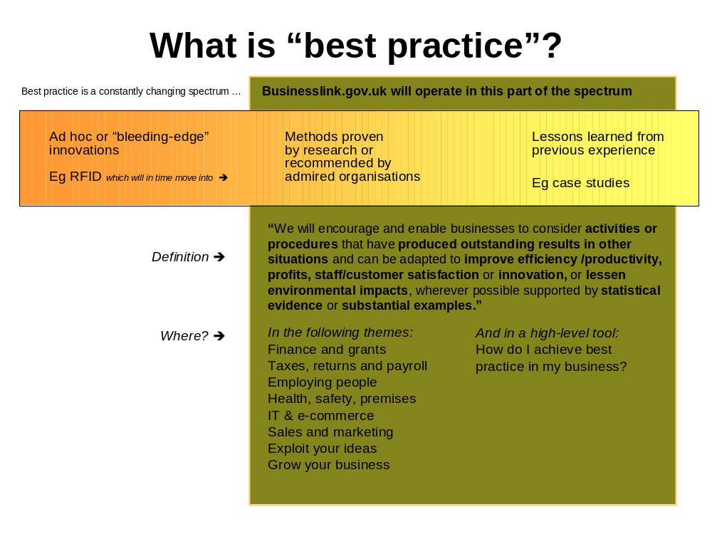
- This does mean that we aim to make businesses aware of ways in which they can “raise their game” in many ways and places across the site.
- This doesn’t mean that there is a separate “theme” called best practice, or even that the words best practice need appear anywhere on the site. The key point about best practice information is that it should appear credible and relevant in context, not that it should be picked out as a separate stream of information to the customer.

Our structure

Basic site structure diagram
Layer 0
Layer 1
Layer 2
Layer 3
Level 2
Level 3
Level 1
Topic
Editorial
Resource
Signpost
Home page
Theme landing pages
Sub-theme(s)
Factsheets, Case studies
Action links to external sites
Links to related guides
Helplines
Guide
Introduction

Overview

The home page lists the 12 business themes, each of which links through to the respective theme landing pages. These pages break the themes down into a number of sub-themes that link through to the guide titles in that area.
The introduction page, also known as level 1, explains what the user should expect from the guide. There then follows up to nine level 2 pages of more detailed information and links to relevant sites. For example:
Guide title: Taking on staff - the options
Level 1: Introduction
Level 2: Do you need new staff?
Level 2: What’s the best way for me to take on extra people?
Level 2: Full-time or part-time employees
Level 2: Employment agency - temporary staff
Level 2: Freelancers and outside contractors
For a definition of all terms used on the site - and where applicable - a full description, see the glossary of additional terms.
Throughout the site, there are right-hand panels listing links to helpful related information:
Site location | Helpful related information
Home page | Promo slots
Theme landing page | Interactive tools  Top guides for this theme  Promo slots
Sub-theme page | No right-hand links
Guide introduction page | Helplines  Action links
Guide detail pages | Helplines  Action links  Also on this site

For example, this is a visual explanation of how a typical level two looks and fits into the structure:
