Write a marketing plan
Version no and date

Business details
Name of business owner
Name of business
Business address
Post code |  | Telephone
Home address
Post code |  | Home telephone
Date business commenced
Legal status
Principal activities

CONTENTS
Write a marketing plan 1
Part 1 - Executive summary and mission statement 3
1.1 Writing a marketing plan 3
1.2 Executive summary 4
1.3 Mission statement - your business' values and beliefs 5
Part 2 - The current situation analysis - the internal landscape 6
2.1 Product or Service 6
2.2. Pricing 8
2.3 Place 8
2.4 Promotion 9
2.5 People 9
2.6 Processes 10
2.7 Physical evidence 10
Part 3 - The current situation analysis - the external landscape 11
3.1 Market overview 11
3.2 Competitor analysis 11
Part 4 - SWOT analysis 13
4.1 Strengths 13
4.2 Weaknesses 13
4.3 Opportunities 14
4.4 Threats 14
4.5 Summary 15
Part 5 - Objectives - the internal landscape 16
5.1 Overall strategy 16
5.2 Product or service 17
5.3 Pricing 19
5.4 Place 19
5.5 Promotion 20
5.6 People 20
5.7 Processes 21
5.8 Physical evidence 22
Part 6 - Resources and evaluation 23
6.1 Resources 23
6.2 Evaluation 23
6.3 Need further help? 24

Part 1 - Executive summary and mission statement

1.1 Writing a marketing plan

A marketing plan goes hand-in-hand with writing your marketing strategy and business plan. Once you have written your marketing strategy, a marketing plan will help you think of all the aspects of your marketing and set out the roadmap of how you are going to achieve your goals. Your marketing plan is an organic document which you can return to and update at anytime.
Notes…

1.2 Executive summary - what your business is aiming to achieve
An executive summary is an overview of your marketing plan and needs to be at the front of your marketing plan.

Make sure it:

- covers the highlights from your marketing plan
- is clear, concise and to the point - use limited jargon or acronyms
- is well written and stimulates the readers attention - be sure that you include your passion and vision

Remember the summary needs to give the reader enough information to understand the purpose of your marketing plan.

1.3 Mission statement - your business' values and beliefs:
Your mission statement is a clear and engaging statement of what your business aims to achieve by being in business and your vision for the future.
You should make that sure you:
- cover the core values goals of your business
- align your values with the target market

Part 2 - The current situation analysis - the internal landscape
To move your business forward, you need to have an understanding of the current landscape at the time of writing your marketing plan. When considering the present marketing situation, you need to take into account the following areas:

2.1 Product or Service
What need does your product or service meet? Do you have a unique selling point? Provide the facts, figures and research to illustrate these points.
Our product or service (or product / service group) | Proportion of sales | What are their features/benefits?
Our product or service (or product / service group) | Proportion of sales | Features | Benefits

Our customers

Our business will be selling to

Number of customers we expect to win in each group and what they will spend

Trends in our chosen market

How we know this

2.2 Pricing
What’s your current pricing strategy? Do you allow for discounts to regular customers? What are the discounts based on?

2.3 Place
Where and how do you sell your product or service? Are you an online shop or do you have a shop front? Consider your distribution and delivery channels.

2.4 Promotion
What are your current marketing activities? What media options do you use to reach your customers? Consider providing an estimate of how much you spend on these media outlets and the return on investment you receive from these methods.

2.5 People
Are your staff knowledgeable about your product or service? Do you have enough staff to handle your orders? Do they provide quality of service?

2.6 Processes
Are your processes written down and organic? Do they ensure consistency of service? Are they up-to-date with your current systems or goals?

2.7 Physical evidence
Does your website or premise(s) convey the right message about your business?

Part 3 - The current situation analysis - the external landscape
Now that you have considered the internal factors of your business, you need to take into account the factors beyond your control - the external landscape. Aim to present an overview of the key markets and challenges your business is currently facing.

3.1 Market overview
Consider the current developments in product development and service offerings. Are there any opportunities in the upcoming changes? Also note your demographics, customers and target markets. Are they going through changes in the near future?

3.2 Competitor analysis
Most businesses compete with other businesses. Even if you are in a niche market, competition will almost certainly come along. Knowing your competitor gives you insight into how to approach your marketing plans. Understanding their competencies and what you do best provides a valuable opportunity to get the most out of your marketing budget. Consider running a SWOT analysis on your competitors.

Our major COMPETITORS |  | How they compare to us and to each other | Their strengths and weaknesses
 |  | How they compare to us and to each other | Strengths |  | Weaknesses
How our prices compare with the competition
Product/service |  |  |  | Our price |  | Competitor price
1 |  |  |  | £ |  | £
2 |  |  |  | £ |  | £
3 |  |  |  | £ |  | £
4 |  |  |  | £ |  | £
5 |  |  |  | £ |  | £

Part 4 - SWOT analysis
After exploring the current internal and external landscape, now is a good time to do a SWOT analysis on your business. List your business' main strengths and weaknesses. You will discover valuable information in previous sections of the marketing plan that you can use and further expand on in this section. Focus on what you can develop for your business going forward.

4.1 Strengths

4.2 Weaknesses

Preparation is a key part of running a successful business as it can help you when an unexpected challenge comes along. In this section, consider all the key elements from outside influences and how they could be used as opportunities. It is also advisable to consider outside threats to your marketing plan.

4.3 Opportunities
Consider new marketing opportunities, development of new products or services, gaps in the market and new or changing demographics.

4.4 Threats
Consider unexpected situations - such as environment issues, negative business images or perceptions, new competition, changes to the economy or the law and trend shifts.

4.5 Summary


Part 5 - Objectives - the internal landscape
Your strategy statement is an overview of how your marketing objectives are going to be achieved. It needs to provide a summary to the reader of how detailed strategies will be outlined below. Look over the SWOT analysis, key opportunities and threats and business plan to help you choose the areas you want to work on. Remember to include a description of what success will look like, and add some of your enthusiasm and passion here too.

5.1 Overall strategy
Year 1

Year 2

Year 3

Year 4

Year 5

Tactics

5.2 Product or service
Aim to cover your long-term product strategy in this section. If you are providing a service, take into account additional features such as people, process and the physical appearance of your business premises.

Please double click in the table below to access the embedded Microsoft Excel sheets to input your figures, Microsoft Excel will automatically update the total for you.

MARKETING OBJECTIVES – sales by value (£s)

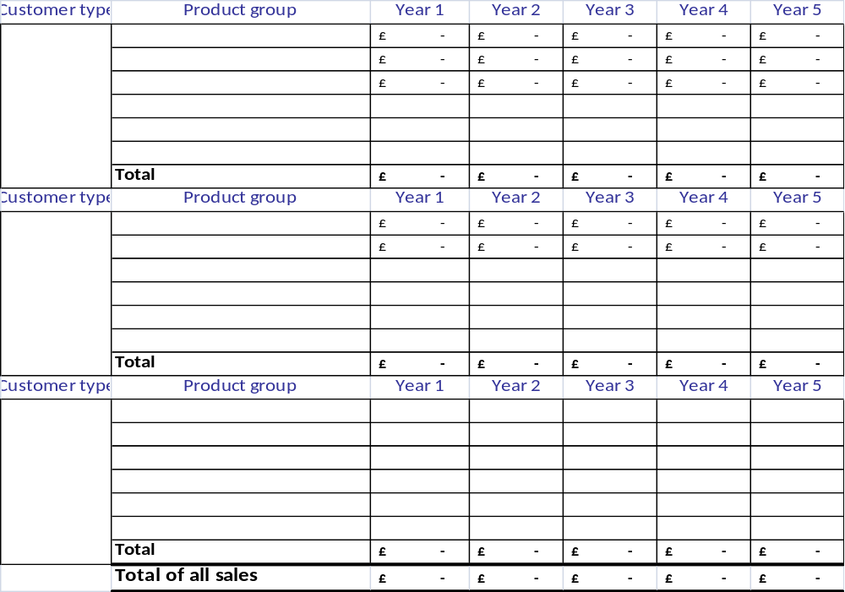
You can also download the marketing objectives table shown above in Microsoft Excel format (XLS, 16K).

5.3 Pricing
All pricing needs to take into account the cost of producing or delivering the product or service, marketing and contributing to a profit. There are four keys points to consider:
- Cost - does the price cover the cost of producing or delivering the product or service?
- Demand - is there a large demand?
- Competition - what are your competitors charging?
- What is the image or perception of your product/service?

5.4 Place
Take into account your distributors, using specialists' intermediaries and where you sell your product.

5.5 Promotion
What promotional activity is best suited to your marketing strategy? Consider all forms of promotion including social media, public relations, advertising and packaging.

5.6 People
Do your staff need further training on customer service or on your product or service?

5.7 Processes
Encouraging staff to follow regular routines and make use of quiet periods will help ensure processes meet a high standard.

5.8 Physical evidence
Your staff and premises are marketing your business every day, as they are who the customer will first see and then experience. You might consider membership cards and loyalty programs as part of your strategy.

Part 6 - Resources and evaluation

6.1 Resources
Things we need
Resource | When | How funded | Cost
 |  |  | £
 |  |  | £
 |  |  | £
 |  |  | £
 |  |  | £
 |  |  | £
 |  |  | £
 |  |  | £

6.2 Evaluation
Your marketing plan needs to be an organic document, which may change or grow according to circumstances. It’s a good idea to review your marketing plan along with your marketing strategy once a year.

6.3. Need further help?

Create your marketing strategy
Decide how to market your product or service to potential customers

Write a marketing plan
How to identify your objectives and write a plan that will help your marketing generate sales

Marketing on a tight budget
Advice on how to get the most out of a small or limited marketing budget

Understand your competitors
How to identify your competitors, find out more about them and then use this information to improve your business

Develop an e-marketing plan
What are the key components of an e-marketing plan and what benefits can such a plan deliver to your business

Case studies
- Here's how I developed and implemented a marketing plan
- Here's how I developed and implemented an e-marketing plan

You are reminded that Businesslink.gov.uk’s Terms and Conditions apply to your use of this marketing plan template.

