Government Campaigns

Campaign template guidance
V0.1

Author: Adam Rowland

Owner: Carole Morgan

Document Control

Approved By:
Name | Position | Date

Checked By:
Name | Position | Date

Reviewed By:
Name | Position | Date

Revision History:
Name | Version | Date | Summary of changes

Glossary of Terms:
Term | Explanation

Table of Contents

1 Introduction 4
1.1 Campaigns at businesslink.gov.uk 4
2 The campaigns template 4
2.1 Campaigns page features 5
2.2 Basic template overview 5
2.3 Enhanced template overview 6
3 Using the template 6
3.1 Basic campaign 6
3.2 Enhanced campaign 8
Appendix A 10
A.1 Basic page layout options 10

Introduction

The purpose of this document is to provide guidance to marketing teams and digital agencies when using the businesslink.gov.uk campaigns template to produce a government-led online campaign.

Campaigns at businesslink.gov.uk

Businesslink.gov.uk is operated by Serco on behalf of HM Revenue & Customs. The site, one of three government ‘supersites’, is a key platform in supporting the move towards Transformational Government.

Business Link is delivered through the national website http://www.businesslink.gov.uk, as well as through nine syndicated regional sites, a telephone helpline and a regional network of over 2,500 advisers who offer a face-to-face business advice service.

The campaigns functionality was designed to enable government departments to promote short-term communications activity as a ‘soft-landing’ into the main businesslink.gov.uk portal.

For more detailed information regarding the businesslink.gov.uk campaigns proposition please read the ‘Marketing Campaigns Proposition for Government Departments’ document.

The campaigns template

The businesslink.gov.uk campaigns template offers two distinct options:

- Basic
- Enhanced

All businesslink.gov.uk campaigns pages have a thin businesslink.gov.uk branded header (inc. logo, search box and login areas) and the standard page footer (inc. links to our terms & conditions and accessibility policy).
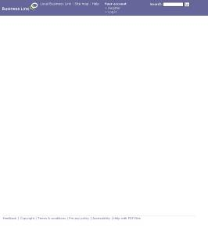

A blank campaigns page demonstrating the thin header and standard page footer

Campaigns page features

A campaigns page is noticeably different to the standard content pages found on businesslink.gov.uk.

- Does not contain metadata
- Cannot be found via internal / external search or on the site map
- Wider workable area
- No left hand or right hand navigation
- Thinner Business Link branded page header

Basic template overview

The basic template is the simplest form of campaigns page on offer. It uses predefined CMS fields to create a set layout. A basic page has four optional content areas:

- Banner header – A clickable image that spans the top of the page. Usually, this image would contain the creative branding, the campaign title and possibly a logo:



- Approved copy – The main campaign message is outlined in the main copy element of the page. Text should be kept to around 250 words. Copy appears beneath the banner header.

- Main image – A large image can be used to add more depth and coherence to the campaign creative. The image sits beneath the banner header and to the right of the main copy.

- Government department logo – A clickable logo can be added above the page footer with the text ‘Produced in association with:’ (not editable)

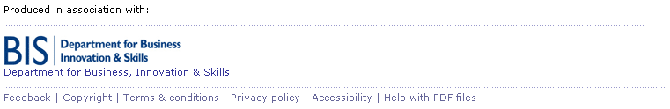

Enhanced template overview

The enhanced campaigns option offers greater flexibility and control over the layout of the page. It uses custom XHTML and CSS to produce a customised look and feel for the campaign.

Custom XHTML and CSS can be combined with elements of the basic template to produce a combination look and feel. For example, a page could use the CMS fields for the banner header and department logo but use custom code for content in between.

Using the template

For all campaigns, government departments (or their appointed agency) will develop the campaign creative. The campaign assets will be delivered to businesslink.gov.uk for build as a basic or enhanced (or combination of the two) campaign page. All page assets should be supplied with a mock-up of how the finished product should appear.

Basic campaign

All elements of the basic campaign page are optional depending on the nature and scope of the campaign.

The technical specification for basic campaign assets is as follows:

Element | Maximum Dimensions | Type
Banner header | 730px wide | JPG, PNG
Main copy (inc.links) | 250 words (approx.) 1 link to a businesslink.gov.uk page | Rich Text, .txt, MS Word
Main image | 300 x 300px | JPG, PNG, GIF
Logo | 90px wide | JPG, GIF
Mock up |  | PDF, JPG

All assets must be submitted to businesslink.gov.uk at least 10 working days prior to campaign launch.

Basic campaign production workflow

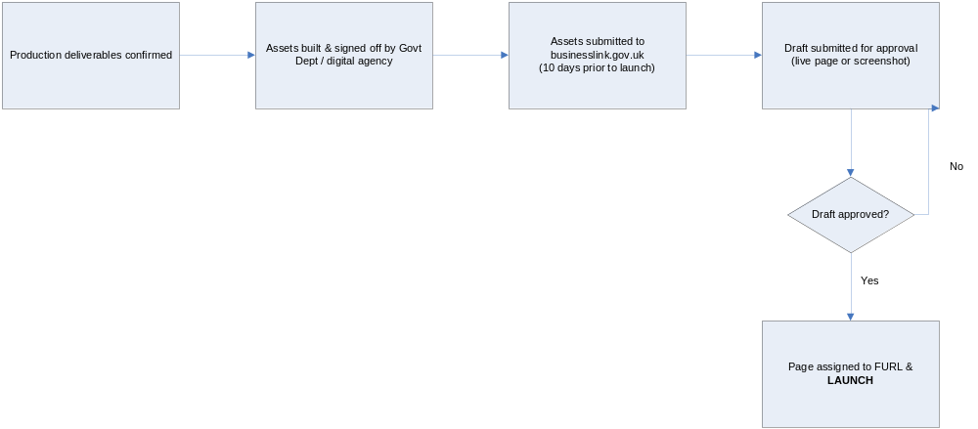

Enhanced campaign

Enhanced campaigns use a template in order to aid the build process. The build process is split into two sections:

- Digital build within the template (coding) – This is carried out by the Govt Dept or digital agency
- System build within the businesslink.gov.uk CMS – This is carried out by businesslink.gov.uk using the returned template.

The enhanced template will be delivered via the businesslink.gov.uk Campaigns Team once the campaign brief and proposition are completed.

The template contains a Readme file which describes the contents:

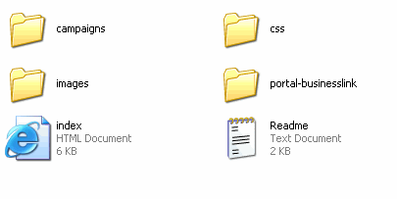
1
21
31
41
51
61

Element | Contents
1 | > CSS (Customisable style sheet) > images (example images)
2 | Businesslink.gov.uk portal images (do not amend)
3 | Customisable HTML – instructions should be overwritten
4 | Businesslink.gov.uk global style sheets (do not amend)
5 | Businesslink.gov.uk global style sheets and images (do not amend)
6 | Readme explanation of contents

The only elements of the template that should be edited are:

- custom_campaign01.css (campaigns > css)
- index.html (root)

This template will produce a local-only version of the campaign page which should be returned to businesslink.gov.uk at least 10 days prior to campaign launch date.

Enhanced campaign production workflow

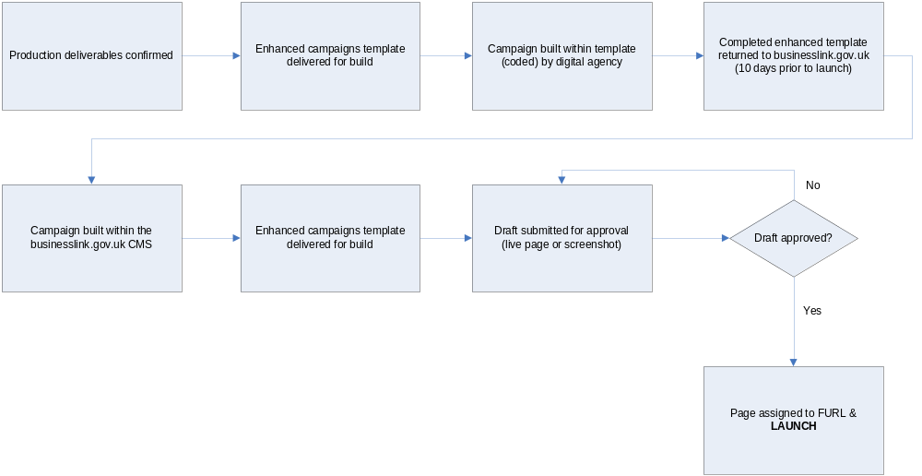

  - 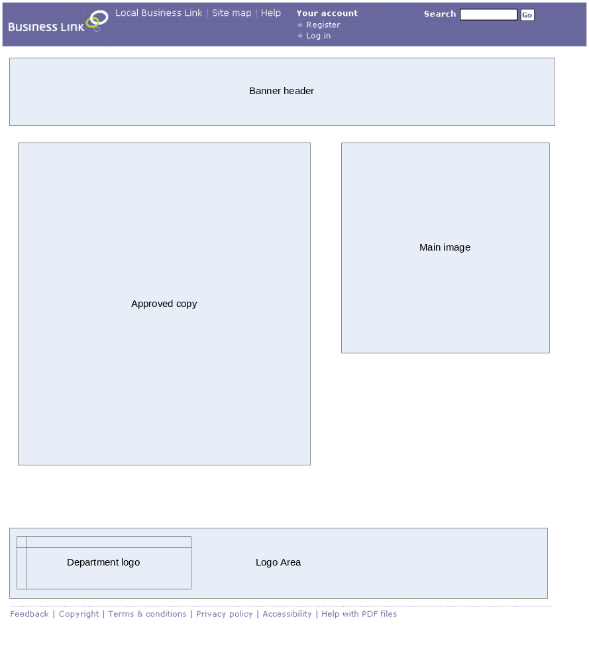Basic page layout options

Businesslink.gov.uk should be involved in the initial planning stages of every campaign to ensure expectations and capabilities are explained and understood.

