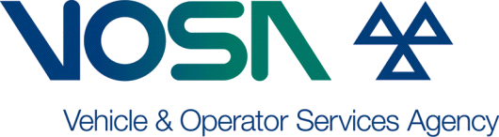
APPLICATION FOR A REPLACEMENT
APPROVAL CERTIFICATE
(Car/Light Goods and Motorcycles etc.)
Please complete and return this application to; The Vehicle and Operator Services Agency
APPLICANT DETAILS
Name:
Address:
Postcode:

VEHICLE DETAILS
Make:
Model:
Year of Manufacture:
Approx test date:
Vehicle Identification Number (VIN) or chassis number.
Has the vehicle been registered with DVLA? |  |  |  |  |  |  |  |  |  | YES |  |  |  |  |  |  | NO
If yes, please state registration number
Please explain why the replacement is necessary.

PAYMENT DETAILS
Payment Method : You will be contacted by telephone for Credit/Debit card payments
Cheque |  | Postal  Order |  | Credit or  Debit card |  | Cash  (over the counter only) |  | Pre-funded  Account

NOTES
The Motor Vehicles (Approval) Regulations 2001, and The Motor Cycles Etc. (Single Vehicle Approval) Regulations 2003, and the Road Vehicle (Approval) Regulations 2009 provide for the issue of a replacement Approval Certificate in certain circumstances and provided the appropriate fee is received.

Please be aware that you may be required to present the vehicle for inspection in order for VOSA to verify the details. If the original certificate is subsequently found, it must be returned to VOSA.

Signed:
Full name in capitals:
For, and on behalf of:
Original certificate serial number:
Duplicate certificate serial number:

