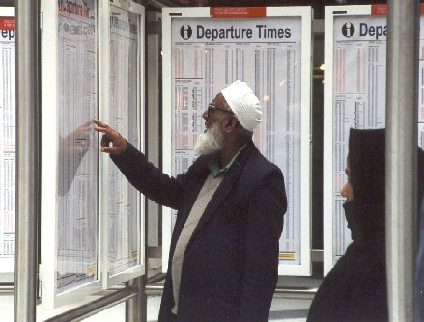
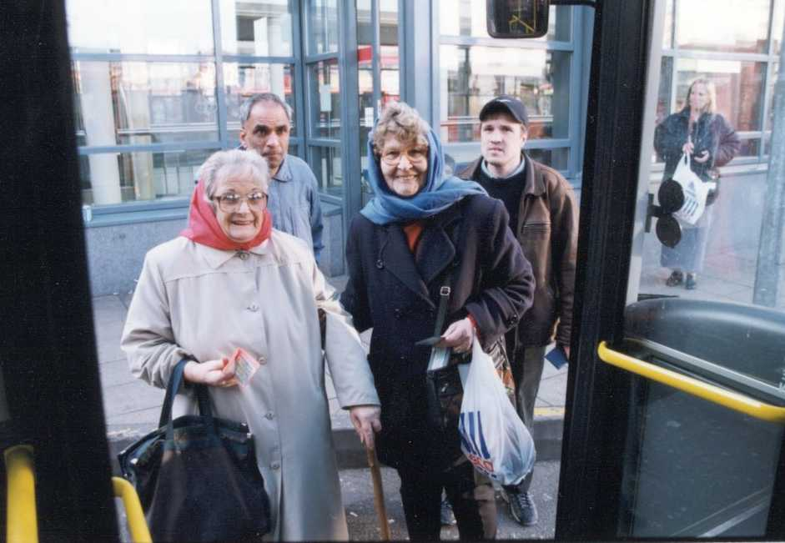
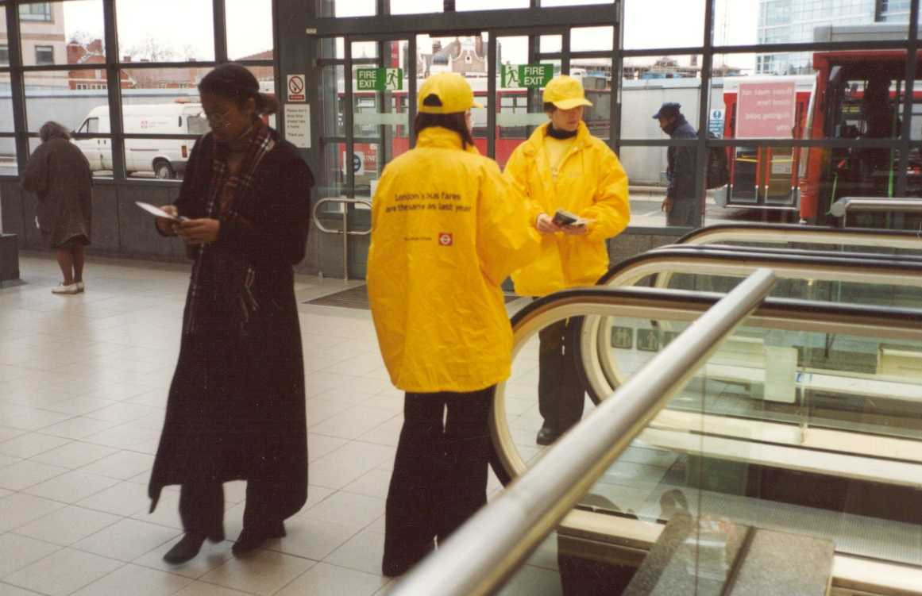

December 2012
Transport for Everyone: an action plan to promote equality

The Department for Transport has actively considered the needs of blind and partially sighted people in accessing this document. The text will be made available in full on the Department’s website. The text may be freely downloaded and translated by individuals or organisations for conversion into other accessible formats. If you have other needs in this regard please contact the Department.
Department for Transport
Great Minster House
33 Horseferry Road
London SW1P 4DR
Telephone 0300 330 3000
Website www.dft.gov.uk
General email enquiries FAX9643@dft.gsi.gov.uk

© Crown copyright 2012
Copyright in the typographical arrangement rests with the Crown.
You may re-use this information (not including logos or third-party material) free of charge in any format or medium, under the terms of the Open Government Licence. To view this licence, visit www.nationalarchives.gov.uk/doc/open-government-licence/ or write to the Information Policy Team, The National Archives, Kew, London TW9 4DU, or e-mail: psi@nationalarchives.gsi.gov.uk.
Where we have identified any third-party copyright information you will need to obtain permission from the copyright holders concerned.

Contents

Foreword p4

1. Complying with the Equality Duty – where are we now? p5

2. Why do we need an Equality Action Plan p14

3. Equality Action Plan p15

Headline 1: Information and Communication p17
Headline 2: People and Culture p18
Headline 3: Safety and Personal Security p19
Headline 4: Developing Personal Competence p21
Headline 5: Working with Civil Society p23
Headline 6: Policy and Evidence Base p24

Annex A p27

Foreword

Transport affects all our lives. We use it to get to work, to access services and to take part in leisure activities. It supports business and is a key contributor to economic growth. As the diversity of our society grows, our transport services are evolving to reflect all our differing needs.

The Department for Transport’s Equality Action Plan sets out in one place what we are doing to ensure people from all communities in society have the option to use public transport.

In developing our policies, we draw on evidence gathered from a number of sources. These include local authorities, passenger representative bodies and independent advisory groups. We also work with private sector transport operators, who are not typically covered by the equality duties, to ensure that they nonetheless consider the needs of all their customers in delivering transport services.

We have already made a lot of progress in providing a more accessible and fair transport system but we know there is more to do. This Action Plan builds on that progress, setting out what we will be doing over the next three years to make things better. We are inviting the views of all interested parties on the priorities we have identified and to help us to implement the Plan.

I am also today publishing the Accessibility Action Plan that is designed to sit alongside this document, and prioritises accessibility issues for disabled people and those with reduced mobility.

By promoting equality and valuing diversity, we can deliver a transport system that works for everyone.

[Signature]

Norman Baker

Parliamentary Under Secretary of State

1. Complying with the Equality Duty - where are we now?

“A fair and equal society, where people's talents are valued regardless of disability, race, faith, age, gender and sexuality, is a vital ingredient for sustained economic growth and for national pride and fulfilment.”
Maria Miller, Minister for Women and Equalities

“The Civil Service is committed to improving the delivery of public services for everyone in society. Through understanding the diversity of society… and by respecting and valuing differences, we can provide the policies and services that people want from us.”
Civil Service Diversity Strategy

1.1 The Department’s commitment towards a fair and inclusive transport network is mirrored in its Business Plan 2012-2015 which sets out that it will “develop and publish an Equalities Action Plan to support the published DfT equality objectives, to ensure that social impacts, well being and fairness are embedded in DfT policy”.

1.2 We have identified the following equality objective, to help us achieve that aim:

To deliver better access to jobs and key services through an accessible and socially inclusive transport system, by removing the barriers to travel and ensuring that social impacts are addressed in policy development and service delivery.

1.3 We know from our evidence base that different groups of people have different experiences when using the transport network and we are working to ensure that we address their needs, where this is appropriate and realistic.

Young people

1.4 Children and young people share many of the concerns and criticisms of public transport expressed by adults. Their issues often relate to their transition from dependence to independence, as transport plays an important role at particular ‘trigger points’ such as the move from primary to secondary school, and the move from education to employment.

1.5 Children and young people make the majority of their trips by bus, to get to school or college, leisure facilities and work.

1.6 A study by the Department for Education found that 81 per cent of young people find it easy to access information about public transport times in their area, while 92 per cent feel confident using public transport.

1.7 The majority of young people report that they feel safe using public transport in their area, although some say it is not always a friendly or welcoming environment.

1.8 Affordability can be a barrier for older children and young people, with the UK Youth Parliament reporting that half of young people think public transport is too expensive, and 83 per cent saying they would use it more if it were cheaper. In addition, some young people find the boundaries between youth and adult charging regimes confusing.

1.9 The Department recognises that bus fares for young people vary across the country. In many cases this is the result of bus operators responding to their local market. We do not plan to enforce an age limit for charging an adult fare or to legislate to create a national concessionary travel scheme for young people in England. However, in our regular engagement with the bus industry we will ask that they take the lead on considering consistent discounted fares offers for young people.

1.10 We are also providing funding towards school travel costs through the Local Sustainable Transport Fund (LSTF). In 2011-12, this included transitional funding for links to school, Bike Club and walking to school projects. From 2012-13 all funding goes direct to local authorities, at least 20 of which are undertaking school focused activities.

1.11 On the national rail network discounted price fares for young people are available through the 16-25 Railcard. It costs £28 and saves around one third on a wide range of tickets including all Standard and First Class Advance fares. It is also available to those older than 25 who are in full-time education. There are some travel restrictions, with a minimum fare on weekday mornings. The scheme is run by the Association of Train Operating Companies and DfT requires all the train operators to participate.
1.12 The Department is currently working with the transport industry and young people’s representatives to tackle the transport issues affecting young people.

Youth Transport Select Committee

The Department supported the founding of the first Youth Select Committee, chaired by the British Youth Council. The Committee runs along the lines of the formal Parliamentary Select Committee structure and gives young people the opportunity to hold inquiries into topics of importance to them.

The first oral evidence session on safe, affordable and accessible transport for young people took place on 6th July 2012.

DfT and the Department for Education answered questions on a number of issues including:

- School transport and the implications of the raising of the participation age
- The concessionary fares available to young people
- The age at which young people should pay adult fares
- Better Bus Areas and how to ensure young people are involved in discussions between bus companies and local authorities
- The accessibility of transport for disabled young people and those living in rural areas.

The Government will formally respond to the Committee’s recommendations by the end of the year.

1.13 DfT has endorsed two publications that help young people to use buses: ‘How to make buses better – a guide for young people’ and ‘Working with young people to make buses better – a guide for the bus sector’. Both guides showcase a range of principles and solutions, with a central theme being the involvement of young people, working with local transport providers to develop local solutions.

Older people

1.14 We have established the right to free bus travel for older people in primary legislation. Local buses are the most commonly used mode of public transport, and can provide a lifeline to essential services for older people. The statutory concession allows older people to travel free during off-peak periods, and recognises the importance of public transport for older people and the role that access to affordable transport has to play in tackling social exclusion and maintaining well-being.

1.15 In the November 2010 Spending Review the Chancellor confirmed the Government's commitment to protect this type of key benefit.

1.16 DfT published the ‘Older People’s Transport Solutions’ which is designed to signpost local authorities to existing resources and information, including innovative examples of transport schemes around the country that are helping older people to stay mobile and active.

Women travellers

1.17 In responding to surveys women say they want:
- safer night buses
- reliable taxis and mini-cabs especially at night
- manned stations
- good lighting and visibility, and CCTV cameras
- more and better trained staff on buses and trains, especially at non peak times.

1.18 The transport industry is using a number of staffing options to reassure passengers across the whole journey including street wardens, taxi marshalls and community support officers,

1.19 In 1997 there were 2,132 British Transport Police officers. There are now over 3,200 police and community support officers patrolling the rail network. Accredited staff, appointed under the Railway Staff Accreditation Scheme, work with the British Transport Police to patrol trains and stations, reassuring the public and contributing to a reduction in crime and anti-social behaviour.

1.20 One way to improve women’s perception of being safe on public transport is to increase the numbers of women working in the industry. Currently, male employment in the industry is much higher - 73% male compared to 27% female. The Department is ready to work with employers and unions to consider how to increase the numbers of women seeking employment in the Transport sector and to take action to tackle the barriers.

1.21 The transport industry has already started taking action to encourage more women to become train drivers and engineers and break down the perception that it is a “man’s job”. Network Rail, for example, says its engineering schemes traditionally attract more men than women but it wants to cast its net wider so that it can make its business stronger.

1.22 The Department has published the ‘Women and Transport Gender Audit’ to facilitate review of the services provided by local and transport authorities.

Ethnic minority communities

1.23 The Department has engaged with representatives of the Sikh community since June 2010, as we have developed a method of security screening religious/cultural headwear at airports, that provides equivalent security to that of hand searching, but without requiring security staff to physically touch headwear.

1.24 We expect the outcome to be a revision to EU regulation to allow the use of the alternative method under conditions where the existing hand search method would be considered to be inefficient or undesirable.

1.25 The revised method has been successfully trialled at UK airports for more than 18 months. The Department has written to Ministers in other Member States advising them of the trial and offering assistance.

1.26 The trial will continue for a further 12 months while changes to EC regulation are developed and agreed.

Community Ambassador Project

The Department’s Community Rail Ambassador Project has won the Understanding and Engaging Communities Award at the Civil Service Diversity and Equality Awards ceremony 2012.

The Ambassador’s project was developed to help socially excluded and ethnic minority communities access and use the local rail network.

The project, which has been delivered with our partners Northern Rail, Transport for Greater Manchester and the East Lancashire Community Rail Partnership, recruited “ambassadors” from local communities at four different locations and used them to engage with other residents to better understand, and then overcome, barriers to local rail travel.

The project has been very successful with hundreds of people from ethnic minority communities introduced to the rail network and awareness of rail travel raised with many more people from diverse communities.

Training transport staff

1.27 We know that the behaviour and attitude of transport staff goes a long way to ensuring that customers have a positive experience when using public transport. Transport operators also recognise this and have introduced different initiatives to promote it as an attractive and safe mode of travel.

1.28 The Department wants transport staff to have the appropriate training to help people so that passengers can travel in a safe environment.

1.29 Since September 2008 all professional bus and coach drivers have been required to hold a Certificate of Professional Competence. The aim is to improve bus drivers’ knowledge and skills, with training that includes road safety, driver awareness and passenger awareness

1.30 The Public Service Vehicles Conduct Regulations require drivers of regulated buses to take all reasonable precautions to ensure the safety of disabled passengers who are on, or who are entering or leaving the vehicle.

Safer Transport

1.31 Some people express concerns about using public transport because of a particular characteristic they have, such as their gender or race, or because they need to travel at certain times of the day or night. These concerns include walking to, and waiting at, bus stops or in train stations.

1.32 Feelings of safety can be affected by the poor condition of public transport vehicles where these are dirty, littered or vandalised, as can poor behaviour of passengers and staff.

1.33 Research the Department carried out found that people from ethnic minority communities’ fear of racial attacks and language difficulties can be a particular barrier to public transport use.

1.34 DfT has introduced a number of initiatives to improve personal security at rail stations and on board trains, including the Secure Stations Scheme, which accredits those train stations that have implemented a comprehensive package of security measures for both passengers and staff. It specifically addresses fear of crime by specifying that stations ask their passengers how safe they feel.

1.35 Around 1300 stations are currently accredited under the Secure Stations Scheme which is sponsored by the Department for Transport with accreditation undertaken by the British Transport Police. Over 95% of all overground and underground rail journeys, and 100% of DLR journeys, currently involve passengers starting or finishing their journey at a Secure Station. The ten busiest rail stations in Great Britain are accredited under the scheme and ten train operating companies have achieved 100 % accreditation of their network.

1.36 The National Station Improvement Programme addresses passenger safety concerns by designing out crime.

1.37 Increasing CCTV coverage, real time information, help points and complementary policing are all designed to improve personal security at stations.

1.38 The Department is working with the Passenger Transport Executive’s Safety and Security Group on rolling out tools for reporting incidents of crime and anti-social behaviour and improving transport security.

1.39 DfT chairs the Public Transport Crime Liaison Group, a dedicated forum for transport organisations, the police and passenger representatives to share information on what they are doing to reduce crime and anti-social behaviour on the network and to improve passenger perceptions of their personal security. The group has agreed to work together to disseminate good practice that is being taken forward around the country and to raise awareness of crime reporting models.

1.40 One example of the good practice that the group has recognised could be replicated elsewhere is Merseytravel’s “Stop Hate on Public Transport” campaign which has introduced an on-line and telephone based third party reporting tool for passengers and staff to report hate crime incidents that occur on the public transport network within Merseyside

1.41 The Department will publish a Door to Door Strategy by the end of 2012, which will focus on improving the door to door journey experience, including making transport and interchange hubs safer environments.

1.42 We also support cross Government initiatives aimed at tackling crime and anti-social behaviour based on gender, sexual orientation, and gender reassignment and have commitments in strategies focussed on eliminating violence against women and girls and tackling hate crime.

Rural transport

1.43 Public transport is important for both the sustainability and independence of rural communities. Inadequate transport provision is a very real concern and can be a barrier to the prosperity of all those living in rural areas. In recognition of this, the Department provided 76 rural local authorities with a share of £10 million in 2011-12 and again in 2012-13.

1.44 There are a number of possible transport solutions that enable people living in rural communities to travel without using the car. As well as rural buses, the Department supports other services including Taxi-Buses, Dial-a-Ride services and Community Transport.

1.45 Wheels to Work schemes provide transport, usually mopeds, motorcycles, electric bikes or bicycles, to people who are unable to access training, employment or education, due to a lack of suitable public or private transport. These schemes can particularly benefit those living in isolated rural communities and can play an important part in helping people to come off benefits and regain their independence. DfT has provided £50k in 2012-13 for Wheels to Work.

1.46 We have funded a rural transport toolkit which provides guidance, including best practice examples, for local authorities to help address the problems associated with providing rural transport solutions.

1.47 Local transport authorities retain the freedom to make the right decisions for their communities.

Community Transport

1.48 Community Transport services play an important role where other forms of transport are not available. The Local Transport Act 2008 increased the flexibility of arrangements for providing these services to local people.

1.49 Community transport can also provide effective and efficient transport solutions that are tailored to meet the more specialised needs of different groups and individuals.

1.50 The Department has funded a web-based community transport search facility called CT online (http://www.ctonline.org.uk/), which allows people to obtain information on local community-run transport in any area of England, including the location of transport providers and the services they provide. This also contains links to Community Transport operators’ websites.

1.51 We have also contracted the Community Transport Association to provide consultancy support to rural areas on rolling out community transport services. The contract is worth approximately £200k per year. Additional investment in the sector has also been made available through the Local Sustainable Transport Fund.

Travel Training

1.52 The Department encourages local authorities and other organisations to introduce more travel training schemes which are aimed at giving various groups of people, including older people who have given up driving, the skills and confidence to use public transport safely and independently.

1.53 Over 150 schemes are currently in operation around the country. We have published a report that provides guidance, promotes best practice and exchanges information on running travel training schemes for those who are seeking to develop or establish such schemes. The report is available at: http://www.dft.gov.uk/pgr/inclusion/tts/traveltrainingguide/pdf/guidance.pdf

Transport accessibility

1.54 We have made significant steps towards making our public transport system accessible to all. Additional information is available in the Department’s Accessibility Action Plan.

2. Why do we need an Equality Action Plan?

2.1 The need for an accessible and inclusive transport network is reflected in the following facts and figures:

- 13 per cent of working age respondents to a survey said they had decided not to apply for a particular job in the last 12 months because of transport problems.

- One in six people in England aged over 50 are socially isolated. Mobility problems and losing access to transport are associated with a withdrawal from leisure activities and cultural engagement.

- In 2009 42 per cent of households in the most rural areas had a regular bus service close by, compared to 96 per cent of urban households.

- 40 per cent of young people in rural areas said that transport issues influenced their decisions about post-16 education.

- Women often have safety concerns about using public transport, especially at night, and are still more likely to feel consistently insecure than men when travelling after dark.

- A quarter of young people from black and minority ethnic groups experienced harassment due to their colour, race or religion, on public transport.

- 69 per cent of missed maternity care appointments were due to transport or transport-related factors.

2.2 While many of these barriers are faced by the wider travelling public, the significance of the impact on people from some disadvantaged backgrounds and communities can vary greatly.

2.3 As part of its public sector equality duty, the Department is seeking to remove the barriers - not just those relating to physical access, but also to the availability and affordability of transport, as well as to those things that undermine people’s confidence to travel, such as safety issues or a lack of information.

The action plan

The following action plan sets out what the central Department for Transport will do over the next three years to promote equality and an inclusive transport system. This is a living document and will be reviewed and amended as appropriate.

We welcome views on the priorities identified. Comments should be sent to equalities@dft.gsi.gov.uk by 15 February 2013.

Theme 1: Information and Communication
 | Action | Description | Expected outcomes | Lead | Delivery
What is the problem?  - Lack of reliable timetables, up-to-date and clear information in different formats/languages, lack of knowledge of availability  - Information about services, frequency, routes may be hard to find and understand by some groups  - Young people are often unaware of different concessions offered by bus companies and what is available for different age groups  - Older people more likely to rely on notices, leaflets and word of mouth than internet  - People can be unaware of rural and community transport schemes, and their entitlement  - More flexible family-friendly ticketing is needed  Simple targeted information will help raise awareness of the services on offer | 1 | Roll out of a one-stop web-based tool providing details of bus services and fares information for Young People | Enabling young people to access details of services and fares relevant to them across the country and promote their use of bus travel.  Remaining 15% of bus operators to sign up | Confederation of Passenger Transport  DfT | 2013
 | 2 | Introduce and promote smart ticketing systems, supported by integrated and innovative ticketing arrangements | Improved passenger experience through greater convenience  The introduction of “smart, flexible season tickets” giving passengers more choice about when and how they travel | DfT  Local Authorities  Transport Operators | 2012-2015
 | 3 | Work with the Community Transport Association to integrate CT Online and Transport Direct on-line search facilities | To enable individual transport planning of door-to-door journeys to more easily include community transport services | DfT  Community Transport Association | 2013
 | 4 | Evaluate and update the Transport Solutions for Older People Resource Guide | Signpost Local Authorities to existing resources and information for providing tailored transport solutions for an ageing but increasingly active population | DfT | 2013

Theme 2: People and Culture

 | Action | Description | Expected outcomes | Lead | Delivery
What is the problem?  - There remains a lack of diversity in certain areas within the transport industry  - Standards of customer care in transport provision vary, often perceived to be due to a need for more staff training  - LGBT issues need to be discussed and reflected in training and induction courses for transport staff  - Some faith groups are disadvantaged by the time structures of mainstream transport provision - routes and information do not always reflect their travel demand patterns  “I notice more women bus drivers in London which is good… There should be more publicity about these types of successes and this in turn would generate more interest from other women”. | 1 | DfT is encouraging the transport sector to promote employment in the industry to under-represented groups | Improved statistics on diversity in the rail industry | DfT  Rail Industry and Unions | On-going
 | 2 | Further implementation of gender auditing by transport operators to assess whether their services take account of the specific needs of all passengers: men, women and children | The ‘Women and Transport Checklist’ will be reviewed and updated, in line with the current equality duty, and distributed to transport operators | DfT | 2013
 | 3 | Encourage transport operators to provide on-going staff training on customer care, taking account of the needs of different groups of people | The behaviour of transport staff becomes less of a barrier to the acceptability of public transport | DfT  Transport Operators | On-going

Theme 3: Safety and Personal Security

 | Action | Description | Expected outcomes | Lead | Delivery
What is the problem?  - A perceived lack of personal security/safety remains a barrier for certain equality groups  - Some BME and lower income groups are disproportionately represented in casualty figures  - Some young people have anxieties about the safety of public transport  - Tools for reporting, recording and analysis of crime and anti-social behaviour incidents remain inadequate in some areas  - A lack of safe walking and cycling facilities has a disproportionately adverse impact on certain equality groups  - Waiting at stations is a particular concern for women and the LGBT communities, who feel vulnerable to crime and fear of crime when travelling  - The routes to many stations, bus stops and taxi ranks may be poorly designed from the perspective of personal security  - One of the key issues for older people is the end to end journey. Older and disabled people need to be able to get to the station or bus stop.  This girl had been bullying me for a long time and she said she’d beat me up after school. I stayed in when the bell went and didn’t go to the gate or the bus stop. Finally a teacher said he would walk with me to the gate. But I knew it would just happen the next day and she lived near me.’ | 1 | Work with transport operators and police to disseminate good practice on tackling hate crime, promoting personal security and to reviewing transport staff training | Engage with partners at the Public Transport Crime Liaison Group twice yearly, to reduce the incidence and perception of crime on public transport  Enabling easier reporting of incidents and more robust data collection | DfT  Transport Operators  Police  TfL | 2013
 | 2 | Continue to address road safety issues to reduce the number of children and young people, and people from BME and low income backgrounds killed and seriously injured | Implementation of the Government’s Strategic Framework for Road safety. | DfT  Local Authorities | On-going
 | 3 | Improve the safety of the door to door journey | Publication of a Door to Door Strategy that sets out the Department's aims for the short, medium and long term delivery of seamless door to door journeys  Make transport and interchange hubs safer environments | DfT | Dec 2012
 | 4 | Conduct a review with the pan-industry Passenger Transport Executive (PTE) Safety and Security Group to identify actions to tackle transphobic hate crime on transport | Deliver DfT commitment in cross Government Transgender Action Plan | DfT | 2013
 | 5 | Continue to monitor the impact of the Secure Stations scheme on the rail network | Further roll out to remaining stations  Collection and analysis of data on crime type and incidence, and impact on ticket sales | DfT  BTP  TfL | Ongoing
 | 6 | Work with partners to identify options for tackling hate crime and bullying on buses, particularly as it affects children | Conduct evidence review on Hate Crime.  Disseminate good practice on tackling bullying on buses. | DfT  DfE  Transport for Greater Manchester | 2013

Theme 4: Developing Personal Competence

 | Action | Description | Expected outcomes | Lead | Delivery
What is the problem?  - Some equality groups do not have the competence needed to negotiate use of the public transport system  - Language can be a barrier for some ethnic minority groups, making it difficult to access public transport  - Age – elderly people do not have access to the internet, or mobile phone applications  - Concerns about safety prevent some people from taking up cycling | 1 | Work with partners, including Local Authorities, rural councils and voluntary and community groups, to promote safe active travel | Further investment in off-road networks and rights of way  Safer cycle and walking routes between in rural communities  Greater take up of active travel among equality groups | DfT  Local Authorities  Civil Society | On-going
 | 2 | Further roll out of Bikeability Training for young people and older people | Greater take up of active travel among equality groups | DfT | On-going until 2015
 | 3 | Further roll out of Community Ambassadors scheme | Greater use of the rail network by socially excluded ethnic minority groups | DfT | On-going
 | 4 | Encourage further development of Travel Training schemes to help give older people and others the skills and confidence to travel independently and safely. | Those eligible for travel concessions will be offered travel training  Give people the skills and confidence to travel independently and safely. | DfT  Local Authorities | On going
 | 5 | Increase the availability of Local Authority travel voucher schemes | Wider availability of voucher schemes for people from eligible groups who are unable to benefit from concessionary travel | DfT | Ongoing

Theme 5: Working with Civil Society

 | Action | Description | Expected outcomes | Lead | Delivery
What is the problem?  - The voluntary and community sector retain a desire to work in partnership with DfT but often have limited resources  - DfT not always aware of the benefits of working with VCS  - Knowledge of the Compact agreement between government and the VCS is patchy | 1 | Involve the voluntary and community sector, particularly those representing vulnerable people, in policy development and service delivery | Improvement of the voluntary sector’s engagement in transport policy and delivery | DfT | 2012 and on-going
 | 2 | Implement the principles and commitments of the Compact agreement between government and the voluntary sector through staff briefings and mapping exercise | Internal staff seminar, to coincide with Compact Week, and mapping of engagement with the VCS further embeds the Compact in the Department  DfT works effectively in partnership with the voluntary and community sector (also known as the civil society) to achieve common goals and outcomes for the benefit of different communities using public transport | DfT  Office for Civil Society | 2012-2013
 | 3 | Continue active engagement with young people and their representatives to inform transport policy | Submission of joint Government response to Youth Transport Select Committee report, and follow up recommendations where appropriate | DfT  DfE | 2013

Theme 6: DfT Policy and Evidence Base
 | Action | Description | Expected outcomes | Lead | Delivery
What is the problem?  - Evidence gaps on the new equality groups to be filled through research and consultation with partner organisations  - Problems accessing services are particularly acute in rural areas - people in rural communities who do not drive and have limited access to public transport find their range of options constrained.  - Staff competence to be strengthened | 1 | DfT and its Agencies to publish their equality objectives and annual equality information | In complying with the public sector Equality Duty, the Department will be transparent in its decision making and accountable to service users and interested parties | DfT  Agencies | Dec 2012 and on-going
 | 2 | Provide ongoing training to staff on the equality duties and on social and distributional impacts for transport scheme appraisal | Increased awareness within DfT(c) and the Agencies which will impact our policy making and service delivery | DfT  Agencies | Ongoing
 | 3 | Conduct research to assess the impact of transport policies on people who share the newly protected characteristics | Take steps to understand the impact of our policies on age, sexual orientation, gender reassignment, pregnancy and maternity, religion or belief | DfT | By March 2013
 | 4 | Rural Proofing – Identify the rural impacts of DfT policies, engaging with people in rural communities as appropriate.  Adopt and effectively implement the principles and guidance set out in the refreshed Rural Proofing toolkit. | Supporting rural communities by ensuring that their needs and interests are fully reflected in policies and programmes, including providing alternatives to the car for rural dwellers. | DfT | 2013
 | 5 | Provide training on the Equality Duty to DfT General Counsel staff | Develop DfT lawyers’ knowledge and capacity | DfT  Treasury Solicitors | Dec 2012
 | 6 | Begin collating evidence on the barriers to older people cycling, and develop a set of metrics on well being benefits. | Greater take up of cycling among older people | DfT | 2013
 | 7 | Incorporate data on ‘well being’ in DfT evidence base | To ensure that we have a full understanding of the role that transport plays in the lives of diverse groups | DfT | On-going
 | 8 | Review DfT consultation and involvement guidance, ensuring that people and organisations representing all the current protected groups contribute to the development of transport policy | Active engagement with parties who are able to identify barriers faced by different groups | DfT | 2013
 | 9 | Further research will be done within DfT on the relationship between transport and the social isolation of older people | To inform future policy making as it affects older people | DfT | 2013

ANNEX A

1. Each of the Department for Transport’s Executive Agencies is responsible for developing its own work programme for promoting diversity and equality. Further information can be found on their websites, as detailed below:

Driver and Vehicle Licensing Agency
https://www.gov.uk/government/organisations/driver-and-vehicle-licensing-agency

Vehicle and Operator Services agency
https://www.gov.uk/government/organisations/vehicle-and-operator-services-agency

Highways Agency
https://www.gov.uk/government/organisations/highways-agency

Vehicle Certification Agency
https://www.gov.uk/government/organisations/vehicle-certification-agency

Maritime and Coastguard Agency
https://www.gov.uk/government/organisations/maritime-and-coastguard-agency

Driving Standards Agency
https://www.gov.uk/government/organisations/driving-standards-agency

2. Information on the Department’s diversity strategy for its workforce can be found at:
https://www.gov.uk/government/uploads/system/uploads/attachment_data/file/3548/equality-objectives.pdf

https://www.education.gov.uk/publications/standard/publicationDetail/Page1/DFE-RR009
http://www.pteg.net/NR/rdonlyres/32399446-3847-4383-B786-D3B1BCCA42CF/0/GuidetobusesforyoungpeopleFINAL.pdf
http://www.pteg.net/NR/rdonlyres/6489D9A3-5F02-400B-91E8-73F9291DE06B/0/TransportsectorguideFINAL.pdf
https://www.gov.uk/government/publications/transport-solutions-for-older-people
DfT Evidence Base Review of Mobility
Sources: NatCen (2012) English Longitudinal Study of Ageing Wave 5; Department for Transport, Transport Statistics 2009; Department for Transport (2007) Evidence Base Review on Mobility – Choices and Barriers for Different Social Groups
The Equality Action Plan does not cover the Department’s Executive Agencies or its workforce policies. Details of where to find out more about these are at Annex A.

