ASSESSMENT OF THE ONLINE BUSINESS SUPPORT OFFER
Growth and Improvement Service, My New Business
and Helpline
DECEMBER 2012

Report by:
Centre for Enterprise and Economic Development Research (CEEDR),
Middlesex University Business School and
BMG Research.
Contents
Executive Summary 1
1. Introduction 1
1.1 Research Rationale and Context 1
1.2 Key Research Aims: 1
2. Methodology 1
2.1 Introduction 1
2.2 Stage 1 – In-depth Surveys with New and Established SMEs 1
2.3 Stage 2 – Large-scale Survey of SMEs in England 1
3. Survey of SMEs in England 1
3.1 Introduction 1
3.2 SME Characteristics of Business Link Users and Non Users 1
3.3 Market Penetration and Use of Business Link Services 1
3.4 Concerns for SMEs in the Last 12 Months 1
3.5 Barriers to Using Business Support and Latent Demand 1
3.7 Summary of SME Survey Key Findings 1
4. Survey of SME Business Link Users 1
4.1 Introduction 1
4.2 Length and Frequency of Use of Business Link 1
4.3 Types of Assistance Sought from the Business Link and Service Effectiveness 1
4.4 Impacts of Using Business Link Services 1
4.5 Problems Using the Business Link Services 1
4.6 Awareness and Use of Mentorsme 1
4.7 Alternative Business Assistance to Business Link 1
5. Baseline Survey of New and Established Business Use 1
5.1 Introduction 1
5.2 Baseline Survey Profile 1
5.2 Initial Review of My New Business 1
5.3 Initial Review of My New Business 1
5.4 Initial Review of Mentorsme 1
6. Final Survey Report 1
6.1 Survey Profile 1
6.2 Frequency of Use 1
6.3 Main Reasons for Continued Use 1
6.4 Site Navigation and Ease of Finding Assistance 1
6.5 Overall Satisfaction 1
6.6 Extent to which MNB and GIS addressed queries 1
6.7 Layout and clarity of information 1
6.8 Suggestions for improvements to the MNB and GIS websites 1
6.9 Comparisons between the Core Business Link site and GIS and MNB 1
6.10 Problems Finding Information 1
6.11 Awareness, Use and Appraisal of Alternative Service Providers 1
6.12 Most and Least Successful Assistance 1
6.13 Increased Awareness of Mentoring 1
6.15 Changes in Satisfaction Levels 1
6.16 Outcomes of Assistance Received 1
6.17 Mentoring Outcomes 1
6.18 Overall Impacts of Assistance Received 1
6.19 Identification of New Business Issues 1
6.20 Identification of New Business Support Services and the Private Sector 1
6.21 Identification of New Business Opportunities 1
6.22 Other Impacts of Assistance 1
6.23 Other Assistance Used, Not Anticipated 1
6.24 Suggested Improvements to the Business Link Services 1
6.25 Recommended Business Link Services 1
6.26 Forecast Future Regularity of Use of Business Link Services 1
6.27 Final In Depth Survey Key Findings 1
7. Key Findings and Recommendations 1
7.1 The rationale for providing a national Business Link service 1
7.2 The level of penetration for Business Link services 1
7.3 The effectiveness of the online service in relation to the previous offer 1
7.4 Initial Impacts of the Business Link services 1
7.5 The role of the telephone helpline 1
7.6 The extent to which Business Link is promoting third party activity 1
7.7 Barriers to SME use of Business Link 1
7.9 Suggested Improvements to the Business Link Services 1
REFERENCES 1

Executive Summary

Research Rationale

In July 2010, the Government embarked on a major programme of change to the way that people running a business in England accessed information, guidance and support. The programme adopted a Digital First strategy that primarily focussed on delivering web-based services alongside targeted offers of face-to-face support where it could deliver the greatest economic impact e.g. high growth businesses. This sits within the wider Government digital agenda in which both businesses and citizens will be directed to the web first for all of their interactions with Government.
As a first step, enhancements to the Business Link website, supported by a telephone helpline, were made to create a first point of contact to assist pre-start, new and established businesses in England. The structure offered a wide range of web based business support materials and a conduit to other public, private and third sector providers.
The new web-based services, launched 25th November 2011, included specialist support programmes for new and nascent businesses, and for more established businesses:
(i) A comprehensive start-up service provided by ‘My New Business’ (MNB), bringing into one place a comprehensive range of information for those contemplating starting a business, or in the early stages (first year) of running a new business.
(ii) A Growth Improvement Service’ (GIS) providing online diagnostic tools to enable established businesses (trading for at least one year) to identify and solve their business problems, become more efficient, find local events, support and suppliers and access suitable forms of finance.
The focus of this research is on these two new programmes, but it also takes into account the establishment of the ‘Mentorsme’ web portal as a site that promotes and increases the demand and supply for mentoring activities.

Research Aims and Methodology

The research aims require a two stage methodology:

Stage 1: In-depth qualitative research with new Business Link users
In-depth survey research was undertaken with new users of the Business Link service, focusing on whether the new websites were performing effectively in their strategic role of digital transformation by successfully assisting businesses through a website, rather than via higher marginal cost services.
This was achieved through a baseline survey of 80 new users of Business Link services, reporting on their first week of using the services. This consisted of 43 new/nascent businesses, trading for less than one year, that were starting to use the My New Business (MNB) new/nascent business assistance website service, and 37 established businesses trading for at least one year that were starting to use the Growth Improvement Service (GIS) to assist established businesses to develop and grow. Follow up in-depth surveys with 52 of these (31 new/nascent and 21 established) were conducted to explore the extent and experience of their ongoing use of the service after one to two months. At this stage 36 (19 new/nascent and 17 established) were continuing to use the services.

Stage 2: A large scale quantitative survey of SMEs in England
A large scale quantitative survey was undertaken in order to provide robust evidence of SMEs in England to assess the overall economic impact of the new Business Link online service offer. This was achieved by a survey of 507 non users of Business Link and 1001 users.

Key Findings

The rationale for providing a national Business Link service
There is a considerable demand for a national service to provide information and advice for businesses, but a distinct dichotomy in results:
- 27 per cent of SMEs In England were Business Link users in the past year
- 27 per cent of SMEs In England had not heard of Business Link
- 26 per cent were users of private sector business support
- Four per cent were both Business Link and private sector users
- 49 per cent had not used formal business assistance in the past year.
Business Link Users were characterised as more likely to be: private limited companies (50 per cent); younger businesses (25 per cent trading under two years); operating at below the VAT threshold (60 per cent); women owned (35 per cent); more highly educated (47 per cent of owner-managers educated to at least degree level). They were also more growth seeking, likely to be achieving sales and employment growth and more confident of increases in sales turnover in coming years than non-users.
Non-users of Business Link were characterised as more likely to be: sole traders (48 per cent); trading for between 4-10 years (31 per cent); in the primary, construction, manufacturing, information/communications and administrative sectors; twice as likely to be using private sector business assistance (30 per cent). They were also more survival seeking, less growth seeking and more than twice as likely as users to be shedding labour.

Types of Concerns and Business Assistance Use by Business Link Users
Information on regulations, a mix of information and advice on managing cashflow and sales and marketing and more in-depth strategic advice on business growth and survival are the main issues facing English SMEs.
- The main business concerns among Business Link users were for: business growth and development, sales and marketing, managing cashflow, regulatory issues and business survival. The most frequently sought assistance being for: regulations, tax and compliance, business development and growth, and sales and marketing.
- The 52 in-depth survey SMEs priority reasons for continued use of the Business Link service were for: tax and payroll and sales and marketing, with more established businesses interested in improving their sales.

The level of penetration for Business Link services

The survey of English SMEs found that broadband access at work or home is crucial for Business Link users.
- Almost all Business Link users (99 per cent) have access to broadband, with three quarters having both home and work broadband, fifteen per cent only have home access and one per cent only have smartphone access.
- Six per cent of all SMEs surveyed either have no broadband access (4 per cent) or only smartphone (2 per cent) access to broadband.
- One quarter of SMEs in England (27 per cent) used the Business Link website in the last year, three per cent used the telephone helpline, two per cent used other Business Link services and one per cent used the Mentorsme website.
- Five per cent of Business Link users in the last year have started using the website since December 2011, with a further eight per cent in total being new users in the past year.
- 42 per cent of existing users have used the website since its inception in December 2011.
- Only 17 per cent of Business Link users in the past year were aware of the Mentorsme website, suggesting widespread lack of knowledge and understanding about this service.

Perceptions of Business Link
Business Link users have higher expectations of the website service than their non user counterparts, but with higher expectations of finding straightforward information than strategic advice.
- Four fifths of users expect the Business Link website to provide straight forward information on the day to day running of their business and two thirds expect it to provide strategic advice on business growth and development, compared to around half of non users in each case.

Awareness and use of the new Business Link website services
Whilst Business Link users were more aware of changes made to the website in the last six months than their non user counterparts, their level of awareness and recognition of use was typically low.
- Nine per cent of users knew that Business Link had introduced new website services in the past six months.
- One fifth of SMEs in England were aware of the Events Finder and Learning Resource and four per cent had used each of these services.
- 14 per cent were aware of GIS and one per cent had used it.
- 11 per cent were aware of MNB (including one in eight of those trading for less than two years). One per cent had used the service.
- 11 per cent were aware of Mentorsme and one per cent had used it.

Awareness and Use of Mentorsme
There is limited awareness and use of the Mentorsme website. This has been predominately visited by older established SMEs, with a strong bias for users to become a mentor. It is too early to properly assess any impacts from this service.
- Two thirds of visitors wanted to find out about becoming a mentor, whilst just 17 per cent wanted to find a mentor.
- Only 18 per cent rated the site as at least fairly good in relation to the range of mentoring organisations available.
The in-depth survey required for half, equally split between new and established SMEs, to visit the Mentorsme website:
- One quarter (7/26) visiting the site were interested in taking this further, evenly split between those seeking a mentor now and those considering doing so later at a time when it will assist growth. Only one experienced business manager was considering becoming a mentor.

Frequency of Use of Business Link services
The vast majority of Business Link users were only occasionally using the service, as and when required:
- 83 per cent use Business Link three to four times a year at most,15 per cent at least monthly.
- Young firms, trading less than two years, were more frequent users: 22 per cent use the site at least once per month.
Assessing the use of the new Business Link services since the changes in December 2011:
- The most frequently used services were: Events, Contracts and Business Finders and Learning Resources (one in seven users in the last year).
- Around six-eight per cent confirmed use of GIS, MNB and Mentorsme.
The in-depth survey found that amongst the new users of Business Link:
- Four fifths will continue to use Business Link in the next year: with a slightly high proportion of GIS (18/21) than MNB (24/31) doing so, and with greater regularity of use of GIS.
- More than two thirds (36/52) of new and established businesses, state that Business Link will be their first place to look for future business assistance.

The effectiveness of the online service in relation to the previous offer
Amongst users the new Business Link website services were highly regarded, and were generally considered to be an improvement on the previous offer:
- 19 per cent of Business Link users before and since December 2011 indicated the Business Link website was better than the previous one. Eight per cent indicating it is much better. None suggested that it is worse.
- Most types of assistance received were rated as at least partially meeting needs, comparable with the level of Databuild’s (2010) average satisfaction rates (93 per cent).
Users of the new Business Link services provided mainly positive assessments:
- The most highly rated services were: GIS, Business Finance Finder and Events Finder (three quarters rated at least fairly useful), followed by MNB (64 per cent).
- Only 14 per cent rated Mentorsme as at least fairly useful and 40 per cent indicated that the Learning Resources were not very useful.
- 48 per cent stated that the service had (at least to some extent) led them to consider new options for their business.
Business Link users compare the new service favourably to other sources of business assistance. It is considered (at least to some extent):
- More trustworthy (74 per cent), higher quality (59 per cent) and more impartial (55 per cent).
In-depth survey users exhibited high levels of satisfaction:
- Four fifths (30/36) of MNB and GIS users were at least fairly satisfied with the service and that their queries were being addressed. It is “free, quick, easy to use, up to date, trusted, accurate and jargon free information.”
- A small number of respondents required more detailed information and prefer face to face assistance.
- There was widespread praise for the clarity and presentation of the new Business Link service with three fifths indicating that MNB and GIS would encourage further use.

Satisfaction Levels
The in-depth surveys indicate high levels of client satisfaction after one to two months of initial experience in using MNB and GIS:
- The most successful forms of assistance were more information related for new/nascent businesses and strategic for established businesses.
- All aspects of the GIS and MNB services examined were good or excellent for at least 70 per cent of the 36 continuing SME users.
- The service was rated good or excellent by more than four fifths of respondents for quality, usefulness, thoroughness and speed of downloading.
- Ease of navigation rose from 69 per cent (good or excellent) after one week to 75 per cent, as the users became more familiar with the sites, particularly amongst the GIS users (53 per cent rising to 71 per cent).
- It is in relation to the support package provided that more established GIS users were less satisfied (64 per cent rating as good or excellent).

Initial Impacts of the new Business Link services
Whilst it is too early to make an assessment of the full impacts of the assistance received by SMEs from the new Business Link services, it is possible, mainly from the qualitative survey evidence, to gain an insight into the likely impacts:
- Half of the SMEs (26/52) had made changes to their business as a result of assistance received, with similar proportions for MNB and GIS. The main changes related to financial management and adopting new sales and marketing approaches (including social media).
- Half (27/52) had experienced some impacts, more notably among new/nascent (17/31) than older established (10/21) SMEs. These mainly related to: complying with regulations (9), management and work efficiency improvements (5) and improved marketing activities (5).
- Two fifths (21/52) mentioned other ‘softer’ impacts such as “raising confidence” and “confirming that the business is on the right track”.
- Almost all continuing users had browsed MNB and GIS with almost half finding additional useful information. One quarter were alerted to new business issues by using the ‘Performance Checker’ and ‘Finder’ tools.
- One quarter of new and established SMEs, indicated that Business Link had opened up new opportunities (e.g. marketing, contracts, mentoring).
Business Performance:
- 12 per cent of all new Business Link service users indicated that their business performance had improved: one third indicating significant improvements, half mentioning increased sales turnover and profitability.
- Half of the in-depth survey users were definitely more likely to survive and grow, whilst just one in seven suggest that they would perform just as well without the Business Link assistance received.
Time savings:
- 43 per cent of all Business Link users in the last year indicated time savings, with 10 per cent indicating considerable time savings. Half (27/52) of the in-depth survey users indicated time savings, notably because: “It is a one-stop-shop and it is easy to search out what we need.”
Financial Benefits:
- 22 per cent of all Business Link users in the last year gained financial benefits: 18 per cent by savings and nine per cent by increased returns. One third (17/52) of in depth survey users indicated financial savings relating to time savings, efficiencies and savings on accountants fees.

The role of the telephone helpline
The Business Link telephone helpline is continuing to assist a minority of existing Business Link website users:
- Thirteen per cent of Business Link users in the last year have used the telephone helpline (representing three per cent of all SMEs).
- Two fifths of helpline users required more detailed information and one fifth required clarification on information.
- One in five helpline users found it helpful, whilst one in seven felt strongly that it had not been helpful.
- Telephone helpline users were significantly more likely to be using other services such as face-to-face assistance, workshops and seminars.
- Use of the helpline increased with length and frequency of use of the Business Link websites and was not related to lack of broadband access.
- Helpline users were experienced, regular Business Link website users who were used to calling the telephone helpline and will continue to do so.
The in-depth survey of new users of GIS and MNB indicated limited knowledge and no use of the telephone helpline:
- One quarter knew about the telephone helpline service and one in seven of those that encountered problems knew about this service. Over half of those encountering problems stated that they would definitely have called the helpline, had they known about this. None had actually done so.

The extent to which Business Link is promoting third party activity
Fifteen per cent of Business Link users (4 per cent of SMEs in England) have used private sector assistance during the last year. Whilst this proportion is small, there are signs that it is increasing:
- A significantly higher proportion of Business Link users receiving private sector assistance during the past year have done so since the new Business Link website services were established in December 2011.
- One in eight Business Link users have used private sector assistance since December 2011, but only 16 per cent of these after using Business Link. Private sector assistance was typically sought for specialist assistance (e.g. professional, technical, or trade related) or for repeat use.
There is substantial evidence of referral from the Business Link website:
- 47 per cent of users were referred to other websites. One third of these would not have found other website services without Business Link. Half (27/52) of the in-depth survey new and established SMEs had their awareness raised about other websites: two thirds mentioned private sector providers, with some progressing to paid services.

The role and use of Intermediaries
- One fifth of SMEs provide intermediary business assistance. This proportion is significantly higher (30 per cent) among Business Link users, with intermediaries being more likely to be frequent users.

Alternative Business Assistance to Business Link
Business Link users most frequently mentioned the Internet/Google and accountants as alternative sources for both straight forward information and strategic advice:
- Internet and Google were most frequently mentioned for information (40 per cent) and strategic advice (25 per cent). Accountants were mentioned by one in six for both information and strategic advice.
- One fifth of users do not know or will not look for alternative assistance, rising to almost one third in relation to strategic advice.
- One third would be prepared to pay for strategic advice.
Evidence from the in-depth survey of 52 new Business Link users indicated widespread awareness:
- Almost four-fifths of new and established businesses were aware of alternative sources of business assistance, particularly the HMRC website, which was typically referred to as “far less helpful.”
- Business Link was generally preferred as “it offers a complete package of information and user friendliness.”
- One fifth (seven MNB, four GIS) found unanticipated assistance, notably for contracts, accountants, apprenticeships and wage subsidies.

Barriers to SME use of Business Link
Barriers to using Business Link assistance mainly relate to those not using any business assistance in the past year:
- Non users that expressed concerns with running their business in the past year did not use formal external assistance mainly because it was too expensive (17 per cent) and a lack of trust (14 per cent). Almost half felt they had sufficient internal resources to overcome these concerns.
The in-depth survey of new MNB and GIS users found some issues relating to navigating and finding sufficient information for the assistance required:
- Nearly two fifths of MNB and GIS users reported problems finding information, notably relating to financial management and overseas trade.

Suggested Improvements to the Business Link Services
Recommendations for improvements to the new Business Link services were provided by the in-depth survey of new MNB and GIS business users:
- Just over two thirds (36/52) suggested improvements. The most frequently mentioned being for: better website access and layout (8); sector specific requirements (6); and more in depth information (5).

1. Introduction

1.1 Research Rationale and Context
The Government has undertaken a major programme of change to the way in which people running a business in England can access information, guidance and support. This has developed from guidelines first presented in the Richard Report (2008) and has resulted in the provision of a primarily web based national Business Link service for England, replacing the previous regional services. This sits within the wider Government digital agenda in which both businesses and citizens will be directed to the web first for all of their interactions with Government.
The enhanced Business Link website, supported by a telephone helpline and small number of specialist telephone advisors, was designed to act as the first point of contact to assist pre-start, new and established businesses in England. The service provided a wide range of web based business support materials designed to cover all major aspects of business activity, but also acted as a conduit to other business support providers in the public, private and third sectors, particularly with the aim of increasing business to business advice and help.
Included in the new Business Link web based service, established on the ‘businesslink.gov’ website on 25th November 2011 were, specialist support programmes for new and nascent businesses, and for more established businesses:
(i) A comprehensive start-up service provided by ‘My New Business’ (MNB), bringing into one place a comprehensive range of information for those contemplating starting a business, or in the early stages (first year) of running a new business.
(ii) A Growth Improvement Service’ (GIS) provided online diagnostic tools to enable established businesses (trading for at least one year) to identify and solve their business problems, become more efficient, find local events, support and suppliers and access suitable forms of finance. The programme focused on providing established businesses with the information they require to plan and grow.
The focus of this research is on My New Business and the Growth & Improvement Service but, additionally, other changes in business support provision in England have also taken place, which need to be taken into account:
(i) The new Business Link Helpline launched in November 2011, to assist businesses that cannot find what they are searching for on the website, or who are unable to access the Internet. Results from the Small Business Survey (2010) reveal that one fifth of Small and Medium sized Enterprises (SMEs) do not have broadband access and that this is a particularly problem for the self employed (23 per cent). The indications are also that a further eight per cent of SMEs do not use the internet for any business use at all.
(ii) The establishment of the ‘Mentorsme’ web portal as a site which promotes and increases the demand and supply for mentoring activities. This builds on Government work with the British Bankers Association (BBA) and existing mentoring organisations in order to establish a cohesive framework of experienced business mentors offering practical advice to existing businesses and people wanting to start a business.
(iii) The establishment of ‘The Business in You’ website, designed to encourage business start-up and growth.
The new single Government portal for businesses and citizens, www.Gov.uk replaced Direct.Gov and the Business Link website on 17th October 2012.

1.2 Key Research Aims:
BIS has developed an overarching evaluation and monitoring strategy for its Business Improvement Programme, within which this early evaluation of the Business Link web sites focusing on My New Business (MNB), the Growth Improvement Service (GIS) and Mentorsme, and the Business Link telephone helpline comes. The primary objectives of the research, as set out in the BIS research specification are set out below.
To conduct in-depth survey research with new users of the Business Link service to determine:
- Primarily, whether MNB and GIS have performed an effective role against the strategic objective of ‘digital transformation’ by successfully assisting businesses through a website rather than via services with higher marginal cost (e.g. face to face)
- To make an early assessment of the value of the services provided to new users, with a focus on cost effectiveness and effective referral to other appropriate business support services in the public, private and third sectors.
- To make an early assessment of the effectiveness of the new online services relating to: raising business awareness of their support requirements; stimulating demand for third party support (e.g. private sector); tools such as the ‘Events Finder’ and ‘Contracts Finder’; the level of customer satisfaction; the extent to which customer needs are being met; the likely net impact on start-up rates and employment growth

To conduct a large-scale robust survey of SMEs in England to assess the overall economic impact of the new Business Link online offer (web and helpline), which will cover the key objectives for the in-depth survey, and additionally collect evidence relating to:
- The rationale for government provision of the national Business Link service
- The level of SME market penetration for each service element (e.g. MNB, GIS, Mentorsme, The Business in You)
- Estimate the extent of latent demand for each service element
- The effectiveness of the online service and helpline in relation to the previous offer
- The extent to which the changes in the Business Link service are promoting third party (notably private and third sector) activity
- Barriers to SME use of the new Business Link service

2. Methodology

2.1 Introduction
The methodology adopted for this research follows closely that set out in the BIS commissioning brief. This required a two stage approach in order to provide; firstly, in-depth experiential feedback from new users of the new Business Link website services and; secondly, a robust large-scale survey of SMEs in England (with less than 250 employees) to assess the level and extent of demand for the new Business Link website and helpline services. The fieldwork research was undertaken between April and June 2012, with each stage detailed below.

2.2 Stage 1 – In-depth Surveys with New and Established SMEs
The ‘Stage 1’ in-depth surveys, undertaken via telephone with SME owner-managers, were designed to provide an early assessment of the new Business Link website services. Their primary objective was to determine whether MNB, GIS and MS are effective in ‘digital transformation’, providing successful assistance through new website services, rather than the more expensive alternative of face-to-face advice. This required the recruitment of a minimum of 80 new users of the new Business Link website (either never used it before, or only since 25th November 2011), 2011. The aim (allowing for some drop-out) was to track approximately 30 new and nascent businesses, trading for up to one year, and 30 established businesses trading for over one year, through their first few months of using the new Business Link service. New and nascent businesses were able to try out the MNB service and established SMEs were able to try out the GIS. Additionally, half of these ‘mystery shoppers’ were asked to look at the Mentorsme (MS) website and half were asked to look at The Business in You website. A crucial factor here is that the recruited SMEs had genuine requirements for external assistance and, therefore, an incentive to try out and review the new service.

2.2.1 Sampling and recruitment
Stage 1 consisted of three stages – 1a, 1b and 1c. New/nascent and established businesses were recruited at Stage 1a, provided with web links and asked to look at the relevant new Business Link websites. They were then re-contacted after one week in order to ascertain their initial impressions. A minimum of three weeks later they were again re-contacted to arrange interviews for an in depth assessment of the websites’ content, patterns of usage and effectiveness in digital transformation.

Stage 1a
The initial assessment was that 120 SMEs needed to be recruited at Stage 1a, to enable 80 interviews at Stage 1b, and 60 at Stage 1c. However, in practice many of those recruited in Stage 1a did not have the time to look at the website, and were therefore unable to participate further, or did not want to continue with the research having seen the website. In the event it required the recruitment of 302 SMEs for this stage.
To be eligible for recruitment, respondents had to be SMEs (less than 250 employees), with broadband access, and unfamiliar with the businesslink.gov.uk website (e.g. never used, used less than five times ever, only used for the first time in the last month, or used more frequently but only to access information, not strategic advice). Respondents were recruited via CATI (Computer Assisted Telephone Interviewing).
The sample was drawn from the Thomson New Connection database for new/nascent businesses (defined as having been set up within the last year), and from the Dun & Bradstreet commercial database for established businesses (set up for more than one year). The latter sample was heavily drawn from businesses 1-5 years old, as it was thought that the content of the GIS section of the website would be most relevant to them. Only those in the manufacturing, transport, retail and distribution (TRAD), business services and other services were recruited.
New/nascent businesses were asked to look at MNB and MS/BiY, whilst established businesses looked at GIS and MS/BiY. 182 new/nascent businesses were recruited, and 120 established businesses. Because most of the businesses were young, the size of business tended to be small: in total 91 sole traders were recruited, 154 micro businesses (1-9 employees), 48 small businesses (10-49 employees) and 9 medium sized businesses (50-249 employees). 62 businesses were recruited from the manufacturing sector, 82 from TRAD, 81 from business services, and 77 from other services. Stage 1a was conducted between April and May 2012.

Stage 1b
80 interviews were conducted with businesses recruited at Stage 1a. As mentioned above, it proved very difficult to get recruits to look at the websites in sufficient detail to merit the Stage 1b interview, and Stage 1b fieldwork continued longer than anticipated.
Overall, 43 new/nascent businesses and 37 established businesses completed this Stage. 43 of these were sole traders, 33 were micro businesses, two were small businesses and two were medium-sized businesses. Stage 1b was conducted between May and June 2012.

Stage 1c
A total of 52 completed in-depth final telephone interviews were conducted with SMEs, 31 nascent/new and 21 established SMEs. Interviewing took place between June and July 2012.
The final qualitative survey, typically lasting 30 minutes, explored the ongoing patterns of use of the Business Link websites, gaining an early assessment of their value to the business (both current and potential during the next 12 months) and aspects which worked particularly well and were considered most useful and those where improvements could be made.

2.3 Stage 2 – Large-scale Survey of SMEs in England
‘Stage 2’ consisted of a large scale telephone survey with owner-managers of 1500 currently trading SMEs in England, sampled and weighted in order to provide robust quantitative data representative of the English SME population (businesses with less than 250 employees and including self employed). The objective was to assess the economic impact of the offer by surveying 1000 users of Business Link (defined as any element of the Business Link online offer, including the businesslink.gov website, core Business Link website, MNB, GIS, Mentorsme (MS) or telephone helpline), during the 12 months prior to interview. This survey aimed to provide evidence of market penetration for each element, the effectiveness of the new service and the extent to which it is helping to promote private sector activity. The definition of ‘users’ was constructed in-line with the previous businesslink.gov monitoring survey for comparator purposes and where surveyed SMEs had made use of the service prior to changes they were asked to compare the new services with the previous offer. This was contrasted by a survey of 500 non users, designed to provide evidence of latent demand and the barriers to service take-up for certain groups.

2.3.1 Sampling design
Stage 2 consisted of two Stages – Stage 2a, a general business survey; and Stage 2b, a survey of Business Link users only.

Stage 2a
The objective of Stages 2a and 2b was to gain 1500 CATI interviews in total, 1000 among Business Link users, 500 among non-users. In order to improve the efficiency of the overall Stage in terms of finding users, the sample drawn for Stage 2a was skewed towards those more likely to use Business Link (based on previous surveys e.g. 2010 Small Business Survey).
Sample was drawn from Dun & Bradstreet’s commercial database in the approximate proportion of 1/6 no employee (sole trader), 1/3 micro businesses, 1/3 small businesses and 1/6 medium sized businesses. A spread of sectors was sampled, with those more likely to be using Business Link oversampled. Because newer businesses are more likely to use Business Link, those aged five years or under were also oversampled.
Users were classified as anybody who had visited or used any of the following in the 12 months preceding interview: Businesslink.gov.uk, the Business Link helpline, other Business Link services or the Mentorsme.co.uk website.
Stage 2a was conducted between the 8th and 24th May 2012. In this time 507 interviews with non-users were obtained, and 217 with users.
At the analysis stage, Stage 2a data were weighted back to the profile of England businesses by employee size, broad sector and age bands, using the 2011 BIS Business Population Estimates (BPE) as targets.

Stage 2b
Further sample was drawn from Dun & Bradstreet in order to gain the remaining 783 interviews needed to obtain 1000 interviews with users. This was skewed towards those sectors and ages of businesses more likely to use Business Link, as informed by the Stage 2a interviews. All respondents were screened in order to ensure that they were users, and full interviews were not conducted with those that were not.
Stage 2b was conducted in June 2012, the boost interviews occurring between the 24th May and 22nd June 2012..
At the analysis stage, Stage 2b data were weighted back to the profile of Business Link users in England by employee size, broad sector and age, as informed by the weighted data resulting from the Stage 2a interviews.
The average length of telephone interviews with users was 20 minutes, compared to 10 minutes for non users.
A key element of Stage 2 was to assess whether the current Business Link offer provides value for money and specifically whether the new Government offer, which is less expensive to deliver than the previously more intensive offer (which included greater emphasis on telephone and face to face assistance), is having equal or greater impact. A two fold problem exists in that on the one hand there is limited comparator data from the previous Databuild Report (2010) and the users have only had a relatively short period of time to use the new service. However, it is possible to assess value for money through benchmarking against key data relating to: visibility of the service, proportion of users, satisfaction with various elements and perceptions as to whether the new service is better, worse or the same.

3. Survey of SMEs in England

3.1 Introduction
This chapter reports on findings from the initial Stage 2a survey of 724 current trading SMEs in England, representing 217 users of Business Link services during the previous 12 months and 507 non users. The data was collected via a telephone survey of owner-managers in May and June 2012. The data has been weighted by sector, SME employment size and trading age in order to provide a robust representation of the current overall English SME population of 3.9 million (valid base survey figures are provided in the n= note under each table or chart). Where findings are reported as ‘significant’, this refers to being at or beyond the .05 level. Additionally, where appropriate, data are presented from the Stage 2b survey of 1001 Business Link users during the past year in order to provide a larger more robust set of data for users.

3.2 SME Characteristics of Business Link Users and Non Users
This section profiles the characteristics of the Business Link user and non user SMEs surveyed, which have been weighted in order to assess key characteristics of the types of SMEs currently using, or not using, the Business Link services.
An assessment of the overall market penetration of Business Link has been undertaken during the survey process, with Business Link users defined as those SMEs surveyed that had used the service during the previous year. The overall market penetration has been calculated as the proportion of the total number of SMEs surveyed that were Business Link users at the stage when the stratified random survey achieved the quota of 500 non users. Weighted data have been apportioned in order to proportionally represent the ‘users’ and ‘non users’ of Business Link.
- The overall market penetration for Business Link use amongst the English SME population during the 12 months prior to the survey was 27 per cent
This proportion of Business Link users is higher than that found in the recent Barriers to Business Support study (BIS, 2011) which found one fifth of SMEs had used public, mainly Business Link, services during the last three years. However, that study did not include businesses with no employees.
It is notable that the ‘users’ and ‘non users’ of Business Link contain important private sector user sub groups which the previous Barriers to Business Support (BIS, 2011) study indicated as having significantly better performance characteristics than those that only used public sector assistance, or no formal assistance at all. ‘Private sector’ here refers broadly to independent providers which might include non profits (e.g. enterprise agencies and trade bodies). Use of private sector services is here restricted to formal assistance received for a specific business issue (e.g. other than a typical day to day transaction, such as a bank deposit, input purchase or customer service query).
- Four per cent of SMEs were Business Link users that also used private sector business assistance during the previous 12 months (15 per cent of Business Link users).
- 22 per cent of SMEs only used private sector business assistance during the previous 12 months (30 per cent of Business Link non users).
- Just over half (51 per cent) used no formal external assistance in the past 12 months.

3.2.1 Legal status

The vast majority of English SMEs are sole traders or private limited companies. The Business Link users are characterised as having a slightly higher proportion of private limited companies and considerably lower representation of sole traders, when compared to the non users.

Table 3.1: Surveyed Users and Non Users by Legal Status

Legal Status | Users | Non Users | All SMEs
n= | 1001 | 507 | 724
 | Col% | Col% | Col%
Sole Trader | 39 | 48 | 46
Private Ltd | 50 | 46 | 47
Partnership | 2 | 3 | 3
PLC | 1 | 1 | 1
Other* | 8 | 2 | 3

Note: *‘other’ category contains Community Interest Companies, Limited Liability Partnerships, Companies Limited by Guarantee and an Industrial Provident Society

3.2.2 Sectoral distribution
Figure 3.1 presents the broad sectoral breakdown for the surveyed ‘users’ and ‘non users’ of Business Link services during the twelve months prior to being interviewed. There are significant differences between the broad sectors in terms of their proportions of Business Link users, with higher proportions of users in the other services (37 per cent), business services (36 per cent) and TRAD (transport, retail and distribution, 31 per cent) sectors and lower proportions in the primary (0 per cent), construction (16 per cent), manufacturing, Infocomms (information and communications) and administration sectors (all 18 per cent). The high proportion of Business Link users in the other services (30 per cent of users) and business services (24 per cent) is in line with findings from the previous Barriers to Business Support (BIS, 2011) study, which also found lower proportional use in the manufacturing (4 per cent) and construction (11 per cent) sectors.

Figure 3.1: Surveyed Users and Non Users by Broad Sector

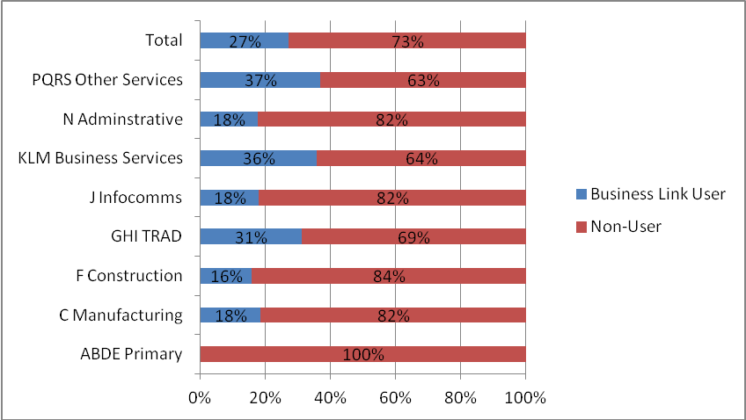

Note: Base = All SMEs in England (n=724)

3.2.3 Location
The surveyed SMEs were sampled in order to provide broad coverage across England and to avoid a bias towards either large urban conurbations or more remote rural areas. The survey consists of two-thirds urban and one third rural English SMEs. The overall distribution of SMEs across the English regions is indicative of the national pattern, with a larger concentration in Greater London and the South East (37 per cent), and few in the North East (3 per cent).
Overall, the survey revealed little difference between urban and rural SMEs in their use of Business Link: 26 per cent of rural SMEs were Business Link users compared to 27 per cent of urban SMEs. However, only 13 per cent of remote rural SMEs use Business Link.

3.2.4 Business Trading Age Distribution
The survey contains a good distribution of businesses by trading age, with just over a quarter (28 per cent) of SMEs trading for less than four years and just over two fifths (44 per cent) trading for 11 or more years. One in seven SMEs were new businesses, trading for less than two years.

Figure 3.2 demonstrates that the youngest businesses, trading for less than two years, were twice as likely to be Business Link users. The Barriers to Business Support study (BIS, 2011) also exhibited proportionally higher use of public sector support (mainly from Business Link) amongst the youngest start-up businesses.
It is also notable that there is a considerable dip in the use of Business Link services in the 4-10 years trading group, which may be a group where the GIS service needs to achieve greater market penetration.

There is equal representation of Business Link users and non users in the 2-3 year and longest established businesses (trading for 11 or more years) categories.

Figure 3.2: Surveyed Users and Non Users by Number of Years Trading

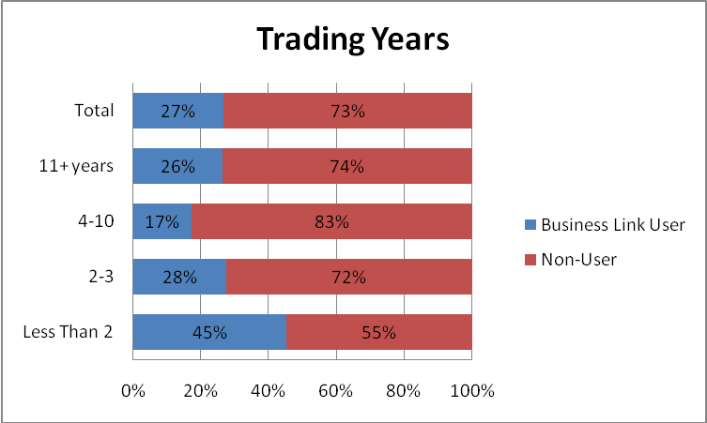
Note: Base = All SMEs in England (n=724)
3.2.5 Business Size
The proportion of SMEs in the survey has been weighted to reflect the English national distribution by employment size, with three quarters of SMEs being self employed, one fifth being micro businesses (1-9 employees) and just four per cent being small (3 per cent) and medium sized (1 per cent) businesses. The proportions of Business Link users and non users in each size category are very similar (Figure 3.3).
With the exception of medium sized businesses (with 50-249 employees), where only 20 per cent of those surveyed were found to be users, there were no significant differences in terms of usage of Business Link according to employment size of business.
Figure 3.3: Business Employment Size

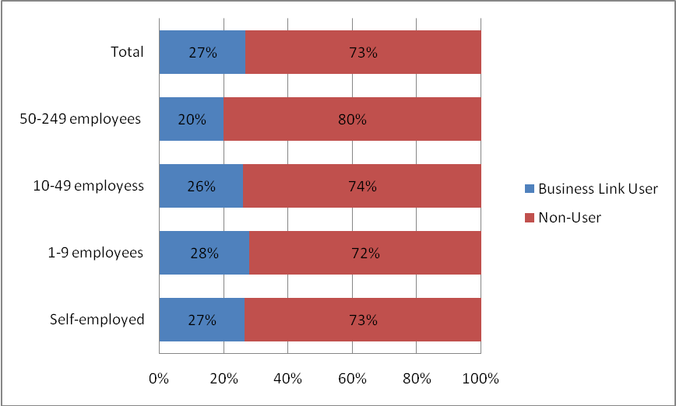
Note: Base = All SMEs in England (n=724)
Just over half (54 per cent) of surveyed SMEs disclosing their sales turnover data for the last year have a sales turnover which is under the current VAT threshold of £73,000, with seven per cent earning less than £10,000 and only seven per cent generating £1m or more.

Business Link users typically have lower sales turnover than their non user counterparts. A higher proportion of Business Link users (three fifths) had sales turnover of under £73,000 than non users (48 per cent). One in ten Business Link users had earned less than £10,000, compared to six per cent of non users, and only four per cent had generated £1m or more, compared to seven per cent of non users.

Table 3.2: Business Link Users and Non Users by Sales Turnover Size
 | Users | Non Users | All SMEs
n= | 1001 | 507 | 724
 | Col.% | Col.% | Col.%
Less than £73,000 | 61 | 48 | 54
£73,000 - £249,999 | 25 | 35 | 30
£250,000 - £499,999 | 6 | 6 | 6
£500,000 - £999,999 | 4 | 4 | 3
£1m - £2.49m | 3 | 4 | 4
£2.5m plus | 1 | 3 | 3
Note: Excludes don’t know and refused

3.2.6 Business Performance
In this section the performance of the surveyed SMEs has been measured in terms of their sales turnover and employment change recorded during the previous 12 months. Their current main business objectives are also examined, along with forecast projections for sales turnover and employment change over the next 12 months.

Sales Turnover Performance:

Just under one third of SMEs had increased their sales turnover during the previous 12 months, with almost one quarter experiencing declining sales turnover. Business Link users exhibit a slightly higher proportion of businesses with sales turnover growth, but also a slightly higher proportion with declining sales turnover.

Table 3.3: Sales Turnover Change in Last Year

 | Users | Non users | Total
n= | 1001 | 507 | 724
 | Col% | Col% | Col%
Increased | 37 | 33 | 32
Decreased | 28 | 26 | 24
Stayed roughly the same | 35 | 42 | 45
Note: Excludes don’t know and refused

It is notable that amongst the SMEs exhibiting sales turnover growth during the past year, Business Link users (33 per cent) were significantly more likely to experience higher growth of 50 per cent or more than their non user counterparts (9 per cent). This is explained in part by the higher proportion of young growth oriented businesses (trading for less than two years) that are Business Link users. One third had also used private sector assistance since December 2011, supporting evidence from the Barriers to Business Support study (BIS, 2011) which found users of both public and private sector assistance to be the highest growth performers.
Employment Performance:
Just one in twenty SMEs exhibited increased employment during the past year, with almost one quarter shedding employment. Business Link users were slightly more likely to increase employment than non users and less than half as likely to shed labour, with a greater proportion remaining stable.

Table 3.4: Employment Change in Last Year

 | Users | Non Users | Total
n= | 1001 | 507 | 724
 | Col% | Col% | Col%
Increased | 8 | 5 | 5
Decreased | 13 | 29 | 23
Stay roughly the same | 80 | 67 | 72
Note: Excludes don’t know and refused
Business Performance Forecasts:
The surveyed SMEs were asked to forecast their sales and employment performance over the next 12 months.
Just over one third (34 per cent) of SMEs forecast increasing sales turnover during the next year, with one fifth (21 per cent) indicating declining sales turnover. Business Link users were more optimistic, with half forecasting increased sales turnover and only 15 per cent forecasting a decline.
Almost one quarter (23 per cent) of SMEs forecast increasing employment during the next 12 months, with only three per cent indicating shedding labour. There was little difference between Business Link users and non users.
Table 3.5: Sales Turnover Forecast in the Next year

 | Users | Non Users | Total
n= | 1001 | 507 | 724
 | Col% | Col% | Col%
Increase | 50 | 34 | 34
Decrease | 15 | 21 | 21
Stay roughly the same | 36 | 45 | 44
Note: Excludes don’t know and refused

3.2.7 Current Business Objectives
Surveyed SME owner-managers were asked for their main current business objectives. Almost two fifths (38 per cent) are concerned with business survival, whilst almost one quarter (23 per cent) are aiming to grow their business, with just over one third seeking stability and three per cent aiming to sell or close their business.

Business Link users (37 per cent) exhibit a higher proportion than non users (21 per cent) that are growth seeking, but almost half the proportion that are seeking survival (25 per cent, compared with 43 per cent of non users) with a fairly similar proportion seeking stability. Business Link users were also twice as likely to be planning to sell or close their business.

Table 3.6: Growth Objectives

 | Users | Non Users | Total
n= | 1001 | 507 | 724
 | Col% | Col% | Col%
Growth | 37 | 21 | 23
Stability | 31 | 33 | 36
Survival | 25 | 43 | 38
Close or sell the business | 6 | 3 | 3

3.2.8 Formal Business Operations
The surveyed owner-managers were asked a series of questions about the formal operations of their business. This revealed that almost half have websites and regular quarterly management accounts, the latter being associated with larger SMEs that are trading at above the VAT threshold of £73,000. Almost one third of the SMEs have written business plans, whilst slightly less than one quarter have total quality management processes and written HR policies. Only six per cent are involved in exporting.

Business Link users demonstrate greater use of a wide range of formal business operations than their non user counterparts. This was particularly evident in terms of having a website, written business plans and they were twice as likely to be exporting. Non users exhibit slightly more use of TQM, whilst a similar proportion of users and non users have none of these formal business operations.

Monthly or quarterly accounts were most evident amongst primary, administrative and other services, written business plan were most evident in business and administrative services and least used by primary, construction, TRAD and other services. Performance related pay was more evident in the construction and infocomms sectors.

Larger SMEs were far more likely to exhibit formal business operations, particularly in relation to having a written HR policy where small and medium sized businesses (81 per cent) were almost twice as likely to have one as micro businesses (48 per cent). SMEs achieving sales growth in the last twelve months were more likely to have a website, written business plan, regular monthly accounts and TQM.

Figure 3.4: Business Link Users and Non Users by Formal Operations Profile

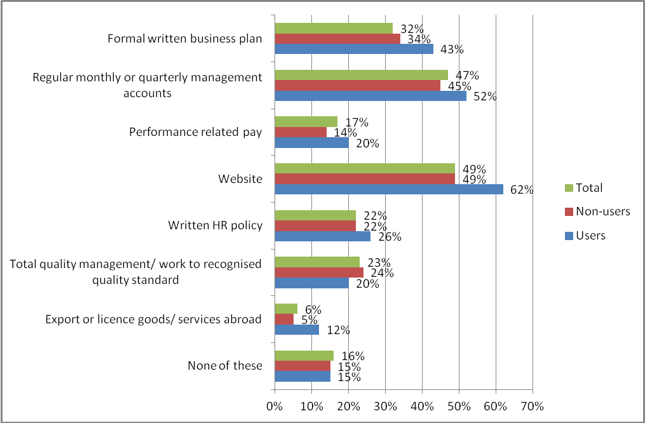
Note: Base = all SMEs in England. Total n= 724, Business Link users = 1001, non-users = 507

3.2.9 Management characteristics
This section is divided into management characteristics for the SME as a whole and characteristics which specifically relate to the owner-manager survey respondent.
SME Management characteristics:
More than three quarters (78 per cent) of surveyed SMEs only have one manager, less than one in five (17 per cent) have two managers and just five per cent have three or more managers. A higher proportion of Business Link users (81 per cent) than non users (70 per cent) only have one manager. However, Business Link users also exhibit a slightly higher proportion with three or more managers (7 per cent compared to 5 per cent).

Nearly one quarter (23 per cent) of surveyed SMEs are majority women owned, with a significantly higher proportion of these businesses being Business Link users (35 per cent) compared to their male owned counterparts (24 per cent). This finding is in line with the Barriers to Business Support study (BIS, 2011).
Just over one in ten (11 per cent) surveyed SMEs are majority Ethnic Minority owned (EMBs). A smaller proportion of these EMBs (19 per cent) are Business Link users than their white owned counterparts (28 per cent) (significant at beyond .1level).
Respondent characteristics:
Business Link users are more likely to be highly educated than non users, with almost half (47 per cent) possessing a degree or higher level formal qualifications, compared to less than one third (31 per cent) of non users. Six per cent of non users and four per cent of users possessed no formal qualifications.

Figure 3.5: Manager Qualifications by Users and non Users

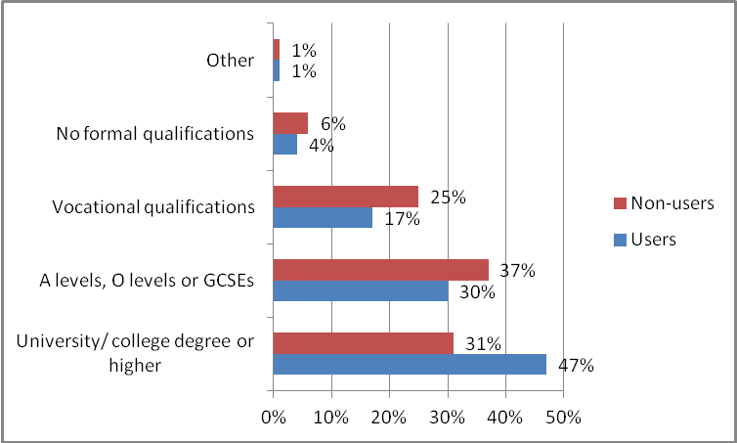
Note: Excludes don’t know and refused. Base Business Link users n = 987, non-users = 501
Nine per cent of Business Link users have less than two years management experience, compared to just four per cent of non users. There is a strong correlation between young businesses trading for less than two years, which are significantly more likely to use Business Link, and respondents with less than two years management experience. There is little difference in the proportions of Business Link users amongst the more experienced manager categories, with slightly less highly experienced managers (with over 10 years management experience) using Business Link.

Figure 3.6: Management Experience by Users and Non Users
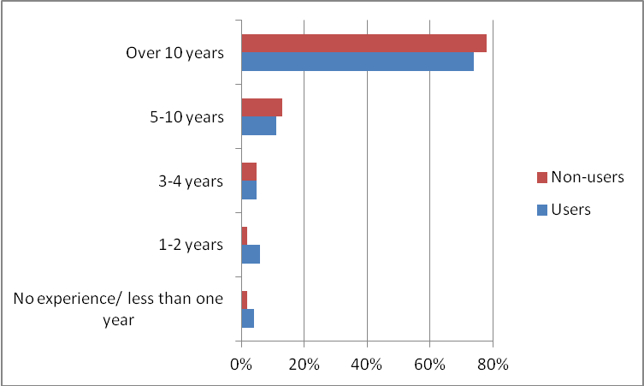
Note: Excludes don’t know and refused. Base Business Link users n = 987, non-users = 504

One in ten respondent owner-managers stated that they have a longstanding illness or registered disability, with little difference between Business Link users and non users.

3.3 Market Penetration and Use of Business Link Services
3.3.1 Introduction
This section focuses on the SMEs’ extent of knowledge and use of Business Link services during the previous 12 months. Account is taken of SMEs’ ability to use the new Business Link website facilities by establishing how they are able to access broadband internet, and also the extent to which they have actually used the Business Link websites, telephone helpline, or other more intensive face-to-face services (e.g. advisor meetings and workshops).
3.3.2 Access to Broadband
Only four per cent of English SMEs do not have any access to broadband, whilst a further two per cent only have access via a smartphone. The vast majority, almost three fifths, have access to broadband at work and home.
Table 3.7: Access to Broadband by Users and Non Users
 | Users | Non Users | Total
n= | 1001 | 507 | 724
Access to Broadband | Col.% | Col.% | Col.%
Yes - work | 8 | 16 | 18
Yes - home | 15 | 24 | 19
Yes - both | 75 | 53 | 57
Only on smartphone | 1 | 3 | 2
None | 1 | 5 | 4

Users of Business Link during the last 12 months virtually all have access to broadband, either at home or at work, with three quarters having access at home and work, whereas one in twenty non users do not have any access to broadband and a further three per cent only have access via a smartphone. Significantly, Business Link helpline users were all businesses with broadband access at work.
A significant proportion (61 per cent) of primary sector SMEs did not have broadband access and rural SMEs were significantly more likely not to have broadband access than their urban counterparts (9 per cent compared to 1 per cent): 14 per cent of remote rural and six per cent of semi rural SMEs do not have broadband access, with only 51 per cent of remote rural SMEs having home access to broadband compared to 82 per cent of urban SMEs.
3.3.3 Knowledge and use of different Business Link services in the last 12 months
- 71 per cent of SMEs have heard of Business Link, 27 per cent have not and two per cent were uncertain.
- More than one third of non users (37 per cent) had not heard of Business Link, with a further three per cent of non users stating ‘don’t know’.
Knowledge of Business Link was greatest amongst the primary (97 per cent) and business service (83 per cent) sectors and least amongst the infocomms (49 per cent) and administration (56 per cent) sectors. Younger SMEs, trading for less than two years, were more likely to know about Business Link (78 per cent) than those trading for five years or more (68 per cent), whilst those SMEs seeking survival were least likely to know about Business Link (57 per cent).
- One quarter of SMEs in England (27 per cent) have used the Business Link website in the last year
- Three per cent have used the Business Link telephone helpline in the last year
- Two per cent have used other Business Link services in the last year
- One per cent have used the Mentorsme website in the last year
The vast majority (91 per cent) of Business Link users during the past 12 months have used the website (Businesslink.gov.uk), with more than one fifth (22 per cent) receiving face-to-face advice or attending workshops or seminars and one in eight users calling the helpline (13 per cent). Just four per cent of Business Link users had visited the ‘Mentorsme’ website in order to find out about mentoring.
Business Link website use was greatest amongst younger SMEs, trading less than two years (44 per cent), those trading at below the VAT threshold of £73,000 (37 per cent), women-led businesses (35 per cent), those achieving at least 25 per cent sales turnover increase in the last year (35 per cent) and those with a growth objective (33 per cent). Least use of the website came from businesses with a survival objective (13 per cent) and ethnic minority led (17 per cent).
Business Link telephone helpline users were significantly more likely to be using other services such as face-to-face assistance, workshops and seminars.

3.3.4 Reasons for Business Link Users Not Using Services
Table 3.8: Reasons for Business Link Users Not Using Services
Row % | No Need | Not Aware | Time Issues | Prefer F/F | Poor Service | Other | Don't Know
Business Link  core website (n=74) | 58 | 8 | 21 | 10 | 2 | 0 | 1
Business Link  Helpline (n=889) | 82 | 14 | 0 | 1 | 1 | 1 | 1
Other Business Link  Services (n=794) | 75 | 15 | 3 | 1 | 0 | 4 | 2
Mentorsme  Website (n=964) | 44 | 51 | 0 | 0 | 0 | 1 | 3
Note: Figures are based on Business Link Users that are not using the specified services
More than half (53 per cent) of all Business Link users stated that they did not use at least one service because they were unaware of it.
Typically, most Business Link users are not using specific services because they do not have a need for them. This is particularly the case for the telephone helpline and other services such as seminars, workshops and face to face advice.
However, half (51 per cent) of the Business Link users during the past year were unaware of the ‘Mentorsme’ website, with a further three per cent responding that they ‘don’t know’ why they did not use the site, strongly suggesting that there is a lack of knowledge and understanding about this service.
One in seven Business Link users were not aware of other services such as face-to-face advisers, training and seminar events, with a further three per cent mentioning issues relating to availability and timing of these services.
Almost one in seven Business Link users were not aware of the telephone helpline, with a further one per cent preferring face to face assistance.
Although few business Link users did not use the core website service, largely because they did not need to, one fifth mentioned timing issues and one in ten would prefer a face to face service.

3.3.5 Usage of the Business Link Helpline
More than two fifths (44 per cent) of respondents that had used the new Business Link website since December 2011, but had not used the telephone helpline, indicated that they were not aware of it.
Businesses in the TRAD (69 per cent), businesses services (68 per cent) and construction (63 per cent) sectors were significantly more likely to know about the helpline than those in the other services (28 per cent) and manufacturing (34 per cent). Managers responding from medium sized businesses (50-249 employees) were also significantly less likely to know about the telephone helpline (30 per cent) than their smaller counterparts, whilst women-led (38 per cent) and ethnic minority owned (42 per cent) businesses were also slightly less aware of the telephone helpline. More than four fifths of users of GIS (89 per cent) and MNB (83 per cent) were aware of the Business Link telephone helpline.
Amongst the 20 SMEs that had used the telephone helpline to assist with a problem in using the new Business Link website, the vast majority (86 per cent) stated that it was either fairly or very easy to find the helpline, whilst 13 per cent indicated that it was very difficult to find.
Opinions were divided amongst the helpline users with website problems as to the effectiveness of the assistance received. One in five agreed that it was helpful, whilst two thirds were undecided and 14 per cent felt strongly that it had not been helpful.
Where SME owner-managers had experienced problems whilst using the new Business Link website and were aware of the telephone helpline but had not used it (59 respondents), they were asked why this was the case. Around half noted that there was no need to call the helpline, with others mentioning that it was late at night, that they had previously had a bad experience using the helpline, that they felt the response would be too slow, or that the helpline advisor would be unable to deal with the request.
For SME owner-managers that were not aware of the telephone helpline and had experienced problems in using the new Business Link website (60 respondents), they were asked if they had known about the helpline whether they would have used it. Just under half (47 per cent) of these respondents indicated that they would have used the telephone helpline.

3.3.6 Intermediary Service Users
The surveyed owner-managers were asked if they are intermediaries providing business assistance to other businesses and, if so, whether they make use of the Business Link services to help them to assist others to run their businesses.
One fifth (21 per cent) of the surveyed SMEs provide intermediary business assistance to other businesses. These are significantly more likely to be Business Link service users: 30 per cent have used Business Link services in the past year, compared with 21 per cent of non users.
Table 3.9: Reasons for Business Link Use by Business Intermediaries
Row % (n=274) | Own Business | Advising Clients | For Specific Firms | Other | Don’t know
Information on regulations/legislation | 73 | 40 | 15 | 1 | 6
Strategic advice on running a business | 65 | 34 | 13 | 4 | 13
Government transactions - tax/permits/licences | 60 | 19 | 6 | 8 | 19
Note: n=274 Business Link users that are business intermediaries
The owner-managers of businesses providing intermediary business services were asked to what extent they have been using Business Link’s services during the last year for either their own business support or for general client advice or specific firm assistance.
Two fifths of these business intermediaries are using Business Link information on regulations and legislation for general client advice, with one in seven using these services to provide this information for specific clients.
Just over one third are using Business Link’s strategic advice on running a business for their general client advice, with one in eight doing so for specific firms.
Just under one fifth of these intermediaries are using Business Link to advise clients on government transactions such as tax, permits and licences, with only six per cent mentioning doing so for a specific client firm.

3.4 Concerns for SMEs in the Last 12 Months
This section examines the main concerns facing English SMEs during the previous 12 months. This provides a strong indication as to the potential demand amongst English SMEs for the types of formal external assistance provided by Business Link.
The most frequently mentioned significant concerns amongst SMEs in England during the 12 months prior to the survey were: dealing with regulatory issues and business survival (both 44 per cent), followed by developing and growing the business (42 per cent) and managing cashflow (41 per cent). One fifth mentioned no significant concerns.
Figure 3.7: Types of Significant Concerns for SMEs in the Last 12 months, by Business Link Users and Non Users
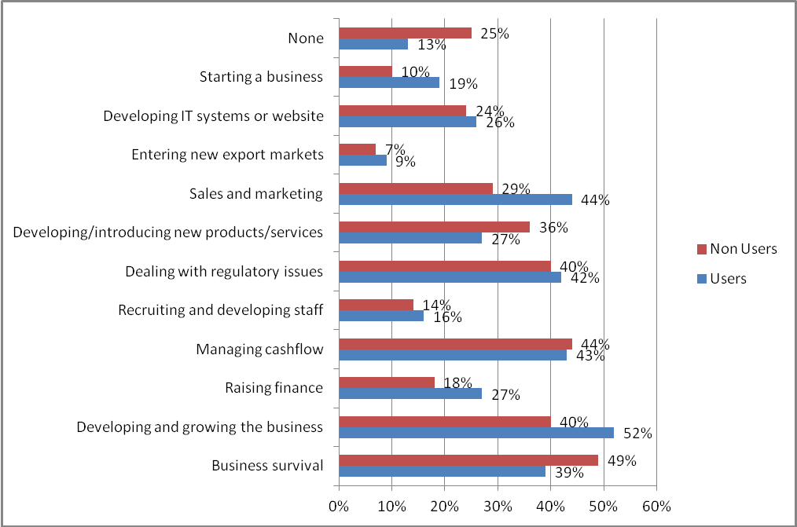
Note: n= Business Link users = 1001, non-users = 505 (excl 2 DK)
The evidence (Figure 3.7) is that SMEs are most frequently using Business Link to address significant concerns relating to business growth and development (52 per cent of all users in the last year), sales and marketing (44 per cent), managing cashflow (43 per cent), regulatory issues (43 per cent) and business survival (39 per cent).
Furthermore, SMEs using Business Link in the previous 12 months were more likely to have growth, sales and marketing, raising finance and business start-up concerns and less likely to have business survival and new product/service development needs than their non user counterparts. Non users were twice as likely to indicate having no business concerns during the past twelve months.

3.4.1 Potential for latent demand
From a potential latent demand perspective, it is notable that three quarters of non users exhibited significant business concerns during the previous 12 months. Whilst it can be expected that some of these will have been able to resolve these matters internally within the business’s own resources, or through informal assistance from family, friends and other business acquaintances, or from private assistance such as from accountants, banks or consultants, there are likely to be some who have been unable to resolve their problems in these ways and who are not using Business Link. This is explored further in the following section.

3.5 Barriers to Using Business Support and Latent Demand

This section examines the barriers which prevent SMEs from using formal external business assistance services and the potential levels of latent demand amongst English SMEs for business assistance, where the owner-managers acknowledged that they possess insufficient internal business resources to resolve their most significant concerns in running their business during the past year.

3.5.1 Barriers to Using External Assistance
Almost half of SMEs (49 per cent – 70 per cent of all non-Business Link users) have not used any form of business support in the previous 12 months. One third of these (33 per cent) claimed they had no need for external assistance, with 28 per cent claiming they had sufficient internal resources and expertise for running and developing their businesses. Combing these responses (as multiple responses were allowed), 48 per cent indicate they have either no need for external assistance or sufficient internal resources.
Table 3.10: Barriers for Non Users to Using Business Support
 | Col%
No need for external assistance | 33
Sufficient internal business resources | 28
Assistance is too expensive | 17
Do not trust external assistance | 14
Difficult to find time to use external assistance | 12
Right type of assistance does not exist | 12
Difficult to find appropriate assistance | 11
Advisers do not understand firm's needs | 11
Insufficient quality of assistance | 9
Deterred by previous experience | 8
None of the above reasons | 33
Don’t Know | 6
Sub total with no need/internal resources | 48
Sub total indicating that they may have a need for business support | 29
Note: Base = all who have not used any business support in the previous 12 months n=380
Other mentions given in response to this question indicated that external business support might be needed, but that there were reasons why it was not sought. The most frequently mentioned were that external assistance is too expensive (17 per cent), not trusted (14 per cent), that there is not time for the owner-manager to use assistance or that the right type of assistance does not exist (both 12 per cent), with just over one in ten mentioning difficulties finding the appropriate assistance and that advisers do not understand their business. Around one in twelve were deterred by a previous bad experience using external assistance, or insufficient quality of assistance, whilst one third did not give any of the given prompted reasons for not using business support.
Combing these responses (as multiple responses were allowed), 29 per cent indicated that they may have a need for external assistance. This is equivalent to 14 per cent of all SMEs. This was most likely to be the case for micro businesses (25 per cent of all micros).

3.5.2 Evidence of Types of Latent Demand
Table 3.11: SMEs with Insufficient Internal Resources to Meet Significant Concerns
Significant concern | Users | Non Users | All SMEs
 | Col.% | Col.% | Col.%
n= | 1001 | 507 | 724
Business survival | 12 | 14 | 13
Developing and growing the business | 21 | 9 | 8
Managing cashflow | 10 | 9 | 8
Dealing with regulatory issues | 10 | 8 | 8
Sales and marketing | 18 | 8 | 7
Developing IT systems or website | 16 | 6 | 6
Recruiting and developing staff | 8 | 8 | 6
Developing/introducing new products/services | 8 | 7 | 6
Entering new export markets | 5 | 6 | 5
Raising finance | 13 | 4 | 5
Starting a business | 5 | 2 | 1

Based on all SMEs in England, 13 per cent consider business survival as a significant concern that cannot be addressed through internal resources, with eight per cent saying developing and growing the business, managing cashflow and regulatory issues.
Business Link users are more likely than non-users to have significant concerns that cannot be addressed internally. Compared to non-users, this is most likely to be the case with growing/developing the business (21 per cent vs. nine per cent), sales and marketing (18 per cent vs. six per cent), developing IT systems or websites (18 per cent vs. six per cent), raising finance (13 per cent vs. four per cent) and starting a business (five per cent vs. two per cent).
The table below summarises concerns that businesses have, whether they think they have sufficient internal resources for these, whether they use the private sector to address these concerns, and whether there is a concern that is not being addressed.
Table 3.12: Significant Concerns – Whether Needs are Being Met
Significant concern  (Row %) | Sufficient Internal Resources | Do Not Have Sufficient Internal Resources/ Unsure |  |  | Not a Concern
Significant concern  (Row %) | Sufficient Internal Resources | Use PS Support | Do Not Use PS Support |  | Not a Concern
Significant concern  (Row %) | Sufficient Internal Resources | Use PS Support | Use BL | Unmet Need | Not a Concern
Business survival | 31 | 7 | 2 | 3 | 56
Developing and growing the business | 27 | 9 | 4 | 2 | 58
Managing cashflow | 29 | 10 | 1 | 1 | 59
Dealing with regulatory issues | 32 | 6 | 6 | 2 | 56
Sales and marketing | 21 | 4 | 4 | 2 | 71
Developing IT systems or website | 14 | 1 | 1 | 3 | 80
Recruiting and developing staff | 8 | 2 | 4 | 1 | 85
Developing/introducing new products/services | 22 | 4 | 4 | 1 | 69
Entering new export markets | 1 | 1 | 1 | 2 | 94
Raising finance | 13 | 1 | 4 | 1 | 81
Starting a business | 7 | * | 1 | 2 | 90

Base = all SMEs (n=724) * = a figure greater than zero but less than 0.5%

It should be noted that those who claim they have sufficient internal sources may still be using Business Link or private sector support, and those that have private sector support may also be using Business Link. Nor does the table take into account whether SMEs think that the support they are receiving (private sector or Business Link) addresses their needs or not. However, the table does give an indication of the areas of concern where SMEs seek no support at all, the proportion being between one and three per cent of all SMEs for each concern.

3.5.3 Use of Private Sector Business Support
Surveyed owner-managers were asked if they had received any formal private sector assistance during the previous 12 months. This was defined as assistance for specific business issues, over and above the typical day-to-day transactions undertaken by the business (e.g. bank deposits, purchasing goods and materials etc.). The private sector has been loosely defined here as also including Third Sector not for profit type organisations, such as some enterprise agencies and trade bodies.
- Just over one quarter (26 per cent) of SMEs in England had received formal private sector business assistance during the previous 12 months.
- Fifteen per cent of Business Link users had also received private sector business assistance during the previous 12 months.
- Twice the proportion of non users (30 per cent) had received private sector business assistance during the previous 12 months.
- A significantly higher proportion of Business Link users that had received private sector assistance during the previous year had done so since the new Business Link website services had been established in December 2011: 81 per cent compared to 65 per cent of non users.
Table 3.13: Types of Private Sector Provider Used by Business Link Users and Non Users
 | Users | Non Users | All SMEs
n= | 1001 | 507 | 724
 | Col.% | Col.% | Col.%
Accountants | 9 | 17 | 14
Banks | 3 | 4 | 5
Private Training Provider | 1 | 6 | 4
Membership Organisation | 2 | 5 | 4
Sector/Trade Organisation | 2 | 3 | 3
Private Consultants | 2 | 3 | 2
Solicitors | 5 | 1 | 2
Mentoring Organisation | 1 | 1 | 1
Other | 2 | 2 | 2
Any private sector support | 15 | 30 | 26
None | 85 | 65 | 70
Don't Know | 0 | 5 | 4

Table 3.13 above presents a breakdown of the main types of private sector providers that were used for business assistance during the past year. This demonstrates that:
- Accountants were by far the most frequently mentioned providers of private sector business assistance for Business Link non users and proportionally twice that for Business Link users. This suggests that accountants are an important source of business assistance for non users.
- A higher proportion of non users mentioned receiving assistance from private training providers and membership organisation such as the Federation of Small Business (FSB).
- Higher proportions of Business Link users received specialist business assistance from solicitors.
Based on all SMEs in England receiving private sector assistance since December 2011, the main types of assistance were in the following areas:
- Regulations (43 per cent)
- Managing cashflow (43 per cent)
- Developing and growing the business (39 per cent)
- Business survival (26 per cent)
- Sales and marketing (20 per cent)
- Developing/introducing new products and services (19 per cent)
- Raising finance (13 per cent)
- Developing IT systems/ company website (11 per cent)
- Recruiting/developing staff (8 per cent)
- Starting a business (5 per cent)
- Entering new export markets (3 per cent)
Table 3.14: Extent of Needs Being Met by Types of Private Sector Assistance Used Since December 2011
Type of Assistance |  | Fully Met | Partly Met | Not Met | Don’t know
 |  | Row% | Row% | Row% | Row%
Regulations | n=70 | 94 | 5 | 0 | 1
Managing cashflow | n=33 | 90 | 3 | 6 | *
New products/services | n=24 | 84 | 16 | 0 | 0
Recruitment/developing staff | n=35 | 75 | 24 | 0 | *
Developing IT/website | n=39 | 73 | 24 | * | *
Survival | n=27 | 67 | 27 | 6 | *
Sales & marketing | n=26 | 67 | 8 | 25 | *
Start-up | n=11 | 65 | 34 | * | 0
Developing/growing | n=52 | 53 | 46 | * | 0
Raising finance | n=32 | 41 | 28 | 31 | 0
Export | n=7 | * | * | 0 | 91
* A figure which is more than zero but less than 0.5%
Table 3.14 above, which is based on all SMEs that use private sector advice, demonstrates that private sector assistance received since December 2011 seems to be meeting most needs (fully or partly) in most areas.
Sample sizes are small, and some caution needs to be observed in the interpretation, but private sector advice seems to be meeting the needs of all who use it for regulations, developing new products and services, recruitment and development of staff, developing IT/websites and developing/growing businesses. It does not meet needs in particular for sales and marketing and raising finance. Because of very small sample sizes, the reasons why private sector support does not appear to meet needs in these areas is unclear.

3.6 Awareness and Perceptions of Business Link Services
Table 3.15: Perception of what Business Link Website Services should provide
 | Users | Non Users | All SMEs
n= | 1000 | 495 | 712
 | Col.% | Col.% | Col.%
Informative | 28 | 28 | 30
Strategic | 13 | 20 | 17
Both informative and strategic | 53 | 26 | 33
Other | 1 | 1 | 1
Don't Know | 5 | 25 | 19

Note: Base = all SME internet users

Business Link users have a much stronger awareness and perception of what the Business Link website is expected to offer than their non user SME counterparts:

81 per cent of users expect the website to be informative, offering straightforward assistance with the day to day running of their business, compared to just over half of non users (54 per cent)

Almost two thirds (66 per cent) of users expect the website to offer strategic advice on how to grow and develop their business, compared to less than half (46 per cent) of non users.

Only nine per cent of users knew that Business Link had introduced new services to the website in the past six months, compared to less than one per cent of non users.
Table 3.16: Awareness and Use of Business Link Web Services
 | Users |  | Non Users | All SMEs
 | Aware | Used | Aware | Aware
n= | 1000 | 1000 | 495 | 712
 | Col.% | Col.% | Col.% | Col.%
Events Finder | 30 | 15 | 16 | 22
Learning Resources | 30 | 14 | 14 | 20
Growth Improvement Service | 20 | 3 | 8 | 14
Business Support Finder | 30 | 7 | 7 | 14
Mentorsme | 17 | 4 | 7 | 11
Contracts Finder | 17 | 7 | 5 | 11
Business Finance Finder | 25 | 9 | 6 | 11
My New Business | 20 | 5 | 8 | 11
Case Study Videos | 17 | 6 | 3 | 9
None of These | 37 | 62 | 74 | 59
Don't Know | * | 2 | 2 | 1
Note: Based on SME internet users. * = a figure of more than zero, but less than 0.5%
Users of Business Link in the past year are more aware of the new website services listed above, with more than three fifths (63 per cent) aware of at least one of these services, compared with just under one quarter (24 per cent) of non users.
Overall, user and non user respondents were most aware of the ‘Events Finder’ and ‘Learning Resource’, with Business Link users considerably more aware of the ‘Business Finance Finder’ and ‘Business Support Finder’ than their non user counterparts.
One in ten of all SMEs (11 per cent) and one in eight (13 per cent) businesses trading for less than two years were aware of My New Business. In fact, awareness of MNB was higher among businesses founded before 2001 (17 per cent).
Around a third (36 per cent) of Business Link users were able to mention using specific elements of the new website service.
The most frequently used new services were the ‘Learning Resources’ and ‘Events Finder’.
Awareness of the new services was lowest in the manufacturing (56 per cent unaware) and infocomms (56 per cent) sectors. It was highest among administration (75 per cent aware) and other services (74 per cent aware).

3.7 Summary of SME Survey Key Findings

3.7.1 SME Characteristics of Business Link Users and Non Users
- Business Link users are more likely to be private limited companies than non-users and are less likely to be sole traders.
- There are significantly higher proportions of users in the other services (37 per cent), business services (36 per cent) and TRAD (transport, retail and distribution, 31 per cent) sectors, and lower proportions in the primary (0 per cent), construction (16 per cent), manufacturing, information/communications and administration sectors (all 18 per cent).
- Only 13 per cent of remote rural SMEs used Business Link in the last year (compared to 27 per cent of all SMEs in England).
- The youngest businesses, trading for less than two years, were twice as likely to be Business Link users. It is also notable that there is a considerable dip in the use of Business Link services in the 4-10 years trading group.
- Medium-sized businesses (with 50-249 employees) are less likely to be Business Link users than are smaller businesses
- Business Link users typically have lower sales turnover than their non user counterparts: three fifths had sales turnover of under £73,000 compared to 48 per cent of non users.

- Business Link users (37 per cent) were slightly more likely to have increased their sales turnover in the last year than non users (33 per cent), more likely to have increased employment (8 per cent compared with 5 per cent of non users) and half as likely to have shed labour (13 per cent compared to 29 per cent).
- Of those experiencing an increase in turnover in the last year, Business Link users were more likely to experience higher growth of 50 per cent or more than their non user counterparts (34 per cent compared to nine per cent).
- Fifty per cent of Business Link users think they will increase sales in the next 12 months, compared to 34 per cent of non-users.
- Business Link users (37 per cent) exhibit a higher proportion than non users (21 per cent) that are growth seeking. Twenty-five per cent of users are seeking survival, compared with 43 per cent of non users.
- Business Link users were far more likely to have a range of formal processes than their non user counterparts, notably relating to having a website and written business plans and were also twice as likely to be exporting.
- Thirty-five per cent of women owned businesses are Business Link users, compared to 24 per cent of male owned businesses.
- Business Link users appear more likely to be highly educated than non users with almost half having a degree or higher level formal qualifications (47 per cent of users compared with 31 per cent of non users).
- One in 10 Business Link users have less than two years management experience, compared to just four per cent of non users.

3.7.2 Market Penetration and Use of Business Link Services
- 27 per cent of SMEs in England were Business Link users in the past year. Three per cent had used the Business Link helpline in this period, two per cent other Business Link services, and one per cent the Mentorsme website.
- 26 per cent had used private sector business assistance during the past year.
- Four per cent had used both Business Link and private sector assistance.
- 49 per cent had used no formal business assistance in the past year.
- 27 per cent of SMEs in England have not heard of Business Link.
- Almost all Business Link users during the last 12 months have access to broadband, either at home or at work, with three quarters having access at home and work. Five per cent of non users do not have any access to broadband.
- 21 per cent of SMEs provide intermediary business assistance. These are significantly more likely to be recent Business Link service users (30 per cent compared with 21 per cent of other SMEs).

3.7.3 Concerns for SMEs in the Last 12 Months
- The evidence suggests that users are most frequently using Business Link to address concerns relating to business growth and development (52 per cent), sales and marketing (44 per cent), managing cashflow (43 per cent), regulatory issues (43 per cent) and business survival (39 per cent). .
- Business survival (13 per cent) followed by developing and growing the business, managing cashflow and dealing with regulations (all 8 per cent) were proportionally the greatest concerns where SMEs’ internal resources were unable to adequately address the issue. For non users these concerns related most to survival (14 per cent), developing and growing the business and managing cashflow (both 9 per cent).
- Business Link users demonstrate far greater proportions of concerns, for which they have insufficient internal resources to deal with, particularly in respect of business growth and development (21 per cent), sales and marketing (18 per cent) and developing IT systems (16 per cent).

3.7.4 Barriers to Using Business Support
- 48 per cent of those with concerns for their business, but not using any formal external assistance during the last year, felt they had sufficient internal resources to overcome these concerns. Overall among this group, the main reasons why external assistance was not sought were that external assistance is too expensive (17 per cent) or not trusted (14 per cent).

3.7.5 Use of Private Sector Business Assistance
- Twice the proportion of non users (30 per cent) had received private sector business assistance during the previous 12 months,, compared to Business Link users (15 per cent).
- Accountants were by far the most frequently mentioned providers of private sector business assistance for Business Link non users, proportionally twice that for Business Link users.
- Private sector assistance is fully meeting the needs of most users, but is less likely to do so for start-ups, developing/growing the business and raising finance.

3.7.7 Awareness and Perceptions of Business Link Services

81 per cent of users expect the website to be informative, offering straightforward assistance with the day to day running of their business, compared to just over half of non users (54 per cent)

Two thirds (66 per cent) of users expect the website to offer strategic advice on how to grow and develop their business, compared to less than half (46 per cent) of non users.

Nine per cent of users knew that Business Link had introduced new services to the website in the past six months, compared to less than one per cent of non users.
- SMEs were most aware of the ‘Events Finder’ (22 per cent) and ‘Learning Resource’ (20 per cent), used by four per cent of SMEs in England.
- 14 per cent were aware of ‘Growth Improvement Service’, which was known to be used by one per cent of SMEs in England.
- 11 per cent of SMEs in England were aware of the ‘My New Business’ service, including one in eight businesses trading for less than two years. It has been used by one per cent of SMEs in England.
- 11 per cent of SMEs in England were aware of Mentorsme and only one per cent had used the website.

4. Survey of SME Business Link Users

4.1 Introduction
This chapter reports on findings from the Stage 2b survey of 1001 English SMEs that have used Business Link services in the previous 12 months. The data has been weighted by employment size, sector and trading age in order to be representative of all SME Business Link users in England (valid base n= is provided under each table, significance refers to at or beyond the .05 level).

4.2 Length and Frequency of Use of Business Link

4.2.1 Business Link website
Business Link users were asked when they first started using the Business Link website, how frequently they have used the Business Link website during the past year and whether they have used it since December 2011, when the new website service was launched.
- Five per cent have started using the website since December 2011, with a further eight per cent starting within the last year. Almost two thirds (65 per cent) have used the website for between one and five years and almost one fifth (19 per cent) have been using the website for more than five years.

- Additionally, over two fifths (42 per cent) of existing users have used the new Business Link website service since its inception in December 2011.

- The vast majority (83 per cent) use the Business Link website three to four times a year at most, with one in eight using it monthly and just three per cent using it more frequently. Only two per cent of Business Link website users visit the website at least once per week.

- Those using the Business Link website for more than five years were significantly more likely to be using the website at least once per month (29 per cent compared to 12 per cent of those using the website for less time). Those starting to use the service during the last year were most likely to be using it more than once per week (3 per cent).

Figure 4.1: Frequency of Use of Business Link Website in the Last Year

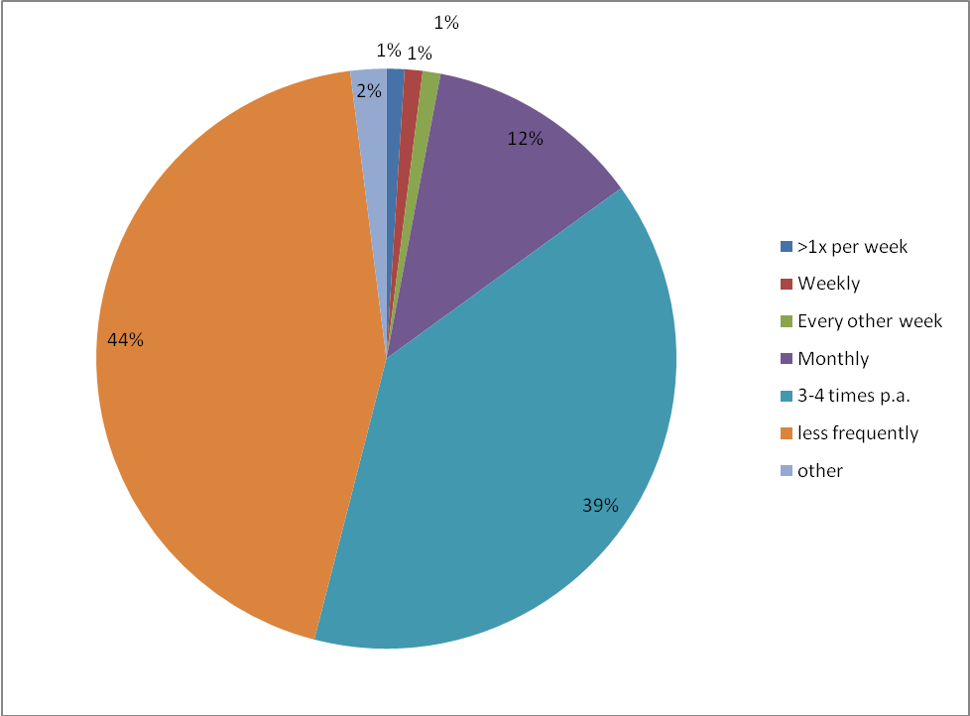
Base = all users of Businesslink.gov.uk (n=930)
Figure 4.2: Distribution of Business Link Website Users by Length of Use

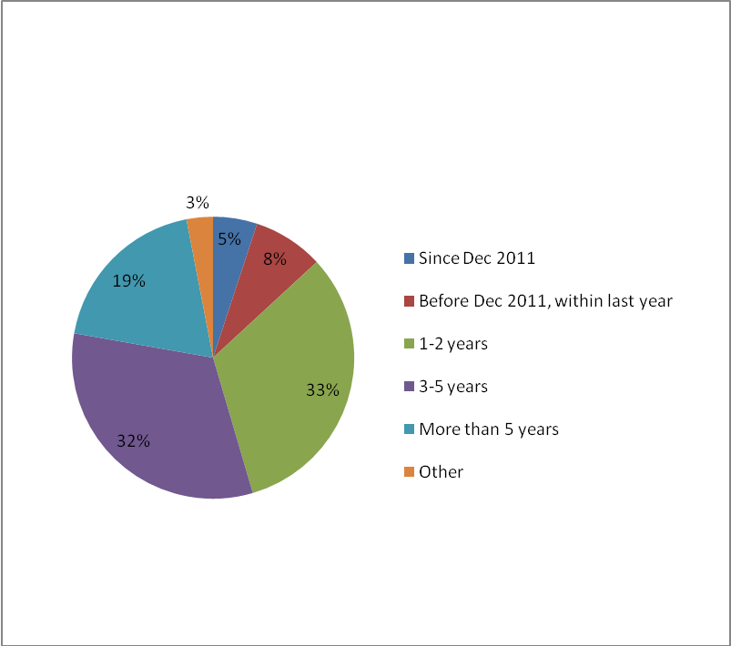
Base = all users of Businesslink.gov.uk (n=930)
Table 4.1: Frequency of Use of Business Link Website in the Past Year
 | Weekly | Monthly |  | 3-4 pa | Less | Other
Employment Size | Row% | Row% |  | Row% | Row% | Row% | n=
Zero | 1 | 11 |  | 40 | 47 | 1 | 173
1 to 9 employees | 4 | 20 |  | 35 | 39 | 2 | 434
10 to 49 employees | 3 | 27 |  | 41 | 24 | 6 | 281
50 to 249 employees | * | 20 |  | 40 | 40 | 0 | 42
Trading Age
< 2 years | 2 | 20 | 40 |  | 35 | 3 | 254
2 to 3 years | 2 | 14 | 39 |  | 45 | * | 191
4 to 10 years | * | 10 | 50 |  | 38 | 2 | 219
11 plus years | 1 | 10 | 34 |  | 54 | 1 | 266
Sector
Manufacturing | 0 | 4 | 60 |  | 36 | * | 86
Construction | 3 | 4 | 29 |  | 64 | * | 48
TRAD | 1 | 12 | 48 |  | 39 | 0 | 69
Infocomms | 5 | 25 | 30 |  | 35 | 5 | 84
Business Services | 1 | 26 | 37 |  | 36 | 1 | 312
Administration | 8 | 9 | 31 |  | 52 | 1 | 127
Other services | 1 | 9 | 39 |  | 48 | 3 | 185
Intermediary
Yes | 3 | 19 | 31 |  | 43 | 4 | 279
No | 1 | 11 | 42 |  | 45 | 1 | 638
Table 4.1 demonstrates that business intermediaries providing services to other businesses were significantly more likely to be more frequent users of the Business Link website: 22 per cent of intermediaries using the site do so at least once per month, compared to 12 per cent of other SME users.
Sectoral analysis also indicates this, with business services (27 per cent) and information and communications services (31 per cent) exhibiting significantly higher proportions of SMEs using the Business Link website at least once per month than other sectors.
It is also notable that young firms trading for less than two years are more frequent users of the Business Link website (22 per cent using the website at least once per month) whilst, conversely, those with no employees are less frequent users of the service (12 per cent use the website at least once per month).
London (23 per cent) and the North East (41 per cent) had the highest proportion of Business Link users using the website at least once per month, whilst in the East Midlands, East of England and West Midlands it was less than one in ten users that visited the site at least once per month. London has the highest proportion of intermediary businesses using the Business Link website, whilst the North East has a high proportion of young firms trading for less than two years (33 per cent) and a low proportion of self employed (53 per cent).

4.2.2 Use of the Business Link Telephone Helpline
Three per cent of all SMEs in England (13 per cent of Business Link users in the last year) claim to have used the Business Link Telephone Helpline. However, only five per cent of Business Link users in the last year have used the Helpline since November 2011.
Use of the helpline service increased with ability and frequency of use of the Business Link website and was not related to a lack of broadband internet access. Amongst those that have used the telephone helpline since November 2011, a significantly higher proportion of use came from those with both home and work access to broadband (four fifths of all helpline users), whilst none of the SME Business Link users without access to broadband had used the helpline in this period. Furthermore, 30 per cent of helpline users in this period were more regular users, using the site at least once per month.
More recent telephone helpline users are also characterised as being significantly more likely to be more experienced managers, in older established SMEs and from the ‘other services’ sector.
- The overall picture of recent telephone helpline users is of experienced, regular, Business Link website users who are used to calling the telephone helpline service for assistance and continue to do so.

4.3 Types of Assistance Sought from the New Business Link and Service Effectiveness
In this section the focus is on the use of the new Business Link website and telephone helpline services since they were initiated in December and November 2011, respectively. First, the types of assistance sought are investigated and then an assessment of satisfaction with these new services is undertaken, examining the extent to which users’ assistance needs have been met, the usefulness of various Business Link websites and tools and initial impacts from the assistance received.
Just over two fifths (42 per cent) of Business Link users during the past year had made use of the new Business Link website or the telephone helpline services. The results presented in this section relate specifically to this group of users.
Table 4.2 indicates that the most frequently mentioned type of Business Link assistance used since November 2011 has been for dealing with regulatory issues, followed by assistance to develop and grow, and then sales and marketing.
Based on those using the Business Link website or using the Helpline since November/December 2011, the main subjects that people sought information or advice about were as follows:
- Regulations (40 per cent)
- Developing and growing the business (27 per cent)
- Sales and marketing (19 per cent)
- Raising finance (16 per cent)
- Business survival (14 per cent)
- Recruiting/developing staff (14 per cent)
- Starting a business (14 per cent)
- Developing/introducing new products and services (11 per cent)
- Entering new export markets (8 per cent)
- Managing cashflow (7 per cent)
- Developing IT systems/ company website (5 per cent)
Table 4.2: Type and Effectiveness of Assistance Sought from Business Link, Since November/December 2011
Meeting Needs: |  | Fully | Partly | Not Met | D/K
 |  | Row% | Row% | Row% | Row%
Managing cashflow | n=57 | 68 | 24 | 8 | 0
Dealing with regulatory issues | n=274 | 52 | 39 | 9 | *
Starting a business | n=64 | 48 | 47 | 3 | 2
Developing/introducing new products/services | n=54 | 47 | 45 | 6 | 1
Recruiting and developing staff | n=143 | 43 | 52 | 4 | 1
Business survival | n=70 | 34 | 58 | 8 | *
Raising finance | n=80 | 32 | 28 | 40 | *
Sales and marketing | n=81 | 28 | 66 | 3 | 3
Developing and growing the business | n=130 | 26 | 67 | 6 | 1
Developing IT systems or website | n=38 | 22 | 74 | 3 | 1
Entering new export markets | n=27 | 11 | 35 | 54 | 0
* = a figure of more than zero, but less than 0.5%
Most types of assistance appear to be meeting needs at least partly in more than nine out of ten cases. The exceptions are entering new export markets (54 per cent) and raising finance (40 per cent), where at least two fifths of those respondents using these types of services indicated that the assistance received had not met their needs. Only just over one in ten seeking assistance with export market development indicated that their needs were fully met. It is also notable that only around a quarter of those seeking assistance for sales and marketing, developing and growing the business and developing IT systems and websites indicated that their needs were fully met by the Business Link service.
In terms of fully meeting respondent users’ needs, the most successful types of assistance have been for managing cashflow (68 per cent) and dealing with regulatory issues (52 per cent), where at least half of users have received services which fully met their needs.
We do not know exactly why needs were not met in 40 per cent of cases for raising finance. The problems that people have with the Business Link website mainly relate to not being able to find the detail they require, and qualitative evidence from other surveys suggests that the Business Finance Finder is considered too general by some, and does not pinpoint, for example, exactly where grants and financial Government assistance or tax relief may be available for particular sectors.
The most frequently mentioned used Business Link website services since December 2011 have been the Events Finder (13 per cent of those using the website in this period), Contracts Finder (13 per cent), Learning Resources (14 per cent) and Business Finance Finder (13 per cent). The Growth Improvement Service (6 per cent), My New Business (8 per cent) and Mentorsme (8 per cent) were less likely to be used, although it is recognised that respondents may not have known which service they were using.
Table 4.3: Usefulness of New Business Link Website Services, Since December 2011
 |  | Very useful | Fairly useful | Neutral | Not very useful | Not at all useful | D/K
 |  | Row% | Row% | Row% | Row% | Row% | Row%
Growth Improvement Service (GIS) | n=46 | 42 | 41 | 11 | 5 | 1 | *
My New Business (MNB) | n=43 | 39 | 25 | 6 | 27 | 0 | 2
Events Finder (EF) | n=82 | 35 | 40 | 23 | * | 2 | 0
Contracts Finder (CF) | n=77 | 29 | 32 | 32 | 4 | 2 | *
Business Finance Finder (BFF) | n=69 | 28 | 50 | 7 | 3 | 7 | 5
Case Study Videos | n=48 | 28 | 37 | 23 | 12 | * | *
Learning Resources | n=85 | 23 | 22 | 9 | 40 | 1 | 5
Business Support Finder (BSF) | n=75 | 15 | 38 | 12 | 12 | 10 | 12
Mentorsme (MS) | n=19 | 5 | 9 | 63 | 4 | 17 | *
* = a figure of more than zero, but less than 0.5%
Those services rated as most useful were the Growth Improvement Service (GIS), Business Finance Finder (BFF) and Events Finder (EF) which three quarters or more users indicate are at least fairly useful, with slightly over two fifths rating GIS as very useful and more than one third rating EF as very useful.
Almost two thirds of users found My New Business (MNB), Case Study Videos and the Contracts Finder (CF) at least fairly useful, with almost two fifths of MNB users finding this service very useful, but over one quarter rating it as not very useful.
Slightly under half of the Learning Resource users rated this service as at least fairly useful, with more than two fifths rating it as not very useful or not at all useful.
Only one in seven Mentorsme users found this service at least fairly useful, with the majority providing a neutral response. Just over one fifth rated this service as not useful, including one in ten that stated it was not at all useful.

4.3.1 Initial Perceptions of Business Link Assistance
Table 4.4 demonstrates that the new Business Link services are well regarded by the majority of service users, particularly in terms of their trustworthiness, quality and impartiality.
Almost three quarters (74 per cent) of Business Link users since November 2011 indicate (at least to some extent) that the service is more trustworthy than other sources of business assistance, with more than two fifths strongly agreeing with this point.
Almost three fifths (59 per cent) agreed (at least to some extent) that Business Link provides better quality information on matters such as regulations than other sources of business information.
More than half (55 per cent) agreed (at least to some extent) that Business Link is more impartial than other sources of business assistance and a similar proportion (54 per cent) agreed (at least to some extent) that it that it will lead to improved business performance.
Less than half (48 per cent) indicated (at least to some extent) that Business Link had led them to consider new options, or provided them with better strategic advice, whilst one quarter indicated (at least to some extent) that it had not helped them to consider new options and more than one in ten were uncertain whether the service offers better strategic advice tan other sources of business assistance.
Table 4.4: Initial Perceptions and Impacts of Business Link Services, since November/December 2011
 | Agree strongly | Agree slightly | Neutral | Disagree slightly | Disagree strongly | D/K
 | Row% | Row% | Row% | Row% | Row% | Row%
More trustworthy than other sites | 43 | 31 | 13 | 10 | 2 | 1
More impartial than other sites | 34 | 21 | 28 | 12 | 1 | 4
Better quality than other sites | 28 | 31 | 21 | 11 | 6 | 3
Better strategic advice than other sites | 22 | 26 | 26 | 13 | 2 | 11
Made me consider new options | 18 | 30 | 25 | 15 | 10 | 2
It will lead to improved performance | 16 | 38 | 30 | 9 | 6 | 1
Note: Base = all who have used the Business Link website or Helpline since November/December 2011 (n=542)

4.3.2 Benefits from the Telephone Helpline, Since November 2011
SME owner-managers that had used the new Business Link telephone helpline, established since November 2011, were asked to attribute the proportion of any benefits that resulted from this. More than one quarter (29 per cent) indicated that it had been of some benefit with five per cent stating that these benefits would not have been possible without the helpline.

4.3.3 Comparison between the New and Old Business Link Website Services
Those SME owner-managers that had used both the new Business Link website, since December 2011, and the previous Business Link website were asked to compare them.
Nearly one in five (19 per cent) respondents indicated that the new Business Link website is better than the previous one, with one in twelve (eight per cent) stating that it is much better. No respondents suggested that the new website is worse, but nearly half (46 per cent) were unable to make a reasonable comparison, stating that they ‘don’t know’.
Where improvements were noted, the main areas of improvement were considered to be: ease of navigation (30 per cent), including improved search tools; provision of more information (17 per cent); improved quality of information (16 per cent); improved clarity of information (six per cent); and more up-to-date information (five per cent).
Figure 4.3: Comparison between the New and Old Business Link Websites
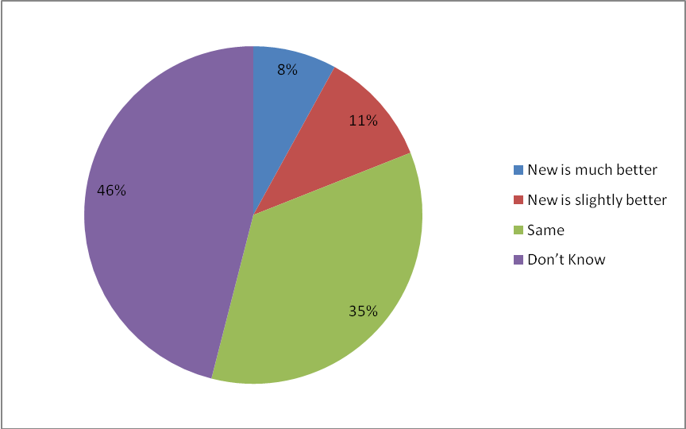
NB. Base = All who have used Business Link website before and since December 2011 (n=494)

4.3.4 Initial Impacts on Business Performance
As a result of receiving assistance from the new Business Link services, since November 2011, SME owner-manager respondents were asked if this had made a real difference in the performance of their business.
One in eight (12 per cent) respondents mentioned that using the new Business Link services had improved their business performance, with four per cent indicating that their performance was significantly better. For one in six respondents (17 per cent) it was too early to provide a clear response. This was consistent across most sectors, apart from business services where one quarter indicated at least some improvement and construction where significantly only one per cent mentioned improvement, whilst in the administrative services over one third (36 per cent) stated that it was too early to tell.

Figure 4.4: Business Performance Impact Resulting from New Business Link Services
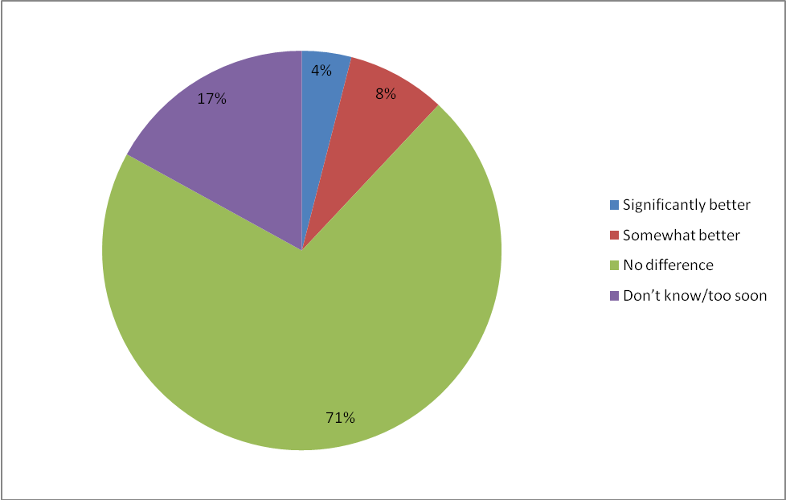
NB: Base = all who have used the Business Link website or helpline since November/December 2011 (n=542).
For the SMEs where improvements had been experienced (77 respondents), half mentioned increased sales turnover and profitability, two fifths mentioned that it enabled business survival, one third mentioned that it led to a re-evaluation of the business and almost one fifth (18 per cent) mentioned that it led to diversification.

4.4 Impacts of Using Business Link Services
This section investigates the initial impacts of the Business Link assistance received during the last year on the surveyed 1001 service users.
Of those that had used the Business Link website or helpline in the last year, more than two fifths (43 per cent) experienced at least some time savings by using Business Link services, with one in ten saving a great deal of time and only five per cent experiencing wasted time. Whilst there were no significant differences recorded, manufacturing (58 per cent) was the sector where managers were most likely to indicate time savings, with construction and primary activities the least likely (29 and 18 per cent respectively). Those that had used the Business Link website since December 2011 were slightly more likely to record time savings (53 per cent), with users of GIS (90 per cent) more likely to record time savings than MNB (53 per cent), with the various ‘Finder’ tools saving time for around three quarters of users.
Figure 4.5: Extent to which Business Link Services Have Saved Time
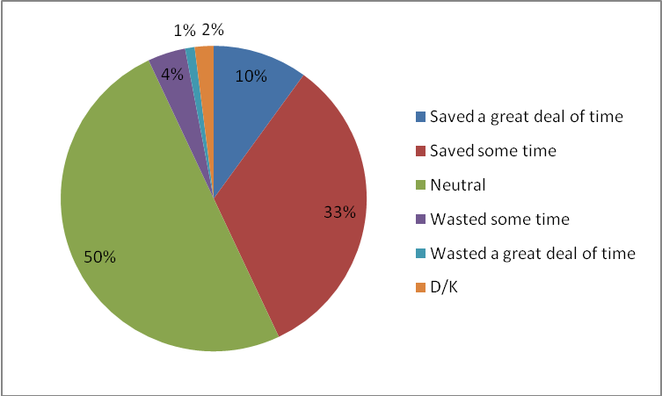
NB: Base = all who have used the Business Link website or helpline in the last year (n=941)
More than one fifth (22 per cent) of SME Business Link users reported some forms of financial benefit from using Business Link’s services during the last year. Eighteen per cent had saved money, whilst it had enabled nine per cent to achieve greater financial returns. Manufacturing businesses (38 per cent) were most likely to report time savings whilst construction sector (11 per cent) users were least likely to. Half of GIS users reported financial savings compared with just below one quarter (23 per cent) of MNB users and between a quarter and a third of ‘Finder’ tool users.
Figure 4.6: Extent of Financial Savings/Returns from Using Business Link Services
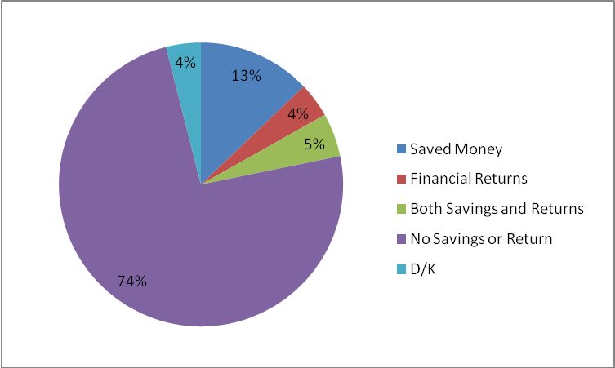
NB: Base = all who have used the Business Link website or helpline in the last year (n=941)
Table 4.5: Whether Saved Both Time and Money
 | Website Users in Last Year | Helpline Users in Last Year | All Website/Helpline Users in the Last Year
n= | 924 | 112 | 941
 | Col% | Col% | Col%
Saved both time and money | 17 | 21 | 17
Saved time, not money | 27 | 22 | 26
Saved money, not time | 5 | 2 | 5
Saved neither | 52 | 54 | 52
NB: Base = all who have used the Business Link website or helpline in the last year
Table 4.5 above shows the overlap between time and money savings. Forty-eight per cent of those that had used either the Business Link website or helpline in the last year claimed they received either time or money savings. This proportion was even higher (56 per cent) among those that had used the website since December 2011.
As seen in the figures on the previous page, most commonly, time rather than money was saved. Seventeen per cent of users in the last year saved both time and money, with 26 per cent saving time but not money. Only one in twenty saved money but not time. Therefore, there is some indication that for those that saved money, for the majority this may have come about as a result of the time they saved.
Those using the website since December 2011 were significantly more likely than average to have saved time, but not money (38 per cent).

4.4.1 Amount of Time Saved
The median amount of time saved gain for SMEs reporting a time saving was 7 hours. Of those who could calculate a time saving, 56 per cent said this was up to one working day (between 1 and 7 hours), 23 per cent between one and two days, five per cent between two and three days, and 16 per cent more than three days.
The mean amount of time saved was 19 hours, rising to 24 hours among those using the website since December 2011.
Of those that claimed using the Business Link website or helpline had wasted time, the median amount of time wasted was between one and two days.

4.4.2 Amount of Money Saved
The median amount of financial gain for SMEs reporting money savings was £500. One in seven reporting financial benefits of between £50 and £250, just over one third reporting benefits of between £250 and £500, two fifths reporting benefits of between £500 and £1000 and one in six reporting financial benefits of between £1,000 and £5,000.
The mean amount of financial gain was £1053. This increased to £1175 among those using the website since December 2011.
There were no significant differences in the means and medians between those who saved just money, and those that saved both time and money.

4.4.3 Referrals to Other Websites
Almost half (47 per cent) of those using the Business Link website or helpline services since December 2011 found the information they needed through other external websites, through linkage from the Business Link site. Perhaps surprisingly, this was significantly less likely to be the case for those that used private sector support since December 2011 (37 per cent). Whether Business Link has encouraged usage of private sector support is therefore inconclusive.
One third of those (one in six of all Business Link users since December 2011) referring to using other sites stated that they would definitely not have found the external website services that they required without the Business Link referral. Again, this proportion was significantly lower among those that have used private sector support since December 2011 (15 per cent).

4.4.4 Usage of Private Sector Support After Using Business Link
Although one in eight users of the new Business Link services had used private sector assistance since November/December 2011, only 16 per cent of these have done so after using the Business Link website or helpline.
There is some conflicting evidence as to the influence of the new Business Link services on the use of private sector assistance. Two thirds of those using the new Business Link services prior to using the private sector (28 respondents), stated that the new service had made little or no difference to their use of private sector. However, around half indicated that it had helped them to select appropriate private sector support and increased their use by showing them the benefits of private sector services. However, for almost two fifths, the new Business Link services had actually reduced their need for private sector support.
Business Link users that had received private sector assistance during the past 12 months were asked why they had obtained private sector assistance rather than use Business Link. By far the most common answer was to source specialist skills that are not available within Business Link (38 per cent), followed by having previous experience of private sector support (22 per cent), previous poor experience with Business Link (8 per cent) and because private sector assistance had been free (8 per cent).
More than three quarters (77 per cent) of the Business Link users who have used private sector assistance since December 2011 have paid for this assistance. The median amount paid was £2,000, ranging from £17 to £30,000, with one per cent paying less than £100, one third paying between £100 and £1,000, 27 per cent paying between £1,000 and £10,000 and 40 per cent paying between £10,000 and £30,000.

4.5 Problems Using the New Business Link
This section examines the problems encountered by Business Link users since the new website was initiated in December 2011 and the new telephone helpline was installed in November 2011.
Table 4.6: Types of Problems Encountered Using the New Business Link Website
 | Website Users Since December 2011 | Helpline Users Since November 2011
n= | 536 | 37
 | Col% | Col%
Obtaining detail required | 17 | 42
Navigating the site | 10 | 9
Understanding information | 6 | 20
Getting site content to work | 3 | 0
Other | 4 | 16
No problems | 72 | 33
NB: Base = all who have used the Business Link website or helpline since November/December 2011 (n=542).
Table 4.6 indicates that nearly three quarters (72 per cent) of the new Business Link website users encountered no problems. The most common problem encountered was not being able to obtain sufficient detail to meet the needs of the SME (17 per cent), followed by one in ten users experiencing difficulties in navigating the site. Those using the telephone helpline most frequently did so because of problems relating to obtaining more detailed information and obtaining clarification of the information provided.

4.6 Awareness and Use of Mentorsme
The ‘Mentorsme’ website has been established to provide information for those potentially seeking to find or become a mentor. It is not properly part of the businesslink.gov.uk website, although there are numerous links to it from Business Link. In this section the extent of awareness and use of this new website are examined.
One in six Business Link users (17 per cent) was aware of the Mentorsme website service. By sector, TRAD and manufacturing businesses were most likely to know about the site (29 per cent of each), whilst the primary, construction and administrative sectors were least likely with no more than one in ten owner-managers being aware. In terms of age and size of businesses, the longest established businesses (23 percent of those operating for 11 or more years) were most aware, whilst there was less variance by employee size.
Table 4.7 below indicates that Business Link users most frequently mentioned finding out about Mentorsme from the Business Link website (43 per cent), followed by information coming via email (17 per cent) and recommendation (14 per cent). The Get Mentoring campaign and other Business Link sources, excluding the website, were each mentioned by four per cent of respondents.
Table 4.7: How the Mentorsme Website was Discovered
Method of discovery | Col %
From Business Link website | 43
Received an email/from an email contact (source not given) | 17
Recommendation from friend/colleague/family/client/other business | 14
Get Mentoring initiative/campaign | 4
Business Link (not website) | 4
Internet search/Google | 2
Other | 2
Attended a learning course / university where it was mentioned | 2
Current / previous employment | 2
Local/National media | 1
Attended a networking event / meeting / forum | 1
Sector trade body/association | 1
Can’t remember | 8
Base = all aware of the mentorsme website (n=149)
In terms of sector, 70 per cent of those aware of Mentorsme from the administrative and ‘other services’ sectors found it via the Business Link website, a significantly higher proportion than in other sectors, whilst TRAD businesses were equally distributed in sourcing Mentorsme from the Business Link website, emails and recommendations. Younger trading businesses were more likely to find out about Mentorsme from the Business Link website (66 per cent of those trading less than two years), whilst less than one third of the oldest businesses (trading for 11 years or more) found Mentorsme through the Business Link website and these businesses were more likely to have discovered Mentorsme through a recommendation (20 per cent) or email (25 per cent). The most experienced managers, with over 10 years’ managerial experience, were also more likely to have found Mentorsme via the Business Link website (62%).
Just four per cent of Business Link users in the last year had used Mentorsme (one per cent of all SMEs in England). This equates to 37 respondents.
Figure 4.7 indicates that two thirds of those visiting the Mentorsme website did so to find out about becoming a mentor, whilst just one in six did so in order to find a mentor for their business.
Figure 4.7: Reasons for Visiting the Mentorsme Website
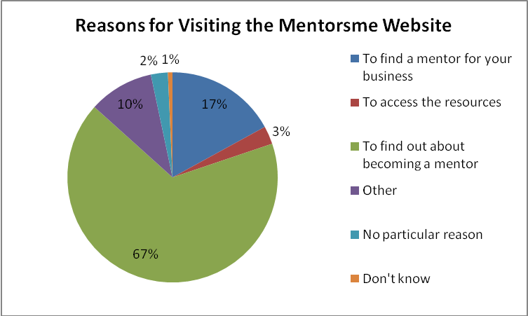
Base = all who have visited mentorsme website in the last year (n=37)
The SMEs that had used the Mentorsme website were asked to rate the site. Around seven out of ten respondents rated the site at least fairly good in terms of ease of use to search for a mentor or mentoring organisation, relevance and usefulness of the site content. However, less than one fifth stated that the site was at least fairly good in relation to the range of mentoring organisations available. Furthermore, more than one fifth rated the usefulness of the Mentorsme website as fairly poor or poor.
Figure 4.8: Rating of the Mentorsme Website
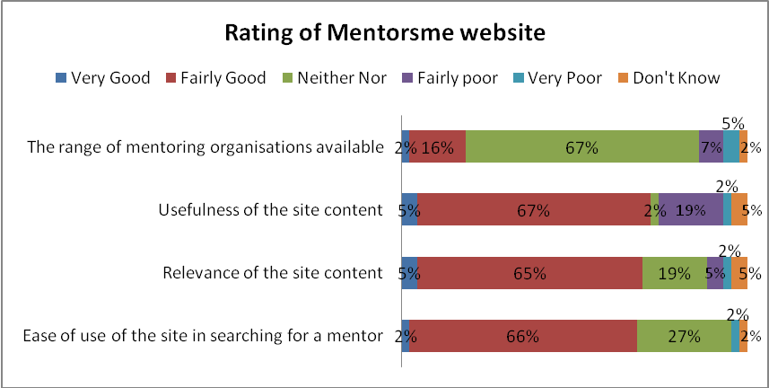
Base = all who have visited mentorsme website in the last year (n=37)
Out of the users of the Mentorsme website, almost three fifths (58 per cent) stated they would use it again and almost one third (30 per cent) suggested they would recommend it to others. Only one in eight (12 per cent) said they would do neither.
Only five owner-managers reported on the question of whether or not they had found a mentoring organisation and, of these, four had not been able to. The main reason for saying this was because they were too busy. Only one respondent indicated that they had already received assistance, face-to-face from their mentor, and this had helped their business to perform better. Therefore, less than one per cent of those who have heard of the Mentorsme website have thus far been able to successively utilise it to find a mentor and improve their business in some way, although this finding is based on very small sample sizes.

4.7 Alternative Business Assistance to Business Link
This section examines the counterfactual position for Business Link users, seeking to find out how they would have managed with their business assistance requirements in the absence of the Business Link service.
Table 4.8: Alternative Sources of Business Information and Advice
 | Information | Advice
 | Col.% | Col.%
Internet/Google | 40 | 25
Accountant | 17 | 16
Other Govt agencies | 8 | 3
Business colleagues/networks | 8 | 15
Trade bodies | 6 | 6
Local Authority | 5 | 4
Family and friends | 5 | 6
Bank | 4 | 6
Chamber of commerce | 4 | 3
Educational/public trainer | 3 | 1
Management consultant | 3 | 1
Enterprise Agency | 2 | 0
Mentor | 0 | 2
Solicitor | 1 | 0
Other | 7 | 4
Nowhere | 11 | 19
Don't know | 8 | 12
NB: Base = all who have used the Business Link website or helpline in the past year (n=941)
SME Business Link users were asked if the Business Link website and telephone helpline were not currently available, where they would go for straightforward business information and also more strategic business advice. Table 4.7 above demonstrates that the internet, Google and accountants are the most frequently mentioned alternative sources of both information and strategic advice. The types of alternative sources of business assistance varied according to whether information or strategic advice was being considered. For example, other government agencies, such as HMRC, were cited by one in twelve respondents seeking information such as on tax and regulatory matters, but only by three per cent requiring strategic advice. It is notable that the internet and Google remain the most frequently mentioned sources of alternative strategic advice, but that this also declines in relative terms to one quarter of respondents (declining from 62 per cent to 18 per cent amongst administrative businesses), whilst accountants retain the same proportion of responses (one in seven) for both information and strategic advice and that business colleagues and networks are increasingly mentioned by one in seven respondents as a source of strategic advice.
A great range of responses were received which were influenced by the types of external assistance being considered. For example, technical sectoral information would be likely to be provided by a trade body, but this could also provide specialist strategic sector advice. Whilst accountants were widely referred to, this was particularly evident amongst the construction sector where more than two fifths would seek both information and strategic advice from this source. Business colleagues and networks were perceived as a much more important source of strategic advice for the TRAD sector (29 per cent) and those trading over 10 years (one fifth). Family and friends were only considered as an alternative source of information and advice for self employed and micro businesses with less than 10 employees.
It is of note that almost one in five (19 per cent) respondents state that they either ‘don’t know’ where to look or will not look for alternative information and that this group represents almost a third (31 per cent) of SME Business Link users in relation to strategic advice. Whilst the data is small and not significant, this group seems to be characterised by manufacturing and medium sized firms (50-249 employees) and those firms recently acquainted with Business Link, having only used the service since December 2011.

4.7.1 Willingness to Pay for Strategic Business Advice
Sixty-one per cent of Business Link website/helpline users in the last year indicated that they would seek other sources for strategic advice should Business Link not have been available. Almost one third of these (32 per cent) indicated that they would be prepared to pay for strategic business advice, with a further seven per cent indicating uncertainty on this point.
Those SME Business Link users that were more prepared to pay were significantly more likely to be medium sized businesses and more likely to be growth seeking, have experienced recent sales turnover growth, and to be businesses trading for more than three years. Businesses that had recently started to use Business Link, since December 2011, were significantly less likely to be willing to pay for strategic advice.
Figure 4.9: Business Link Users prepared to pay for strategic advice
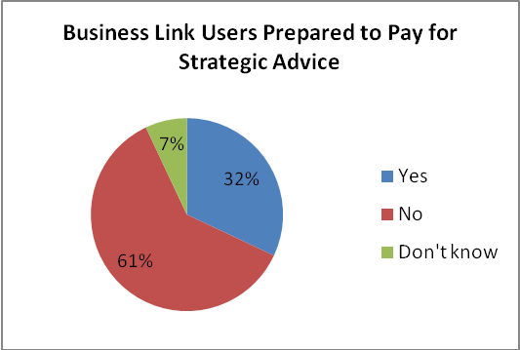
Base = Business Link website/helpline users in the last year that would seek alternative sources for strategic advice should Business Link not be available (n=521)
Those SMEs that were willing to pay for strategic business advice were asked approximately how much they would be prepared to pay per year for this advice. The median annual amount suggested was £200, but ranged considerably higher, with one fifth of respondents being prepared to pay at least £1,000 per year and nine per cent mentioning at least £2,000 per year.

4.7.2 Reasons for Preferring to Use Business Link
Business Link users that had not had any private sector support in the last year were asked if there were any particular reasons why they had used the Business Link website or helpline instead of the private sector.
Table 4.9: Reasons for Using Business Link
Reasons: | Col%
Free service/less expensive | 11
Easy accessibility and use | 7
Better quality/relevance | 7
Trusted | 6
Impartial | 5
Good previous experience | 5
Government backed | 4
Recommended | 2
Search Engine selection | 2
Well known | 1
Other | 5
No reason, no answer | 45
NB: Base = Business Link website/helpline users in the last year that have not used private sector sources (n=721)
The most frequently mentioned reason for using Business Link services was financial, with more than one in ten mentioning that the service was free, and in three per cent of responses less expensive than alternative business assistance. Ease of accessibility and use, and the quality and relevance of the information provided were also mentioned, along with the trustworthiness and impartiality of the service. Repeat use due to having a good previous experience with the Business Link service and the fact that it is a government backed and recommended service were also mentioned. Whilst there were many other responses, these did not follow any particular patterns and included accidentally finding the site, not being aware of anything else and not having any particular need for other services. It is notable that almost half did not, or were not able to, provide an answer.
4.8 Key Findings from the Survey of SME Business Link Users
4.8.1 Length and Frequency of Use of Business Link
- Five per cent of Business link users in the last year started using the website since December 2011, with a further eight per cent starting within the last year. 64 per cent have used the website for between one and five years and 19 per cent have been using it for more than five years.
- 42 per cent of existing users have continued to use the new Business Link website service since its inception in December 2011.
- The vast majority (83 per cent) use the Business Link website three to four times a year at most, with one in eight using it monthly and just three per cent using it more frequently.
- Business intermediaries were significantly more likely to be more frequent users of the Business Link website: 22 per cent of intermediaries using the site do so at least once per month.
- Young firms, trading for less than two years, are more frequent users: 22 per cent using the website at least once per month. Conversely, those with no employees are less frequent users of the service: 12 per cent use the website at least once per month.
- Telephone helpline users did so mainly in relation to obtaining more detailed information (41 per cent) and obtaining clarification of the information provided (20 per cent).
- One in five helpline users found it helpful, whilst two thirds were undecided and 14 per cent felt strongly that it had not been helpful.
- Recent telephone helpline users are experienced, regular, Business Link website users who are used to calling the telephone helpline service for assistance and continue to do so.
4.8.2 Types of Assistance Sought from the New Business Link and Service Effectiveness
- 42 per cent of Business Link users during the past year had made use of the new Business Link website or the telephone helpline services.
- The most frequently mentioned types of assistance used have been for regulatory issues (40 per cent), business development and growth (27 per cent) and sales and marketing (19 per cent).
- Most types of assistance are at least partly meeting needs in the majority of cases. The exception was entering new export markets (46 per cent of needs were partly/fully met). The most successful types of assistance are managing cashflow (68 per cent fully met) and dealing with regulatory issues (50 per cent).
- The most frequently used new services have been the Events Finder, Contracts Finder, Learning Resources and Business Finance Finder (all 13-14 per cent), whilst the Growth Improvement Service, My New Business and Mentorsme were confirmed to have been used by between 6-8 per cent of those that had used the website since December 2011.
- Those services rated as most useful were the GIS, Business Finance Finder and Events Finder (all rated at least fairly useful by 75 per cent), followed by MNB (64 per cent), with only 14 per cent rating Mentorsme as at least fairly useful.
- 74 per cent of users since December 2011 stated that the service (at least to some extent) is more trustworthy than other sources of assistance, with 59 per cent indicating that it is higher quality, 55 per cent suggesting it is more impartial and 48 per cent stating it led to considering new options.
- 19 per cent of those using before and since December 2011 indicated that the new Business Link website was better than the previous one. The main improvements were: ease of navigation, including improved search tools; provision of more information; and improved quality of information.
- 47 per cent were referred to other websites: one third stating they would not have found these without Business Link.
- 12 per cent mentioned that using the new Business Link services had improved their business performance: one third indicated significant improvements, half mentioned increased sales turnover and profitability.
4.8.3 Initial Impacts of Business Link Services
- 43 per cent of Business Link users during the last year had experienced time savings from the services received, while five per cent felt their time had been wasted.
- 22 per cent gained financial benefits from using Business Link’s services during the last year: eighteen per cent saved money, whilst nine per cent achieved greater financial returns.
4.8.4 Problems Using the New Business Link
- 72 per cent of the new Business Link website users encountered no problems.
- The most common problem encountered was insufficient detail to meet the SME’s needs (16 per cent), followed by navigational problems (10 per cent).
- 44 per cent of Business Link website users, since December 2011, excluding telephone helpline users, were not aware of the helpline.
- Half of those encountering problems, that did not know about the telephone helpline would have used it if they had known about it.
4.8.5 The Relationship Between Business Link and the Use of Private Sector Business Assistance
- Although one in eight users of the new Business Link services had used private sector assistance since November/December 2011, only 16 per cent of these have done so after using the new service.
- By far the most common reason for using private sector assistance was for specialist skills that are not available within Business Link (almost half), followed by continuing to use previous private sector sources (almost one quarter).
- 77 per cent of Business Link users using private sector assistance since November 2011 have paid for the service.
4.8.6 Awareness and Use of Mentorsme
- 17 per cent of Business Link users were aware of the Mentorsme website service. Those that were aware found out about it from the Business Link website (43 per cent), email (17 per cent) and via recommendation (14 per cent).
- Two thirds visited the Mentorsme website to find out about becoming a mentor, whilst just 17 per cent did so in order to find a mentor.
- Around seven out of 10 respondents felt the site was at least fairly good in terms of ease of use to search for a mentor or mentoring organisation, relevance and usefulness of the site content. Only 18 per cent fifth rated the site as at least fairly good in relation to the range of mentoring organisations available.
- Out of the 37 users of the Mentorsme website, almost three fifths stated they would use it again and almost one third suggested they would recommend it to others.

4.8.7 Alternative Business Assistance to Business Link
- The internet and Google (40 per cent for information, 25 per cent for strategic advice) and accountants (one in six for both) are the most frequently mentioned alternative sources of both information and strategic advice. Business colleagues and networking are also an important source of strategic advice (15 per cent).
- 19 per cent of Business Link users in the last year stated that they would not know where to look for alternative information. Nearly a third said this in relation to strategic advice.
- 32 per cent of those who would want advice if the Business Link website was not available would be prepared to pay for strategic business advice.
- The most frequently mentioned reason for using Business Link services rather than the private sector was financial, with more than one in ten mentioning that the service was free or less expensive than alternative business assistance.

5. Baseline Survey of New and Established Business Use

5.1 Introduction
Chapters five and six report on findings from in-depth, predominately qualitative survey of SME owner-managers with little or no experience of the new Business Link website, established in December 2011, recruited to test out this new web-based service. The primary objective was to determine whether the My New Business (MNB), Growth Improvement Service (GIS) and Mentorsme (MS) websites are effective in ‘digital transformation’, providing successful assistance through new website services, rather than the more expensive alternative of face-to-face advice. The survey aimed to track recruited SMEs through their initial experience of using the new service in order to gain insight into the practical issues for users and the initial perceived value of the service to these businesses.
The final research (those that completed the task to the end of the qualitative phase) comprised of:
- 31 new/nascent businesses in pre-start or trading for less than 12 months to test out the ‘My New Business’ (MNB) website service
- 21 established SMEs trading for at least 12 months to test out the ‘Growth Improvement Service’ (GIS).
Additionally, it was requested that these mystery shoppers examine the ‘Mentorsme’ (MS) website in relation to the possibility for either finding a mentor or offering a mentoring service. The aim was also to get a spread of use of different web tools and services, with established SMEs being directed to the business tool finder and assess your business performance options, and new/nascent businesses to the overview of business support services, start-up learning directory and access to finance section.
The research process involved initially oversampling by recruiting 80 SMEs (43 new/nascent and 37 established) in order to allow for the expected drop out of at least 10-15 per cent experienced in other studies of this type. These represent 26 per cent of 302 SMEs initially recruited, which actually followed web links provided and reported back after one week on their initial progress and experience in using the new website. These 80 SMEs form the baseline from which the final 52 were interviewed between 4-8 weeks later during June 2012. Progress to the final in-depth interview was monitored through three, weekly, emails providing links to new Business Link web services for the mystery shoppers to try out.
The remainder of this chapter presents a summery of the baseline data collected from the initial survey of 80 SME mystery shoppers after one week of using the new Business Link website services. Chapter six reports on the in-depth qualitative survey work undertaken with the 52 SME mystery shoppers that reported back on their experience of using the new Business Link services, at least one month after completing the baseline survey. Please note that all data shown in this section is unweighted.

5.2 Baseline Survey Profile
Eighty SMEs recruited as ‘mystery shoppers’ were surveyed after one week of using the new Business Link websites; 43 were new/nascent businesses, trading for less than 12 months, including two businesses that were not yet trading, and 37 were more established businesses trading for at least one year, with one in ten businesses trading for more than five years.
Table 5.1: Trading Age
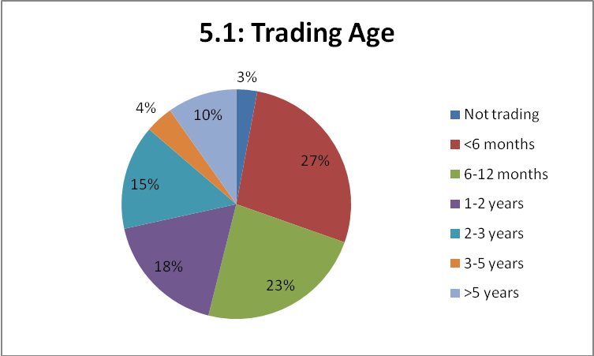

Table 5.1 below indicates that the vast majority of mystery shopper businesses were sole traders or private limited companies, with almost half of the new/nascent businesses being sole traders, whilst more established businesses exhibit a higher proportion of partnerships (19 per cent). Around five per cent of surveyed businesses are from the Third Sector (not for profit businesses).
Just over half of the surveyed SMEs have no employees, with two fifths being micro businesses (1-9 employees) and only five per cent employ ten or more people. Two established medium sized businesses (50-249 employees) were surveyed. This sample reflects both the relatively smaller proportion of small and medium sized businesses in the overall economy and the reduced need for external assistance for larger businesses that have a more substantial internal resource base.
There is good distribution across sectors selected for this survey, with manufacturing, construction and utilities representing one quarter, TRAD (transport, retail and distribution) representing 29 per cent, business services almost one fifth, public and administrative services one sixth and other services (arts and personal services) representing just over one in ten. The sectoral distribution between new/nascent and established SMEs is very evenly matched.
Table 5.1: Key Business Characteristics
 | New/Nascent |  | Established |  | Total
 | No. | Col.% | No. | Col.% | No. | Col.%
Legal Status  Sole trader  Partnership  Private Ltd  Other | 21  2  18  2 | 49  5  42  4 | 11  7  17  2 | 30  19  46  5 | 32  9  35  4 | 40  11  44  5
Employment Size  Zero  Micro (1-9)  Small (10-49)  Medium (50-249) | 19  23  1  0 | 44  54  2  0 | 24  10  1  2 | 65  27  3  5 | 43  33  2  2 | 54  41  2.5  2.5
Sales Turnover (£)  <73k  73k-250k  250k+ | 31  6  0 | 84  16  0 | 16  8  6 | 53  27  20 | 47  14  6 | 70  21  9
Sales Growth (next year)  Increase  Same  Decrease | 37  6  0 | 86  14  0 | 26  10  1 | 70  27  3 | 63  16  1 | 79  20  1
Employment Growth  Increase  Same  Decrease | 18  25  1 | 42  56  2 | 17  20  0 | 46  54  0 | 35  44  1 | 44  55  1
Sector  Manufacturing  Construction/Utilities  TRAD  Business Services  Administration  Public Services  Other Services | 9  2  13  8  2  5  4 | 21  4  30  18  5  12  9 | 7  2  10  7  3  4  4 | 19  5  27  19  8  11  10 | 16  4  23  15  5  9  8 | 20  5  29  19  6  11  11

More than two thirds were currently trading at below the VAT threshold of £73,000, which is again reflective of the concentration of very small, young SMEs in the survey. Just under one in ten achieved at least £250,000 sales turnover in the last financial year and these were all more established SMEs.

With regard to growth expectation over the next year, almost four fifths forecast growth in their sales turnover, with just over two fifths forecasting employment growth. Younger businesses were more likely to forecast sales turnover growth, whilst more established businesses were more likely to forecast employment growth.

Table 5.2: Key Management Characteristics

 | New/Nascent |  | Established |  | Total
 | No. | Col.% | No. | Col.% | No. | Col.%
More than one owner | 18 | 42 | 17 | 46 | 35 | 44
>50% female owned | 10 | 23 | 11 | 30 | 21 | 26
>50% ethnic minority owned | 4 | 9 | 4 | 11 | 8 | 10
Manager Age:  <30 years old  30-50 years old  50+ years old | 3  33  6 | 7  79  14 | 4  20  11 | 11  57  32 | 7  53  17 | 9  69  22
Manager Experience:  <1 year  1-4 years  5+ years | 10  4  28 | 24  9  67 | 5  7  25 | 14  20  66 | 15  11  53 | 19  14  67
Manager Qualification:  Degree or higher degree  Other  None | 22  19  1 | 53  45  2 | 19  16  2 | 51  44  5 | 41  35  3 | 52  44  4

Table 5.2 demonstrates that more than two fifths of the surveyed SMEs had more than one owner, with one quarter being majority female owned and one in ten being ethnic minority owned, with little difference between the new/nascent and more established businesses.
More than two thirds of respondent owner-managers were aged between 30-50, with just over one fifth aged over 50 and less than one in ten aged under 30. Those aged over 50 were more likely to be in established businesses.
Two thirds of managers had more than five years of managerial experience, including those in the new/nascent businesses, suggesting that they had previous experience managerial experience prior to starting up their current business. However almost a quarter of new/nascent owner-manager respondents had less than a year’s experience.
Just over half of the surveyed owner-managers had at least a degree level qualification while only four per cent had no formal qualification.

Table 5.3: Business Capability Measures

 | New/Nascent |  | Established |  | Total
 | No. | Col.% | No. | Col.% | No. | Col.%
Formal Business Plan | 27 | 63 | 23 | 63 | 50 | 63
Management accounts | 24 | 56 | 29 | 78 | 53 | 66
PRP | 8 | 19 | 7 | 19 | 15 | 19
Website | 32 | 74 | 26 | 70 | 58 | 73
HR Policy | 11 | 26 | 15 | 41 | 26 | 33
Quality Standards | 13 | 30 | 13 | 35 | 26 | 33

Table 5.3 indicates that almost three quarters of the surveyed businesses have a website and around two thirds have formal business plans, produce regular monthly or quarterly management accounts, whilst one third have an HR policy or use formal quality standards (e.g. British Standards or TQM systems), and less than one fifth use profit related pay (PRP). Younger and smaller businesses exhibit less use of regular management accounts, which are less likely to be used if they are not VAT registered, and less use of HR policies (which would be unnecessary for self employed).

Table 5.4: Business Markets Barometer

 | New/Nascent |  | Established |  | Total
 | No. | Col.% | No. | Col.% | No. | Col.%
Healthy Cashflow:  Agree  Neutral  Disagree | 27  6  9 | 65  14  21 | 23  6  7 | 64  17  19 | 50  12  16 | 64  15  21
Manager Costs/Efficiencies:  Agree  Neutral  Disagree | 38  2  1 | 93  5  2 | 35  0  2 | 95  0  5 | 73  2  3 | 93  3  4
Easy to find new customers:  Agree  Neutral  Disagree | 17  6  19 | 40  14  46 | 15  9  13 | 40  24  36 | 32  15  32 | 41  18  41
External finance not problem:  Agree  Neutral  Disagree | 16  5  17 | 42  13  45 | 15  7  13 | 43  20  37 | 31  12  30 | 43  16  41
Retain existing customers:  Agree  Neutral  Disagree | 36  3  1 | 90  8  2 | 33  3  0 | 92  8  0 | 69  6  1 | 91  8  1

Table 5.4 indicates that managing costs and efficiencies and retaining customers are considered to be relatively straightforward for the surveyed SMEs. However one fifth had issues with cash-flow and four fifths were concerned about finding new customers and access to external finance. Nearly half of new/nascent businesses surveyed were concerned about finding new customers and access to external finance.

5.2 Initial Review of My New Business
The new/nascent businesses recruited to mystery shop the new business Link services were sent internet links and directed to the My New Business (MNB) website and surveyed a week later. At this stage 43 new/nascent businesses completed this task, with findings from these businesses presented in this section.

5.2.1 Expectation and Initial Types of Information Sought
Respondents were asked whether they expected the website to be informative by providing information relating to the day to day running of their business, or strategic, relating to strategic advice on matters such as how to grow their business.

- Four fifths of respondents (35) expected to find information
- Half of respondents (22) expected to find strategic advice
- Two fifths expected to find a combination of the two

Table 5.6: Types of Assistance Sought

Type of Assistance | No. | Col.% (n=43)
Tax/Payroll | 31 | 72
Growing the business | 27 | 63
Planning the business | 26 | 61
Managing the business | 26 | 61
The workplace | 17 | 40
Employing people | 16 | 37
Forming and naming a business | 14 | 33

Table 5.6 demonstrates that the most frequently mentioned type of assistance required was for straight forward information relating to tax and payroll issues, with strategic growth, planning and management issues all required by around three fifths of the new/nascent businesses. Forming and naming a business was only mentioned by one third of respondents, but this is likely to be indicative of the fact that the majority of surveyed businesses were already trading.

5.2.3 Use of the Tax/Payroll MNB Section
The 31 new/nascent businesses that used the tax/payroll section of the MNB website were asked what they specifically looked at. A wide range of issues were examined, but VAT (22 cases) was by far the most frequently mentioned, followed by National Insurance and tax for the self employed (both 14 cases) and PAYE (13 cases).

5.2.4 Use of the ‘Managing a Business’ Section
The 26 new/nascent businesses that used the managing a business section of the MNB website were asked what they specifically looked at. By far the most frequently mentioned type of assistance mentioned was sales and marketing (21 cases), followed by obtaining finance (15 cases), IT (14 cases) and e-commerce (10 cases).

5.2.5 Types of Tools Used and Extent of Usefulness

Table 5.7: Use of MNB Website Tools and Extent of Usefulness

MNB Website Tool | No. | Useful | Neutral | Not Useful
Video case example | 11 | 9 | 0 | 2
Video tutorial | 10 | 8 | 0 | 2
Written case study | 8 | 2 | 5 | 1
List making tool | 10 | 4 | 3 | 3
Downloadable template | 10 | 10 | 0 | 0
Shortlist of tasks | 8 | 7 | 0 | 1
None | 15 | - | - | -

Table 5.7 demonstrates that two thirds of nascent/new mystery shoppers used the MNB tools in their first week on the sight. Those that used the tools exhibit an even spread of use amongst the tools, with each receiving use from between a fifth and a quarter of the new/nascent mystery shoppers. All that used the downloadable templates deemed them useful, whilst task shortlists and videos also received high proportional responses of usefulness. Written case studies and list making tools were deemed less useful.

Those that did not use specific tools were asked why this was the case. In the vast majority of cases this was because they were not interested or had no need, rather than because they did not know it existed, which typically related to less than one in ten cases.

5.2.6 Overall Initial Assessment of the MNB Service
Table 5.8: Overall Assessment of MNB Services After One Week

Assessment (Row% n=43) | Exc. | Good | Neutral | Poor | V. Poor
Usefulness of information | 33 | 47 | 16 | 2 | 2
Thoroughness | 28 | 54 | 14 | 2 | 2
Quality of advice | 33 | 54 | 9 | 2 | 2
Ease of navigation | 26 | 46 | 18 | 5 | 5
MNB presentation | 26 | 53 | 12 | 2 | 7
Speed of downloading | 30 | 26 | 44 | 0 | 0
Support package provided | 23 | 35 | 25 | 12 | 5

Table 5.8 demonstrates that the MNB website received high levels of approval amongst the 43 mystery shopper businesses testing out these new website services. Four fifths of respondents indicate that the MNB website was either good or excellent in terms of its presentation and delivery of useful high quality and sufficiently thorough information. Ease of navigation was also judged as good or excellent by nearly three quarters of the respondents. Speed of downloading material on the website and provision of a suitable support package were judged as good or excellent by less than three fifths of respondents and one in six indicated that the support package provided was poor or very poor.

Two thirds of respondents stated that they would have found the MNB website more useful when they were initially setting up their business. This response is reflective of the high proportion of nascent/new business respondents that were already trading at the time of the survey.

Four fifths of respondents indicated that the MNB website had provided business assistance that was of ‘material use’ to their business, and therefore likely to make a positive impact on it.

5.3 Initial Review of My New Business
The businesses established for at least one year recruited to mystery shop the new Business Link web services were sent internet links and directed to the Growth Improvement Service (GIS) website and surveyed a week later. At this stage 37 established businesses completed this task, with findings from these businesses presented in this section.

5.3.1 Expectation and Initial Types of Information Sought
Respondents were asked whether they expected the website to be informative by providing information relating to the day to day running of their business, or strategic, relating to strategic advice on matters such as how to grow their business.

- Almost three fifths of respondents (21) expected to find information
- Almost two thirds (24) expected to find strategic advice
- More than one third (13) expected to find a combination of the two

Table 5.9: Types of Assistance Sought

Type of Assistance | No. | Col.% (n=43)
Strategies for growth | 23 | 62
Finance and logistics | 21 | 57
Setting a vision for growth | 18 | 49
Assessing current performance | 15 | 41
Managing growth | 12 | 32
Tendering for contracts | 9 | 24
Growing internationally | 4 | 11

Table 5.9 demonstrates that the most frequently mentioned type of assistance required related to strategies for growth, closely followed by finance and logistics. Nearly half of respondents were interested in setting a vision for growth and two fifths were looking to assess their current performance. The relatively small proportions seeking information on tendering for contracts and international trade are probably reflective of the balance of sectors represented in the survey, which has a high proportion of high street shops and personal services represented.

5.3.2 Use of the ‘Strategies for Growth’ Section
The 23 established businesses that used the strategies for growth section were asked what they specifically looked at. Product and service development (15 cases) and sales growth (14) were most frequently mentioned, followed by strategic sourcing (10) and technology (8).

5.3.3 Types of Tools Used and Extent of Usefulness
Table 5.10: Use of GIS Website Tools and Extent of Usefulness

MNB Website Tool | No. | Useful | Neutral | Not Useful
Video case example | 14 | 11 | 3 | 0
Video tutorial | 10 | 8 | 2 | 0
Written case study | 15 | 11 | 4 | 0
List making tool | 4 | 3 | 1 | 0
Downloadable template | 3 | 3 | 0 | 0
Shortlist of tasks | 8 | 4 | 3 | 1
None | 9 | - | - | -

Table 5.10 demonstrates that three quarters of established businesses using GIS made use of specific tools. Videos and written case studies were most frequently used, followed by shortlist of tasks tool. All of the tools appear to be useful for the majority of users, with the possible exception of the shortlist of tasks. Additionally, one quarter of respondents (9 cases) referred to following a link to another website.

Where tools were not used, this was typically because the respondent was not interested in using the tool, but for almost one fifth of these non users it was because they did not know that the specific tool existed. Almost one third of those businesses not using the shortlist of tasks did not realise this tool was available.

5.3.4 Overall Initial Assessment of the GIS Service
Table 5.11: Overall Assessment of GIS Services After One Week

Assessment (Row% n=37) | Exc. | Good | Neutral | Poor | V. Poor
Usefulness of information | 27 | 49 | 24 | 0 | 0
Thoroughness | 24 | 60 | 16 | 0 | 0
Quality of advice | 22 | 60 | 16 | 2 | 0
Ease of navigation | 16 | 46 | 30 | 5 | 3
GIS presentation | 35 | 60 | 5 | 0 | 0
Speed of downloading | 32 | 49 | 16 | 3 | 0
Support package provided | 8 | 43 | 32 | 8 | 8

Table 5.11 demonstrates that the new GIS website is considered to be well presented by almost all of the established mystery shopper SMEs, with more than one third stating that it is excellent. There is also a high proportion of approval for the service with more than three quarters rating it good or excellent for providing useful, thorough and high quality information and speedy downloading. However, almost one third of users rated site navigation as neutral or poor and almost half rated provision of a suitable support package as neutral or poor, with one in six rating this as poor. Previous studies such as the Business Link Mystery Shopper (BIS, 2009) have found that established businesses are more likely to have specific business assistance enquiries (e.g. technical and sector based) and greater expectations of support delivery than their younger start-up counterparts.

Four fifths of the established SME mystery shoppers using GIS stated that this service would provide them with assistance that is ‘material to their business’ and was therefore likely to enable their business to develop and grow.

5.4 Initial Review of Mentorsme
Just over half (42) of the mystery shoppers were directed to look at the ‘Mentorsme’ (MS) website. These were split evenly between 22 new/nascent businesses and 20 established SMEs.

- Just over one quarter (11 cases) were interested in finding a mentor, with a higher proportion of established SMEs (35%) compared with new/ nascent (18%) being interested.
- One eighth (5 cases) were interested in becoming a mentor for another business, with little difference exhibited between new and established businesses.

5.4.1 Overall Initial Assessment of the Mentorsme Service
Table 5.12: Overall Assessment of MS Services After One Week

Assessment (Row% n=42) | Exc. | Good | Neutral | Poor | V. Poor
Understanding mentoring role | 21 | 55 | 14 | 8 | 2
Useful for finding a mentor | 31 | 43 | 19 | 5 | 2
Useful for becoming a mentor | 24 | 41 | 33 | 0 | 2
MS presentation | 29 | 43 | 19 | 7 | 2
Ease of navigation | 38 | 43 | 10 | 7 | 2
Ease of finding suitable mentor | 12 | 24 | 45 | 10 | 9

Table 5.12 demonstrates that the new MS website was very well received, with three quarters of the mystery shopper users stating that it helped them to understand the role of mentors and that it would be helpful in finding mentors. The site was also rated as good or excellent in terms of ease of navigation by four fifths of respondents, with almost three quarters indicating that it was well presented. Around one in ten users were dissatisfied with the site, but this increased to one fifth in relation to finding a suitable mentor, with one quarter of established SMEs stating difficulties in finding suitable mentors compared with one seventh of new/nascent respondents.

Having visited the website:

- One tenth (4 cases) were interested in finding a mentor, including two new and two established businesses
- Three established SME owner-managers were interested in becoming mentors for other businesses
- One in eight (5 cases) had read information on the website about the ‘Get Mentoring’ campaign
- One established business had made contact with a mentoring organisation, with a further five businesses (4 established) considering doing so in the future.

5.5 Perceptions of Business Link
The 80 mystery shopper SME owner-managers were asked about their previous use of Business Link:

- Just over three fifths (50 cases) had used Business Link previously, just over half of new/nascent (24 out of 43 cases) and seven out of ten established SMEs (26 out of 37).

Of the 50 SMEs with previous experience of Business Link:

- Nearly three fifths (29 cases) stated that the new Business Link website is an improvement, whilst only three respondents felt it was worse.

All of the 80 mystery shoppers were asked if they had used any other business assistance during the last six months (i.e. not including Business Link, since the new Business Link websites have been operational):

- Just over one third (29 cases) had used other websites; two fifths of established SMEs and just under one third of new/nascent businesses
- Almost one third (24 cases) had received face to face assistance; over two-fifths of new/nascent compared to one in eight established SMEs
- One in seven (12 cases) had received telephone support.

The 29 mystery shoppers that had used other websites for business assistance were asked how the new business Link website compared:

- Almost half (14 cases) reported that the new Business Link website is better that the other websites that they had used, with only one in ten (3 cases) indicating that it was worse.
- More than half of new/nascent businesses reported the new business Link websites to be better than alternative websites, compared to just under two fifths of established SMEs.

5.6 Perceptions of Initial Impacts
The 80 mystery shoppers owner-managers were asked for an initial assessment of the impacts of using the new Business Link website, based on their first week’s experience.

- More than four fifths (67 cases) indicated that they expected time savings; almost nine out of ten new/nascent respondents and just over three quarters of established SME respondents.
- Nearly three fifths (46 cases) expected to make financial savings; nearly three quarters of new/nascent respondents and half of established SMEs.
- Nearly three quarters of all respondents thought that using the new Business Link website would improve their business performance.

Table 5.13: Overall Assessment of Business Link Services in Comparison to Other Sources of Business Assistance, After One Week

Assessment (Row% n=80) | Agree |  |  | Disagree
 | Strong | Slight | Neutral | Slight | Strong
Considered new options | 29 | 38 | 21 | 5 | 7
Is more impartial | 49 | 25 | 14 | 7 | 5
Is more trustworthy | 59 | 16 | 13 | 7 | 5
Better quality | 56 | 11 | 19 | 6 | 8
Better strategic advice | 40 | 28 | 19 | 9 | 5

Table 5.13 demonstrates that there is widespread support for the new Business Link website amongst the surveyed SMEs. Three quarters of respondents believe, at least to some extent, that the new site is more trustworthy and impartial than other alternative sources of information, with two thirds stating this is the case with regard to quality, strategic advice and introducing new options to the business. There is little difference between new/nascent and established SME respondents.

5.7 Summary of Key Findings from the Baseline Survey

5.7.1 Profile
- The baseline survey contains 43 new/nascent and 37 established SMEs
- These were primarily sole traders (32), partnerships (9) or private limited companies (35)
- The vast majority were self employed (43) or micro businesses (33) with sales turnover below the VAT threshold (47)
- The businesses were mainly growth seeking; almost four fifths forecast sales increase and nearly half forecast employment increase in the next year
- One quarter were female owned and one in ten were ethnic minority owned businesses
- Two thirds of managers had five or more years of management experience and half had degree level qualifications
- Finding new customers and accessing finance were the main concerns of these businesses

5.7.2 Profile
- Four fifths were seeking information, half were seeking strategic advice
- Tax/payroll, business growth, business planning and management were the main types of assistance sought
- Two-thirds used the website tools. Templates, videos and the shortlist of tasks were the most frequently used tools
- MNB was highly rated by a majority of users, but one in six were not satisfied with the support package offered

5.7.3 GIS
- Three fifths were seeking information and two thirds were seeking strategic advice (a higher proportion than for MNB).
- Strategies for growth, finance and logistics and visions for growth were the main types of assistance sought
- Written case studies and videos were the most frequent used tools, with the shortlist of tasks being least successful
- GIS was highly rated by a majority of users, but one in seven were not satisfied with the support package provided

5.7.4 Mentorsme
- 42 looked at the MS site; 22 new/nascent and 20 established SMEs
- One quarter (11) were initially interested in finding a mentor and five were interested in becoming mentors for other businesses
- The site was generally well received, but almost one fifth complained that it would not easily find them a suitable mentor
- After visiting the MS site four respondent owner-managers were interested in finding a mentor and three in becoming a mentor.

5.7.5 Perceptions of Business Link and Initial Impacts
- Three fifths had used Business Link and three fifths of these previous users stated that the new website was an improvement.
- One third had used other websites, with half of these stating that the new Business Link website was better than alternative sites
- More than four fifths believed that using the new Business Link website would save them time, three quarters believed that it would improve their business performance and three fifths stated that it would save them money
- The new Business Link website compared very favourably to other sources of business assistance, for the majority of new and established SME mystery shoppers.

6. Final Survey Report
This Chapter presents the findings from the final in-depth qualitative telephone survey with the 52 SME mystery shoppers that completed the process, and were undertaken between one and two months after their baseline survey interview. It should be noted that whilst the recruited SMEs all had stated needs and desires to use the external assistance provided by the new Business Link websites, in some cases they found it difficult to find time or prioritise using the service within the research timescale and in other cases they simply refused to continue. The reasons for this fall-out are explored in this section.

6.1 Survey Profile
The final in-depth survey of 52 users of the new Business Link website services consisted of three fifths (31 businesses) that were new, including one business that had not yet started trading and two fifths (21 businesses) that were established and trading for at least one year, including five businesses that had been trading for more than three years.
Figure 6.1: Final survey users by Trading Age
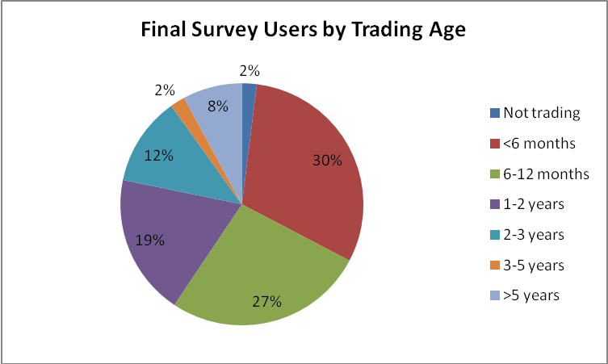
Base = all who completed mystery shopping exercise to qualitative interview (n=52)

Table 6.1: Final Survey Sector and Employment Size by New and Established Users
 | New/Nascent |  | Established |  | Total
 | No. | Col.% | No. | Col.% | No. | Col.%
Sector
Manufacturing | 7 | 23 | 5 | 24 | 12 | 23
Construction | 1 | 3 | 1 | 5 | 2 | 4
TRAD | 11 | 36 | 4 | 19 | 15 | 28
Business Services | 3 | 10 | 5 | 24 | 8 | 15
Administration | 2 | 7 | 3 | 14 | 5 | 10
Public Services | 3 | 10 | 2 | 10 | 5 | 10
Other Services | 4 | 13 | 1 | 10 | 5 | 10
Employment Size
Zero | 17 | 55 | 4 | 19 | 21 | 40
1-5 Employees | 13 | 42 | 11 | 52 | 24 | 46
6-10 Employees | 1 | 3 | 2 | 10 | 3 | 6
11-25 Employees | 0 | 0 | 4 | 19 | 4 | 8

The final in-depth survey of 52 new business users of the new Business Link website services is distributed across the selected sectors, with around a quarter in manufacturing and TRAD (mainly retail), one in seven in business services and almost one third evenly distributed amongst the administrative, public and other services. There is a relatively similar sectoral distribution amongst the new/nascent and older established businesses surveyed, but with a higher proportion of TRAD within the new businesses and a higher proportion of business services amongst the older established businesses surveyed.
The businesses in the final in-depth survey are predominately very small micro and self employed businesses, with only 14 per cent having more than five employees and just one in twelve with more than 10 employees. This is largely reflective of the types of businesses that are wishing to use the new Business Link services and which were willing and able to participate in the survey within the time parameters allowed.

6.1.1 Differences in the Profile of Respondents between Baseline and Final Survey
In terms of the age of business, there was little difference between the 80 baseline respondents and those making it through to the final survey (53 per cent of baseline were prestart/new businesses, compared to 55 per cent of final survey).
By employment size, neither of the two medium-sized businesses recruited for the baseline made it to the final survey. Twenty-one of those with no employees made it to the final survey (less than half of the 43 originally recruited). By contrast, the micro businesses were more likely to persevere (27 out of 33). The number of small businesses actually increased from the baseline – from 2 to 4, as a result of increased numbers of employees between the two survey stages.
By sector, drop-out was most noted in the TRAD (23 recruited, 15 completed final survey) and business services sectors (15 recruited, 8 completed final survey). All of those recruited in the administrative sector (5 respondents) completed the final survey.
The reasons for being unable to complete the review process were, in some cases, because they decided that the service was not for them. This typically related either to not having any particular need for assistance, or lack of time because the respondent was very busy and their need for assistance was not urgent. In a small number of cases it was not possible to contact the owner-manager within the time frame of the research and messages left for them were not responded to.
However, of the 52 who completed the final survey, 16 admitted that they had not continued to use the website since the baseline survey. The reasons for this are explored below.

6.2 Frequency of Use
Table 6.2: Frequency of Use
Frequency | Number | Col.%
None | 16 | 31
Once or twice | 13 | 25
Several times per month | 13 | 25
Once a week | 6 | 11
Several times per week | 4 | 8
Total | 52 | 100
Just under one in five of the 52 respondents completing the follow-up survey were regularly using the Business Link website, at least once a week in the month to two months since the baseline interview. These more frequent users were primarily young businesses with only one trading for more than three years and they were mainly self employed or micro businesses with only one or two employees. They spanned a range of sectors, with manufacturing and retail being most represented. Their main business assistance requirements were diverse, including: tax, access to finance, regulation and compliance, sales and marketing including using the contracts finder, tendering and growth management issues. Common features were a lack of internal resources in the business, a clear need for assistance and willingness to make time and seek out assistance. These owner-managers had a range of managerial experience and were all educated to at least ‘A level’ standard, with the majority holding degree level qualifications.
Almost one third (31 per cent) of the 52 respondents completing the follow-up survey mentioned that they had not looked at the new Business Link websites since the baseline survey. These were predominately new businesses that were in early trading and where the owner-manager stated that they were “too busy” and in most cases perceived “no need” to use the service. A common feature was that although these were mainly new businesses, three quarters of the owner-managers surveyed in this group had more than five year’s managerial experience.
It was also notable that one quarter of respondents mentioned that they had been restricted in their use of the websites, typically only accessing them once in the month or two since the baseline survey. This group of respondents contained a higher proportion of established businesses, with common responses suggesting that they were “too busy” or, having examined a particular issue typically relating to financial or employment regulations, they had no other immediate needs.
Amongst the occasional users were several longer established SMEs where experienced owner-managers have no current perceived needs other than to “…occasionally keep up with employment and other regulatory matters that might affect the business” and some start-ups where the owner-managers were experienced as they had previously started other businesses, or had other internal or closely linked resources such as a management team, investment board, or franchiser to refer to.
In several cases where the business manager was experienced, or the business had been trading for almost one year, respondents felt that they were in-between MNB and GIS. As one manager of a bridal shop trading for almost a year stated: “MNB isn’t really suitable for us, as it seems to be more aimed at those planning to start-up, or in the early stages of trading.”
Although almost a quarter of respondents had used other websites, none mentioned that their use of the new Business Link websites had been curtailed because they had found an alternative web-based service that was deemed equal or better than that provided by Business Link. HMRC was the most frequently mentioned other website visited during the previous month or so. Other websites mentioned included the Federation of Small Business (FSB), Valuation Office, Business Zone, a private finance finder site and a trade sector site.

6.3 Main Reasons for Continued Use
The respondents provided a wide range of types of assistance that gave them reasons for continuing to use the Business Link website services.
Table 6.3: Main Reasons for Continuing to use Business Link
Main Types of Assistance | New/Nascent | Established | Total
Tax/payroll | 7 | 3 | 10
Sales and marketing | 3 | 6 | 9
Employment | 2 | 1 | 3
Accessing finance | 2 | 0 | 2
Financial management | 1 | 2 | 3
Management development | 1 | 1 | 2
Business performance | 0 | 1 | 1
Intellectual Property | 0 | 1 | 1
Environmental regulations | 0 | 1 | 1
Mentoring information | 1 | 0 | 1
Nothing in particular | 0 | 3 | 3
Number | 19 | 17 | 36
Table 6.3 presents the main priority types of assistance required by those SMEs that continued to use the Business Link MNB and GIS services in our survey. The most frequently required priority types of assistance related to tax and payroll and sales and marketing. New/nascent businesses were particularly keen to ensure that they were properly informed about tax and payroll issues. A good example was an experienced public services manager, who had recently started a new family services business “Although I’m an experienced manager, in a new business you have to perform many roles. I’ve never had to do tax and payroll before and I need to get this in good order until we are large enough to employ someone else to do this.”
More established businesses were particularly interested in ways to improve their sales and marketing. For example, an established self employed conference organiser stated “I’m very reliant on four or five major customers and would like to broaden my customer base.” Amongst those businesses seeking to improve their marketing activities, several new and established retailers mentioned that they were seeking information about using social media approaches. Information on employment law and regulations in conjunction with access to finance issues relating to wage and training subsidies were mentioned by several owner-managers considering taking on new employees.
Financial management and cost efficiency improvements were key requirements for several established SMEs, whilst both new and established SME respondents were interested in management training and development.
Three established business owner-managers indicated that they had no current specific requirement, but were happy to look at the GIS site with a view to knowing where to look for their future needs. A female owner-manager of a manufacturing business with three staff that had been trading for three years exemplified this position:
“It has been helpful to have had a good look at the business tools link, looking at employment, finance, sales, international trade, marketing, e-commerce and IT protection. These are specific areas of interest going forwards and when we require these services we will return to GIS in the future.”
The main priorities for assistance were more likely to require strategic advice than the secondary priorities mentioned for ongoing use of the MNB and GIS website services. This is because the main priorities centred on issues such as marketing and management strategies and approaches for developing the business, whereas the secondary priorities were more likely to relate to tax, employment and other regulatory matters for which straight forward information would suffice. The most frequently mentioned lesser priority was for health and safety information.

6.4 Site Navigation and Ease of Finding Assistance
Respondents were asked how they had navigated the MNB and GIS websites in order to find the assistance that they required.
Table 6.4: Main Approaches to Navigating MNB and GIS
Site Navigation Approach | MNB: New/Nascent | GIS: Established | Total
Left side tabs | 11 | 0 | 11
Top tabs | 2 | 1 | 3
Central tabs | 1 | 11 | 12
Search entry | 3 | 2 | 5
Combination | 2 | 3 | 5
Number | 19 | 17 | 36

Since MNB and GIS have slightly different layouts, notably relating to GIS not having left-side page tab links, the responses to navigation are not entirely compatible in total.
Table 6.4 indicates that the most frequent approach to navigating and finding priority assistance for MNB was by using the tabs on the left side of the screen. A couple of respondents specifically mentioned using the top tabs and using the business support and finance finder options, or the central page tabs specifically in relation to entering the start-up learning directory and three respondents mentioned typing in specific searches.
GIS does not have left-side tables and it was the central tabs with the most popular topics that were most frequently used as entry points to the assistance required, whilst only a couple of respondents mentioned using the top tabs or search entry function.
The vast majority of MNB and GIS continuing users had specific information searches in mind when entering the sites, but almost all had also undertaken additional browsing of the sites whilst on-line, with almost half finding useful additional information.
Around one third of those continuing to use the MNB and GIS websites had followed links from these sites to other business assistance websites. These most frequently included the HMRC site (6 cases), but also included the Valuation Office, The Business in You website, Mentorsme, Google Adwords, NBV (Nottingham Business Ventures) enterprise agency, a local chamber of commerce, an apprenticeships website, and specific mention of using the Business Support Finder and Contracts Finder tool sites.

6.5 Overall Satisfaction
Respondents that had continued to use the MNB and GIS website services during the 1-2 month period were asked how they now rated the service, after this continued use.
Table 6.5: Overall Satisfaction with MNB and GIS
Level of Satisfaction | MNB: New/Nascent | GIS: Established | Total
Very Satisfied | 11 | 10 | 21
Fairly Satisfied | 5 | 4 | 9
Neutral | 1 | 2 | 3
Fairly Dissatisfied | 1 | 1 | 2
Very Dissatisfied | 1 | 0 | 1
Number | 19 | 17 | 36

Table 6.5 demonstrates that in terms of their overall satisfaction, over four-fifths of those owner-managers that had continued to use the Business Link websites were at least fairly satisfied, with almost three fifths of both MNB and GIS users being very satisfied. Only a couple of users were fairly dissatisfied and one user of MNB was very dissatisfied.
Owner-managers that were very satisfied indicated that the provision of a free, quick and easy to use service which provided up-to-date, trusted and accurate jargon free information, as and when required, worked well for them. One new pharmacy owner stated:
“Very satisfied. It has offered a free service and been quick, easy and effective in finding grants for IT assistance and training and wage subsidies for new staff.”
An established business services SME manager seeking marketing information mentioned:
“Just what I was looking for, quick and easy. I liked what's popular, the helpline links, clear terms and that it’s not cluttered.”
An experienced food service manager was particularly impressed with a specialist catering sector section that they had found.
Amongst those that were neutral or slightly dissatisfied with the service, there were some references to preferences for “a personal touch” and that “it is better to have someone to speak to and explore issues with.” Some also referred to the fact that, “although it has improved, it is still the same old lists.” One new self employed retailer complained that:
“It was difficult to get to the section on bookkeeping, which was under the finance tab. It was too generic and didn’t answer the specific questions that I had.”
The very dissatisfied user of MNB, a disabled female owner-manager of a manufacturing company, stated:
“Business Link is very complicated and bombards you with information, making setting up a business overwhelming. I sought further support from Business Link, leaving messages, but no one returned these and I then gave up on this.”

6.6 Extent to which MNB and GIS addressed queries
Four fifths of those continuing to use the MNB and GIS services during the past month or two were at least fairly satisfied that these services were addressing their queries. More than half of those using MNB were very satisfied, compared to one third of those using GIS. This finding is consistent with other recent studies (BIS, 2009) which indicate that more established SMEs are more likely to have very specific requirements and to have higher, more demanding, expectations of business assistance services.
Table 6.6: Satisfaction that MNB and GIS Addressed Queries
Level of Satisfaction | MNB: New/Nascent | GIS: Established | Total
Very Satisfied | 11 | 6 | 17
Fairly Satisfied | 4 | 8 | 12
Neutral | 2 | 1 | 3
Fairly Dissatisfied | 1 | 2 | 3
Very Dissatisfied | 1 | 0 | 1
Number | 19 | 17 | 36

Amongst those businesses that did not feel that the new Business Link website services were fully addressing their enquiries, more established GIS users were most vocal in their complaints. One manager of an established business service firm stated:
“Information on IP was hard to find as I had to search and you need to know what the question should be. What was provided was basic, although there were links in place to specialists.”
An established retail business owner reported that:
“It could do with more on finance support - how to overcome the bad attitudes of banks, not just a list of providers. The site was good on regulations information.”
The owner of an established manufacturing company found the GIS site good for international trade information, but: “One issue not covered was lack of a duty tariff table for international trade.” However, the owner-manager of an established administrative sector business acknowledged that “…although the site does not have as much detail as we required, it is essentially a stepping stone to further information.”
A couple of owner-managers referring to GIS and MNB stated that the information provided was much too generic and that they “much prefer face to face meetings” and “interaction with advisors” when it comes to effectively receiving business assistance. A self employed owner of a new health therapy business typified the sector specific requirements of some respondents:
“I looked in the business sector link and there's nothing related to my business...it would be helpful to have some more guidance on that sort of thing...therapies...health and beauty.”

6.7 Layout and clarity of information
There was widespread praise for the clarity of layout of the information provided. The vast majority of respondents mentioned that information was presented in suitably “bite sized” sections which were “relevant and clear” and “not too dense, technical and overwhelming.” There were a couple of suggestions to improve screen visibility and simplify the presentation of material. For example, one owner of a new property service business, looking at sales and marketing and VAT and bookkeeping issues, mentioned that: “Some sections could have been made more pithy and easy to digest.”
Only in a couple of cases were there complaints and these related to requiring more substantive answers to queries, particularly in relation to strategies for growth and the accounts and bookkeeping sections.

6.8 Suggestions for improvements to the MNB and GIS websites
Whilst the vast majority of GIS and MNB users were satisfied with the service that they were receiving, there were some suggestions for improvements.
Suggestions for improvements to MNB:
- Provide links to specialist providers with evidence of quality ratings status
- Provide PAYE calculator function
- Provide an event finder tab
- Clearer link to helpline advisor
- Easier to find bookkeeping section (currently linked under ‘finance’ section)
- Simplify presentation, making sections less ‘dense’ and ‘busy’ in places
- Colour code sections to enable easier differentiation

Suggestions for improvements to GIS:
- Ability to save favourite links
- More tab links, including one for an IP section
- Pop-up sub menus on tabs to give foresight on direction of tab links, to aid navigation on the site
- More depth of assistance to the finance finder
- Improved design for the visually impaired (a suggestion from an older manager with sight disability).

6.9 Comparisons between the Core Business Link site and GIS and MNB
The majority (three fifths) of owner-managers that were able to distinguish between the new Business Link services and the core website indicated that the GIS and MNB websites were better presented than the core Business Link website. Three quarters of new and nascent business respondents preferred the presentation of the new MNB website, compared to only half of established business respondents that preferred the new GIS website. It should be noted that one quarter of MNB users, who were new to using the Business Link service, were unable to make a comparison.
The new/nascent businesses that were able to make a comparison typically found MNB better, clearer and easier to use and stated that this new presentation and format would definitely encourage them to use the site more often.
Established businesses provided a more mixed set of responses with those in favour noting that the site was “similar but better, with better layout and is more useable”, “more ‘private sector looking” and “less like a government, civil service style website” and that this would definitely encourage them to use the site more often. However, around one third indicated that they preferred the core Business Link site, because it was clearer to use, “providing clear direction” and “more functional.” These were typically established business owner-managers who had previously used the service and were used to the old style of website.

6.10 Problems Finding Information
Nearly two fifths of owner-managers reported problems in finding the information that they required on the website. Problems encountered were evenly split between MNB and GIS, typically relating to very specific issues that were not answered such as information on VAT on EU trade and payroll tax reclaims. One owner-manager noted that the Events Finder did not find any local training courses, whilst another complained that there was no indication of the price of services that they were being referred to. One respondent had a problem running a video programme and one manager forgot their account username. A more general observation was that a respondent could not remember where they had found information and wished that they could have saved the link.
Just over one quarter of owner-managers knew about the telephone helpline service and one in seven of those that encountered problems knew about this service, with over half of those encountering problems stating that they would definitely have called the helpline, had they known about this. In the event, none had actually done so.

6.11 Awareness, Use and Appraisal of Alternative Service Providers
Almost four fifths of owner-managers were aware of other business assistance services that they could have used instead of the MNB and GIS websites, with a fairly even split between new/nascent and more established businesses.
The most frequently mentioned alternative service was HMRC (10 cases). Internet search engines, such as Google, were mentioned by four respondents, with three specifically mentioning using their accountants and a couple of others mentioning other private professional services such as HR firms. A couple of owner-managers mentioned trade association assistance, including from the FSB. Similar numbers mentioned sector networking groups, or using private finance finder services and a couple of new businesses were using Local Authority start-up advisory services which involved face-to-face advice from advisors and one respondent mentioned using Sussex Enterprise. One owner-manager mentioned the alternative private sector ‘Business Zone’ website as an alternative for generic business information.
Why Preference for Business Link:
Business Link was generally preferred to other website providers and notably because it was free and “it offers a complete package of information and user friendliness”. A typical response came from a new self employed retailer who stated “Business Link is the first place to go to for trusted information on any business subject.” Respondents specifically mentioned that it was the “first place to go to for up to date and trusted information on regulations”, with reference to financial (e.g. tax, payroll and VAT), employment, health and safety and environmental regulations.
Why Preference for Alternative Assistance:
Alternative business services were preferred for their face-to-face assistance, which was particularly referred to by a couple of new businesses receiving ongoing assistance from Local Authority business start-up advisors. Another new business that was a member of a sector networking group described Business Link as “the last resort.” There was also a preference for established businesses to go to trade associations for specific sector based information, with Business Link being considered as a more generalist provider (a finding which is in line with previous Business Link mystery shopper research, BIS 2009).
Managing without Business Link:
When asked how they would have managed without Business Link, the vast majority responded that they would use other websites that they were already aware of, such as HMRC and Direct.gov, or search on the Internet (typically using Google) in the hope of finding suitable information, but “this could be a bit hit and miss and unreliable.” Those that were already preferring to use more intensive face-to-face advisory and networking services would continue to do so, whilst some would be forced to consider going straight to paid advisors such as accountants and HR professionals, or seek advice informally from other local business people.

6.12 Most and Least Successful Assistance
The most successful forms of assistance received cover a wide range of types of assistance and tend to be more information related for new/nascent businesses and strategic for established businesses.
Most Successful Assistance:
Overall information relating to tax, VAT and payroll was most frequently mentioned (just over one quarter; 10 cases), particularly by new/nascent businesses. Sales and marketing was the second most frequently mentioned (just under one quarter; 8 cases), relating to issues such as websites, social media, e-commerce, e-contract finder services and also ideas for strategic market development. One new business specifically mentioned that the video on branding had been helpful. Health and safety information was important for both new trading (3 cases) and established (2) businesses, with other regulatory issues such as employment also proving important (one sixth of businesses). Management development was mentioned by one quarter (4 cases) of established businesses, notably relating to improving financial management and business record keeping. Three very young businesses specifically mentioned that the MNB set-up tasks list was very helpful.
Least Successful Assistance:
Half of the nascent/new and established business owner-managers mentioned types of assistance provided by MNB and GIS that were not helpful for them. For many established businesses this related to their only having specific information needs such as on regulations and that a lot of the GIS site was not currently relevant to them (e.g. international trade, environmental regulations), although it might become so at some time in the future.
In the case of new/nascent businesses one in five owner-managers indicated that they were “beyond the basic business planning and accounting stage” with one stating that “MNB probably isn’t right for us.” One respondent mentioned that a poor video example of a business that wasn’t in their sector was too generic with regard to key performance indicators, another complained that “being provided links to paid for services was not helpful for a new business with no funds, especially as there was no indication of the cost of the services on offer.” A couple of owner-managers mentioned that the marketing information was no more than confirmatory and not particularly innovative.
Additionally, one in seven respondents specifically mentioned that they had no interest in mentoring, with some stating that they were “a bit confused” by this when they had followed links to the Mentorsme site.

6.13 Increased Awareness of Mentoring
The owner-managers were asked whether using MNB and GIS had raised their awareness of mentoring services. Almost half (16/36) of the respondents, equally divided between new and established businesses indicated that it had done so, and of these around half had been positively encouraged to give mentoring further consideration, with only one respondent indicating that they had become less interested. However, only one in eight respondents were currently interested in pursuing the idea (e.g. one was considering engaging with an agency, another had received a mentoring handbook with a view to becoming a mentor), with others stating that the timing was not right.

6.15 Changes in Satisfaction Levels
Using the initial baseline data for the 36 SMEs (19 new/nascent and 17 established) that completed the final in-depth interview survey stage, the changing levels of satisfaction with aspects of the MNB and GIS services as the mystery shoppers progressed with their use of these new services, over the one to two months between the baseline and final survey interviews, are presented.
The overall ratings assessments (Figure 6.2) for all of the aspects of the GIS and MNB website services examined were good or excellent for at least 70 per cent of the 36 SMEs that had continued to use the services over the past couple of months. Overall, at this stage the service was rated good or excellent by more than four fifths of respondents for quality, usefulness, thoroughness and speed of downloading. It is in relation to the support package provided that more established GIS users were less satisfied, with one in six initially indicating that it was fairly poor or poor. However, there is evidence of an increase in satisfaction as the proportion rating this aspect of the service as good or excellent rose after a couple of months from 47 per cent to 64 per cent.
It is notable that the overall ratings for ease of navigation rose with continued use (the proportion rating this as good or excellent rose from 69 per cent to 75 per cent) as the users became more familiar with the sites and particularly amongst the GIS users (increasing from 53 per cent to 71 per cent). There was also an increase in satisfaction with the speed of downloading materials (good or excellent ratings rising from 54 per cent to 84 per cent), which was mainly to do with a higher proportion of users undertaking these functions in line with their increased usage over time. There was an overall decline in ratings of good or excellent for presentation (falling from 91 per cent to 75 per cent), which was most evident amongst GIS users (declining from 100 per cent to 70 per cent), which may relate to difficulties encountered in finding sufficient information and detail on some specific matters and to “difficulties trying to return to information found previously.”
Table 6.7: Overall Assessment of GIS and MNB Services: One Week and One to Two Months
 | Excellent | Good | Neutral | Fairly Poor | Very Poor
Usefulness of information | Row% | Row% | Row% | Row% | Row%
MNB: 1 week  1-2 months  GIS: 1 week  1-2 months  Total: 1 week  1-2 months | 47  47  24  53  36  50 | 47  37  53  29  50  33 | 6  11  23  18  14  14 | 0  5  0  0  2  3 | 0  0  0  0  0  0
Thoroughness
MNB: 1 week  1-2 months  GIS: 1 week  1-2 months  Total: 1 week  1-2 months | 47  47  41  41  44  44 | 41  32  35  41  39  36 | 12  21  24  18  17  20 | 0  0  0  0  0  0 | 0  0  0  0  0  0
Quality of advice
MNB: 1 week  1-2 months  GIS: 1 week  1-2 months  Total: 1 week  1-2 months | 53  53  24  53  39  53 | 37  32  65  29  50  31 | 10  15  11  12  11  13 | 0  0  0  6  0  3 | 0  0  0  0  0  0
Ease of navigation | Excellent | Good | Neutral | Fairly Poor | Very Poor
MNB: 1 week  1-2 months  GIS: 1 week  1-2 months  Total: 1 week  1-2 months | 37  58  12  47  25  53 | 47  21  41  24  44  22 | 16  16  35  23  25  19 | 0  5  6  6  3  6 | 0  0  6  0  3  0
GIS presentation
MNB: 1 week  1-2 months  GIS: 1 week  1-2 months  Total: 1 week  1-2 months | 26  47  41  41  33  44 | 58  32  59  29  58  31 | 16  16  0  18  9  17 | 0  5  0  12  0  8 | 0  0  0  0  0  0
Speed of downloading
MNB: 1 week  1-2 months  GIS: 1 week  1-2 months  Total: 1 week  1-2 months | 26  47  41  53  33  50 | 16  26  47  41  31  33 | 58  27  6  6  33  17 | 0  0  6  0  3  0 | 0  0  0  0  0  0
 | Excellent | Good | Neutral | Fairly Poor | Very Poor
Usefulness of information | Row% | Row% | Row% | Row% | Row%
Support package provided
MNB: 1 week  1-2 months  GIS: 1 week  1-2 months  Total: 1 week  1-2 months | 26  37  6  41  17  39 | 42  37  41  23  42  31 | 22  21  35  24  26  22 | 5  5  6  12  6  8 | 5  0  12  0  9  0

6.16 Outcomes of Assistance Received
All of the 52 surveyed SME owner-managers were asked if the assistance that they had received from the new Business Link websites had led them to make any changes in their businesses.
Half of the businesses had actually made changes as a result of the assistance received, with similar proportions of MNB and GIS users doing so.
Additionally, around one in ten mentioned that they were likely at some time in the near future to make changes as a result of assistance received.
The main types of changes mentioned were:
- Financial management, particularly in relation to bookkeeping, tax/VAT compliance and invoice chasing (6 cases)
- Adopting new sales and marketing approaches, including setting up websites and using social media (5 cases)
- Business planning and management improvements, including a new business that had put into place approaches demonstrated in a management video (4 cases).
- Employment information leading to taking on new staff (4 cases)
- Health and safety regulations (2 cases).

A small minority of respondents noted that although they had not made any changes, the information received confirmed that they were doing things correctly, for example in respect of tax and payroll and various regulatory issues and in the case of a new corporate support business “a video on branding confirmed that we were on the right tracks.”
There was a broadly even split between strategic advice and straightforward information leading to changes in the business operation. Strategic advice tended to relate to issues around business planning, management and marketing activities, whereas straightforward information tended to relate to regulatory matters, with employment law and access to wage subsidies information impacting mainly positively on employment growth.
Examples of straightforward informational changes:
“Grant aid of 50% of a new recruit’s salary for 6 months has made a big difference.” New pharmacy, seeking to grow and open another retail outlet.
“Provided contracts information for hiring short-term staff and was very helpful.” - New highly growth oriented cleaning company.
“Read information and have adapted accounts and tax returns accordingly.” - New self employed retailer.
“In particular, the performance checker flagged up issues and gave tips to structure and approach customer invoice chasing.” - Established self employed business service.
Examples of strategic advice changes:
“Advice on the legal status of the business has enabled critical business planning decisions to be made with far greater understanding.” - Established self employed business service, seeking expansion.
“Exploring social media has been useful and possibly crucial for developing my marketing and sales operations.” - New art gallery business.
“The business performance checker had been very persuasive in my taking the decision to wind down the business.” - Established self employed personal services business.
“We will be employing a telemarketing company as a result of the information provided.” – Established women-led manufacturing small business (11 employees).

6.17 Mentoring Outcomes
Half of the businesses recruited to mystery shop the new Business Link website services were provided a link and asked to look at the Mentorsme website. Of these businesses just over one quarter (7/26) expressed an interest in taking this further, with an even split between those that will actively seek out a mentor now and those that will consider this carefully in the future, particularly in helping them to grow the business.
Those that are currently seeking mentors are mainly new businesses. For example, one owner-manager of a business selling and maintaining blinds and awnings, trading for almost one year stated:
“I’m very interested in the idea of a mentor who can be a sector specialist and help us to gain access to the corporate market.”
One established women-led health sector business had contacted several potential mentors and is awaiting further information from them.
One experienced owner-manager of a new business mentioned that they were actively considering becoming a business mentor, whilst another new business was already receiving intensive face-to-face advice from a Local Authority business start-up advisor and so was effectively being mentored at present.

6.18 Overall Impacts of Assistance Received
Just over half of the businesses (27/52) acknowledged some form of impact from the overall assistance received form the new Business Link websites, after one to two months of use. New/nascent businesses provided slightly more evidence of impact (17/31) than established SMEs (10/21). The most frequently mentioned types of impact were:
- Complying with regulations (9 cases)
- Improved management and efficiency of working (5)
- Improved marketing (5)
- Improved financial management (4)
- Increased employment (4)
- Growth in sales (3).

All 52 of the mystery shopper businesses completing the final stage interview after one to two months of using the new Business Link web services were asked how the business expected to perform over the next year and the extent to which this could be related to the use and potential ongoing use of the new service.
Four fifths of the surveyed businesses willing to provide a forecast indicated growth in sales turnover and profitability during the next 12 months (32/40) and almost half (19/40) forecasted increased employment. Only one business had forecast a decline in activity and this was a self employed personal service where the owner-manager is nearing retirement.
- Just under half (25) of the mystery shoppers stated that they were definitely more likely to survive and grow as a result of using the new Business Link services, with a further one in six (8) suggesting that this might be the case to some extent.
- Conversely, one in seven (7) indicated that they would perform just as well without the new Business Link assistance, with a further one in ten stating that it is too early to tell.

Some examples of the reasons for these responses are provided below:
“BL made the difference, we were well informed, the service was free and we found the capital equipment grants we were looking for.” - New pharmacy business.
“Business Link has really helped us to improve our on-line sales and marketing and we are unsure where else we would get such reliable information.” - New arts and crafts shop.
“This assistance on a range of regulatory and employment matters, including for training and taking on new staff, is helping us to improve our strategic decision making to grow the business.” – Established young expanding cleaning company.
“It was helpful, but I would have found the same assistance on tax and payroll from HMRC.” – New family services businesses.
Time savings:
Just over half (27/52) of owner-managers indicated that using the new Business Link websites had saved them time. There was little difference between MNB and GIS users in this respect. The manager of an established electrical manufacturing company typified the favourable responses: “It is a one-stop-shop and it is easy to search out what we need.”
Financial savings:
One third (17/52) of the owner-managers indicated that using the new Business Link websites had saved them money. For some it was too early to tell, whilst others made an initial estimate purely based on the time savings to find information. However, there were also some clear examples of financial savings generated from the assistance provided by MNB and GIS, as follows:
“There will be cost savings from efficiencies of set-up e.g. tax savings and quicker access to information” – Established business service.
“We will save money as the Business Link service allowed us to plan and network to find suitable services quickly, with more focus on our requirements.” - New property services business.
Several new businesses mentioned saving money by not having to use accountants to sort out basic tax and payroll issues, whilst there were also a couple of businesses that had found equipment grants and wage subsidies for taking on new staff.

6.19 Identification of New Business Issues
All 52 SME owner-managers that undertook the final survey were asked whether using the new Business Link services had enabled them to identify new issues and previously unforeseen problems that might affect their business.
One quarter of respondent owner-managers, equally distributed between new/nascent and older established businesses stated that using the new Business Link website services, specifically relating to MNB and GIS had raised their awareness of previously unforeseen business issues. Respondents generally mentioned the use of “web browsing and using links and indexes”, but more specifically mentioned the ‘Business Performance Checker’, using ‘Finder’ tools relating to finding contracts and business training, business planning tools and raising awareness of regulations. One owner-manager stated that:
“Using the service allows me to weigh up the options, when planning what to do.”

6.20 Identification of New Business Support Services and the Private Sector
Just over half (27/52), equally divided between the surveyed new/nascent and more established SME owner-managers, stated that the new Business Link websites had raised their awareness of other services such as from HSE and HMRC.
Two thirds of these businesses (16/27) specifically mentioned becoming aware of private sector services, which they had found through links to other websites and via the ‘Business Support Finder’, ‘Contracts Finder’ and ‘Events Finder’ tools, links from the new business case studies and the Mentorsme site. At this early stage only three new businesses mentioned the possibility of resulting payments to the private sector:
- A new cleaning business had found a trade body, through the ‘Contracts Finder’ that could help them to promote their business, but only once they had been trading for year and that this would require some form of annual membership payment (c. £100 per year).
- One new self employed arts and crafts business respondent mentioned that the new start management case studies had led him to seek out and start paying £10 per month to use Google Adwords.
- A self employed new bridal shop owner mentioned that the MNB service had led her to engage an accountant to organise the end of year accounts which would probably cost several hundred pounds, at £50 per hour fee rate, but that initial consultations had been free.

The likelihood was that others would in time be willing to pay for private sector assistance that they could find through the Business Link websites, particularly for attendance at events and training sessions.

6.21 Identification of New Business Opportunities
A quarter of the owner-managers, equally divided between new and established SMEs, mentioned that using the new Business Link services had opened up new opportunities for their business. These new opportunities included: identifying the need for a new website; finding out about wage subsidies for taking on new staff; using the contracts finder to generate new business; undertaking new forms of marketing, including through social media; networking activities; and corporate business development offered through taking on a suitable mentor. Examples of these responses include:
“Networking...how to get suppliers and things like that, perhaps giving us avenues to people we wouldn't necessarily use." - Established small administrative business.
“It made me realise the importance of advertising. It makes you realise how useful networking can be.” - Self employed new manufacturing business.
In the vast majority of cases (9/13) these opportunities were thought to be ‘very useful’, with the remaining responses indicating that these opportunities are at least ‘fairly useful’.

6.22 Other Impacts of Assistance
Two fifths (21/52) of owner-managers mentioned that the assistance that they had received from the new Business Link service had provided other impacts. These tended to be ‘soft’ impacts relating to raising confidence, particularly in respect to confirming that they are on the right track. In this respect, new businesses were more likely to provide responses relating to confidence building:
“The videos are really inspiring and boost confidence when working on your own can be dispiriting at times.” - Self employed new property business owner.
“Just confirmatory, so I’m more confident with information given on compliance matters.” – New self employed retail business.
"Nearly all the information was new to me...I've always been an employee...all the things that have been really basic has been a real help to me, just knowing what to do about those sorts of things." – New self employed retail business.
The more established businesses typically mentioned that the service provided a “useful safety net” particularly in terms of regulatory compliance issues and that “this assurance raised confidence within the business.”

6.23 Other Assistance Used, Not Anticipated
One fifth of respondents (11/52), almost twice as many new (7 cases) as established (4 cases), specifically mentioned other types of assistance that they had come across which was not originally anticipated when they started using the new Business Link website services. These included:
- Contracts Finder (2 cases)
- Mentoring (2 cases)
- Accountancy requirements (2 cases)
- Regulations including health and safety (2 cases)
- Business planning issues (1 case)
- Wage subsidies for employing new staff (1 case).

6.24 Suggested Improvements to the Business Link Services
Just over two thirds (36/52) of the surveyed owner-managers made suggestions for improvements to the new Business Link service, with the remainder stating that they were either satisfied that the new service was perfectly sufficient, or had not yet had time to properly answer this question. A wide range of suggestions for improvements were provided and these can be grouped as follows:
- Improvements to the website access and layout (8 cases) including colour coding sections, reducing the density of text, better navigational tools and tabs, ability to save links and favourites and ability to have a more memorable user ID (e.g. email address).
- Sector specific requirements (6 cases) particularly relating to developing sector specific sections and links to professional trade bodies. More specifically, these included: a health and beauty salon; an engineering company stating the need for information and specific links to industry standards (British Standards) and regulations; a manufacturer ideally seeking mentoring and sector specific assistance; two business services mentioning the need for links to relevant trade bodies; a craft/retailer requiring more assistance for creative industries.
- Improvements to specific types of assistance (5 cases) including providing a proper bookkeeping section, more depth on marketing including telemarketing and scripting, better access to finance information, better export regulatory information, and an assurance that regulatory information is up to date.
- The need for a quality guide to external service providers (2 cases).
- The need for an intermediate service for those beyond initial start-up (2 cases), but not ready for GIS.
- The need for a personal contact element to the service (3 cases).
- Better publicity for the Business Link service and websites (2 cases).
- The Mentorsme website needs to provide more detailed information about mentoring, how it works, what the companies provide, local provision, quality and costs (2 cases).

6.25 Recommended Business Link Services
Four fifths (41/52) of the surveyed owner-managers would recommend the Business Link service to other SMEs, with similar levels of recommendations for MNB and GIS. The main services recommended were:
- Start-up assistance (15 cases), with specific recommendations for the start-up management case studies and business template.
- Tax and regulatory information (7 cases), relating to financial regulations for tax, NI, PAYE and VAT.
- Marketing assistance (4 cases), notably in respect to developing websites, e-commerce and social media.
- Health and safety (3 cases).
- Business planning and management (3 cases), including special reference to the business performance checker which “all businesses should do.”
- HR and employment assistance (2 cases).
- Finance Finder tool (2 cases).

Additionally, four respondents simply stated that they would recommend “everything about the service” and one business specifically referred to the Mentorsme site.

6.26 Forecast Future Regularity of Use of Business Link Services
The 52 surveyed SME owner-managers were asked whether they intended to continue to use Business Link services and, if so, how regularly this was likely to be during the next 12 months.
Table 6.7: Forecast Regularity of Use of Business in the Next Year, by New and Established SMEs
Regularity of Use | New/Nascent |  | Established |  | Total
 | No | Col% | No | Col% | No | Col%
Several times a week | 2 | 6 | 1 | 5 | 3 | 6
Once per week | 2 | 6 | 3 | 14 | 5 | 10
Several times per month | 5 | 16 | 5 | 24 | 10 | 19
Once or twice per 6 weeks | 9 | 30 | 5 | 24 | 14 | 27
Once or twice per year | 6 | 19 | 4 | 19 | 10 | 19
Not in the next year | 7 | 23 | 3 | 14 | 10 | 19
Total | 31 | 100 | 21 | 100 | 52 | 100

- Just over four fifths forecasted continued use of the new Business Link website services over the next year, with a slightly higher proportion of GIS (18/21) than MNB (24/31) users wishing to do so.
- More than one third (18/52) would use the new services at least several times per month, with GIS users indicating more regular use of the service than their MNB counterparts: almost one in five GIS users forecasted continuing use of the service at least once per week (4/21) compared to one in eight (4/31) MNB users.

More frequent continuing users of Business Link services were more likely to refer to requiring more intensive strategic assistance and advice, particularly for managing business development and growth and in respect of improving sales and marketing.
“I will use it quite regularly as there’s plenty to read up on sales and marketing still, plus the events finder for training and meetings and using links to other services etc.” – Self employed woman in a new property business.
Occasional users would continue to use the Business Link services “as and when required”, particularly for straightforward information, such as keeping up to date with financial, tax, employment and other regulatory issues such as health and safety.
- More than two thirds (36/52), with similar proportions of new/nascent and established businesses, indicated that the new Business Link website is likely to be the first place that they will look for future external business assistance.
Many owner-managers indicated that Business Link would be the first place to go to for business assistance, as it is a “one-stop-shop for business help”, and particularly for reliable and trusted up to date information on a range of regulatory and tax issues. Alternative sources of assistance mentioned were internal resources within the business such as other managers and owners, friends and family, HMRC for tax issues, Business Zone for general assistance and a Local Authority start-up service which offered face to face advisor assistance.

6.27 Final In Depth Survey Key Findings
This section provides a summary of key findings from the final in-depth survey of 52 mystery shoppers of the new Business Link website services, including 31 MNB users and 21 GIS users.

6.27.1 Frequency of Use and Reasons for Fall Out
- Just under one in five were regularly using the Business Link website, at least once a week. These were primarily young businesses, mainly with no employees or micro businesses, with manufacturing and retail being most represented.
- Almost one third, predominantly new businesses, had not looked at the new Business Link websites since the baseline survey.
- In several cases where the business manager was experienced, or the business had been trading for almost one year, respondents felt that they were in-between MNB and GIS.
- Almost a quarter of respondents had used other websites. None had found an alternative web-based service that was deemed equal or better than that provided by Business Link.

6.27.2 Main Reasons for Continued Use
- The most frequently required priority types of assistance related to tax and payroll and sales and marketing. More established businesses were particularly interested in ways to improve their sales and marketing.

6.27.3 Site Navigation
- Almost all continuing users had also undertaken additional browsing of the sites whilst on-line, with almost half finding useful additional information.

6.27.4 Overall Satisfaction
- Over four-fifths (30/36) of continuing users were at least fairly satisfied, with similar proportions of MNB than GIS users being very satisfied. This was because it was a free, quick and easy to use service which provided up-to-date, trusted and accurate jargon-free information.

6.27.5 Extent to which MNB and GIS addressed queries
- Four fifths of those continuing MNB and GIS users were at least fairly satisfied that these services were addressing their queries.
- A couple of respondents referring to GIS and MNB stated that the information provided was much too generic and that they “much prefer face to face meetings”.

6.27.6 Comparisons between the Core Business Link site and GIS and MNB
- There was widespread praise for the clarity of layout of the information provided. Three fifths of respondents that were able to distinguish between the new Business Link services and the core website indicated that the GIS and MNB websites were better presented and would encouraged their further use.

6.27.7 Problems Finding Information
- Nearly two fifths reported problems in finding the information that they required on the website, evenly split between MNB and GIS, typically relating to specific issues that were not fully answered (e.g. information on VAT, EU trade and payroll tax reclaims).
6.27.8 Awareness, Use and Appraisal of Alternative Service Providers
- Almost four fifths were aware of other business assistance services that they could have used instead of the MNB and GIS websites, fairly evenly split between new/nascent and more established businesses. The most frequently mentioned alternative service was HMRC (10 cases).
- Business Link was generally preferred to other website providers and notably because it was free and “it offers a complete package of information and user friendliness”.

6.27.9 Most Successful Assistance
- The most successful forms of assistance were more information related for new/nascent businesses, and strategic for established businesses.
6.27.10 Changes in Satisfaction Levels
- Overall ratings assessments for all of the aspects of the GIS and MNB services examined were good or excellent for at least 70 per cent of the 36 continuing SME users.
- Overall, at this stage the service was rated good or excellent by more than four fifths of respondents for quality, usefulness, thoroughness and speed of downloading.
- Ease of navigation rose with continued use (good or excellent ratings rising from 69 per cent after one week to 75 per cent) as the users became more familiar with the sites. This was particularly the case amongst the GIS users (rising from 53 per cent to 71 per cent).
- It is in relation to the support package provided that more established GIS users were less satisfied (64 per cent rating as good or excellent).
6.27.11 Outcomes of Assistance Received
- Half of the 52 SMEs had actually made changes as a result of the assistance received, with similar proportions of MNB and GIS users doing so.
- The main types of changes mentioned were: financial management, particularly in relation to bookkeeping, tax/VAT compliance and invoice chasing; adopting new sales and marketing approaches, including setting up websites and using social media.
6.27.12 Mentoring Outcomes
- Just over one quarter (7/26) of those visiting the Mentorsme website expressed an interest in taking this further, evenly split between those that will actively seek out a mentor immediately and those that will consider this carefully in the future, particularly in helping them to grow the business.
- Only one experienced business manager was considering becoming a mentor.
6.27.13 Overall Impacts of Assistance Received
- Just over half (27/52) acknowledged some form of impact from using the new Business Link websites, after one to two months. New/nascent businesses provided slightly more evidence of impact (17/31) than established SMEs (10/21).
- The most frequently mentioned types of impact were: complying with regulations (9 cases); improved management and efficiency of working (5); improved marketing activities (5).
- Just under half (25) stated that they were definitely more likely to survive and grow as a result of using the new Business Link services, with a further one in six (8) suggesting that this might be the case to some extent.
- One in seven (7) indicated that they would perform just as well without the Business Link assistance, with a further one in 10 stating that it is too early to tell.
- Just over half (27) indicated that using the new Business Link websites had saved them time.
- One third (17) indicated that using the new Business Link websites had saved them money.
6.27.14 Identification of New Business Issues
- One quarter, equally distributed between new/nascent and older established businesses stated that the new Business Link website services had raised their awareness of previously unforeseen business issues, notably through using links and indexes, the ‘Business Performance Checker’ and ‘Finder’ tools.

6.27.15 Identification of New Business Support Services and the Private Sector
- Just over half (27), equally divided between new/nascent and more established SME, stated that the Business Link websites had raised their awareness of other services (e.g. HSE and HMRC).
- Two thirds of these businesses (16/27) specifically mentioned becoming aware of private sector services (e.g. accountants and trade bodies), with three reporting likely progress to paid services.
6.27.16 Identification of New Business Opportunities
- One quarter, equally divided between new and established SMEs, mentioned that using the new Business Link services had opened up new opportunities for their business (e.g. marketing, contracts, wage subsidies and mentoring).
6.27.17 Other Impacts of Assistance
- Two fifths (21/52) indicated that the assistance that had been received from the new Business Link service had provided other impacts. These tended to be ‘soft’ impacts relating to raising confidence, particularly in respect to confirming that they were on the right track (e.g. regulatory compliance, financial management and marketing).
6.27.18 Other Assistance Used, Not Anticipated
- One fifth (11/52), almost twice as many new (7 cases) as established (4), specifically mentioned other types of assistance that they had come across which was not originally anticipated (e.g. contracts, accountancy, mentoring, regulations).
6.27.19 Suggested Improvements to the Business Link Services
- Just over two thirds (36/52) suggested a wide range of improvements, most frequently regarding improvements to the website access and layout (8 cases); sector specific requirements (6); and improvements to specific types of assistance (5).
6.27.20 Recommended Business Link Services
- Four fifths (41/52) of the surveyed owner-managers would recommend the Business Link service to other SMEs, with similar levels of recommendations for MNB and GIS. The main services recommended were: start-up assistance (15 cases); tax and regulatory information (7); and marketing assistance (4).
6.27.21 Forecast Future Regularity of Use of Business Link Services
- At least four fifths forecast continued use of the new Business Link website services over the next year, with a slightly higher proportion of GIS (18/21) than MNB (24/31) users continuing to do so, and with greater regularity.
- More than two thirds (36/52), with similar proportions of new/nascent and established businesses, indicated that the new Business Link website was likely to be the first place that they will look for future external business assistance.

7. Key Findings and Recommendations
This section presents a summary synthesis of the quantitative surveys of English SMEs and SME Business Link users during the last year and the qualitative baseline and in-depth surveys with new Business Link users.
The findings are presented in relation to the original objectives of the research, which required:
(i) To undertake large scale quantitative survey work in order to provide robust evidence of SMEs in England to assess the overall economic impact of the new Business Link online service offer.
This has been achieved via a large scale quantitative survey of 507 non users of Business Link and 1001 users.
(ii) To conduct in-depth survey research with new users of the Business Link service, with a primary focus on whether the new websites are performing effectively in their strategic role of digital transformation by successfully assisting businesses through a website, rather than via higher marginal cost services.
This was achieved through examining the experience in using the new website services of 43 new/nascent businesses, trading for less than one year that were new to using the My New Business (MNB) new/nascent business assistance website service, and 37 established businesses trading for at least one year that were new to using the Growth Improvement Service (GIS) to assist established businesses to develop and grow. Additionally, half of these businesses were directed towards visiting and using the Mentorsme website to assist owner-managers to find or become a mentor.
The 80 businesses provided a baseline survey for the initial first week’s use of the MNB and GIS services, whilst a follow-up in-depth survey was undertaken after one to two months in order to obtain greater insight from the owner-managers of their ongoing use of the services. At this stage 52 SMEs (31 new/nascent and 21 established) remained contactable and were further surveyed, of which 36 (19 new/nascent and 17 established) were continuing to use the services.

7.1 The rationale for providing a national Business Link service
There is a considerable demand for a national service to provide information and advice for businesses.
The survey of SMEs In England reveals a distinct dichotomy in results:
- 27 per cent of SMEs In England were Business Link users in the past year
- 27 per cent of SMEs In England had not heard of Business Link
- 26 per cent were users of private sector business support
- Four per cent were both Business Link and private sector users
- 49 per cent had not used formal business assistance in the past year.
Business Link Users, when considered against the overall SME population in England, are characterised as more likely to be:
- Private limited companies (50 per cent)
- Younger businesses trading for less than two years (25 per cent)
- SMEs operating at below the VAT threshold of £73,000 sales turnover (60 per cent)
- More growth seeking than non-users (37 per cent of users, 21 per cent of non-users), experiencing higher sales turnover growth, slightly more employment growth, considerably less shedding labour and survival seeking. They are also more confident of increases in sales turnover in coming years than non-users.
- Women-owned businesses (35 per cent use Business Link)
- More highly educated owner-managers (47 per cent have a degree or higher level qualification)
Non-users of Business Link are characterised as more likely to be:
- Sole traders (48 per cent)
- Businesses trading for between 4-10 years (31 per cent)
- More likely to be in the primary, construction, manufacturing, information/communications and administrative sectors.
- More survival seeking and less growth seeking.
- More than twice as likely as users to be shedding labour
- Twice as likely as users to be using private sector business assistance (30 per cent).

7.1.1 Types of Concerns and Business Assistance Use by Business Link Users
Evidence of the SMEs in England’s business concerns from the last year and the types of Business Link assistance sought by users suggests that information on regulations, a mix of information and advice on managing cashflow and sales and marketing and more in-depth strategic advice on business growth and survival are the main issues facing these businesses.
- The main business concerns among Business Link users were for: business growth and development, sales and marketing, managing cashflow, regulatory issues and business survival.
- The most frequently mentioned types of assistance sought have been for: regulations, tax and compliance, business development and growth, and sales and marketing (20 per cent).
Amongst the 52 in-depth survey SMEs the main reasons for participant businesses’ continued use of the Business Link service were:
- Priority assistance related to tax and payroll and sales and marketing, with more established businesses interested in improving their sales.

7.2 The level of penetration for Business Link services
The survey of English SMEs found that broadband access at work or home is crucial for Business Link users.
- Six per cent of SMEs surveyed either have no broadband access (4 per cent) or only smartphone (2 per cent) access to broadband.
- Almost all Business Link users (99 per cent) have access to broadband, with three quarters having both home and work broadband, fifteen per cent only have home access and one per cent only have smartphone access.
- One quarter of SMEs in England (27 per cent) used the Business Link website in the last year, three per cent used the telephone helpline, two per cent used other Business Link services and one per cent used the Mentorsme website.
- Five per cent of Business Link users in the last year have started using the website since December 2011, with a further eight per cent in total being new users in the past year.
- 42 per cent of existing users have used the new website since its inception in December 2011.
- Only 17 per cent of Business Link users in the past year were aware of the Mentorsme website, suggesting widespread lack of knowledge and understanding about this service.
7.2.1 Perceptions of Business Link
Business Link users have higher expectations of the website service than their non user counterparts, but with higher expectations of finding straightforward information than strategic advice.
- 81 per cent of Business Link users expect the website to provide straight forward information on the day to day running of their business, compared to just 54 per cent of non users.
- Two thirds of users expect the website to offer strategic advice on business growth and development, compared to 46 per cent of non users.
7.2.2 Awareness and use of new Business Link website services
Whilst Business Link users were more aware of changes made to the website in the last six months than their non user counterparts, their level of awareness and recognition of use was typically low.
- Nine per cent of users knew that Business Link had introduced new website services in the past six months.
- 22 per cent of SMEs in England were aware of the Events Finder and four per cent had used it.
- 20 per cent were aware of the Learning Resource and four per cent had used it.
- 14 per cent were aware of GIS and one per cent had used it.
- 11 per cent were aware of MNB (including one in eight of those trading for less than two years). One per cent had used the service.
- 11 per cent were aware of Mentorsme and one per cent had used it.
7.2.3 Awareness and Use of Mentorsme
There is limited awareness and usage of the Mentorsme website. Based on limited numbers claiming to have used it, it appears to be predominately visited by older established SMEs (almost three fifths trading more than ten years) and this is reflected in the strong bias for users to become a mentor. It is too early to properly assess any impacts from this service.
- Two thirds of visitors wanted to find out about becoming a mentor, whilst just 17 per cent wanted to find a mentor.
- Only 18 per cent rated the site as at least fairly good in relation to the range of mentoring organisations available.
The in-depth survey required for half, equally split between new and established SMEs, to visit the Mentorsme website:
- One quarter (7/26) visiting the site were interested in taking this further, evenly split between those seeking a mentor now and those considering doing so later at a time when it will assist growth.
- Only one experienced business manager was considering becoming a mentor.
7.2.4 Frequency of Use of Business Link services
The vast majority of Business Link users are only occasionally using the service, as and when required:
- 83 per cent use Business Link three to four times a year at most,15 per cent at least monthly.
- Young firms, trading less than two years, are more frequent users: 22 per cent use the site at least once per month.
Assessing the use of the new Business Link services since the changes in December 2011:
- The most frequently used services were: Events, Contracts and Business Finders and Learning Resources (all 13-14 per cent of Business link users in the last year).
- Around six-eight per cent know they have used GIS and MNB.
The in-depth survey found that amongst the new users of Business Link:
- Four fifths will continue to use Business Link in the next year: with a slightly high proportion of GIS (18/21) than MNB (24/31) doing so, and with greater regularity of use of GIS.
- More than two thirds (36/52), with similar proportions of new and established businesses, state that business Link will be their first place to look for business assistance.

7.3 The effectiveness of the online service in relation to the previous offer
The new Business Link website services are highly regarded, and are generally considered to be an improvement on the previous offer:
- 19 per cent of those using Business Link before and since December 2011 stated that the new Business Link website is better than the previous one, with eight per cent indicating it is much better. No respondents suggested that it is worse, but almost half were unable to make a comparison.
- Most types of assistance received were rated as at least partially meeting needs, which is comparable with Databuild’s (2010) average satisfaction rates (93 per cent).
Users of the new Business Link services provide mainly positive assessments:
- The most highly rated services were: GIS, Business Finance Finder and Events Finder (all rated as at least fairly useful by 75 per cent), followed by MNB (64 per cent).
- Only 14 per cent rated Mentorsme as at least fairly useful, with 63 per cent neutral.
- 40 per cent indicated that the Learning Resources were not very useful.
- 48 per cent stated that the service had (at least to some extent) led them to consider new options for their business.
Current Business Link users compare the new service favourably to other sources of business assistance. It is considered (at least to some extent):
- More trustworthy (74 per cent)
- Higher quality (59 per cent)
- More impartial (55 per cent).
In-depth survey users exhibited high levels of satisfaction:
- Four fifths (30/36) of MNB and GIS users were at least fairly satisfied with the service and that their queries are being addressed, particularly because it is “free, quick, easy to use, up to date, trusted, accurate and jargon free information.”
- A small number of respondents referred to a lack of detail and preferring face to face assistance.
- There was widespread praise for the clarity and presentation of the new Business Link service with three fifths indicating that MNB and GIS would encourage further use.
7.3.1 Satisfaction Levels
The in-depth qualitative baseline and follow-up surveys provide an indication of client user satisfaction levels after one to two months of initial experience in using the new MNB and GIS services:
- The most successful forms of assistance were more information related for new/nascent businesses and strategic for established businesses.
- All aspects of the GIS and MNB services examined were good or excellent for at least 70 per cent of the 36 continuing SME users.
- The service was rated good or excellent by more than four fifths of respondents for quality, usefulness, thoroughness and speed of downloading.
- Ease of navigation rose from 69 per cent (good or excellent) after one week to 75 per cent, as the users became more familiar with the sites, particularly amongst the GIS users (53 per cent rising to 71 per cent).
- It is in relation to the support package provided that more established GIS users were less satisfied (64 per cent rating as good or excellent).

7.4 Initial Impacts of the new Business Link services
Whilst it is too early to make an assessment of the full impacts of the assistance received by SMEs from the new Business Link services, it is possible, mainly from the qualitative survey evidence, to gain an insight into the likely impacts:
- Half of the SMEs (26/52) had made changes to their business as a result of assistance received, with similar proportions for MNB and GIS.
- The main changes related to financial management (e.g. bookkeeping, tax/VAT compliance, invoice chasing) and adopting new sales and marketing approaches (e.g. developing websites, using social media).
- Half (27/52) had experienced some impacts, more notably among new/nascent (17/31) than older established (10/21) SMEs.
- Impacts mainly related to: complying with regulations (9), management and work efficiency improvements (5) and improved marketing activities (5).
- Two fifths (21/52) mentioned other ‘softer’ impacts such as “raising confidence” and “confirming that the business is on the right track” in complying with regulations and undertaking sales and marketing.
- Almost all continuing users had browsed MNB and GIS with almost half finding additional useful information. One quarter had been alerted to new business issues, notably through the ‘Business Performance Checker’ and ‘Finder’ tools.
- One quarter, equally divided between new and established SMEs, indicated that Business Link had opened up new opportunities (e.g. marketing, contracts, wage subsidies and mentoring).
Business Performance:
- 12 per cent of all new Business Link service users indicated that their business performance had improved: one third indicating significant improvements, half mentioning increased sales turnover and profitability.
- Half (25/52) of the in-depth survey users are definitely more likely to survive and grow, with another one in six (8) stating this might be the case.
- One in seven (7) suggest that they would perform just as well without the Business Link assistance received.
Time savings:
- 43 per cent of all Business Link users in the last year indicated time savings, with 10 per cent indicating considerable time savings.
- Half (27/52) of the in-depth survey users indicated time savings, notably because: “It is a one-stop-shop and it is easy to search out what we need.”
Financial Benefits:
- 22 per cent of all Business Link users in the last year indicated financial benefits: 18 per cent saved money, nine per cent received increased financial returns.
- One third (17/52) of in depth survey users indicated that the site had saved them money, relating to time savings, efficiencies and savings on accountants fees.

7.5 The role of the telephone helpline
The Business Link telephone helpline is continuing to assist a minority of existing Business Link website users:
- Thirteen per cent of Business Link users in the last year have used the telephone helpline (representing three per cent of all SMEs).
- Two fifths of helpline users required more detailed information and one fifth required clarification on information.
- One in five helpline users found it helpful, whilst two thirds were undecided and 14 per cent felt strongly that it had not been helpful.
- Business Link telephone helpline users were significantly more likely to be using other services such as face-to-face assistance, workshops and seminars.
- Use of the helpline increased with length and frequency of use of the Business Link websites and was not related to lack of broadband access.
- Recent helpline users are experienced, regular Business Link website users who are used to calling the telephone helpline and continue to do so.
The in-depth survey of new users of GIS and MNB indicated limited knowledge and no use of the telephone helpline:
- One quarter knew about the telephone helpline service and one in seven of those that encountered problems knew about this service.
- Over half of those encountering problems stated that they would definitely have called the helpline, had they known about this. In the event, none had actually done so.

7.6 The extent to which Business Link is promoting third party activity
Fifteen per cent of Business Link users (4 per cent of SMEs in England) have used private sector assistance during the last year. Whilst this proportion is small, there are signs that it is increasing:
- A significantly higher proportion of Business Link users receiving private sector assistance during the past year have done so since the new Business Link website services were established in December 2011: 87 per cent compared to 63 per cent of non users in the same period.
- One in eight Business Link users have used private sector assistance since December 2011, but only 16 per cent of these after using Business Link.
- Private sector assistance was typically sought for specialist assistance (e.g. professional, technical, or trade related) or for repeat use.
There is substantial evidence of referral from the Business Link website:
- 47 per cent of users were referred to other websites, with one third of these stating that they would not have found these services without Business Link.
- Half (27/52) of in-depth survey SMEs, evenly split between new and established businesses, had their awareness raised about other websites: two thirds of these mentioned private sector providers (e.g. accountants and trade bodies), with some progressing to paid services.
7.6.1 The role and use of Intermediaries
- 21 per cent of SMEs provide intermediary business assistance. This proportion is significantly higher (30 per cent) among Business Link users. Intermediaries are also more likely to be frequent users (22 per cent use it at least once per month).
7.6.2 Alternative Business Assistance to Business Link
Whilst a wide range of alternative sources of business assistance were mentioned by current Business Link users, the Internet and Google and accountants are most typically mentioned for both straight forward information and strategic advice:
- Internet and Google were most frequently mentioned for information (40 per cent) and strategic advice (25 per cent).
- Accountants were mentioned by one in six for both information and strategic advice.
- Business colleagues and networking were more frequently mentioned as an important source of strategic advice (15 per cent).
- 19 per cent of users do not know or will not look for alternative assistance, rising to almost one third in relation to strategic advice.
- 32 per cent would be prepared to pay for strategic advice.
Evidence from the in-depth survey of 52 new Business Link users indicated widespread awareness:
- Almost four-fifths, evenly distributed between new and established businesses, were aware of alternative sources of business assistance. The most commonly mentioned was the HMRC website, which was typically referred to as “far less helpful.”
- Business Link was generally preferred as “it offers a complete package of information and user friendliness.”
- One fifth, seven MNB and four GIS users, mentioned finding other unanticipated assistance, notably in relation to finding contracts, accountants and apprenticeships and wage subsidies for new staff.

7.7 Barriers to SME use of Business Link
Barriers to using Business Link assistance have been mainly found in relation to those not using any business assistance in the past year:
- 48 per cent of those with concerns for their business, but not using any formal external assistance during the last year, felt they had sufficient internal resources to overcome these concerns. Overall among this group the main reasons why external assistance was not sought relate to being too expensive (17 per cent) and a lack of trust (14 per cent).
The in-depth survey of new MNB and GIS users found some issues relating to navigating and finding sufficient information for the assistance required:
- Nearly two fifths, evenly split between MNB and GIS, reported problems finding information, notably in relation to finding sufficient information on VAT, payroll and overseas trade matters.

7.9 Suggested Improvements to the Business Link Services
Recommendations for improvements to the new Business Link services were provided by the in-depth survey new MNB and GIS business users:
- Just over two thirds (36/52) suggested a wide range of improvements.
- The most frequently mentioned improvements suggested were for: better website access and layout (8); sector specific requirements (6); and more in depth information on specific types of assistance (5).

7.9.1 Key improvement recommendations from new SME users
- Provide links to specialist providers with evidence of quality ratings status
- Clearer link to helpline advisor
- Simplify presentation, making sections less ‘dense’ and ‘busy’ in places
- Colour code sections to enable easier differentiation
- Ability to save favourite links
- Provide more tab links
- Pop-up sub menus on tabs to give foresight on direction of tab links, to aid navigation on the site
- Provide a PAYE calculator function
- More depth of assistance to the Finance Finder
- Improved design for the visually impaired
- Provide more evidence of price, service and quality provision from mentoring organisation.
- Provide and intermediary service for new businesses which are beyond the initial start-up stage assisted by MNB, but not ready for GIS which is more suited to longer established businesses.

REFERENCES
BIS (2009) Business Link Mystery Shopping Pilots, CEEDR Report for the Enterprise Directorate, Department for Business, Innovation and Skills
BIS (2011) Research to understand the barriers to take up and use of business support, CEEDR and BMG Report for the Department for Business, Innovation and Skills
BIS (2011a) BIS Small Business Survey 2010, IFF Research Report for the Department for Business, Innovation and Skills
Databuild (2010) Businesslink.gov Annual Review 2009-10.
Federation of Small Businesses, FSB Survey (2006), Lifting the Barriers to Growth
Johnson S, Webber DJ and Thomas W (2007) Which SMEs use external advice? A multivariate subregional study, Environment and Planning A
Mole K, Hart M, Roper S, and Saal D (2008) Differential gains from Business Link support and advice: a treatment effects analysis. Government and Policy, Environment and Planning C
Mole K, Hart M, Roper S, and Saal D (2009) Assessing the Effectiveness of Business Support Services in England: Evidence from a Theory-Based Evaluation, International Small Business Journal
Smallbone D, North D, Baldock R, and Ekanem I (2002) Encouraging and Supporting Enterprise in Rural Areas, Report to the Small Business Service, February.
© Crown copyright 2012
You may re-use this information (not including logos) free of charge in any format or medium, under the terms of the Open Government Licence. Visit www.nationalarchives.gov.uk/doc/open-government-licence, write to the Information Policy Team, The National Archives, Kew, London TW9 4DU, or email: psi@nationalarchives.gsi.gov.uk.
This publication is also available on our website at www.bis.gov.uk
Any enquiries regarding this publication should be sent to:
Department for Business, Innovation and Skills
1 Victoria Street
London SW1H 0ET
Tel: 020 7215 5000

If you require this publication in an alternative format, email enquiries@bis.gsi.gov.uk, or call 020 7215 5000.

URN 12/1348

Figures for Business Link Users are based on Stage 2a of the research (Users only) and subsequent Users found in the boost survey (Stage 2b). This is why the sample size for Users is higher than for all SMEs, the latter figure being based on Stage 2a only
These faster growth SMEs were more likely to be using both Business Link and private sector assistance, in-line with the findings of Johnson, S et al. (2007) ‘Which SMEs use external advice? A multivariate subregional study’, Environment and Planning A, 39, 1981-1997.

