 |  | 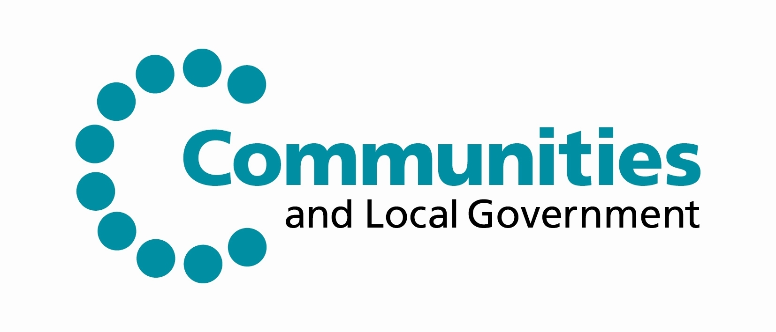

North East England ERDF Competitiveness
Programme 2007-13

ERDF Re-Commitment Strategy
March 2011

- Purpose of the Strategy

The Policy establishes the principles and approach within which the North East Local Management Committee (LMC) will pro-actively re-commit funds which become available in line with the de-commitment of funds within the Programme.

ERDF Intermediate Body functions transferred from One North East to the Department for Communities and Local Government (the Department) on 1st July 2011, the strategy may therefore be subject to further amendment. Any subsequent changes will be agreed by the LMC and notified immediately to all partners.

- Background

Re-commitment of ERDF investment generated as a result of de-commitment action will be guided by the following principles:

- In accordance with ERDF regulation, ERDF resources recycled back into the Programme must remain within the Priority from which they were de-committed;

- All ERDF recycled funds will be re-committed in accordance with established arrangements for selecting and approving projects;

- Recycling of ERDF funds must take full cognisance of Programme performance against indicator targets and prioritised towards activity which will maximise contribution towards the achievement of the performance indicators where the Programme is lagging behind.

In the later years of the Programme when time is limited to develop new activity and when the level of unallocated funds is significantly reduced, the management of re-commitment will consider:

- The development of a reserve list of projects, both new and/or enhancement to existing approvals in order to facilitate the re-commitment of recycled funds swiftly and transparently;

- A clear approach to over-commit resources to compensate for slippage and underperformance of contracted projects post December 2013.

A two stage approach to re-commitment will be adopted:

Stage 1 | Identification, recording and reporting of de-committed funds
Stage 2 | Re-commitment of recycled funds

Stage 1: Identification, recording and reporting of de-committed funds

Funds formally de-committed in accordance with the ERDF De-commitment Strategy will be recorded for each Priority. The related performance indicators (outputs /results/impacts) de-committed as a result will also be clearly identified and recorded. A Re-commitment Management Report will be developed and maintained and will include;

- Total funds made available for re-commitment;
- Funds available for recommitment by priority;
- Performance indicators (outputs/results/impacts) de-committed.

Stage 2: Re-commitment of recycled funds

De-committed funds may be recycled either by:

- Providing additional funds to projects that:
  - are performing on or above profile;
  - are capable of using additional funds to deliver additional activity;
  - can make a strong contribution towards the achievement of performance indicators where the programme is underachieving.

- Approving new projects that can make a meaningful contribution towards the achievement of performance indicators where the programme is underachieving.

All new projects will be subject to the established process agreed with LMC for selecting and approving projects.

Increased allocation to existing projects performing satisfactorily in order to secure increased outputs/results /impacts projects will be considered and endorsed by the ERDF Secretariat and formally approved through the Department’s business process.

During the final 18 months of the programme the Secretariat will develop, in consultation with PEG, a reserve list of projects for each Priority with a view to ensuring readily available activity to take up slippage and under spend from contracted projects.

The reserve list will be developed in an open and transparent manner, prioritising activity capable of meeting the required financial, output, result and impact targets for the priority/programme. The development of the reserve list will be overseen by PEG and reported to LMC.

