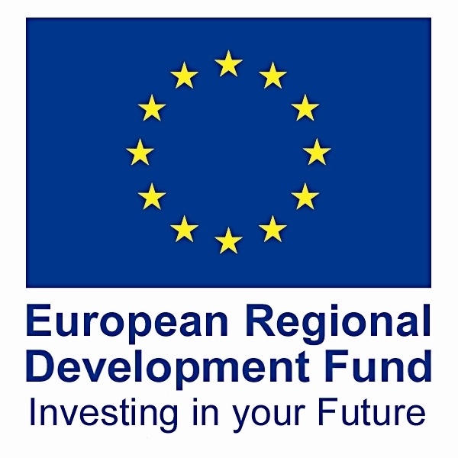


GRANT FOR BUSINESS INVESTMENT
GBI ENQUIRY QUESTIONNAIRE

Once you have read the information on Grant for Business Investment (GBI) available on our website http://www.communities.gov.uk (and then enter GBI in the search engine), and think you are eligible for grant, please answer the following questions and either return them to us by email or call us so that we can advise you on your eligibility.

Company and Project Details
- What is the company’s name, full address and telephone number?
- Does your company have a website? If so, please provide the web address?
- Where will the project be located? (please provide a postcode if possible)
- What does the company do?
- What size is the company (number of employees and approximate turnover)?

Project
- What is the project the company wishes to carry out?
- Will the project result in additional production/ extension of premises/ efficiency gains?
- When do you plan to start and complete the project?
- Have you explored other funding availability? If so, please state what funding has been explored.
- Will you be focusing on a local or wider market, will the company be exporting?
- What will be the impact of the project on energy use and CO₂ emission?

Finance
- What is the capital expenditure within the project (this includes fixed assets i.e. property,
plant & machinery)?
- Financially, why do you need the grant?
- What percentage of the finance is coming from the applicant and/or private sector sources?

Jobs
- Will there be job creation, if so how many?
- Are there any jobs which are at a real risk of being lost within 12 months without the project?
- What are the average salary costs of the jobs to be created or safeguarded?

Innovation and Competition
- What is the innovative feature of your project?
- Does the company have a unique selling point or offer anything that differentiates it from competitors?
- Who are the company’s main competitors within the South West region?

For more information on the Grant for Business Investment (GBI) scheme, please contact:
Sarah Tooze
Business Investment Team Administrator
Department for Communities & Local Government
Mast House
24 Sutton Road
Plymouth
PL4 0HJ

Please return completed enquiry questionnaires via email to:

Sarah Tooze
sarah.tooze@communities.gsi.gov.uk
Tel: +44 (0) 303 444 6575

Please note that the completion of this questionnaire does not constitute as a formal application for the Grant for Business Investment (GBI) scheme. The content of this questionnaire will be used to determine the potential to progress to a full application.

