ERDF Article 55 - Revenue Generating Projects Requirements (ERDF-GN-1-006)
Introduction

  - Article 55 of Regulation 1083/2006 (the General Regulation) defines what a revenue generating project is, sets out how revenues from revenue generating projects should be taken into account in calculating eligible expenditure, when to monitor revenues, and how to deal with differences in the forecast and actual revenues at the end of the project. The aim of Article 55 is to ensure sound and efficient use of the EU budget and to avoid grant funding more than is necessary in respect of such projects, when a loan might have been more appropriate.

  - This paper provides guidance on the treatment of revenue generating projects seeking ERDF support in the context of England and sets out a methodology that must be adopted by all RDAs and project applicants. The guidance also sets out additional project monitoring requirements that need to be included in the ERDF Funding Agreement Project Specific Conditions. A Glossary of terms can be found at Annex E attached.

  - This guidance should be read in conjunction with National Eligibility Rules and the ERDF National Handbook. The guidance has been based on information notes provided by the Committee for the Co-ordination of Funds (COCOF) listed under Reference Material at Annex F attached. Please note that COCOF papers are working documents. The aim of a working document is to provide Commission's services explanations and interpretations of the said rules in order to facilitate the implementation of operational programmes and to encourage good practice(s). However COCOF guidance is without prejudice to the interpretation of the Court of Justice and the Court of First Instance or evolving Commission decision making practice. This disclaimer is now included in new COCOF papers.

- Initial Assessment of the Application of Article 55 to a Project
Part 1 – The Initial Assessment of the Project
  - Article 55(1) of Regulation 1083/2006 defines a revenue generating project as:
- any operation involving an investment in infrastructure the use of which is subject to charges borne directly by users or
- any operation involving the sale or rent of land or buildings, or
- any other provision of services against payment.

  - Article 55 applies to both capital and revenue projects. It is of fundamental importance to understand what is actually meant by “revenue” in the context of Article 55. Revenues are cash in-flows in a project directly paid by users for the goods and/or services provided by the project. Revenues would not therefore include, for example, grants, private sector leverage generated by a project.

  - Once revenue generation within the meaning of Article 55(1) has been identified in relation to a project, the next step is to assess whether or not Article 55 requires the revenue to be accounted for and hence whether a ‘funding-gap’ calculation (where the revenue can be calculated in advance) or a ‘post contract evaluation’ (where it is not possible to objectively estimate the revenue in advance of the project being undertaken) is required.

Part 2 – Projects of less than €1,000,000 total value

  - Article 55 (5) provides the threshold for compliance with the provisions of Article 55(2) to 55(4). The Commission has amended the original Article 55(5) (which previously provided that the procedures for monitoring revenues generated by ‘small operations’ (total cost below €200 000) could be ‘proportionate to the amounts concerned’) Regulation 1341/2008 amended this to increase the threshold to €1,000,000. Subsequent commission guidance has indicated that this should be interpreted as net revenues generated during the project lifetime should still be monitored and deducted from the eligible project expenditure although this can be done as one operation at the end of the project. However, no monitoring nor subsequent deductions should take place after project closure.

  - The amendment was adopted by the European Parliament on 2 December 2008 and is retrospective clause, applying the new Article 55 from August 2006 onwards. For the purpose of determining the Euro value of a project the monthly exchange rate provided by the Commission should be used at the time the project is approved. Any future fluctuations in the exchange rates will not have any impact on the decision made at the time a project is approved.

Part 3 – Projects subject to the State Aid Regime

  - Article 55(6) excludes "projects subject to the rules on State aid within the meaning of Article 87 of the Treaty" from the application of the rules set out within the Article. Nothing in Article 55 makes a payment lawful which would otherwise be unlawful as state aid incompatible with the treaty. Although the risk of compliance with State Aid rules is borne by the grant recipient in the ERDF template offer letters, there is a residual risk of fines and also significant risk of reputational damage to the department of none compliant State Aid. Most projects designed for economic activity will be subject to State Aid, therefore it is essential that the PDT satisfies itself that the project or part of the project is not subject to State Aid before proceeding to Article 55 analysis. The reason for this exclusion is that the rules on State aid for setting the public contribution to the financing of a project or a group of projects (aid amount) have a different and specific purpose from those set out in Article 55. Where a revenue-generating project is subject to the rules on State aid, it is not subject to paragraphs 1 to 5 of Article 55. Where a revenue-generating project is not subject to State aid rules, it is subject to Article 55(1) to (5). This is not a matter of choice of the Member State. Further details are provided in COCOF 08/0012/01-EN “Information note on Article 55(6) of Regulation (EC) No 1083/2006”

  - The rationale behind the drafting of Article 55(6) is that State aid schemes and ad hoc aids normally incorporate tests for market failure and restrictions on eligible costs, and/or allow lower levels of total public sector intervention. It would therefore appear inequitable to require a project to comply with the additional administrative burden imposed by Article 55.
  - Examples of schemes and ad hoc aids which are/are not “subject to the rules on State aid within the meaning of Article 87 of the Treaty” and are/are not thereby exempted from the requirements of Article 55 by the application of Article 55(6) are as follows:

  - Exempt from the requirements of Article 55
    - Land regeneration schemes: For example speculative and bespoke gap funding scheme, historic environment regeneration scheme, and land remediation scheme
    - Notified schemes: For example SFIE, GRAND, Collaborative R&D
    - De minimis (even though regarded as ‘no aid’)
    - Block Exemptions e.g. GBER, SGEI
    - Cases where the delivery body is treated as a ‘wash through entity’ within Art 3 RDI guidelines (research organization or innovation centre) or within the clawback provisions of the German Incubation Centre decision (which would include most of the delivery body contracts entered into by the PDTs and former implementing bodies eg knowledge transfer clusters and university contracts). This is because although these are ‘no aid’ decisions, they are subject, like the de minimis rules, to a separate regime for ring fencing and clawback.
Not Exempt from the requirements of Article 55
    - Infrastructure whose benefits are open and available to all on a non-discriminatory basis
    - Market economy investor principle (MEIP) schemes: For instance where there is a pari passu joint venture or the state support is benchmarked against independently assessed market values
    - No Selective Advantage: For example compensation on a cost basis where it is argued the recipient does not receive an advantage eg grants to delivery bodies like clusters, business links etc and procured contracts.
    - Commission examples of revenue generating non State Aid projects : highways with toll charges, railways, technology parks, cultural buildings, waste water treatment plants

- Summary of Exemptions from Article 55, Complex Projects and inter-relationship with Article 57:

  - The assessment of revenue does not need to be undertaken in the following cases:
- Where projects do not generate revenues (ie do not fall within Article 55.1); or
- Where the total value of the project is below €1,000,000; or
- Where the project activities are 100% State-aid within the meaning of Article 87 and approved under a notified State Aid scheme or block exemption; or
- Where, for example, the operation already generates revenue and the investment will not generate any extra net revenue. For such projects which expand upon an existing revenue-generating infrastructure it is only any additional revenue generated as a result of the ERDF investment which has to be taken into account under Article 55.

  - In the case of complex projects the Commission’s Cost Benefit Analysis Guide 2008 (page 28, section 2.2.1) provides guidance upon how to evaluate whether a scheme should be looked at as one large project or several self-standing smaller projects. It advises: “if [the] benefits and costs of each component are independent, then the components are separable and can be treated as independent projects”. However, notwithstanding the Guide, for the purposes of Article 55, even if following the Guide a Project’s several components are treated as part of one whole project, the different parts should be considered separately. This means that the related costs and incomes appropriate to each component must be segregated and treated separately. For example, a major project may have different components generating different income streams, which would have to be accounted for separately.
  - Complex projects could incorporate components which may fall within the State aid exemptions and some which may not. For example, where a project includes aspects which will generate revenue, but has aspects which will and will not fulfil the four tests of Art 87.1, the project will need to be divided. An assessment of the revenue generated will need to be undertaken in relation to those aspects not exempted by Article 55(6). This calculation will either have to be undertaken in accordance with Article 55(2) or 55(3).
  - Another important consideration is the need to assess the sustainability and durability of a project and/or its component activities in order to comply with Art 57 (1083/2006). This states that a project should only be allowed to retain the contribution from the ERDF if within five years from its completion the project does not undergo any substantial modification:
- affecting its nature or its implementation conditions or giving to a firm or a public body an undue advantage; and
- resulting either from a change in the nature of ownership of an item of infrastructure or the cessation of a productive activity.

  - Article 57 complements the objectives of Article 55. Both Articles seek to prevent a grant recipient from receiving undue advantage from the intervention and ensure that investments which benefit from assistance under ERDF can be written off over a sufficiently long period.

  - Article 57 is being amended to confirm that it only applies to investments in infrastructure or productive investment. It will not apply to financial engineering instruments or revenue projects.

  - In the light of the above, applicants and PDTs should take care to identify whether a given project or any constituent part is included within Article 55(1), and to assess how any revenue should be treated. Article 55(4) provides that the Commission may require the refunding of revenue to the budget of the EU after closure of an operational programme in cases where a project has generated revenue that was not, or was not correctly taken into account under Article 55(2) or (3). Such refunds may be required at the latest three years after the closure of an operational programme. Regulation 539/2010 has amended the original Article 55 revenues to be taken into account under Art 55 (3) and the final Art 55 (4) adjustment for all Art 55 projects to a final deadline of the date of the submission of the closure documents being March 2017.

  - The Flowchart at Annex A summarises the steps which are to be followed in assessing the application of Article 55, as set out above.

- Calculating the ERDF funding-gap pursuant to Article 55(2): Introduction and Relevant Considerations

  - Article 55 (2) applies to projects where the identification of revenue can be objectively estimated in advance. This requires that the contribution from ERDF is determined by the “funding gap” method. This takes into consideration the estimated net revenue from an investment over a specific time horizon also known as the reference period details of which are set out in paragraph 4.5 below. The maximum eligible costs (the funding gap) must not therefore exceed the discounted investment costs less the discounted net revenue. This applies regardless of the way the revenue will be managed, such as, where the net revenue will be re-invested in the project.
  - The embedded excel worksheet at section 5 below must be used to calculate the funding gap to which the ERDF contribution rate can be applied unless the project is a major project. For major projects, applicants should not use the embedded funding gap calculation worksheet PDTs should follow the process outlined in EU Working Paper 4.
  - As stated at paragraph 4.1 above, Article 55 (2) should be used wherever the identification of revenue can be objectively estimated in advance. COCOF 07/007 4/03-EN, “Information note to the COCOF Guidance Note on Article 55 of Council Regulation (EC) No 1083/2006: Revenue Generating Projects” (hereinafter referred to as “the COCOF Guidance Note on Article 55”) emphasises that the possibility of estimating revenue in advance will depend on the feasibility of forecasting tariffs and demand. In terms of the feasibility of making forecasts, the availability of consistent data and previous experience with similar projects will be the most important factors. If the data is lacking or the project is not based on previously tested models then it would not be appropriate to attempt to undertake a funding gap calculation and Article 55(3) should be used instead.

  - As a part of the relevant matters to consider when applying Article 55.2, a linked and important consideration is whether the project should receive a grant from ERDF at all. To calculate the funding gap and assess whether the project should receive grant funding from ERDF (as opposed to a loan), account must be taken of:
- the reference period (also called the project time horizon) appropriate to the category of investment concerned – see paragraph 4.5 below

- the profitability normally expected of the category of investment concerned –see paragraph 4.16 below.

- application of the polluter-pays principle - those costs generated by pollution must be paid by the polluter and should therefore not usually form part of the funding gap calculation (ie should not be taken into account as revenue).

- equity and affordability – this relates to the ability of users to pay for using the facility/service. In this regard, the fee, rent etc charged should be set at a level which takes account of users' income within the area/region concerned.

The Reference Period

  - The first step for any funding gap calculation is to decide the correct reference period, since this will be the period over which the revenue must be tracked.

  - The reference period is a set number of years for which forecasts must be provided in order to conduct a financial analysis. The COCOF Guidance Note on Article 55 defines the reference period as the “number of years of the profit economic life that is the time period beyond which the investment needs to be replaced.” Project forecasts should cover the reference period which should be long enough to encompass its likely mid to long term impact. The projects economic life is not the same thing as the expected useful economic life of individual assets within a project since this could be greater or lesser than the appropriate reference period. It is therefore not appropriate to simply base the reference period on the average service life of fixed capital assets set for accounting purposes.

  - It is normal practice when determining a reference period to refer to a standard benchmark differentiated by sector and based on internationally accepted practices. Table 1 below sets out the reference periods recommended by the European Commission for different categories of investment for the period 2007-13.

EU suggested reference period ERDF 2007-13 Table 1
Sector of Investment | Time Horizon
Railways | 30
Roads | 25
Water | 30
Energy  Telecommunication  Industry | 25  15  10
Other services | 15

  - CLG recommends that reference period set out in Table 1 is applied consistently for all similar projects. Any deviation from Table 1 should be considered on a case by case basis and must be justified on the uniqueness of the project-specific features. In this context it is important to bear in mind the requirements of Article 57 “Durability of operations”.

  - Annex C to this guidance sets out what kind of projects would be normally expected in each of the sector of investment. This is an indicative and not an exhaustive list of projects.

  - Most projects under the Competitiveness Programmes would fall within the ‘Industry’ or ‘Other services’ sectors in Table 1 above. Please refer to Annex C to determine which sector is applicable to a particular project. The choice of reference period may have an extremely important effect on the results of the appraisal process and may also affect the amount of ERDF payable. The longer the reference period, potentially the higher the net revenues to be taken into account in the calculation of the funding gap.

  - CLG recommends that the reference period should start from the date specified in the offer letter. Revenues may come on stream at the start of a project or later on.
  - For a capital project the investment period to be used for monitoring purposes is generally clearly defined and incremental revenues would be expected to come on stream when the investment phase is complete.

  - However, for a revenue project, the situation is less clear cut as the generation of revenue could occur in parallel with the investment phase of the project. For projects where no capital investment is involved, such as provision of a service from an existing facility, it should be easy to establish the starting point when the users start paying, and in many cases it could be at the start of the project or at some point during the investment phase of the project prior to completion.

Profitability

  - ‘Normally expected profitability’ means the ability of the project to generate additional financial resources (i.e. profits) as compared to those resources invested, independently of how the project is going to be financed (such as loans, private equity, or government contribution).

  - The Commission has recommended that an assessment of the normally expected profitability of a project is made in order to verify if the appropriate financing route has been selected. Whilst this is not a part of the funding gap calculation, CLG nevertheless supports the Commission’s recommendation and it is advised that this assessment is undertaken as part of the appraisal of a project when the funding gap is being assessed. The simplest way to assess profitability is to measure the internal rate of return of the investment, that is the discount rate that makes the discounted flow of the project’s costs and revenues add up to zero. In other words, the internal rate of return is the discount rate at which a stream of costs and revenues has a net present value (NPV) of zero.

  - For the purpose of Article 55 projects the financial rate of return for the beneficiary should, in principle, be aligned with the EC standard financial discount rate of 5% real as it reflects opportunity cost of capital. Any higher rate or return would indicate that the grant from EU would bring above normal profits to the beneficiaries. Also projects with high financial rate of return would not need EU grant as they should be able to attract private finance

  - For reference and further information see Annex B setting out the profitability for each sector for projects in the previous ERDF rounds in the EU.

- Calculating the ERDF funding gap pursuant to Article 55(2) Methodology

  - The estimated costs and the estimated revenues (which must not be adjusted for inflation) must be forecast on an annual basis for the reference period appropriate to the sector of investment in which the project is involved. See the section entitled “The Reference Period” above. If, as set out at paragraph 4.3 above, the forecast of revenues over the reference period can be made with reasonable confidence then the revenues should be dealt with under Article 55(2), The Commission expects market research to be done to establish the expected revenue streams and costs and allows a 10% margin on the understanding that precise figures will not be possible. If the project involves innovation which will create an unquantifiable level of demand so that it is not possible to predict future revenues with reasonable accuracy Article 55(3) should be applied. It is important that this analysis is done carefully at the beginning of the project.

  - Details of ineligible costs are contained in National Eligibility Rules Please note that the Commission has confirmed that developer/ operator profit is not allowed as an eligible cost, nor should it be taken into account in the overall funding-gap calculation.

  - The discounted net revenue can then be calculated using discounted cash flow techniques. Using a discount rate has the effect of reducing the value of future costs and benefits to present day terms. For example a discount rate of 5% per annum implies that society values £1 today equally with the certainty of £1.050 in a year’s time. Another way to express this is to say that £1 in a year’s time is worth only 95.24 pence now because 1/1.050 equals 0.9524. The 95.24p figure is the present value (PV) of the £1 and the 0.9524 figure is the relevant discount factor.

  - The discount rate should reflect the opportunity cost of capital. High discount rates tend to favour the acceptance of projects with lower investment and/or a concentration of benefits in the short term, whilst lower rates are associated with longer-term returns. In principle, the Commission recommends that a 5% financial discount rate in real terms is used as an indicative benchmark for public investment projects co-financed by the Funds in the programme period 2007-13. PDTs should use the 5% discount rate for co-financed projects.

  - For a majority of projects, the process to be followed by all PDTs should be based on the process set out in the COCOF Guidance Note on Article 55 COCOF 07/0074/09. The process consists of four steps and is explained below. The embedded funding gap calculation worksheet in Section 5.16 can provide discounted cash flows using the Commission’s recommended discount rate of 5% for all projects.

  - For major projects, however, applicants should not use the embedded funding gap calculation worksheet PDTs should follow the process outlined in EU Working Paper 4. Article 39 of regulation 1083/2006 defines major projects as those whose total cost exceeds €25m in the case of environmental and €50m in other fields. Major projects need prior approval from the Commission. It is important to remember that the EU grant is finally calculated in non-discounted values. If the calculations show that there are no net revenues generated then Article 55 does not apply to the project. However, it is important to establish whether the project would be financially sustainable over the reference period.

Step 1
Establishing the funding gap:
If:
DIC is the discounted investment cost
DNR is the discounted net revenue
FG is the funding gap

Then FG = DIC - DNR
The funding gap (FG) is the difference between the discounted investment costs (DIC) and discounted net revenue (DNR)

  - Only the cash in-flows directly paid by users (eg rents, fees, tolls etc) have to be taken into account in determining the gap. Public and private contributions that do not stem from charges to the users of the service (eg. subsidies, grants or investments) are not taken into account.

Step 2
Finding the discounted eligible Expenditure
If:
DEE is the discounted eligible expenditure
DEC is the discounted eligible costs
P is the percentage consistent with the ratio of discounted eligible cost (DEC) over discounted investment cost (DIC)

DEE = FG * P where P=DEC/DIC X 100

  - Where not all the investment costs are eligible for ERDF support, the net revenue must be allocated pro rata to the eligible and non-eligible parts of the investment cost. In order to determine the proportion of the net revenue that is to be taken into consideration, the discounted investment costs need to be compared with discounted eligible costs (i.e. discounted eligible costs divided by DIC and multiplied by 100). Where part of the project is not revenue generating, its costs and operating costs should not be taken into account. Where a project involves alteration to an infrastructure which is already revenue generating, only the additional costs and revenues should be taken into account, therefore a baseline of the starting position should be taken.

Step 3

Calculating contribution from the Funds
If:
DGeu is the discounted contribution from the Funds
CReu is the EU co-financing rate

Then DGeu = DEE X CReu

Step 4

  - In order to derive the contribution from the Funds in non-discounted values, each discounted eligible expenditure (DEE) or FG from “Step 1” where “Step2” does not apply should be multiplied by (1+r)t where ‘r’ stands for the discount rate (recommended value is 5%) shown as a percentage and ‘t’ for the year in which the related eligible expenditure occurs, and added together as shown below:

Year Discounted Eligible Exp Calculation non-discounted eligible Exp
DEE UDEE
£ £
0 10.25 10.25 x (1+(5/100))0 10.25

1 7.62 7.62 x (1+(5/100))1 8.01

2 8.71 8.71 x (1+(5/100))2 9.61

3 6.92 6.92 x (1+(5/100))3 8.01
Total 33.50 35.86

  - A worked example is shown at Annex G. The example is taken from COCOF Guidance note on Article 55 and includes detailed calculations. The example assumes investment over a four year period. The result is slightly different (lower) as the Commission’s calculations are based on starting with year ‘1’ whereas accepted practice for calculating discounted cash flows is to start with year ‘0’. Because the equation effectively only provides a maximum ERDF contribution to the investment costs, where the operating costs are also being supported by ERDF the support or ineligible costs should be subtracted from the operating costs used for the equation. This will have the result of increasing the net revenue to be removed from the capital costs.

Residual value of assets

  - The Commission has not recommended any particular method for calculating the residual value of an asset but refers to the Cost Benefit Analysis Guide 2008 and Working Document No 4. The residual value will be zero or negligible if a sufficiently long time horizon has been used whereby there is no remaining service potential left in the project. However, for practical reasons this is not always the case. The residual value reflects the ‘salvage’ value of fixed assets or any remaining capacity to generate net revenues. In other words, the residual value can be defined as the virtual liquidation value. The assets in a project would be depreciated using the applicant organization’s stated accounting policies for specific groups of asset categories. The residual value of such assets would be the remaining life of these assets. In case of assets with a very long life, such as a building, a residual value would reflect their potential resale value or continuing use value. Residual value should also include an appraisal of the net revenues the project can generate beyond the reference period, before any substantial revamping or replacement of the old investment. In cases where public utility buildings (e.g. hospitals, museums, universities which provide public service and are regulated by central or local government) will be used for the same purpose (ie public services) after the end of the reference period provided in the financial analysis, so that there is no theoretical possibility to receive income from selling them (liquidation value) PDTs can in general assume that the residual value is equal to zero. However, in order to ensure this, a covenant preventing any future alteration to commercial activities may be required.

  - For the purpose of determining whether or not an operation is a revenue-generating project within the meaning of Article 55(1) and whether or not it is necessary to apply the funding gap method, the simple fact that a piece of infrastructure will have a residual value does not always mean that the funding-gap calculation has to be undertaken. For example, an investment in a new road, which is not subject to tolls or other user charge revenue, would not become revenue-generating solely due to the residual value of the road at the end of the reference period. However, where it is determined that a project does generate incremental net revenue, and the funding gap method must therefore be applied, the residual value must be taken into account in the calculation (subject to the exception in relation to public utility buildings as set out above). Also, the replacement costs of project short-life equipment are taken into account as operating costs in the calculation of the funding gap (see footnote 13 on page nine of COCOF guidance note on Article 55).

  - Should it prove impossible to estimate a residual value at the end of the reference period, the DG Regio Technical Branch has advised that perpetuity should be calculated. This is done by taking the discounted net operating income in the last year of the reference period and dividing it by the appropriate discount rate.

  - Whilst there may be projects where it is known/suspected at the outset that any revenues generated will not fully cover the operating costs so that there is no net revenue position, such service project where only a contribution towards the cost of the service is charged, a calculation will still need to be undertaken (to comply with Article 55(2), notwithstanding that the result of the calculation would demonstrate that the funding gap would equal 100%. Even if the calculation shows that there will be no net revenue position at the end of the reference period, the project’s revenue will still need to be monitored throughout the reference period to ensure that the projected revenue and operating costs were correct.

  - In addition to the above, whilst applicants may, in providing the information for the funding-gap calculation, try to minimize the potential for a project to show a net revenue position, they risk presenting an application that is financially unsustainable because the operating costs are shown to be greater than the income generated. A project must be able to demonstrate how, over the project’s reference period, sources of financing (including revenues and any kind of cash transfers) will consistently match disbursements year-by-year. Sustainability occurs if the net flow of cumulated generated cash flow is positive for all the years covered by the appropriate reference period (or the project breaks even). If the operating costs are shown to be greater than the income generated the applicant may provide a financial guarantee (e.g by a Local Authority) stating that subsidies would be provided to meet any annual operating shortfall. They may also provide evidence of access to bank loans or overdraft facilities. These guarantees would need to be captured in any funding agreement

  - Funding Gap Calculation Spreadsheet

The 'formula cells' are password protected; the password is A55.



- Calculating the Net Revenue Based on Article 55(3)

  - Pursuant to Article 55(3), for projects where it is objectively not possible to estimate in advance the revenue which will be generated with a reasonable degree of confidence, there is an option to leave the calculation on net revenue until after the completion of the project (but before programme closure) at which point any necessary deduction should be made. Article 55(3) requires that “the actual (net) revenue generated within five years of the completion of an operation shall be deducted”. Following the change outlined in Regulation 539/2010 this means the final adjustment should be made before March 2017 the deadline for submission of the closure documentation.

  - The maximum amount to be deducted in accordance with Article 55(3) is to be based on the relevant co-financing rate applied to the project and should not in total exceed the ERDF contribution received by the project in question.

  - The drafting of Article 55(3) has led to the following questions:

- At what point should the five year period commence, given the differences between capital and revenue projects; and
- How should PDTs deal with recovering any revenue generated?

  - Addressing the point raised at paragraph 6.3 above, as discussed at section 4 above, for capital projects the incremental revenues would be expected to come on stream when the investment is complete. This would fit with the drafting of Article 55(3). The five year monitoring period would start from completion, i.e. the point when incremental revenues are generated, and the grant recipient would be required to re-pay an amount equal to the net revenue generated over that five year period, adjusted by applying the co-financing rate. The example in the COCOF Guidance Note on Article 55 (at paragraph 4.3) clearly envisages a situation such as this.

  - However, for revenue projects the generation of revenue could occur in parallel with the investment phase of the project. Since the publication of COCOF Guidance Note on Article 55 in response to queries from Member States the Commission has clarified that the five year period for monitoring revenue could start from the point where the revenue is being generated by the project. In other words the five year period for monitoring of the revenue would occur in parallel with the investment phase of the project.

  - Further to the second question raised at paragraph 6.3.2 above, PDTs should take care to ensure that a project’s net revenue is captured accurately. In the event of default the Commission could require re-imbursement (see further below). An annual externally audited declaration from a person with a suitable level of authority within the grant’s recipient’s organisation (for example the finance director) supplying details of the net revenue (gross operating revenues less gross operating costs) generated by the project should be included as an obligation in the funding agreement. To ensure that audit certificates are reliable it is important that PDTs provide guidance for use by the beneficiaries’ auditors on the scope of the work to be done and the report/certificate to be presented. Audited accounts are not an acceptable substitute for this purpose as these are intended to cover an operation’s entire financial position and not simply the position in relation to net revenue.

  - The PDT will need to ensure measures are in place in the funding agreement to cover this potential debt. In the case of a 3 year revenue project which will be wound up at completion, the deduction could be made at the end date as this 3 years’ worth of revenue would be the only revenue generated. However, it would not be possible in all cases to make the relevant deduction from the final payment of the grant at completion of the project activities. Furthermore, to comply with Article 55(3), projects would still need to carry on monitoring the revenue position for a period up to five years after completion. For a capital project where the actual revenue generation will not start until after completion, the amount of net revenue to be deducted with the final payment of grant on practical completion would be nil.

  - PDTs will have to wait for five years until after completion of a project to obtain a complete picture as to the net revenue generated. or until March 2017 which ever is sooner. Please refer to the specimen Project Specific Conditions included in the model Funding Agreement and attached suggested monitoring template.

  - There is of course always the risk that the original grant recipient may not be in existence five years after completion of the project. To manage such a risk, PDTs are encouraged to take guarantees from grant recipient’s parent companies or its members where possible, and to ensure that any revenues generated are paid into a separate ring-fenced account by the grant recipient.

  - Finally, according to Article 55(3) any deduction must be made at the latest at the partial or final closure of the operational programme, clarified by Regulation 539/2010 to be limited to a final deadline of March 2017. If a project is undertaken towards the end of the programme, so that, for example, only 3 years’ worth of net revenue can be tracked and accounted for before closure of the programme, the remaining net revenue generated will fall to be dealt with under 55(4) and, subject to the 10% tolerance (see further below in section 7).

- Monitoring, Refunding and Irregularities

  - The suggested methodology for monitoring revenue with projects subject to Article 55(3) is set out in section 6 above. As will be seen at paragraph 7.6 below, there is no margin of error when undertaking calculations pursuant to Article 55(3), as a project is dealing with concrete evidence rather than projected figures. Hence the importance of a proper audit trail.

  - For projects which have undertaken an Article 55(2) funding-gap calculation, the actual revenue should be compared with the original projections. If monitoring reveals important discrepancies between the revenue initially estimated and the revenue which will be actually realised, PDTs should have in place mechanisms that would allow them to readjust the grant calculation (if such a situation is discovered before the end of the project) or to recover any overpaid grant (if such a situation is discovered during the monitoring period post completion of the project).During the project period, this will be done via annual audit reports, as per Art 55 (3). See attached monitoring schedule.

  - It may not be practical to suggest an applicant submits annual audit reports for the full reference period or up to 3 years post closure of the whole programme (whichever occurs first). We have to bear in mind that there is a margin of error allowed by the Commission We may decide to monitor funding-gap calculations in the same way as Art. 55(3) up to five years post completion (ie full reports), and then at that stage to take stock of what is going on. If the monitoring reveals that the revenue and operating costs are as anticipated, or they are actually making less net revenue, then an PDT may feel comfortable simply going back to check just before closure of the programme.

  - Irregularities could occur where it is established, upon monitoring and review of the revenue assessed pursuant to the funding-gap method, that the revenue generated is greater than anticipated because the calculation was voluntarily underestimated. In such a case this would be dealt with in accordance with Articles 98 and 99 of Regulations 1083/2006.

` Article 55(4) requires revenue to be refunded to the budget of the EU after closure of the operational programme where it has not been properly accounted for. Such a situation might occur because, for example, a project which anticipated a neutral position under Article 55(2) in fact returned a profit or because net revenue was not captured accurately (or not captured at all) pursuant to Article 55(3). Regulation 539/2010 has limited this correction to the date of submission of the Closure documents being March 2017.

  - The Commission recognises that the funding-gap calculation is not a precise science and has indicated in the COCOF Guidance Note on Article 55 that if the funding-gap varies less than 10%, no compulsory refund is required pursuant to Article 55(4). No similar margin of error exists for projects subject to Article 55(3).

  - If a project has ended but the operational programme has not ended then any surplus revenue can be recycled within the programme. This is the case for projects subject to Article 55(2) or 55(3). Modalities will have to be decided between the Commission and CLG in the context of the preparation of the closure for the 2007-13 period on the most practical solution to implement these provisions with the necessity to ensure the smooth closure of the programmes.

  - PDTs should ensure an efficient yet proportionate monitoring system for revenue generating projects is put in place as soon as possible. Proportionate arrangements should not be introduced on an arbitrary basis but must be based on objective considerations, and principally on the total cost of the revenue-generating projects, the risks involved, and the track record of the beneficiary. The key requirement is the ability to detect variations in revenues in a timely manner, be able to take corrective action, and thus prevent any adverse effect on the funding of the operational programme. There should be proper contractual requirements for beneficiaries to report to PDTs up to programme closure or for a further period of three years after programme closure. The data for reporting could be on an annual basis or from short term surveys depending on the nature and size of the project. It is expected that the Audit Authority will include a sample of revenue generating projects in the annual audit of the operational programme. Amendment of the project is recommended to take place when it is clear that a project will exceed the Commission 10% tolerance, but may be left to the end of the project.

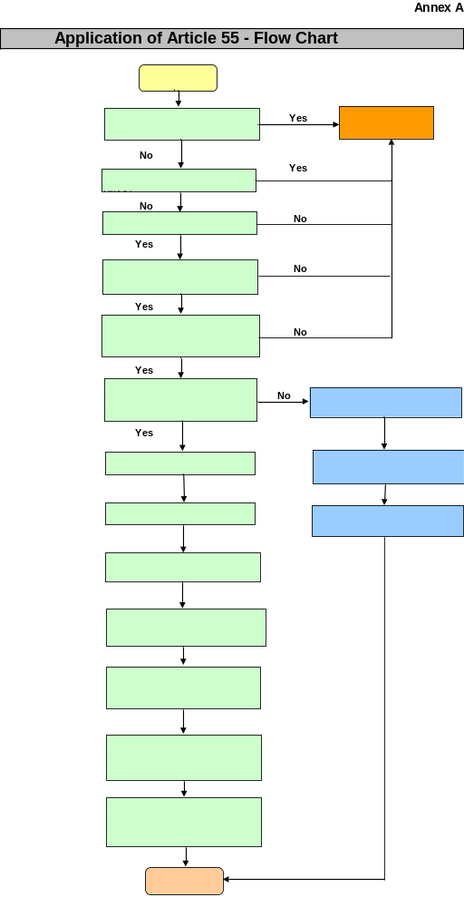

Annex B
Normally expected profitability observed in EU funded projects in previous rounds:
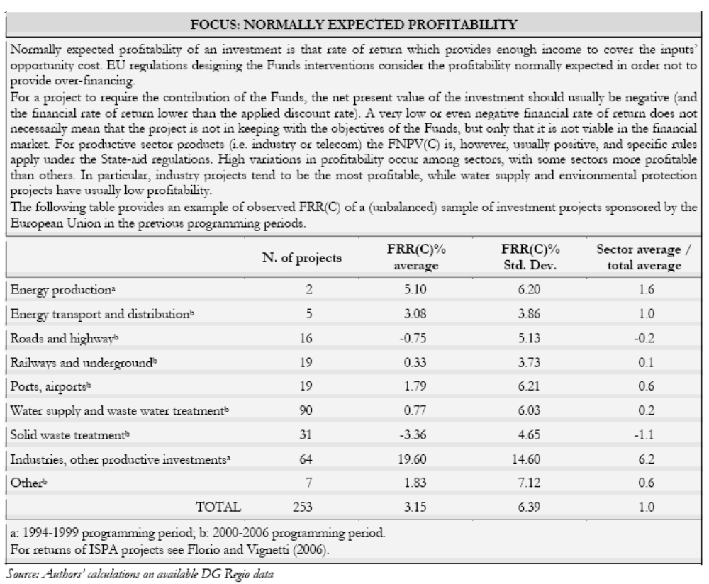
Annex C
Project Reference Period
Sector | Reference period (yrs) | Coverage of projects
Railways  Roads | 30  25 | Investment for the development of new or existing infrastructures. These may include new transport lines or links, or the completion of existing networks, as well as investments intended to upgrade existing infrastructures.
Water | 30 | This covers projects dealing with supply and delivery of water as well as the collection, removal, purification and elimination of sewage, and re-utilisation of waste water.
Energy | 25 | Projects in this sector may include:  - Construction of plants to produce electricity from renewal energy sources;  - Investment directed at energy savings by improving energy efficiency;  - Construction of plants to produce electricity from other sources;  - Prospecting and drilling for natural gas or oil;  - Energy storage transport and distribution.
Telecom. | 15 | This sector covers communications infrastructure broadly in two categories:  Local scale projects:  - local cabling or relay systems to extend services to areas not covered;  - cabling a city, metropolitan or industrial area to provide faster, more powerful networks;  - construction or modernisation of units for band switching with wider networks;  - the laying of cables and construction of relay or satellite stations to link isolated areas.  Broader scale projects:  - the development of international communications systems, to increase the capacity, power and speed;  - increasing the capacity, power and speed of inter-regional communications networks;  - the technological updating of the network to enable connection with new services (eg multi-media services, portable telephones, cable television etc)
Industry | 10 | This sector covers industries and other productive investments usually with the following objectives:  - encouraging the industrialisation of specific sectors in areas that are relatively backward;  - developing new technologies in specific sectors or applying more promising technologies which require a high initial investment;  - creating alternative employment in areas where there has been a decline in the existing productive structure.
Other services | 15 | Education and training infrastructures with focus on one or more of the following:  - Basic education and vocational needs  - Higher education(universities, business schools etc  - Particular needs for specialisation in productive areas  - Improvement of the positioning of young people in the labour market  - Elimination of discrimination between social classes, genders  - Better opportunities for the disabled
 |  | Museum and cultural sites to support tourist industry or simply improve quality of life.
 |  | Hospitals and other health infrastructures for increasing life expectancy and life quality.
Industrial zones and technological parks where the main objectives are:
- The establishment of the infrastructure for industrial zones, commercial and service areas;
- The relocation of productive plants from excessive congested or polluted areas;
- The setting up of new companies and supporting existing ones in a technological park.
Forest and parks projects with different objectives such as:
- Increasing the production of wood or cork for commercial or energy purposes;
- Safeguarding the environment (prevention of social erosion, control of water, environmental protection)
- Promotion of tourist recreational activities.

Annex D

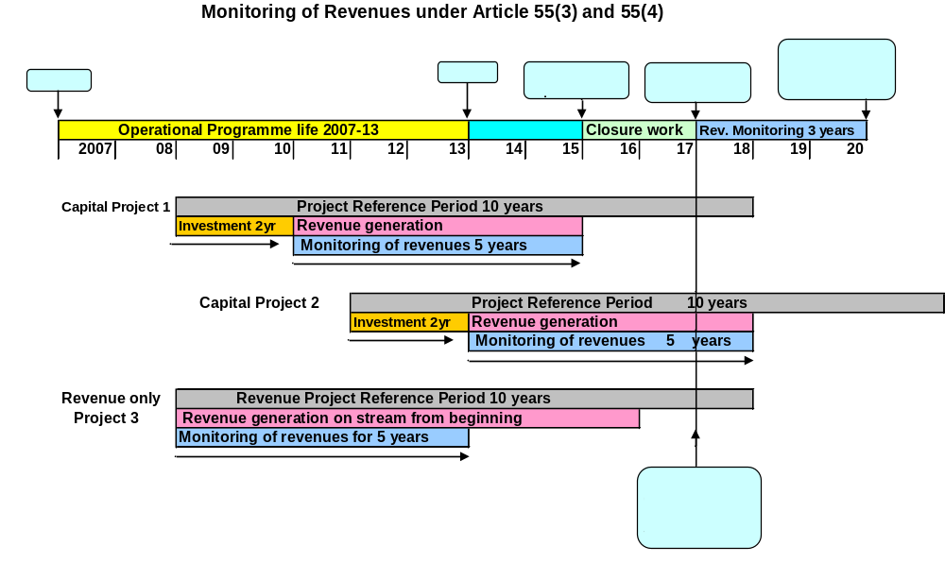

Annex E
Revenue Generating Projects - Glossary of Terms

Current value
It is a synonym of discounted value.

Discount rate
The rate at which future values are discounted to the present. The financial discount rate may differ from economic discount rate.

Discounted value
The present value of cash expected at some time in future. To calculate the present value of a single cash flow, it is divided by one plus the interest rate for each period of time that will pass. This is expressed mathematically as raising the divisor to the power of the number of units of time.
As an example, suppose an individual wants to find the present value of £100 that will be received in five years time. There is a question of how much is it worth presently, and what amount of money, if one lets it grow at the discount rate, would equal £100 in five years.
Let one assume a 12% per year discount rate.
PV = £100 divided by 1 plus 12% (0.12) to the power 5

Since 1.12⁵ is about 1.762, the present value is about £56.74.

Internal Rate of Return (IRR)
The discount rate at which a stream of costs and benefits has a net present value of zero. The internal rate of return is compared with a benchmark in order to evaluate the performance of the proposed project. Financial rate of return is calculated using financial values, economic rate of return is calculated using economic values.

Incremental Net Revenue
The net revenue arising directly as a result of the new investment.

Net Present Value (NPV)
The sum that results when the discounted value of the expected costs of an investment are deducted from the discounted value of the expected revenues.

National capital
Public and private contributions and or financial gains that do not stem from tariffs, tolls, fees, rents or any other form of charge directly borne by the users.

National Capital Profitability
It is the financial rate of return (FRRC) normally expected from the investment of national capital by sector.

Net revenue
It is the difference between total revenues and the operating costs.

Operating costs
For the purpose of calculating funding-gap these include running costs(e.g. labour, raw material, electricity), maintenance expenses and costs for the replacement of project short-life equipment. Financing costs (e.g. interest payments) and depreciation are excludes. Taxes are also ignored.

Reference Period
The reference period is the maximum number of years for which forecasts are provided. Forecasts regarding the future of the project should be formulated for a period appropriate to its economically useful life and long enough to encompass its likely mid to long term impact. The number of year usually reflects the lifetime of the investment and project cycle.

Time Horizon
This is another term for reference period.

Annex F
Reference Material

Source | Available from
Chapters 2 to 4 of the ERDF User Manual | http://www.mcisproject.co.uk/documents.php
COCOF 08/0012/01-EN “Information note on Article 55(6) of Regulation (EC) No 1083/2006 | [DCLG?]
COCOF 07/007 4/03-EN
“Information note to the COCOF Guidance Note on Article 55 of Council Regulation (EC) No 1083/2006: Revenue Generating Projects
EU Working Paper 4– Guidance on the Methodology for Carrying Out Cost-Benefit Analysis (the New Programming Period 2007-2013) | http://ec.europa.eu/regional_policy/sources/  docoffic/2007/working/wd4_cost_en.pdf
Commission’s Cost Benefit Analysis Guide 2008 - Guide to cost-benefit analysis of investment projects. Published by DG Regional Policy in 2008 | http://ec.europa.eu/regional_policy/  sources/docgener/guides/cost/guide2008_en.pdf

Annex G
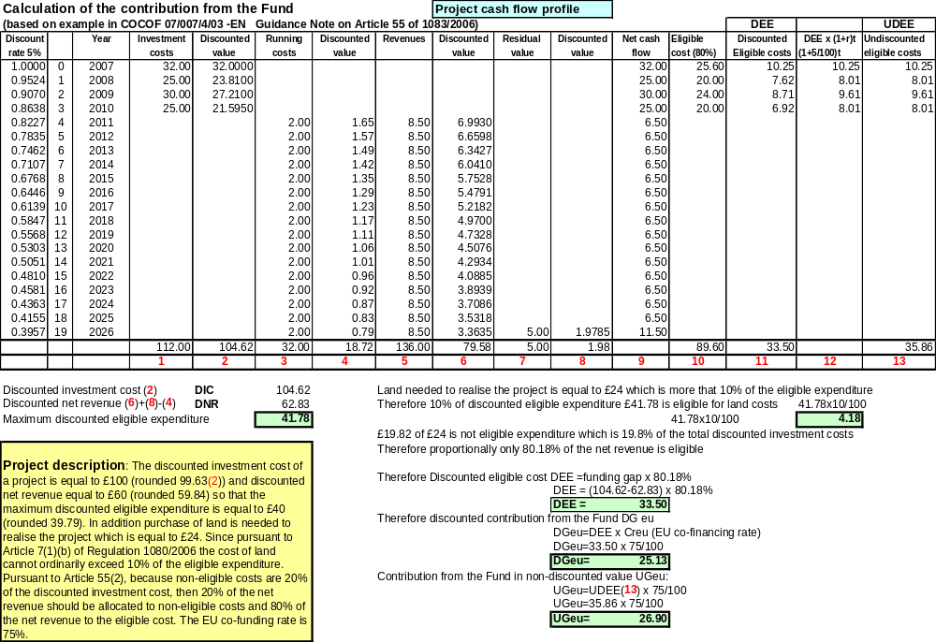
Annex H Article 55.2 Monitoring Template

The undiscounted revenue less operating costs and residual value should be transferred from the original ex-ante Article 55.2 spreadsheet and inserted into G34. The projected undiscounted revenues and undiscounted operating costs should be transferred into the spreadsheet in the years of the project. Where more than one revenue source has been identified and the project is being treated as a number of sub projects with revenues starting at different times, the revenues and costs should be divided into different sources. Post the project end date, the balance of the undiscounted net revenue including the residual value should be put into box I11 for the first source of net revenue and subsequent boxes where there is more than one source of net revenue. As the annual audit reports are received, the estimate costs should be replaced by actual costs. This will automatically re-calculate that the overall cumulative net revenue is estimated to be. G36 shows the difference in value and I 34 the percentage difference. Where the percentage difference exceeds 10% over the original, a re-run of the net revenue calculation is recommended.

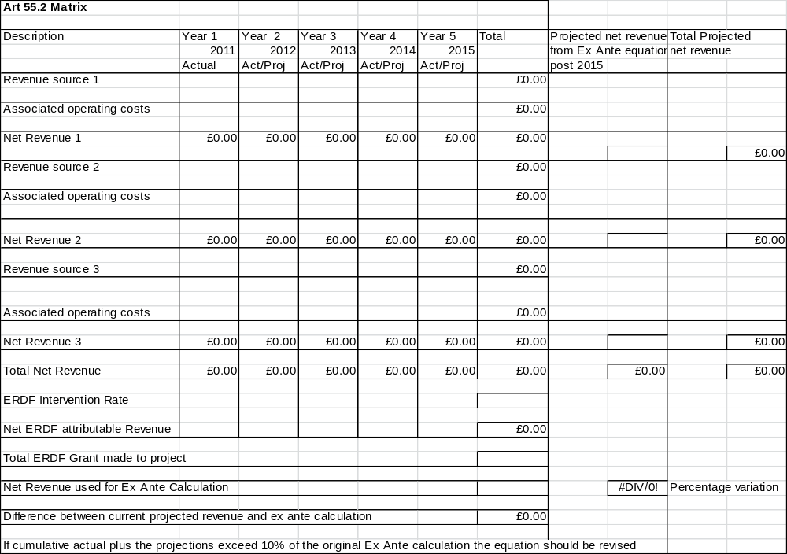

Article 55.3

The information from the annual audit report should be used to populate the attached spreadsheet. The revenue should be tracked from the year that the revenues begin to be generated, not the project start. If there is more than one independent source of revenue which starts at different times, the different revenue streams should be segregated. The years should be designated accordingly i.e. Revenue Source 1 starts generating revenue in 2011 so year 1 becomes 2011, y2 2012 etc. Revenue Source 2 does not start generating revenue until 2013, so Year 1 becomes 2013, yr 2 2014 etc.. The 5 years must be tracked limited only by the closure of the programme.

