
Local Sustainable Transport Fund - Application Form

Guidance on the Application Process is available at:
www.dft.gov.uk/pgr/regional/

Bids for both small projects and initial proposals for large projects should be no more than 20 pages long.

Applicant Information

Local transport authority name(s)*:

*(If the bid is a joint proposal, please enter the names of all participating local transport authorities and specify the co-ordinating authority)

Senior Responsible Owner name and position:

<Name and position of the senior official responsible for delivery of the proposed package of measures>

Bid Manager name and position:

<Name and position of the official with day to day responsibility for delivering the proposed package of measures>

Contact telephone number:

Email address:

Postal address:

Website address for published bid:

SECTION A - Project description and funding profile

A1. Project name:

A2. Headline description:
<Please enter a brief description of the package of measures in no more than 100 words>

A3. Geographical area:

<The area covered by the bid>

A4. Type of bid (please tick relevant box):

Small project bids
Tranche 1 bid
Expression of interest for Tranche 2 (please complete sections A and B only)
Tranche 2 bid

Large project bids
Key component bid
Large project initial proposals

A5. Total package cost (£m):

A6. Total DfT funding contribution sought (£m):

A7. Spend profile:

Details of the funding sought over the period 2011-12 to 2014-15, broken down by financial year and split between revenue and capital. Details of any local contribution should also be included. Please enter figures in £000s (i.e. £10,000 = 10).

£K | 2011-12 | 2012-13 | 2013-14 | 2014-15 | Total
Revenue funding sought
Capital funding sought

Local contribution
Total

A8. Local contribution

Please provide details of the source of any local contribution to the overall cost of the proposed package. Where the contribution is from external sources, a letter confirming their commitment to contribute to the cost of a specific package element(s) will be required.

A9. Partnership bodies

Details of the partnership bodies (if any) you plan to work with in the design and delivery of the proposed package of measures. This should include a description of the role and responsibilities of the partnership bodies such as Civil Society Organisations, Private Sector bodies and Transport Operators, with confirmatory evidence of their willingness to participate in delivering the bid proposals.

SECTION B – The local challenge

B1. The local context

A brief description of the economic environmental and social issues in the geographical area, including plans for housing and jobs growth, and the role of transport in addressing those issues . This should draw on the contextual factors identified in preparing the Local Transport Plan.

B2. Evidence

Details of the transport issues in the geographical area with supporting quantified evidence on use of the transport network (e.g. on journey patterns, volume and proportion of journeys by different modes), on particular problems (e.g. congestion hotspots) and how they give rise to wider consequences (e.g. levels of air quality, access to employment and services). Baseline data relating to the transport challenges that the proposed package of measures are designed to address should be provided to help inform later evaluation of the Fund programme.

B3. Objectives

The objectives set out in the Local Transport Plan with an explanation for how the proposed bid package would support these objectives.

SECTION C – The package bid

C1. Package description

Please provide a detailed description of each of the package elements being bid for.

C2. Package costs

A breakdown of the proposed package of measures with the DfT funding required for individual elements identified by financial year and split between revenue and capital. This should align with the funding profile in Section A.

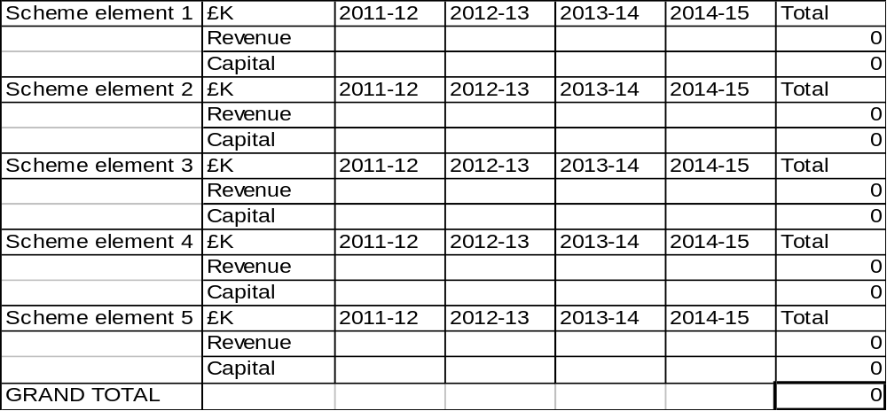

C3. Rationale and strategic fit

An explanation on how the individual measures interlink and mutually support each other and represent a coherent package to successfully address the local challenges identified in Section B. The package proposal should demonstrate a good strategic fit, that it complements policies and proposals in the Local Transport Plan and other relevant local strategies and plans, and that it does not impact negatively on particular groups within the community or locations within or outside the geographical area covered by the bid.

C4. Community support

Please provide evidence of the extent of support within the community for the proposed package of measures.

SECTION D – Value for money

D1. Outcomes and value for money

Please refer to paragraphs 24-28 of the guidance when completing this section. Authorities can draw on their own evidence or use the results from recent similar packages of measures implemented elsewhere to explain the impacts and benefits expected from their proposals.

The proposal will need to set out what specific outputs will have been delivered by the end of the Fund period (i.e. 2014-15) and demonstrate what the expected impact and outcomes will be in terms of economic growth and reducing carbon emissions.

Where possible, in order that the Department can calculate the likely quantifiable benefits from the package proposals, information should be provided of the impacts each year over the period of the Fund, starting from the year before the measures come into operation. The information should include relevant supporting data, such as the following:

- Number of trips per annum and the proportion of trips by different modes
- Overall vehicle mileage per annum
- Average length of trip per annum
- Decongestion benefits (unit costs by type of road and area are available in sections 3.9.5 and 3.12.2 of DfT WebTAG guidance)
- Environmental benefits (same source as decongestion benefits)

Non-quantifiable benefits should also be stated.

D2. Financial sustainability

Bids should describe how the benefits can be sustained without the need for ongoing financial support beyond the Fund period. Where the measures are not expected to become fully financially viable in the short term, the basis for provision to be sustained after the Fund period should be explained and the expected local authority and/or external sources of future funding support stated and quantified.

SECTION E – Deliverability

E1. Implementation

Please provide details below of how implementation would be managed within the authority and through partnership bodies.

E2. Output milestones

Details of key milestones in the delivery plan in terms of defined output measures (NB. please see paragraph 44 of the guidance for further details).

E3. Summary of key risks

Please identify the key risks to delivery and planned measures for managing those risks.

E4. Project evaluation

Please indicate your willingness to co-operate with the Department in evaluating the benefits of the Fund programme.

Submission of bids:

- Tranche 1 small projects - by close on 18th April 2011

- Expressions of interest for Tranche 2 small projects - by close on 6th June 2011

- Tranche 2 small projects – by close on 24th February 2012

- Key Component bids for large projects - by close on 18th April 2011

- Large project initial proposals - by close on 6th June 2011

3 hard copies should be submitted to:

LSTF bids
Department for Transport
3/27 Great Minster House
76 Marsham Street
London
SW1P 4DR

An electronic copy should also be submitted to lstf@dft.gsi.gov.uk

