MANUAL HANDLING RISK ASSESSMENT FORM MoD Form 5012
1/10

Assessment N^{o.}: |  |  |  |  |  |  |  |  | Location: |  |  |  |  |  |  |  |  |  |  | Date:
PART 1 –The Task
Description:
This assessment is: Task specific Person specific |  |  |  |  |  |  |  |  |  |  | Risk: |  | Low |  |  |  | Medium |  |  |  | High
Frequency/day: |  |  |  |  |  |  |  |  |  |  | Time/operation (mins):
Has automation or mechanisation of the processes been considered and implemented:
Yes / No
If No give details as to why this is not a practicable solution:

PART 2 – Assessment
Task/Person |  |  |  | Low  1 |  |  |  |  | Medium  2 |  |  |  |  | High  3 |  |  |  |  |  |  |  |  |  | Score
Hand distance from the lower back |  |  |  | Upper arms aligned  vertically AND  upright trunk |  |  |  |  | Upper arms angled away from body OR trunk bent forward |  |  |  |  | Upper arms angled away from body AND trunk bent forward
Vertical lift region  Pushing or pulling |  |  |  | Above knee AND  below elbow height  Above elbow AND below shoulder height |  |  |  |  | Below knee but above floor  AND above elbow but below head height  Above knuckle AND below elbow height |  |  |  |  | Floor level or below OR  at head height or above  Above shoulder OR below knuckle height
Trunk twisting and sideways bending |  |  |  | Trunk neither twists or bends to the side |  |  |  |  | Trunk twists OR  bends to the side |  |  |  |  | Trunk twists AND  bends to the side
Grip on the load |  |  |  | Containers with well designed handles or handholds, fit for purpose OR Loose parts enabling comfortable grip |  |  |  |  | Containers with poor handles or handholds  OR Fingers to be clamped at 90 degrees under the container |  |  |  |  | Containers of poor design. Loose parts,  irregular objects, bulky or difficult to handle OR  Non-rigid sacks or unpredictable loads
 |  |  |  |  |  |  |  |  |  |  |  |  |  | TOTAL
Environment |  |  |  | Low  1 |  |  |  |  | Medium  2 |  |  |  |  |  | High  3 |  |  |  |  |  |  |  |  | Score
Postural, PPE or Clothing constraints |  |  |  | Unhindered |  |  |  |  | Restricted |  |  |  |  |  | Severely restricted
Floor surface |  |  |  | Dry and clean floor in good condition |  |  |  |  | Dry floor but in poor condition, worn or uneven |  |  |  |  |  | Contaminated/wet or unstable footing (sand, rocks, etc.)
Lighting conditions |  |  |  | Natural daylight or equivalent |  |  |  |  | Very bright (dazzling) or dull |  |  |  |  |  | Dark or impaired vision (e.g. night time or heavy rain)
Obstacles en route when carrying |  |  |  | None |  |  |  |  | Sloping floor, steps, closed doors or tripping hazards. |  |  |  |  |  | Up ladders or similar (e.g. climb on vehicle) or steep slopes
 |  |  |  |  |  |  |  |  |  |  |  |  |  |  | TOTAL
Task/Person |  |  |  |  |  |  | Activity Hazard Risk value
7-12 |  |  |  |  |  |  | 2 Med |  |  |  |  | 3 High |  |  |  |  |  |  | 3 High
5-6 |  |  |  |  |  |  | 1 Low |  |  |  |  | 2 Med |  |  |  |  |  |  | 3 High
4 |  |  |  |  |  |  | 1 Low |  |  |  |  | 1 Low |  |  |  |  |  |  | 2 Med
Environment |  |  |  |  |  |  | 4 |  |  |  |  | 5-6 |  |  |  |  |  |  | 7-12
Activity Hazard Risk value: green = 1 amber = 2 red = 3
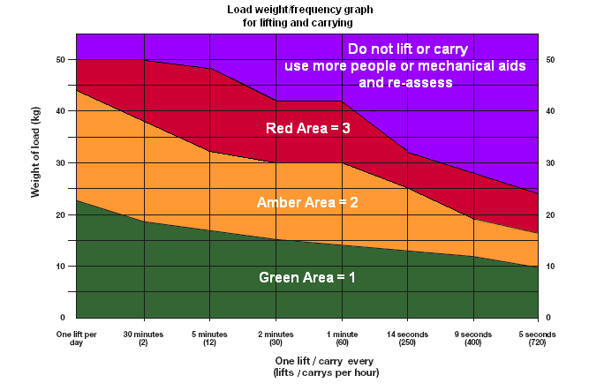
Activity Hazard Risk value |  |  |  |  |  | RISK
3 |  |  |  |  |  | 2 Med |  |  |  | 3 High |  |  |  |  |  |  |  | 3 High
2 |  |  |  |  |  | 1 Low |  |  |  | 2 Med |  |  |  |  |  |  |  | 3 High
1 |  |  |  |  |  | 1 Low |  |  |  | 1 Low |  |  |  |  |  |  |  | 2 Med
Load/Weight Frequency |  |  |  |  |  | 1 |  |  |  | 2 |  |  |  |  |  |  |  | 3
PART 3 – Summary of Control Measures to be included in work instructions
Information Instruction and Training required.

PART 4 – Sign off
Overall Risk |  |  |  |  |  | Low |  |  |  | Med |  |  |  |  |  |  |  | High
Assessor: |  |  |  |  |  |  |  | Service/Staff No: |  |  |  |  |  |  |  | Rank/Grade:
Line Manager: |  |  |  |  |  |  |  | Service/Staff No: |  |  |  |  |  |  |  | Rank/Grade:
PART 5 - REVIEW RECORD When review completed update Issue Status on front page.
Date: Name: Service/Staff No: Rank/Grade:
Date: Name: Service/Staff No: Rank/Grade:

