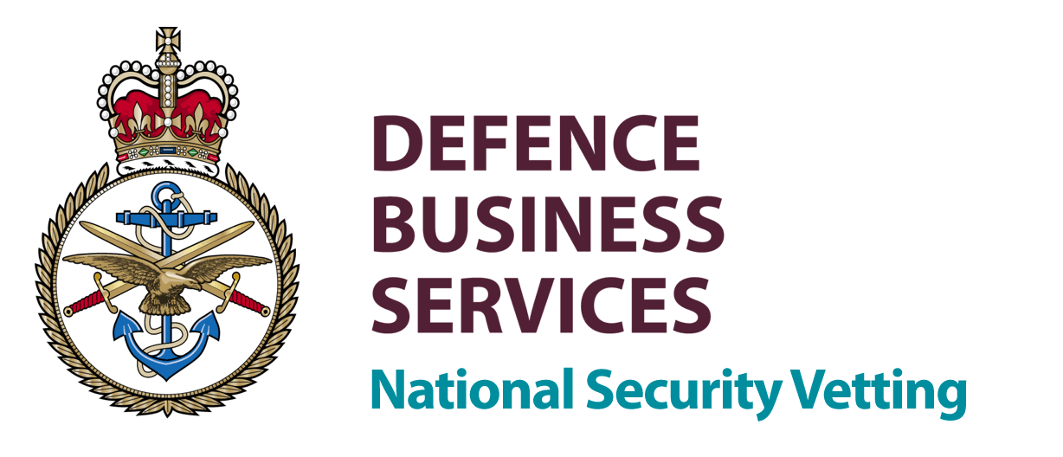

Transfer Request Form

REQUESTED BY

Full Address:
Contact Name:
Telephone Number:
Fax Number:
Authorising Signature:

DETAILS OF TRANSFEREE

Full Name: |  | Date Of Birth:
Previous Surname: |  | Place Of Birth:
Staff/Service Number: |  | Nationality:
Rank/Grade: |  | Level of Clearance Required: | CTC SC DV  (Delete as Applicable)
Type of Employment:  Will the Subject be on your payroll? | YES/NO  (Delete as Applicable) | Contract Number:  (DV Transfer Only, See Note 2)
Transferring from:  Contact Name:  Full Address:  Telephone Number:  Fax Number: |  | Current Clearance Details:  Reference Number:  Date Issued:  Expiry Date:
Date the subject left/is leaving the employment of the sponsor (Clearance Holder, MOD, List X company or Other Government Department). |  |  | Date:
Has subject resided overseas for more than six months in the past year? |  |  | YES/NO  (Delete as Applicable)

Notes:

- For DV and SC transfers please return the completed form to:
By Fax -
FAO: Assessment Co-ord, DBS NSV (York) on 01904 662213
By post -
Assessment Co-ord
Defence Business Services National Security Vetting
Room 152V
Imphal Barracks
Fulford Road
York YO10 4AS

- Transfer of security clearance between List X companies should continue as normal.

- Please complete all boxes on this form in block capitals.

