  Air Warfare Centre |  |  | 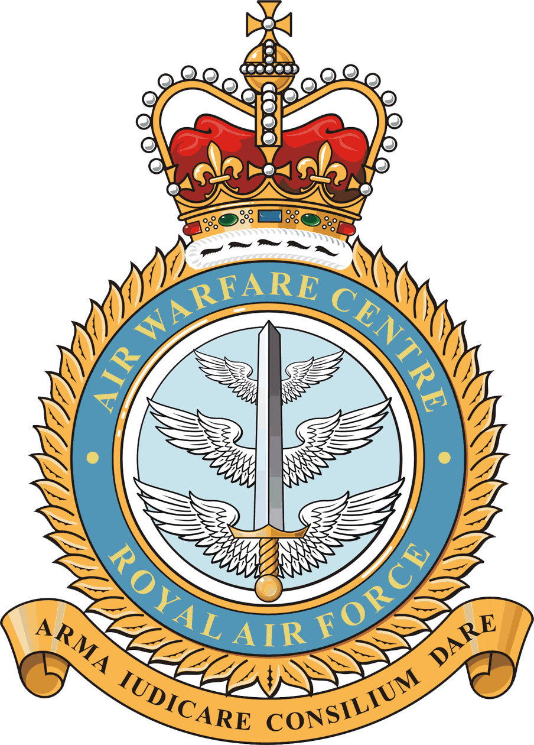
 | Joint Air Delivery Test and Evaluation Unit
 | RAF Brize Norton
 | Carterton
 | Oxfordshire
 | OX18 3LX
 | Tel: 01993 89 7843
 | Fax: 01993 89 6281
 | Email: JADTEU-PAtoCO@mod.uk
All JADTEU Association Members |  | Reference: JADTEU/01_04_01/
 |  | Date: 20 April 2012

Dear Member

I am writing to invite you to the forthcoming JADTEU Association 7th Bi-annual Reunion, which will be held at RAF Brize Norton on Wednesday 27th June 2012. This letter contains the outline programme for the day and an attendance proforma.

This year’s Reunion will take the form of a presentation in the JADTEU Storm Centre and a tour of all JADTEU sections to allow association members the opportunity to visit their former colleagues and to see some of the tasks currently being undertaken at the Unit. This will be followed by lunch and drinks in the Officers’ Mess.

Lunch will cost £6.00 per person and attendees are requested to wear smart casual clothing. If you wish to attend, it would be appreciated if you could return the attached proforma with payment as soon as possible, but no later than Monday 11th June 2012. Even if you are unable to attend, I still invite you to return the proforma or reply by email so that we can ensure that our records are up to date.

The itinerary for the day is as follows:

0930 hrs Arrive at RAF Brize Norton, book in and move to the Officers’ Mess
0940 hrs Coach departs the Officers’ Mess to the Storm Centre for JADTEU presentation
1100 hrs Move by coach to the hangars/sections
1110 hrs JADTEU Association group photo
1215 hrs Move by coach to the Officers’ Mess for lunch
1230 hrs Lunch and drinks in the Coral Bar
1500 hrs Depart Officers’ Mess

There is a severe shortage of parking at RAF Brize Norton, and if no parking spaces are available at the Officers’ Mess, you are recommended to use the large car park in front of the WOs’ and Sgts’ Mess (Building 15 on the enclosed map). You will be met by a JADTEU representative and Service transport at the front of the Officers’ Mess. If this presents a problem, please contact the undersigned as soon as possible in order to make alternative arrangements. Please note that all visitors to RAF Brize Norton are required to be in possession of photo identification (service ID, driving licence or passport) to allow entry to the unit.

For further information relating to the Association, please visit the dedicated website at www.jadteu.mod.uk. You many also like to keep in touch via the JADTEU Facebook page. The link is www.facebook.com/JADTEU - please hit the ‘like’ button to be kept up-to-date with Unit activity.

[Original signed]

N H Mudford
Flight Lieutenant
For Commanding Officer

----------------------------------------------------------------------------------------------------------

ATTENDANCE NOTIFICATION PROFORMA

JADTEU ASSOCIATION 7TH REUNION – 27 June 2012

Attendance: Yes / No (please delete as necessary).

Rank/Title:

Surname:

Forename(s):

Contact Address:

Telephone Number:

E mail address*:

Vehicle Details:

Make: Model:

Registration No: Colour:

Please advise if you have any special dietary requirements:

I attach a cheque for £6.00 per person for lunch (made payable to SERVICE FUNDS RAF BRIZE NORTON).

Return proforma by 11th June 2012 to:

Miss K J Treacy
PA to CO JADTEU
RAF Brize Norton
Oxon
OX18 3LX

* If you provide an e mail address this will be the method used to keep you updated on future Association activity.

