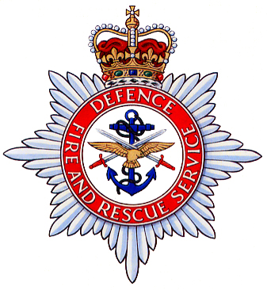
DEFENCE FIRE RISK MANAGEMENT ORGANISATION

APPLICATION TO ATTEND UNIT FIRE SAFETY (UFS) MANAGER, WARDEN, EXTINGUISHER MAINTENANCE, AWARENESS TRAINER

1. Course Requirements
Course Title | Course Number | Assembly Date | Dispersal Date
Alternative Course Details

2. Nominee
Staff/Service Number | Rank or Grade | Surname and Initials | Service, Regiment or Corps | Priority

3. Justification
Current Employment:
Time in Post: |  |  | Time left in Post:
If serving outside UK state return date:
Explanation:

Unit Stamp | Approved By:
Unit Stamp | Rank:
Unit Stamp | Position:
Unit Stamp | UIN:
Unit Stamp | Contact Number:
Unit Stamp | Course Clerk Email for Joining Instructions:
Unit Stamp | Date:

When completed this form should be sent to the Course Admin Officer by post, fax or email.
Post: Defence Fire Training & Development Centre, MOD Manston, Ramsgate, Kent, CT12 5BS
Fax: Internal: 95236 6381 GPTN: 01843 823382 Email: DFRMO-DFTDC-ResourcesGrp@mod.uk

