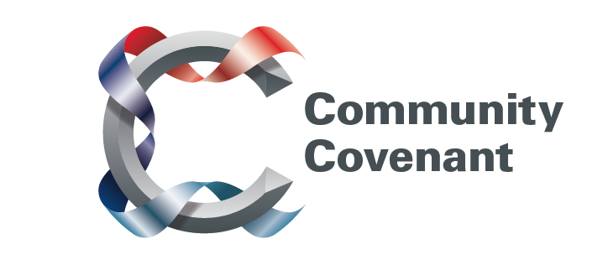

Wales

Below is a list of the areas in Wales with an existing Community Covenant Partnership. Hold down the Ctrl tab on your keyboard and click on the links – they will take you straight through to the external council websites. Should you wish to find out more, do get in touch with them. If a name does not have a link it’s because that council has countersigned the Community Covenant above it.

If your local area has not signed up, click here to find out how set up a Community Covenant.

Isle of Anglesey
Vale of Glamorgan
Swansea City and Borough Council
Powys County Council
Newport City Council

