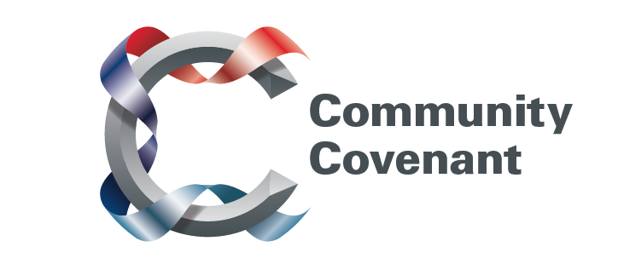

East

Below is a list of the areas in the East with an existing Community Covenant Partnership. Hold down the Ctrl tab on your keyboard and click on the links – they will take you straight through to the external council websites. Should you wish to find out more, do get in touch with them. If a name does not have a link it’s because that council has countersigned the Community Covenant above it.

If your local area has not signed up, click here to find out how set up a Community Covenant.

Central Bedfordshire
Bedford Borough
Cambridgeshire County
East Cambridgeshire District
Colchester Borough
Essex County
Maldon District
Hertfordshire County
Broxbourne Borough
Dacorum Borough
East Hertfordshire District
Hertsmere Borough
North Hertfordshire District
St Alban’s City and District
Stevenage Borough
Three Rivers District
Watford Borough
Welwyn Hatfield District
Maidstone Borough
Norfolk County
Breckland
Broadland District
Great Yarmouth District
King’s Lynn Borough
North Nofolk District
Norwich City
South Norfolk District
Suffolk County Council
Mid-Suffolk District
Ipswich Borough
Suffolk Coastal District
St. Edmundsbury District
Waveney District
Forest Heath District
Babergh District

