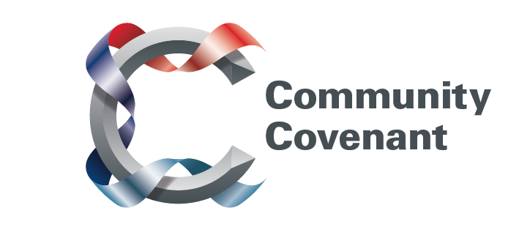

Scotland

Below is a list of the areas in Scotland with an existing Community Covenant Partnership. Hold down the Ctrl tab on your keyboard and click on the links – they will take you straight through to the external council websites. Should you wish to find out more, do get in touch with them.

If your local area has not signed up, click here to find out how set up a Community Covenant.

Angus
East Ayrshire
North Ayrshire
South Ayrshire
Dumfries and Galloway
West Dunbartonshire
Dundee
City of Edinburgh
Fife
City of Glasgow
Inverclyde
North Lanarkshire
South Lanarkshire
East Lothian
Mid Lothian
West Lothian
Moray
East Renfrewshire
Renfrewshire
Scottish Borders

