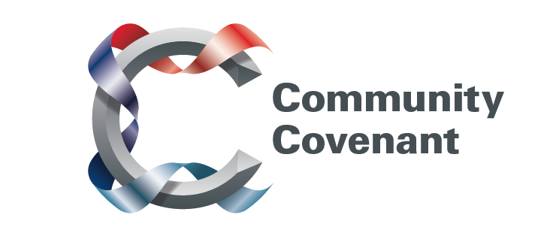

West Midlands

Below is a list of the areas in the West Midlands with an existing Community Covenant Partnership. Hold down the Ctrl tab on your keyboard and click on the links – they will take you straight through to the external council websites. Should you wish to find out more, do get in touch with them. If a name does not have a link it’s because that council has countersigned the Community Covenant above it.

If your local area has not signed up, click here to find out how set up a Community Covenant.

Birmingham City
Dudley Metropolitan Borough
Herefordshire County
Sandwell Metropolitan Borough
Shropshire County
Staffordshire County
Warwickshire County
Coventry City
North Warwickshire Borough
Nuneaton and Bedworth Borough
Rugby Borough
Solihull Metropolitan Borough
Stratford-upon-Avon District
Worcestershire County
Malvern Hills
Bromsgrove District
Redditch Borough
Worcester City
Wychavon District
Wyre Forest District

