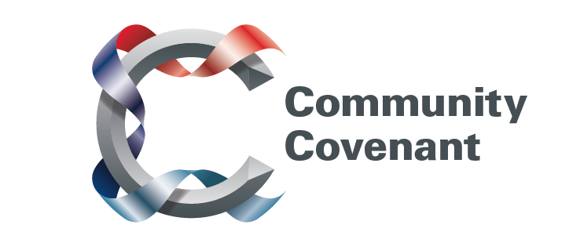

South West

Below is a list of the areas in the South West with an existing Community Covenant Partnership. Hold down the Ctrl tab on your keyboard and click on the links – they will take you straight through to the external council websites. Should you wish to find out more, do get in touch with them. If a name does not have a link it’s because that council has countersigned the Community Covenant above it.

If your local area has not signed up, click here to find out how set up a Community Covenant.

Cornwall
Devon County
Mid Devon District
Dorset County
Bournemouth
Poole
Weymouth and Portland Borough
Christchurch Borough
West Dorset District
North Dorset District
Purbeck District
East Dorset District
Gloucestershire County
Cheltenham Borough
Cotswold District
Forest of Dean District
Gloucester City
Tewkesbury Borough
Plymouth City
Somerset County

