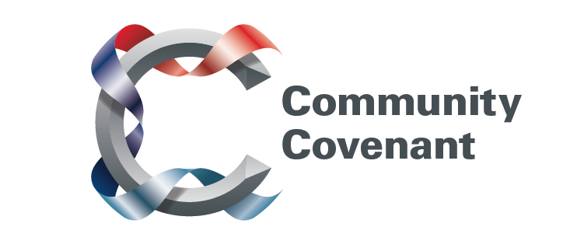

North East

Below is a list of the areas in the North East with an existing Community Covenant Partnership. Hold down the Ctrl tab on your keyboard and click on the links – they will take you straight through to the external council websites. Should you wish to find out more, do get in touch with them. If a name does not have a link it’s because that council has countersigned the Community Covenant above it.

If your local area has not signed up, click here to find out how set up a Community Covenant.

Durham County
Gateshead Borough
Hartlepool Borough
Middlesbrough Borough
Newcastle City
Northumberland County
Stockton-on-Tees Borough
Sunderland City
North Tyneside Metropolitan Borough
South Tyneside Metropolitan Borough

