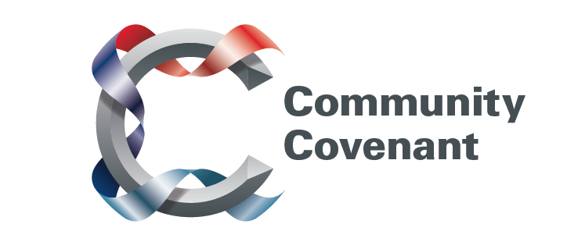

North West

Below is a list of the areas in the North West with an existing Community Covenant Partnership. Hold down the Ctrl tab on your keyboard and click on the links – they will take you straight through to the external council websites. Should you wish to find out more, do get in touch with them. If a name does not have a link it’s because that council has countersigned the Community Covenant above it.

If your local area has not signed up, click here to find out how set up a Community Covenant.

Blackpool City
Cheshire East Borough
Cheshire West and Chester Borough
Halton Borough
Warrington Borough
Knowsley Metropolitan Borough
Liverpool City
Preston City
Rossendale Borough
St Helens Metropolitan Borough
Wirral Metropolitan Borough
Wyre Borough

